11/18/16 Analysis of tweets from last week (Celtics vs. Knicks game)

* Value counts discovered for some keywords
* Collected mostly BEFORE game started
* Total number of tweets collected: 1451
* Final score:

|  |  |  |  |  |  |
| --- | --- | --- | --- | --- | --- |
| Keyword | NBA | Celtics | knicks |  |  |
| Count | 202 | 5 | 972 |  |  |

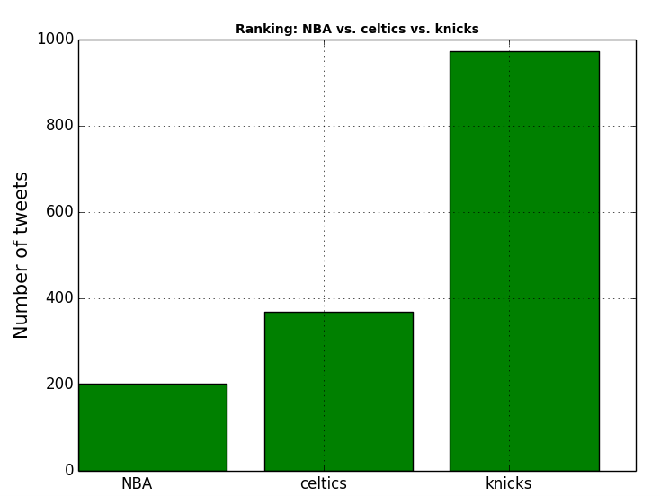

Top 5 most common keywords:

Macintosh HD:Users:Lauren:Desktop:Screen Shot 2016-11-21 at 5.29.08 PM.png

Top 5 most common hashtags:

Macintosh HD:Users:Lauren:Desktop:Screen Shot 2016-11-21 at 5.30.01 PM.png