ANNEX F
TECHNICAL DOCUMENTATION & SPECIFICATIONS
F.3 API ENDPOINT SPECIFICATIONS
Source review date: 10 November 2026

F.3.1 API Overview
ParSU e-Feedback exposes backend operations through Next.js App Router Route Handlers located under src/app/api. The source currently contains 68 route.ts handler files and 98 exported HTTP method handlers, including the GET and POST methods delegated to Auth.js. Dynamic route segments are shown in this annex as {id} or {attachmentId}; the corresponding Next.js folders use bracket notation, such as [id].
Handlers execute server-side in Node.js, parse URL parameters or JSON/form-data requests, apply authentication and resource-level authorization, connect to MongoDB through Mongoose, and return JSON with NextResponse.json. File operations use Cloudflare R2 through the S3-compatible SDK and Resend is called by email workflows. Auth.js is mounted at /api/auth/[...nextauth]; registration, code verification, and resend are separate Route Handlers.
The request guard `auth()` validates the Auth.js session against the current user record, active status, token version, and current authorization claims. Route handlers additionally enforce role, ownership, office, assignment, and head-designation rules. The edge proxy provides a coarse route-level filter for most application routes; route-level checks remain decisive. Password recovery and logout are implemented as Next.js Server Actions, not REST endpoints, and are identified separately in F.3.2.
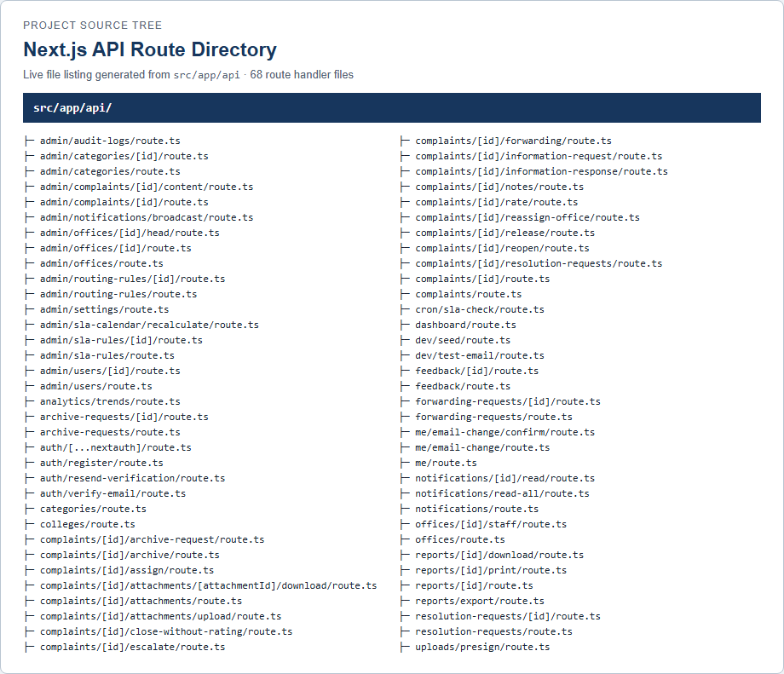
Figure F.4. Next.js API Route Directory. Generated from the actual src/app/api file tree.

F.3.2 API Endpoint Inventory
Table F.9 lists each implemented Route Handler method separately. Dynamic URL parameters are shown in braces. Access levels describe the handler’s server-side checks; they are not inferred from the UI.
Table F.9. API Endpoint Inventory
HTTP Method | API Endpoint | Description | Access Level
Authentication and Student Registration
GET | /api/auth/[...nextauth] | Auth.js GET protocol handler (session/CSRF and related authentication endpoints). | Auth.js protocol; session requirements vary by action.
POST | /api/auth/[...nextauth] | Auth.js POST protocol handler (credential sign-in/sign-out and related authentication actions). | Auth.js protocol; credentials/session requirements vary by action.
POST | /api/auth/register | Register a student account and initiate email verification. | Public; student email/domain checks, verification token/code checks, and rate limits apply.
POST | /api/auth/resend-verification | Resend a pending student verification code subject to cooldown and rate limits. | Public; student email/domain checks, verification token/code checks, and rate limits apply.
POST | /api/auth/verify-email | Verify a student email address using its six-digit code. | Public; student email/domain checks, verification token/code checks, and rate limits apply.
User Management
GET | /api/admin/users | List users with pagination and role filtering; password hashes are excluded. | Administrator only (scoped-role guard mismatch; see F.3.4).
POST | /api/admin/users | Create a role-scoped user account; student verification email is attempted when applicable. | Administrator only (scoped-role guard mismatch; see F.3.4).
DELETE | /api/admin/users/{id} | Delete a user subject to administrator/self-deletion safeguards. | Administrator only (scoped-role guard mismatch; see F.3.4).
GET | /api/admin/users/{id} | Retrieve one user while excluding password hash data. | Administrator only (scoped-role guard mismatch; see F.3.4).
PATCH | /api/admin/users/{id} | Update user profile/role/office/college/status/password or force-logout state. | Administrator only (scoped-role guard mismatch; see F.3.4).
GET | /api/me | Return the signed-in user’s own profile and pending email-change metadata. | Authenticated user; own profile only.
PATCH | /api/me | Update allowed own-profile fields and/or password after current-password checks. | Authenticated user; own editable profile fields only.
POST | /api/me/email-change | Request a login-email change and send a confirmation link. | Authenticated user; current-password check and rate limit.
POST | /api/me/email-change/confirm | Confirm an email change using a single-use token. | No session; valid single-use token.
Complaint Submission and Retrieval
GET | /api/complaints | List complaints filtered by student ownership, office assignment, or admin scope. | Authenticated; results filtered by owner, office, or admin scope.
POST | /api/complaints | Create a student complaint, assign its ticket and SLA dates, and route it initially to active OSAS. | Authenticated student only.
GET | /api/complaints/{id} | Retrieve an accessible complaint with a role-filtered timeline. | Authenticated; complaint ownership/current office/admin-scope checks.
PATCH | /api/complaints/{id} | Edit/withdraw an owner’s unassigned complaint or update status as its assigned handler. | Student owner before pickup, or assigned complaint handler.
Complaint Management and Status Updates
GET | /api/archive-requests | List pending archive requests for the signed-in office head. | Designated active office head.
PATCH | /api/archive-requests/{id} | Approve/reject a pending archive request for the responsible office. | Designated head of the request’s office.
PATCH | /api/complaints/{id}/archive | Archive or restore a complaint after office-head/administrator supervision checks. | Administrator; OSAS Head for OSAS-owned complaint.
GET | /api/complaints/{id}/archive-request | Retrieve the complaint’s archive request after complaint access checks. | Authenticated internal complaint viewer.
POST | /api/complaints/{id}/archive-request | Submit an archive request for review by the responsible office head. | Assigned office_staff on OSAS complaint.
POST | /api/complaints/{id}/close-without-rating | Close an eligible resolved complaint without a student rating. | Authenticated student owner of resolved complaint.
POST | /api/complaints/{id}/escalate | Submit a manual escalation with a required reason. | Administrator or assigned OSAS handler on OSAS complaint.
POST | /api/complaints/{id}/information-request | Create a request for additional student information. | Assigned handler for current complaint office.
POST | /api/complaints/{id}/information-response | Submit the student’s response to an open information request. | Authenticated student owner; complaint awaits information.
GET | /api/complaints/{id}/notes | List internal notes for an authorized complaint handler. | Authenticated internal complaint viewer.
POST | /api/complaints/{id}/notes | Add an internal note to an accessible complaint. | Authenticated internal user with note-write authority.
POST | /api/complaints/{id}/rate | Submit a 1–5 satisfaction rating and optional comment for a resolved complaint. | Authenticated student owner of resolved complaint.
POST | /api/complaints/{id}/reopen | Reopen an eligible complaint with a required reason and audit/timeline event. | Administrator or OSAS Head with complaint access.
GET | /api/complaints/{id}/resolution-requests | List resolution requests for an internally accessible complaint. | Authenticated internal complaint viewer.
POST | /api/complaints/{id}/resolution-requests | Submit a resolution request from the assigned handler for office-head review. | Assigned handler; office_staff/OSAS/VPAA/VPAF.
GET | /api/resolution-requests | List pending resolution requests for the signed-in office head. | Designated active office head.
PATCH | /api/resolution-requests/{id} | Approve/reject a pending resolution request; approval resolves the complaint. | Designated head of the request’s office.
Complaint Assignment and Forwarding
POST | /api/complaints/{id}/assign | Assign/reassign a complaint to an eligible staff handler through office controls. | Responsible office head; administrator override for OSAS.
GET | /api/complaints/{id}/forwarding | List forwarding history for an accessible complaint. | Authenticated user with complaint access.
POST | /api/complaints/{id}/forwarding | Create an OSAS forwarding request or directly forward as OSAS Head. | Assigned OSAS handler may request; OSAS Head may forward.
POST | /api/complaints/{id}/reassign-office | Reject the legacy reassignment request and direct callers to controlled forwarding. | Authenticated; handler enforces role/resource scope.
POST | /api/complaints/{id}/release | Release the handler assignment with a required reason. | Assigned OSAS/office_staff handler.
GET | /api/forwarding-requests | List authorized forwarding-request history, optionally filtered by status. | Administrator, OSAS Head, or OSAS requester.
PATCH | /api/forwarding-requests/{id} | Approve/reject a pending OSAS forwarding request as OSAS Head. | OSAS Head only.
SLA Monitoring
GET | /api/admin/sla-calendar/recalculate | Preview recalculated complaint SLA dates and return a freshness token. | Administrator only.
POST | /api/admin/sla-calendar/recalculate | Apply the SLA date plan only when the submitted preview token is current. | Administrator only.
GET | /api/admin/sla-rules | List SLA rules. | Administrator only.
POST | /api/admin/sla-rules | Create an SLA rule for a category/priority combination. | Administrator only.
DELETE | /api/admin/sla-rules/{id} | Delete an SLA rule. | Administrator only.
PATCH | /api/admin/sla-rules/{id} | Update an SLA rule after category and threshold validation. | Administrator only.
GET | /api/cron/sla-check | Run the secret-protected scheduled SLA warning and escalation scan. | Shared cron secret required.
POST | /api/cron/sla-check | Run the secret-protected SLA scan for QStash/manual callers. | Shared cron secret required.
General Student Feedback
GET | /api/feedback | List the signed-in student’s non-archived feedback. | Authenticated student; own feedback only.
POST | /api/feedback | Submit standalone general feedback as the signed-in student. | Authenticated student only.
DELETE | /api/feedback/{id} | Soft-archive the signed-in student’s own feedback record. | Authenticated student; own feedback only.
PATCH | /api/feedback/{id} | Update the signed-in student’s own feedback record. | Authenticated student; own feedback only.
File Attachments
GET | /api/complaints/{id}/attachments | List attachments for an accessible complaint. | Authenticated user with complaint access.
POST | /api/complaints/{id}/attachments | Register an attachment record on an accessible complaint. | Authenticated user allowed to attach to complaint.
POST | /api/complaints/{id}/attachments/upload | Upload a student information-response file to R2 and register the attachment. | Authenticated student complaint owner.
GET | /api/complaints/{id}/attachments/{attachmentId}/download | Download an authorized attachment from Cloudflare R2. | Authenticated user with complaint access.
POST | /api/uploads/presign | Validate an attachment request and issue a short-lived Cloudflare R2 upload URL. | Authenticated user allowed to attach to complaint.
Notifications
POST | /api/admin/notifications/broadcast | Create a broadcast notification for all users, a role, or an office. | Administrator only.
GET | /api/notifications | List the caller’s visible notifications and unread count. | Authenticated; own recipient and accessible-complaint scope.
PATCH | /api/notifications/read-all | Mark all of the caller’s unread notifications as read. | Authenticated; own notifications only.
PATCH | /api/notifications/{id}/read | Mark one owned, in-scope notification as read. | Authenticated; own in-scope notification only.
Institutional Analytics
GET | /api/analytics/trends | Return complaint summary, monthly trends, and category, priority, domain, and college breakdowns within the caller’s scope. | Authenticated administrator/OSAS/VPAA/VPAF/office_staff.
GET | /api/dashboard | Return role-scoped dashboard counts and complaint lists. | Authenticated administrator/OSAS/VPAA/VPAF/office_staff.
Reports and Exporting
GET | /api/reports/export | List up to 50 generated reports created by the signed-in user. | Authenticated; own generated reports only.
POST | /api/reports/export | Generate a CSV, Excel, or PDF report using caller-scoped complaint data. | Authenticated non-student; report data scoped by role/office.
DELETE | /api/reports/{id} | Delete an authorized generated report. | Authenticated; handler enforces role/resource scope.
GET | /api/reports/{id}/download | Download a ready report from Cloudflare R2 after access checks. | Authenticated; handler enforces role/resource scope.
GET | /api/reports/{id}/print | Render an authorized report for printing. | Authenticated; handler enforces role/resource scope.
Administrative Configuration
GET | /api/admin/audit-logs | Search and paginate system audit records by entity, action, actor, or date range. | Administrator only.
GET | /api/admin/categories | List all categories, including inactive/draft categories, for administrators. | Administrator only.
POST | /api/admin/categories | Create a category and its initial active OSAS routing rule; the category is created inactive pending SLA setup. | Administrator only.
DELETE | /api/admin/categories/{id} | Delete a category when dependent records permit it. | Administrator only.
GET | /api/admin/categories/{id} | Retrieve one category by ID. | Administrator only.
PATCH | /api/admin/categories/{id} | Update category fields after schema and routing checks. | Administrator only.
PATCH | /api/admin/complaints/{id} | Archive or restore the complaint with reason and audit entry. | Administrator only (scoped-role guard mismatch; see F.3.4).
PATCH | /api/admin/complaints/{id}/content | Correct complaint title/description with a reason and audit trail. | Administrator only.
GET | /api/admin/offices | List offices available within the caller’s permitted administrative scope. | Administrator only (scoped-role guard mismatch; see F.3.4).
POST | /api/admin/offices | Create an office after office-type, code, and caller-scope validation. | Administrator only (scoped-role guard mismatch; see F.3.4).
DELETE | /api/admin/offices/{id} | Delete an office when it has no assigned users or dependent records. | Administrator only (scoped-role guard mismatch; see F.3.4).
GET | /api/admin/offices/{id} | Retrieve an office record after scope authorization. | Administrator only (scoped-role guard mismatch; see F.3.4).
PATCH | /api/admin/offices/{id} | Update office metadata after scope and hierarchy validation. | Administrator only (scoped-role guard mismatch; see F.3.4).
DELETE | /api/admin/offices/{id}/head | Remove the office-head designation. | Administrator only.
PATCH | /api/admin/offices/{id}/head | Assign or replace an eligible active user as office head. | Administrator only.
POST | /api/admin/offices/{id}/head | Create an eligible user account and assign it as the office head. | Administrator only.
GET | /api/admin/routing-rules | List routing-rule records. | Administrator only.
POST | /api/admin/routing-rules | Create a category routing rule with validated target and conditions. | Administrator only.
DELETE | /api/admin/routing-rules/{id} | Delete a routing-rule record. | Administrator only.
PATCH | /api/admin/routing-rules/{id} | Update a routing rule while preventing duplicate active category rules. | Administrator only.
GET | /api/admin/settings | Return persisted application settings. | Administrator only.
PATCH | /api/admin/settings | Update validated runtime settings, including upload policy and SLA holidays. | Administrator only.
GET | /api/categories | List active complaint categories with minimal fields for signed-in users. | Any authenticated user; response contains active/minimal fields.
GET | /api/colleges | List active college offices with name/code fields for registration. | Public, read-only.
GET | /api/offices | List active offices with name/code/type fields for authenticated users. | Any authenticated user; response contains active/minimal fields.
GET | /api/offices/{id}/staff | List eligible active staff for an office the caller is authorized to manage. | Responsible head for that office.
Development and Operations
GET | /api/dev/seed | Run the development seed operation when environment and secret checks pass. | Non-production and development secret required.
POST | /api/dev/test-email | Send a verification-format test email to the configured test recipient in non-production. | Non-production and development secret required.

Inventory coverage: 98 HTTP method handlers across 68 route files. The auth catch-all delegates GET/POST to Auth.js. No additional root-level app/api directory or backend route directory was found.
Server Actions (not REST endpoints): forgotPasswordAction and resetPasswordAction in src/features/auth/actions.ts; logoutAction in src/features/auth/actions/logout.action.ts. Password recovery validates FormData, applies the IP/email rate limiter, returns a generic response that does not reveal account existence, and resets a password only with a valid token. Logout calls Auth.js signOut and redirects to /login.
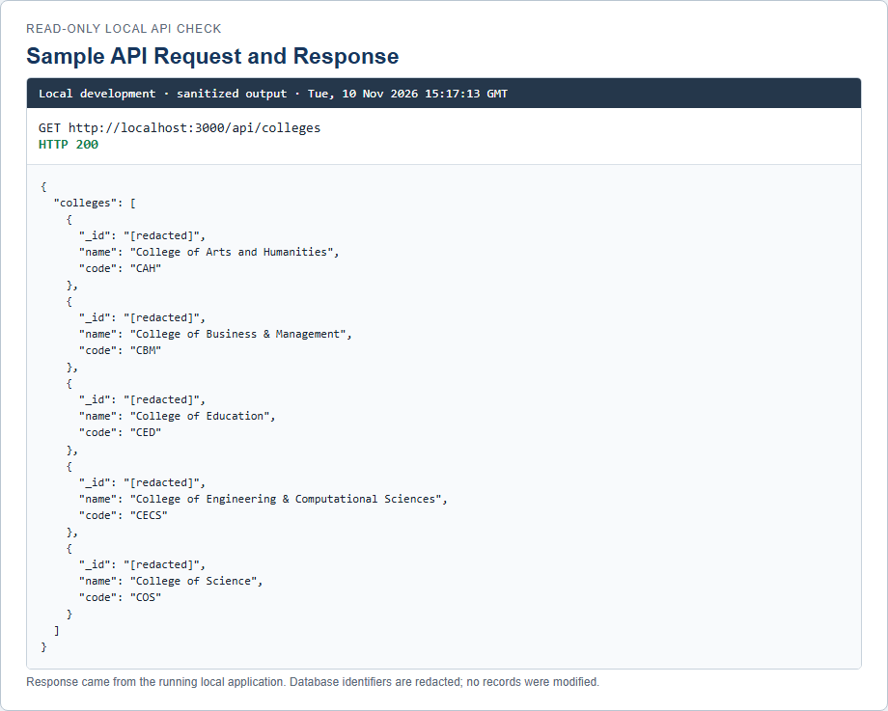
Figure F.5. Sample API Request and Response. Read-only GET request captured from the running local development application; database identifiers are redacted.

F.3.3 Detailed API Endpoint Specifications
The following specifications cover major implemented flows. Request and response examples are illustrative and sanitized; the success/error behavior is taken from the route handler and its imported schemas/services. Full method coverage remains in Table F.9.

Authentication and registration

Endpoint Name: POST /api/auth/register
Specification | Actual Implementation
Endpoint URL | POST /api/auth/register
Source File | src/app/api/auth/register/route.ts
Authentication / Authorized Roles | No prior session; public student self-registration.
Request Parameters / Body | JSON: firstName, lastName, email (@parsu.edu.ph), studentNumber, collegeId, password, confirmPassword.
Success Response | 201 {message}; account is created unverified and a code is sent.
Error Responses | 400 invalid JSON/validation/college; 409 duplicate email/student number; 429 rate-limited (Retry-After); 503 limiter/email delivery unavailable.

Endpoint Name: POST /api/auth/verify-email
Specification | Actual Implementation
Endpoint URL | POST /api/auth/verify-email
Source File | src/app/api/auth/verify-email/route.ts
Authentication / Authorized Roles | Public; six-digit code verification for a ParSU student email.
Request Parameters / Body | JSON: email, code (exactly six digits).
Success Response | 200 {message: 'Email verified. You can now sign in.'}.
Error Responses | 400 invalid body/code; 429 rate limit; 503 rate limiter unavailable.

Endpoint Name: POST /api/auth/resend-verification
Specification | Actual Implementation
Endpoint URL | POST /api/auth/resend-verification
Source File | src/app/api/auth/resend-verification/route.ts
Authentication / Authorized Roles | Public; pending student account only, with cooldown and rate limits.
Request Parameters / Body | JSON: email.
Success Response | 200 {message}; Retry-After: 60.
Error Responses | 400 invalid body; 429 too many requests with Retry-After; 503 delivery/rate-limit error.

Endpoint Name: GET, POST /api/auth/[...nextauth]
Specification | Actual Implementation
Endpoint URL | GET, POST /api/auth/[...nextauth]
Source File | src/app/api/auth/[...nextauth]/route.ts
Authentication / Authorized Roles | Auth.js handler; endpoint actions determine whether a session is needed.
Request Parameters / Body | Auth.js protocol parameters/form fields; credential sign-in uses email and password.
Success Response | Auth.js-defined JSON/redirect/session responses.
Error Responses | Auth.js-defined authentication and protocol errors.

Complaint submission and status

Endpoint Name: POST /api/complaints
Specification | Actual Implementation
Endpoint URL | POST /api/complaints
Source File | src/app/api/complaints/route.ts
Authentication / Authorized Roles | Authenticated student only.
Request Parameters / Body | JSON: categoryRef, title (5–200 chars), description (at least 20 chars). Category must be active; matching SLA rule required.
Success Response | 201 {complaint}; also records timeline/audit and notifications.
Error Responses | 401 unauthenticated; 403 non-student; 400 invalid body/category; 422 OSAS unavailable or no SLA rule.

Endpoint Name: GET /api/complaints
Specification | Actual Implementation
Endpoint URL | GET /api/complaints
Source File | src/app/api/complaints/route.ts
Authentication / Authorized Roles | Authenticated; student, office_staff, administrator, OSAS, VPAA, VPAF; data filtered per user/office/scope.
Request Parameters / Body | Query: page, limit (max 100, default 20), status, q (title/ticket search).
Success Response | 200 {complaints,total,page,limit}.
Error Responses | 401 no session; 403 unsupported role.

Endpoint Name: GET /api/complaints/{id}
Specification | Actual Implementation
Endpoint URL | GET /api/complaints/{id}
Source File | src/app/api/complaints/[id]/route.ts
Authentication / Authorized Roles | Authenticated with complaint ownership/current-office/admin-scope access.
Request Parameters / Body | Path: id.
Success Response | 200 {complaint,timeline}; student timeline omits internal resolution-request/rejection events and student actor identities are redacted for staff.
Error Responses | 401 unauthenticated; 403 not authorized; 404 not found.

Endpoint Name: PATCH /api/complaints/{id}
Specification | Actual Implementation
Endpoint URL | PATCH /api/complaints/{id}
Source File | src/app/api/complaints/[id]/route.ts
Authentication / Authorized Roles | Authenticated; owner-student can edit/withdraw only while submitted; assigned handler can update permitted statuses. A non-head handler cannot mark a complaint resolved directly.
Request Parameters / Body | JSON for student: title and/or description, or status='withdrawn'. Handler: status plus optional message/resolutionSummary.
Success Response | 200 {complaint}; timeline/audit/notification side effects on applicable mutations.
Error Responses | 400 invalid body/transition or complaint already picked up; 401; 403; 404. Generic status route rejects direct assigned/escalated/closed/pending-information transitions with workflow guidance.

OSAS forwarding workflow

Endpoint Name: POST /api/complaints/{id}/forwarding
Specification | Actual Implementation
Endpoint URL | POST /api/complaints/{id}/forwarding
Source File | src/app/api/complaints/[id]/forwarding/route.ts
Authentication / Authorized Roles | Authenticated OSAS/office_staff. Assigned OSAS handler may request; OSAS Head may directly forward.
Request Parameters / Body | JSON: destination ('vpaa'|'vpaf'), reason (1–4000 chars), optional direct boolean.
Success Response | 201 {request}; direct head action creates and approves in one transaction, then transfers office/handler and records timeline/audit/notifications.
Error Responses | 400 schema/rejection reason; 401; 403 role/assignment/head restriction; 404; 409 invalid state/pending archive/config; 500 generic persistence failure.

Endpoint Name: GET /api/complaints/{id}/forwarding
Specification | Actual Implementation
Endpoint URL | GET /api/complaints/{id}/forwarding
Source File | src/app/api/complaints/[id]/forwarding/route.ts
Authentication / Authorized Roles | Authenticated with complaint access.
Request Parameters / Body | Path: id.
Success Response | 200 {requests}, newest first, with requester/reviewer identity fields populated.
Error Responses | 401; 403; 404.

Endpoint Name: GET /api/forwarding-requests
Specification | Actual Implementation
Endpoint URL | GET /api/forwarding-requests
Source File | src/app/api/forwarding-requests/route.ts
Authentication / Authorized Roles | Authenticated administrator, OSAS Head, or OSAS requester; data is filtered by requester/head.
Request Parameters / Body | Query: optional status=pending|approved|rejected.
Success Response | 200 {requests}, maximum 100, newest first.
Error Responses | 400 invalid status; 401; 403 unauthorized history scope.

Endpoint Name: PATCH /api/forwarding-requests/{id}
Specification | Actual Implementation
Endpoint URL | PATCH /api/forwarding-requests/{id}
Source File | src/app/api/forwarding-requests/[id]/route.ts
Authentication / Authorized Roles | Authenticated OSAS Office Head only.
Request Parameters / Body | JSON: action ('approve'|'reject'), reason (optional, required for rejection).
Success Response | 200 {request}; approval transfers complaint to active OVPAA/OVPAF and designated receiving handler.
Error Responses | 400 invalid decision/rejection reason; 401; 403; 404; 409 already decided/ineligible/configuration; 500 generic failure.

Resolution approval workflow

Endpoint Name: POST /api/complaints/{id}/resolution-requests
Specification | Actual Implementation
Endpoint URL | POST /api/complaints/{id}/resolution-requests
Source File | src/app/api/complaints/[id]/resolution-requests/route.ts
Authentication / Authorized Roles | Authenticated assigned handler with supported role office_staff|osas|vpaa|vpaf; complaint processing access required.
Request Parameters / Body | JSON: optional resolutionSummary (max 4000) and message (max 2000). Office head must be configured; complaint must be active and transitionable to resolved.
Success Response | 201 {request}; request, timeline, audit record, and head notification are created.
Error Responses | 400 invalid body/not ready/unassigned; 401; 403 wrong role/handler/archive; 404; 409 missing head or pending duplicate.

Endpoint Name: GET /api/resolution-requests
Specification | Actual Implementation
Endpoint URL | GET /api/resolution-requests
Source File | src/app/api/resolution-requests/route.ts
Authentication / Authorized Roles | Authenticated designated active head of the relevant office (authority is Office.headUserRef, not a dedicated role).
Request Parameters / Body | No query parameters.
Success Response | 200 {requests}; pending requests for the caller’s active head-designated office(s).
Error Responses | 401; 403 not an active office head.

Endpoint Name: PATCH /api/resolution-requests/{id}
Specification | Actual Implementation
Endpoint URL | PATCH /api/resolution-requests/{id}
Source File | src/app/api/resolution-requests/[id]/route.ts
Authentication / Authorized Roles | Authenticated responsible office head; verifies office designation and complaint scope/state.
Request Parameters / Body | JSON: action ('approve'|'reject'); rejectionReason required for reject (max 2000).
Success Response | 200 {request,complaint}; approval resolves complaint; rejection preserves current complaint status. Both create timeline/audit/notifications.
Error Responses | 400 schema; 401; 403; 404; 409 duplicate decision or changed complaint state; 500 persistence verification failure.

Attachments and R2

Endpoint Name: POST /api/uploads/presign
Specification | Actual Implementation
Endpoint URL | POST /api/uploads/presign
Source File | src/app/api/uploads/presign/route.ts
Authentication / Authorized Roles | Authenticated user permitted to attach to referenced complaint.
Request Parameters / Body | JSON: complaintId, fileName, mimeType, sizeBytes. MIME and maximum size come from settings.
Success Response | 200 {uploadUrl,fileUrl,objectKey}; signed URL expires after 300 seconds.
Error Responses | 400 validation/type/size; 401; 403 inaccessible/read-only complaint; 404 complaint; 501 R2 not configured.

Endpoint Name: POST /api/complaints/{id}/attachments/upload
Specification | Actual Implementation
Endpoint URL | POST /api/complaints/{id}/attachments/upload
Source File | src/app/api/complaints/[id]/attachments/upload/route.ts
Authentication / Authorized Roles | Authenticated student owner only; complaint must be active and non-archived.
Request Parameters / Body | multipart/form-data field file; type/size checked against settings.
Success Response | 201 {attachment}; file is uploaded to R2 and an attachment timeline/audit record is added.
Error Responses | 400 missing/invalid/oversize file; 401; 403; 404; 501 R2 not configured.

Endpoint Name: GET /api/complaints/{id}/attachments/{attachmentId}/download
Specification | Actual Implementation
Endpoint URL | GET /api/complaints/{id}/attachments/{attachmentId}/download
Source File | src/app/api/complaints/[id]/attachments/[attachmentId]/download/route.ts
Authentication / Authorized Roles | Authenticated user with complaint access.
Request Parameters / Body | Path: complaint id and attachment id.
Success Response | 200 file bytes with attachment content headers.
Error Responses | 401; 403; 404; 501 storage not configured; 502 storage returned empty content.

Analytics, reports, and notifications

Endpoint Name: GET /api/analytics/trends
Specification | Actual Implementation
Endpoint URL | GET /api/analytics/trends
Source File | src/app/api/analytics/trends/route.ts
Authentication / Authorized Roles | Authenticated administrator, OSAS, VPAA, VPAF, or office_staff; scoped aggregates.
Request Parameters / Body | No query/body.
Success Response | 200 {summary,trends,collegeComparison,categoryBreakdown,priorityBreakdown,domainBreakdown}; office_staff collegeComparison is empty.
Error Responses | 401; 403 unsupported role.

Endpoint Name: GET /api/dashboard
Specification | Actual Implementation
Endpoint URL | GET /api/dashboard
Source File | src/app/api/dashboard/route.ts
Authentication / Authorized Roles | Authenticated administrator, OSAS, VPAA, VPAF, or office_staff.
Request Parameters / Body | No query/body.
Success Response | 200 role-scoped dashboard data from getDashboardData.
Error Responses | 401; 403 student/unsupported role.

Endpoint Name: POST /api/reports/export
Specification | Actual Implementation
Endpoint URL | POST /api/reports/export
Source File | src/app/api/reports/export/route.ts
Authentication / Authorized Roles | Authenticated non-student; report rows are scoped by role and office.
Request Parameters / Body | JSON: format csv|excel|pdf; optional reportType and filters (office/college/domain/priority/SLA/category/date/status).
Success Response | 200 {report}; report status becomes ready and includes downloadUrl after R2 upload.
Error Responses | 400 Zod validation; 401; 403 student; 500 report generation failure.

Endpoint Name: GET /api/notifications
Specification | Actual Implementation
Endpoint URL | GET /api/notifications
Source File | src/app/api/notifications/route.ts
Authentication / Authorized Roles | Authenticated; recipient and related-complaint visibility are enforced.
Request Parameters / Body | Query: unreadOnly=true, limit (max 100, default 20).
Success Response | 200 {notifications,unreadCount}.
Error Responses | 401 unauthenticated.

Administrative configuration

Endpoint Name: GET, POST /api/admin/users
Specification | Actual Implementation
Endpoint URL | GET, POST /api/admin/users
Source File | src/app/api/admin/users/route.ts
Authentication / Authorized Roles | The source calls requireScopedAdmin; actual helper currently admits administrator only (see F.3.4).
Request Parameters / Body | GET query page,limit (max 2000),role. POST JSON: employeeOrStudentId,firstName,lastName,email,password,role and optional officeRef,collegeRef,isActive.
Success Response | GET 200 {users,total,page,limit}. POST 201 {user} (passwordHash removed); student verification email may be sent.
Error Responses | 400 validation; 401; 403 role/scope conflict; 409 duplicate; 503 verification email delivery.

Endpoint Name: GET, PATCH /api/admin/settings
Specification | Actual Implementation
Endpoint URL | GET, PATCH /api/admin/settings
Source File | src/app/api/admin/settings/route.ts
Authentication / Authorized Roles | Authenticated administrator only via requireAdmin.
Request Parameters / Body | PATCH JSON supports ticketNumberPrefix,slaHolidays,uploadMaxFileSizeMb,uploadAllowedMimeTypes,authMaxFailedLoginAttempts,authLockoutDurationMinutes.
Success Response | GET 200 settings; PATCH 200 updated settings.
Error Responses | 401; 403; 400 Zod validation.

Endpoint Name: GET, POST /api/admin/sla-calendar/recalculate
Specification | Actual Implementation
Endpoint URL | GET, POST /api/admin/sla-calendar/recalculate
Source File | src/app/api/admin/sla-calendar/recalculate/route.ts
Authentication / Authorized Roles | Authenticated administrator only.
Request Parameters / Body | GET no body. POST JSON: token from current preview.
Success Response | GET 200 {token,count,skipped,sample}; POST 200 recalculation result and audit record.
Error Responses | 401; 403; 409 stale preview token.

Scheduled SLA operation

Endpoint Name: GET, POST /api/cron/sla-check
Specification | Actual Implementation
Endpoint URL | GET, POST /api/cron/sla-check
Source File | src/app/api/cron/sla-check/route.ts
Authentication / Authorized Roles | No user session; shared CRON_SECRET required as Bearer token or x-cron-secret.
Request Parameters / Body | No body required; GET is Vercel Cron-compatible, POST is QStash/manual-compatible.
Success Response | 200 {checked,escalated,warned}; checks active OSAS complaints, sends warnings/escalates where due, updates last-check setting.
Error Responses | 401 secret mismatch; 503 active OSAS office unavailable.

Illustrative sanitized JSON examples (not production records):
Complaint submission request: {"categoryRef":"<category-id>","title":"Projector unavailable","description":"The classroom projector has not worked since Monday."}
Forwarding request body: {"destination":"vpaa","reason":"The issue requires academic policy review."}
Resolution decision body: {"action":"reject","rejectionReason":"Please include the completed remediation details."}
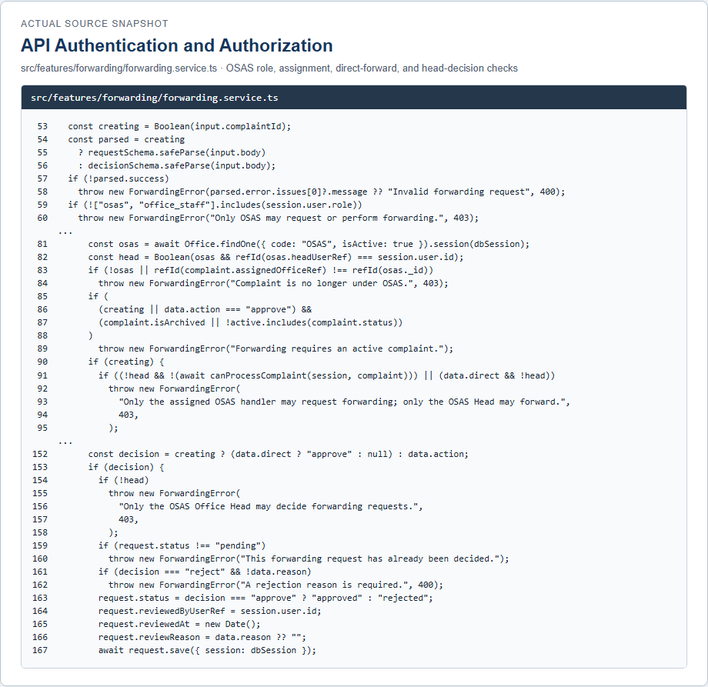
Figure F.6. API Authentication and Authorization Implementation. Forwarding authorization from src/features/forwarding/forwarding.service.ts.
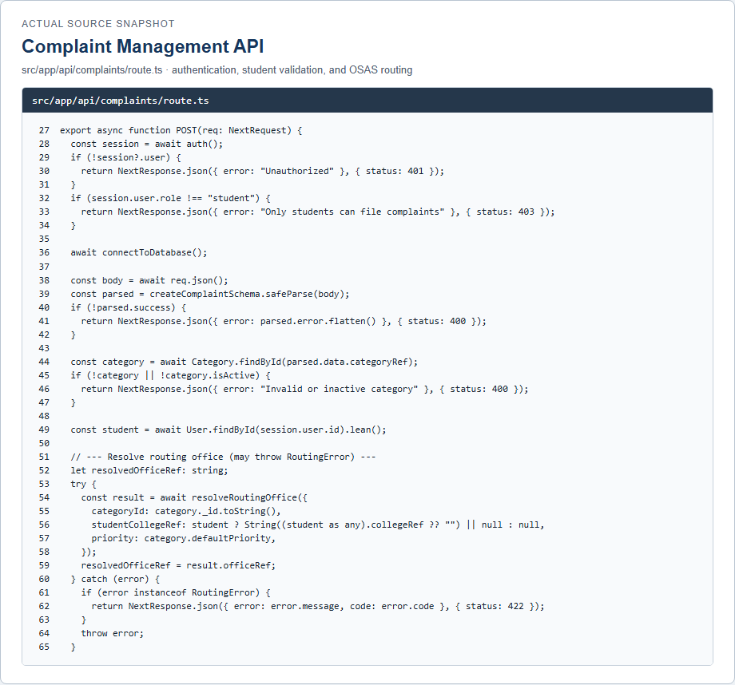
Figure F.7. Complaint Management API Implementation. Source snapshot from src/app/api/complaints/route.ts.

F.3.4 API Authentication and Authorization
Auth.js provides the credential/session protocol at /api/auth/[...nextauth]. Student self-registration is limited by registerSchema to @parsu.edu.ph and requires first/last name, student number, college, password, and password confirmation. Code verification and resend are public endpoints but validate the email/code, enforce cooldowns and Upstash rate limits, and do not require a session. The application’s `auth()` wrapper returns no valid session when the user is missing/inactive, tokenVersion differs, or session claims no longer match the database user.
Students may create complaints and access their own records. They can edit or withdraw only while the complaint remains submitted, respond to information requests, attach files to their complaints, rate a resolved complaint, and manage their own profile, feedback, notifications, and email change. The handlers enforce ownership by comparing the session user ID with the stored studentRef; UI visibility is not treated as authorization.
OSAS office_staff and OSAS-role users may process an OSAS complaint only when they are the assigned handler. Office heads are not a separate user role: the authority is derived from an active Office document whose headUserRef equals the signed-in user. This designation controls staff assignment, resolution approval, archive review, and OSAS forwarding decisions. Assignment management for OSAS is limited to the OSAS Head (or administrator override where coded). The generic complaint PATCH permits a designated head who is also the assigned handler to resolve directly; a non-head handler is directed to the separate resolution-request/approval workflow.
VPAA/VPAF accounts can see/process receiving-office complaints only after a formal forwarding marker, matching receiving office, and assigned handler are present. The forwarding service accepts requests from an assigned OSAS handler; only the OSAS Head may approve/reject or use `direct: true` to formally forward to VPAA/VPAF. Approval assigns the complaint to the designated receiving office head (or the sole active account when exactly one exists), updates ownership/status, and writes timeline, audit, and notifications in a transaction. Administrators have broad complaint access, but the forwarding service’s role check explicitly accepts OSAS/office_staff only; it does not grant administrator direct-forward permission.
Important implementation discrepancy found during source review: `requireScopedAdmin()` is documented in comments as admitting administrator, VPAA, VPAF, and OSAS, but its actual condition rejects every role other than administrator. Route handlers using this helper therefore currently return 403 to VPAA/VPAF/OSAS. The helper is used by user/office/complaint administrative routes. This annex reports the executing condition rather than the intended comment. Other admin handlers calling `requireAdmin()` are administrator-only by design.

F.3.5 API Request and Response Handling
Request parsing: handlers read query parameters from NextRequest/URL, path parameters from the Next.js params object, JSON via req.json(), or multipart form data for the same-origin student upload. Zod `safeParse` validates the principal request bodies. Validation failures commonly return HTTP 400 with a flattened error object; registration/verification handlers also catch malformed JSON and return a JSON 400 response. JSON parse exceptions are not normalized identically by every handler.
Authorization: handlers first resolve the current Auth.js session and then apply role and resource checks. Complaint handlers use ownership, assigned-office, assigned-staff, forwarding markers, active state, and office-head designation. Admin guard failures return 401 or 403 JSON. Most protected API requests rejected by the Next.js proxy also receive HTTP 403 JSON; route handlers still enforce their own decisive checks.
Persistence and side effects: Mongoose reads/writes user, complaint, timeline, assignment, notification, generated-report, and configuration collections. Workflow mutations record audit/timeline entries and notifications where implemented. Formal forwarding and resolution decisions use MongoDB transactions and re-check pending/current state before commit. Status changes use an explicit transition service; some transitions have dedicated routes and are rejected by the generic PATCH handler.
External services: verification, password/email-change, and workflow email are delivered through Resend. Attachment uploads/downloads and generated report files use Cloudflare R2. If R2 is not configured, relevant upload/report endpoints return 501. The cron SLA route requires a shared secret and returns checked/escalated/warned counts; it is also configured in vercel.json as a scheduled GET.
Error responses are route-specific rather than wrapped by one global JSON error envelope. Common implemented statuses include 400 for invalid request/state, 401 for missing authentication, 403 for denied roles/resource scope, 404 for absent resources, 409 for conflicts/stale decisions, 422 for complaint-routing/SLA prerequisites, 429 for rate limits, 500 for selected integration failures, 501 for unavailable storage configuration, and 503 for selected email/rate-limit/OSAS dependencies. The handler inventory and detailed tables identify the status behavior verified for each major endpoint.

