APPENDIX C
SAMPLE INPUT/OUTPUT/REPORTS
C.1 SAMPLE INPUTS
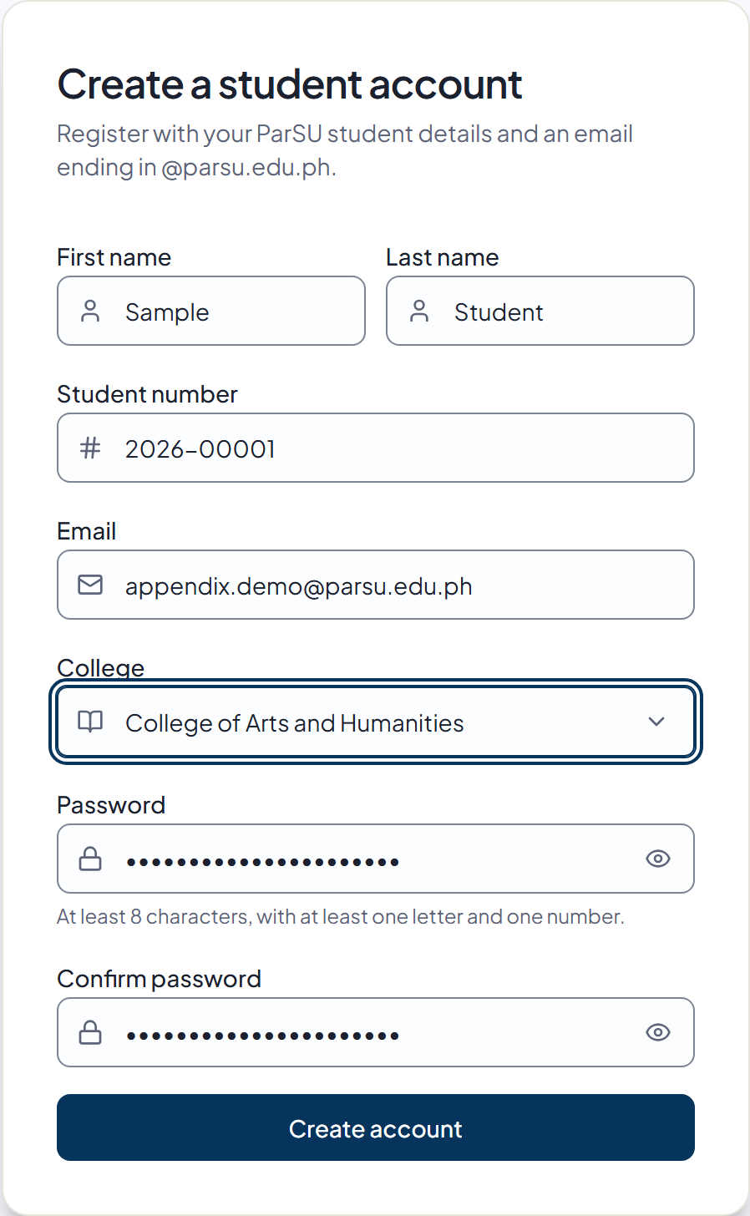
Figure C.1. Sample Student Registration

