1. Delta airline data and crude oil price

(1) initial data

Here we will collected data from yahoo finance on Delta Airline’s daily stock adjust close price from May 2010 to May 2016 (6 years). Totally, we have 1530 samples.

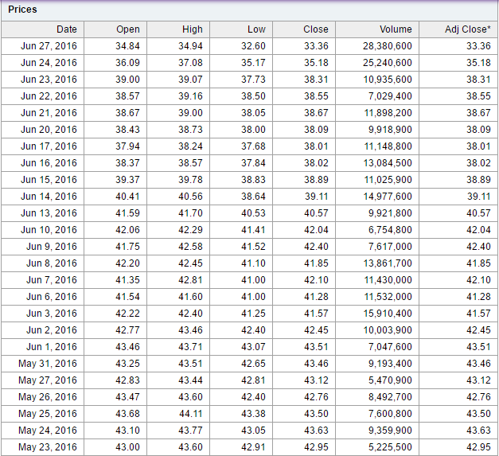

Chart1: Delta airline daily stock price

Reference: <http://finance.yahoo.com/q/hp?s=DAL>

(2)Data description

Chart2: Adjust Close Price on Delta Airline Line Chart



Chart3: Descriptive Statistics on the Adjust Close Price of Delta Airline

The mean value of Delta Airline stock from May 2010 to May 2016 is 24.2513. Also the variance is 234.225, which suggest the data is not around the mean. Experimental value of the skewness is 0.411, which means uptrend during this period. Kurtosis of the data is -1.521, which indicated that the curve is flat and has longer tails on both side (The Kurtosis of normal distribution is 0. )

2. Crude oil price

(1) initial data

Here we will collected data from US. Energy Information Administration on West Texas Intermediate (WTI) crude oil price from May 2010 to May 2016 (6 years)

Reference: <http://www.eia.doe.gov/dnav/pet/TblDefs/pet_pri_spt_tbldef2.asp>

(2)Data description

Chart5:Line Chart of Crude oil price

Chart6: Descriptive Statistics on the Crude Oil Price

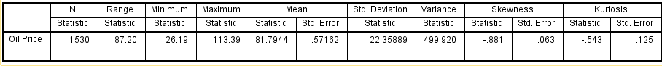

The mean value of crude oil price from May 2010 to May 2016 is 81.7944. Also the variance is 499.920, which suggest the data is not around the mean. Experimental value of the skewness is-0.881, which means downtrend during this period. Kurtosis of the data is -0.543, which indicated that the curve is slightly flat and has a little bit longer tails on both side (The Kurtosis of normal distribution is 0. )

**3. Correlation Test**

(1) Chart5:Line Chart of Crude oil price and delta airline

Delta stock price: As we can see in the chart, from May 2010-January 2013, the share price was relatively steady. After January 2013, the share price went up sharply.

Crude oil price: From May 2010-May 2014, the price was fluctuate. After May 2014, the price went down sharply,

(2) pearson correlation test (linear correlation)

We use pearson correlation test to find the correlation relationship between Delta Airline Price and crude oil price.

|  |  |  |  |
| --- | --- | --- | --- |
| **Chart7:Pearson Correlations Test** | | | |
|  | | Stock Price | Oil Price |
| Stock Price | Pearson Correlation | 1 | -.687** |
| Sig. (2-tailed) |  | .000 |
| N | 1530 | 1530 |
| Oil Price | Pearson Correlation | -.687** | 1 |
| Sig. (2-tailed) | .000 |  |
| N | 1530 | 1530 |
| **. Correlation is significant at the 0.01 level (2-tailed).  According to Chart7, the pearson correlation is -0.687 and also the P value is smaller than the significant number 0.01. So, the conclusion is the crude oil price and the delta airline stock price have the negative correlation relationship.  **4. regression line Model**  (1) Notation definition   |  |  |  | | --- | --- | --- | | Notation | value | unit | | X | Crude oil price | Dollar | | Y | Delta Airline Share Price | Dollar |     (2) Assumption  a. We use the logarithm regression line to describes the relationship between two variables.  b. Crude oil price is the independence variable; Delta Airline Share adjust closed price is the dependence variable.  c.The model we set up is $\ln\left(Y\right)=α+β\ln\left(X\right)+ε$ ( $α$ is constant number, $β$ is coefficient of ln(x), $ε is random error$) | | | |

(3) Estimate model

We use SPSS software to estimate the regression line.

$\ln\left(Y\right)=164.648-32.237\ln\left(X\right)$

Chart: Scatter Plot

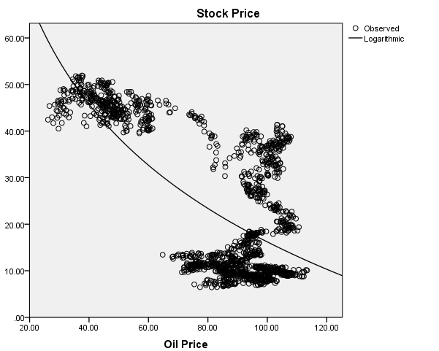

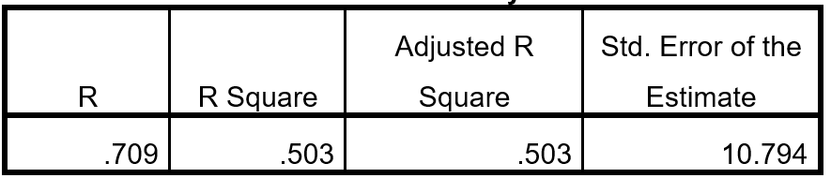

Chart: The coefficient of determination

Conclusion1:The coefficient of determination(R Square)=0.503. This means that 50.3% of variation in Delta Airline’s share price can be explained by variation in Crude oil price.

Conclusion2:Because $β$ is -32.237, which means every 1 unit change in the natural log of oil price can cause 32.237 unit change in the natural log of share price. Oil price does big contribution to the Delta Airline share price

(4) Hypothesis testing

Chart: Coefficient of logarithm model

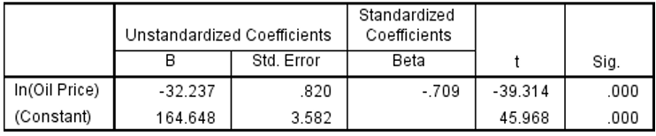

|  |
| --- |
|  |

a. The null hypothesis: The coefficients are 0.

The alternative hypothesis: The coefficients are not equal to 0.

b. We need to compare t value to the critical value

t=(coefficient-0)/standard error

c. $t_{β}$ =(-32.237-0)/0.820=-39.314; $t_{α}$ =(164.648-0)/3.582=45.968

d. The probability level is 0.05. The freedom of degree is 1520-1=1519 and the confidence coefficient

The critical value for two tail is +/-1.96074519. Both t value -39.314 and 45.968 are outside the range.

[-1.96152693, 1.96152693]. We need to reject the null hypothesis and accept the alternative hypothesis.

e. Coefficient range for coefficient

As we know, the model is estimate model, so we can find the 95% confidence intervals for the coefficient

$α$ = -32.237 $±$ 0.820*1.96074519=(-33.8448,30.6292)

$β$ =164.648 $±$ 3.582*1.96074159=(157.624624,171.671376)