Module 3 — Image Blurring and the Convolution Theorem
Student: Jieming Li | Course: CSC 8830 Computer Vision

1. Objective
Implement image blurring by spatial convolution and Fourier-domain multiplication, then verify that both compute the same operation when their discrete kernels, boundaries, and alignment match.

2. Implementation
Pillow applies EXIF orientation, converts inputs to grayscale luminance (L), and resizes with LANCZOS to a maximum dimension of 512 pixels while preserving aspect ratio. Intensities are converted to NumPy float64 and divided by 255 to obtain [0,1]; source files remain unchanged.
Box kernels have equal weights 1/k². Gaussian weights sample exp[−(x²+y²)/(2σ²)] on a centered integer grid and are normalized to sum to one. Both methods receive exactly the same discrete kernel; sizes are positive odd integers and σ is positive.
filtering.py implements spatial convolution by flipping the kernel and looping over its entries with vectorized image slices. The Fourier path uses numpy.fft.fft2, elementwise multiplication, and ifft2; it checks the imaginary residual before taking the real component. It transforms the ordinary unshifted kernel, without fftshift. Zero-padding can darken boundaries because edge neighborhoods include zeros.

3. Theory and derivation
For zero-extended finite sequences, let u and v denote angular frequencies. Start with:
$$g[x,y] = \sum_{m}{\sum_{n}{h[m,n] f[x−m,y−n]}}$$
Substitute the convolution into the two-dimensional Fourier transform:
$$G(u,v) = \sum_{x}{\sum_{y}{\sum_{m}{\sum_{n}{h[m,n] f[x−m,y−n] e^{−i(ux+vy)}}}}}$$
Set a = x−m and b = y−n. Then x = a+m and y = b+n; reordering the finite sums and separating the exponential gives:
$$G(u,v) = [\sum_{m}{\sum_{n}{h[m,n] e^{−i(um+vn)}}}] [\sum_{a}{\sum_{b}{f[a,b] e^{−i(ua+vb)}}}]$$
$$G(u,v) = H(u,v)F(u,v), g = ℱ^{−1}\{HF\}.$$
DFT multiplication produces circular convolution. For an H×W image and a Kₕ×K𝑤 kernel, padding both arrays to at least (H+Kₕ−1)×(W+K𝑤−1) recovers full linear convolution. The code uses exactly that size and crops from ((Kₕ−1)//2, (K𝑤−1)//2), keeping H×W samples. Identical kernels, boundaries, and alignment are required; floating-point roundoff can remain.

4. Experiments and results
The saved run on 21 September 2026 (22:08:52 UTC) completed 3 images × 2 filters × 3 kernel sizes = 18 comparisons using two photographs and a generated checkerboard. The final photograph experiment is complete.
Image key (processed width × height): P1 = photo_01.jpg (424×512); P2 = photo_02.jpg (512×512); C = checkerboard.png (512×384). Both photos were resized; the checkerboard was unchanged. Box and Gaussian sizes were k = 3, 7, 15; Gaussian σ = k/6 = 0.5, 7/6, 2.5 pixels.
Metrics compare raw float64 outputs before clipping, rounding, or PNG conversion. Let Δ = spatial − Fourier:
$$MAE = mean(|Δ|), Max = max(|Δ|), RMSE = √(mean(Δ^{2})).$$
Table 1. All 18 comparisons; errors are in normalized intensity units (rounded to four significant figures).
Image | Filter | k | σ (px) | MAE | Max |Δ| | RMSE
P1 | Box | 3 | — | 1.771e-16 | 9.992e-16 | 2.257e-16
P1 | Box | 7 | — | 2.122e-16 | 9.992e-16 | 2.528e-16
P1 | Box | 15 | — | 2.257e-16 | 1.776e-15 | 2.944e-16
P1 | Gaussian | 3 | 0.5 | 1.991e-16 | 1.443e-15 | 2.545e-16
P1 | Gaussian | 7 | 7/6 | 1.406e-16 | 9.992e-16 | 1.823e-16
P1 | Gaussian | 15 | 2.5 | 2.263e-16 | 1.665e-15 | 2.931e-16
P2 | Box | 3 | — | 2.833e-16 | 1.776e-15 | 3.574e-16
P2 | Box | 7 | — | 2.946e-16 | 1.887e-15 | 3.943e-16
P2 | Box | 15 | — | 7.921e-16 | 5.884e-15 | 1.155e-15
P2 | Gaussian | 3 | 0.5 | 3.190e-16 | 1.887e-15 | 4.032e-16
P2 | Gaussian | 7 | 7/6 | 2.075e-16 | 1.332e-15 | 2.670e-16
P2 | Gaussian | 15 | 2.5 | 3.466e-16 | 2.220e-15 | 4.482e-16
C | Box | 3 | — | 2.714e-16 | 1.665e-15 | 3.512e-16
C | Box | 7 | — | 4.600e-16 | 1.443e-15 | 5.689e-16
C | Box | 15 | — | 7.916e-16 | 2.665e-15 | 9.788e-16
C | Gaussian | 3 | 0.5 | 3.124e-16 | 1.776e-15 | 3.965e-16
C | Gaussian | 7 | 7/6 | 2.186e-16 | 1.110e-15 | 2.745e-16
C | Gaussian | 15 | 2.5 | 7.976e-16 | 2.887e-15 | 1.057e-15
All 18 comparisons pass. The largest absolute difference is 5.884182030513330e-15 (P2, Box, 15×15). Agreement requires |Fourier − spatial| ≤ 10⁻¹² + 10⁻¹⁰|spatial| at every pixel (atol = 10⁻¹², rtol = 10⁻¹⁰). These small nonzero errors support numerical equivalence, not a measure of blur quality.
Software recorded for this run: Python 3.10.2, numpy 2.2.6, scipy 1.15.3, Pillow 12.3.0, matplotlib 3.10.9, streamlit 1.64.0.
Source: results/comparison_metrics.csv and experiment_settings.json; these current results supersede the earlier provisional run described in report_notes.md.

4.1 Representative comparisons
Each saved panel shows original → spatial blur → Fourier blur → absolute difference.
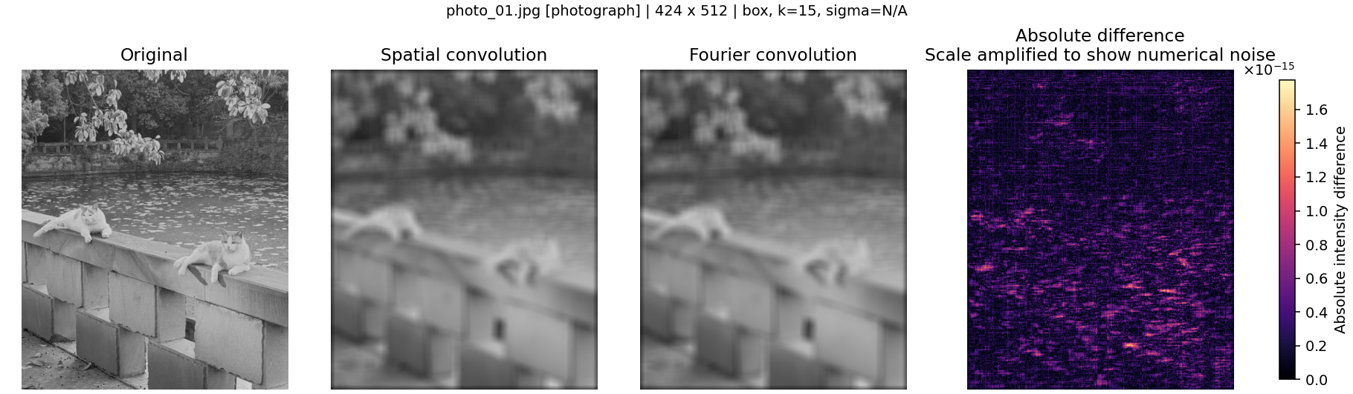
Figure 1. photo_01.jpg (424×512 pixels), Box kernel 15×15; σ is not applicable. Maximum absolute difference: 1.77636×10⁻¹⁵.
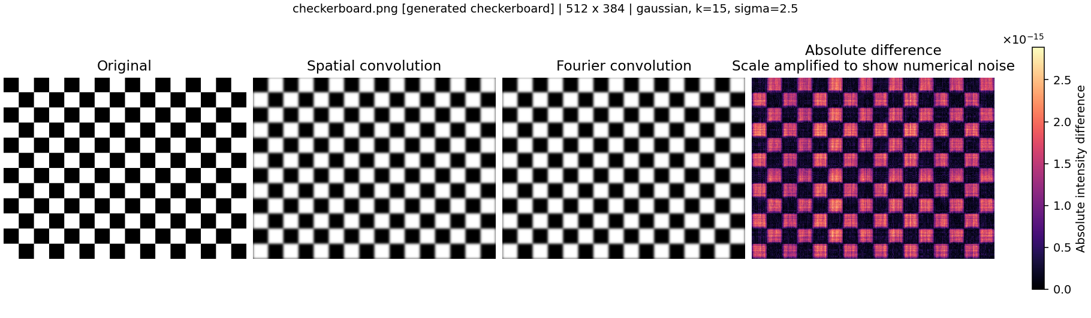
Figure 2. checkerboard.png (512×384 pixels), Gaussian kernel 15×15, σ = 2.5 pixels. Maximum absolute difference: 2.88658×10⁻¹⁵.
Original and blurred images use the same [0,1] display range. Difference maps use separate, amplified color scales near 10⁻¹⁵; their visible colors reveal numerical noise and do not imply a visible mismatch.

5. Conclusion
The 18 completed comparisons support the convolution theorem to float64 precision under matching kernels, zero-padding, and cropping. Nonzero differences remain. Visual similarity alone does not establish equivalence; the derivation and numerical comparisons provide the evidence. Saved verification records also report 81 passing tests, including independent SciPy-reference checks. No speed or perceptual-quality conclusion is claimed.

6. Submission links
GitHub repository: https://github.com/Jieming-Li/CSC-8830_computer_vision
Web application: [ADD URL]
The demonstration video is a separate submission item; this report does not confirm that it has been recorded or submitted.

