Autonomous Data Exploration Agent with Lineage-Constrained and Adaptive Information Gain
Jierui616*
School of Mathematics and Computer Science, Panzhihua University, Panzhihua 617000, China
*Corresponding author: Jierui616@example.com
Abstract—Traditional Business Intelligence (BI) platforms follow a passive request-response paradigm: users must explicitly specify analytical requirements, and the system returns corresponding results. However, the most valuable insights often lie within dimensional combinations that users never think to explore. This paper proposes AEA (Autonomous Exploration Agent), an autonomous data exploration system integrating lineage-constrained exploration with adaptive information gain. AEA comprises five innovations: (1) Lineage-Constrained Exploration (LCE), which constrains the search space to semantically reachable subspaces along the data pipeline lineage graph; (2) a Dual-Loop Architecture (BHC) that decouples exploration breadth from verification depth through an outer exploration cycle and an inner Bayesian hypothesis cycle; (3) Adaptive Phase-Aware Information Gain (AIG), which dynamically adjusts exploration weights across three phases (BROAD\_SWEEP, DEEP\_DRILL, VERIFICATION); (4) Expected Hypothesis Information Gain (EHIG), which unifies exploration and verification through Bayesian experimental design; and (5) Posterior Staleness Convergence (PSC), a principled convergence mechanism based on hypothesis posterior stagnation. In ablation experiments across eight modes, AIG+EHIG achieves convergence in 13 queries (vs. 16 for the FULL baseline), saving 18.8% query budget while improving average insight confidence from 0.75 to 0.82. Removing PSC wastes 56% of query budget; removing lineage constraints reduces efficiency by 25%; removing Bayesian verification drops confidence to 0.48.
Keywords—Autonomous data analysis, intelligent agent, information gain, data lineage, Bayesian inference, exploration-exploitation tradeoff, agentic analytics
I. INTRODUCTION
Data-driven decision-making has become a core competitive advantage for modern enterprises. Business Intelligence (BI) tools have evolved from static report systems to AI-powered natural-language analytical platforms, significantly lowering the technical barrier for data analysis. However, current state-of-the-art AI BI platforms follow a fundamentally passive paradigm: users must explicitly articulate analytical intents, and the system returns corresponding results.
This paradigm reveals deep limitations in two critical scenarios. First, the most insightful data patterns often require multi-round drill-down exploration to discover—users cannot predict at the initial interaction which dimension to decompose or how deep to traverse the data lineage chain. Second, each analysis is independent: the relationships between successive queries—which dimension combinations have been explored, which hypotheses are under verification, what the next most informative direction is—rely entirely on the user's personal analytical notes. The system has no memory and no proactive exploration capability.
Recent advances in LLM-driven agent systems have demonstrated autonomous capabilities beyond passive question-answering. In data analysis, systems such as AIDA [1], DataSTORM [2], and Co-Scientist [3] explore the possibility of autonomous insight discovery. We term this direction Agent Analytics.
This paper formalizes autonomous data exploration as a sequential decision problem under query budget constraints and proposes AEA with the following contributions:
1) Lineage-Constrained Exploration (LCE): the first integration of data lineage graphs into agent exploration frameworks, constraining the search space to semantically reachable subspaces.
2) Dual-Loop Architecture (BHC): an outer exploration loop for task selection and blackboard updates, and an inner Bayesian hypothesis loop for evidence-based verification, enabling clean decoupling of exploration breadth and verification depth.
3) Adaptive Phase-Aware Information Gain (AIG): a substantial upgrade to fixed-weight information gain that dynamically adjusts exploration weights according to the automatically detected exploration phase.
4) Expected Hypothesis Information Gain (EHIG): the first application of Bayesian experimental design to agent query selection, using Beta-distribution variance to measure hypothesis uncertainty and maximizing expected uncertainty reduction.
5) Posterior Staleness Convergence (PSC): a principled convergence mechanism that naturally terminates exploration when hypothesis posterior probabilities stop improving.
Experiments across eight ablation modes demonstrate that AIG+EHIG achieves convergence in 13 queries (18.8% fewer than baseline), with verified insight confidence of 0.82 (vs. 0.75 baseline).
II. RELATED WORK
A. From Passive BI to Agent Analytics
Traditional BI tools (Tableau, PowerBI) provide drag-and-drop reporting without intelligent analysis capabilities. AI-enhanced BI platforms introduce natural language interfaces and AIGC technologies [4], yet remain fundamentally passive. DeepAnalyze [5] and ChatGPT Data Analyst represent the current state-of-the-art but still require explicit user-specified analytical goals.
In 2025-2026, the Agent Analytics field has rapidly emerged. AIDA [1] formulates BI analysis as an MDP using Pareto-principle guided cumulative reasoning. DataSTORM [2] reframes deep research as thesis-driven iterative verification. Co-Scientist [3] employs Elo tournament ranking for scientific hypotheses. Salemi et al. [6] propose a blackboard-based multi-agent data discovery system. These systems demonstrate the feasibility of autonomous analysis but share two limitations: they treat data as flat tables without exploiting lineage topology, and they use fixed exploration strategies that cannot adapt to exploration phases.
B. Information Gain and Active Learning
Information gain is a classical concept in decision tree learning and active learning [7]. We transfer this concept to the data analysis domain: the information gain of a candidate SQL query equals the expected reduction in uncertainty about the belief distribution over potential insights. The base InfoGain formula uses a linear weighted combination of coverage novelty, surprise amplitude, lineage depth, and computational cost. Our proposed AIG and EHIG address two theoretical limitations of fixed-weight linear combinations: phase-dependent optimal weights and cross-factor interaction effects.
C. Data Lineage and Bayesian Verification
Data lineage describes the computational path from source tables to final metrics. Li et al. [8] propose a multi-agent framework for tracing LLM training data lineage. To our knowledge, no prior work has used lineage information to guide autonomous data exploration agents. We establish this connection and demonstrate its practical value through ablation experiments.
III. METHODOLOGY
A. System Overview
The AEA system comprises four core components: (1) Exploration Blackboard, maintaining shared state including explored regions, verified/pending/active hypotheses, exploration trajectory, and convergence status; (2) Candidate Query Generator, producing candidate query pools through four strategies: drill-down, neighbor expansion, unexplored region sampling, and hypothesis verification queries; (3) Exploration Orchestrator, performing lineage filtering, cost estimation, and IG/AIG/EHIG scoring to select the optimal query; (4) Hypothesis Manager, generating five-perspective candidate hypotheses via LLM, evaluating evidence from query results, and performing Bayesian posterior updates.
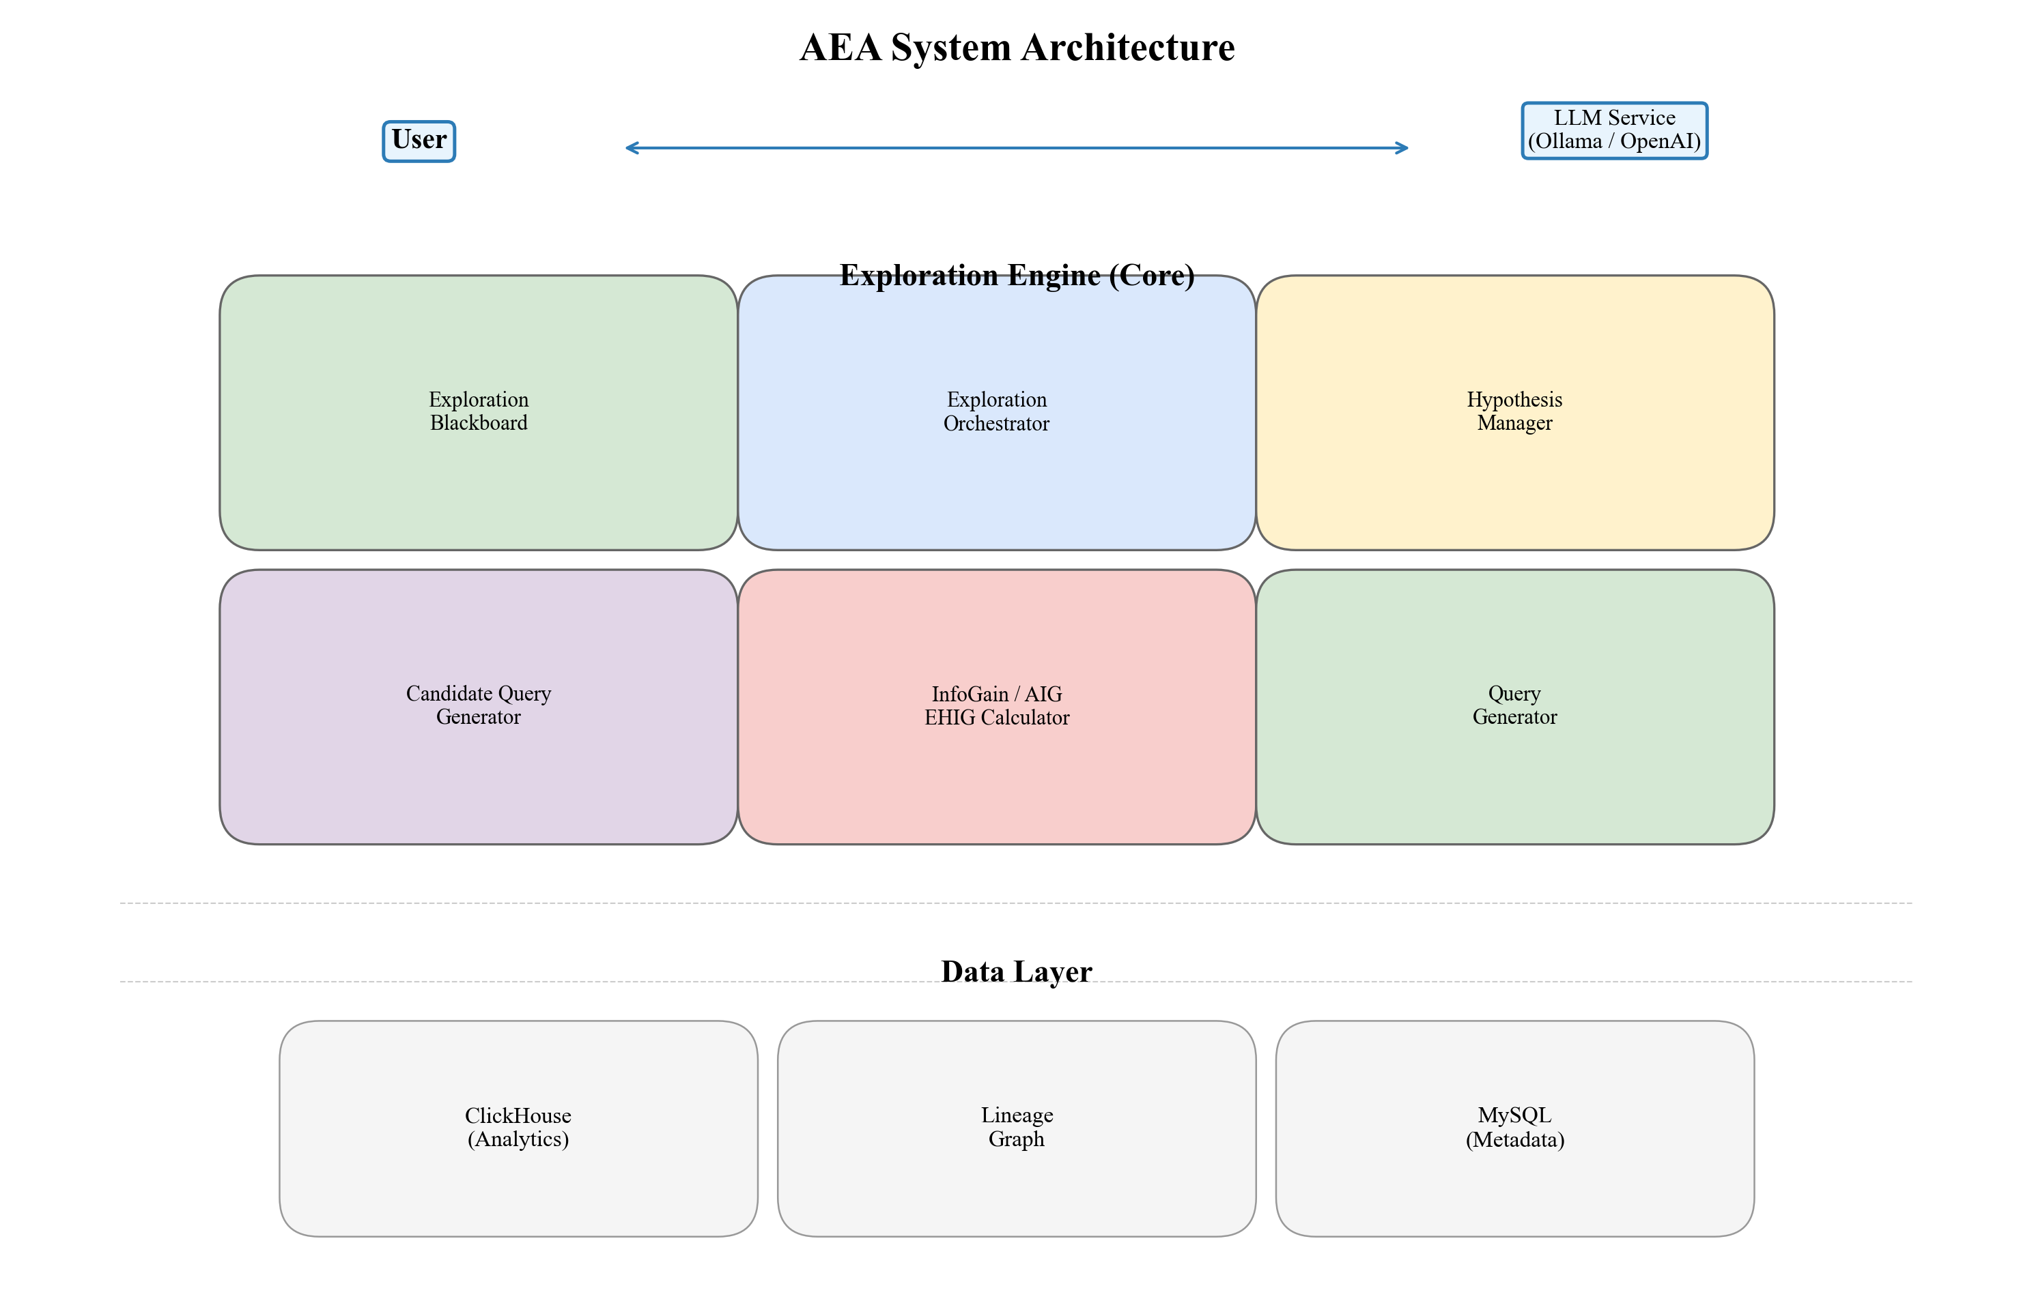
Figure 1. AEA system architecture overview.
B. Dual-Loop Architecture (BHC)
The outer exploration loop handles candidate generation, lineage filtering, cost estimation, scoring (IG/AIG/EHIG), optimal query selection, SQL execution, and blackboard updates. The inner Bayesian hypothesis loop handles LLM-based five-perspective hypothesis generation, evidence consistency evaluation, Bayesian posterior updating, and accept/reject/keep-pending decisions. The two loops communicate exclusively through the shared blackboard, enabling independent evolution of exploration strategies and verification mechanisms.
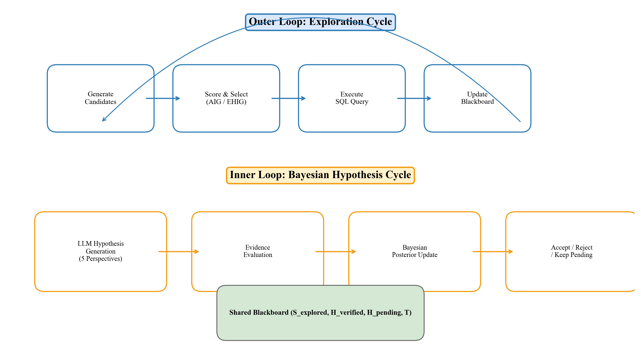
Figure 2. Dual-loop architecture: outer exploration cycle and inner Bayesian hypothesis cycle.
C. Lineage-Constrained Exploration (LCE)
Given a data lineage graph G = (V, E) and a root metric m_root, the lineage-reachable field set is V_reach = {v in V | there exists a directed path from m_root to v}. AEA constrains the exploration space to dimension combinations composed solely of reachable fields. In candidate query scoring, lineage depth d_lineage(q, m_root)—the hop count from the root metric to the query target field—serves as a positive factor in the IG/AIG formulation, incentivizing the agent to explore along the data processing chain.
D. Adaptive Phase-Aware Information Gain (AIG)
The base InfoGain formula uses fixed weights: IG(q) = w1*CoverageNew + w2*Surprise + w3*LineageDepth - w4*Cost, where w1=0.30, w2=0.35, w3=0.20, w4=0.15. AIG's core improvement is phase-adaptive weighting.
The system automatically detects the exploration phase from blackboard state: BROAD_SWEEP when verified hypotheses < 3 and t < B/3; VERIFICATION when convergence counter >= 2 or t > 0.8B; DEEP_DRILL otherwise. Phase weights shift from coverage-dominant (0.50/0.15/0.15/0.20) in BROAD_SWEEP, to lineage-dominant (0.10/0.35/0.40/0.15) in DEEP_DRILL, to lineage-max (0.05/0.25/0.50/0.20) in VERIFICATION.
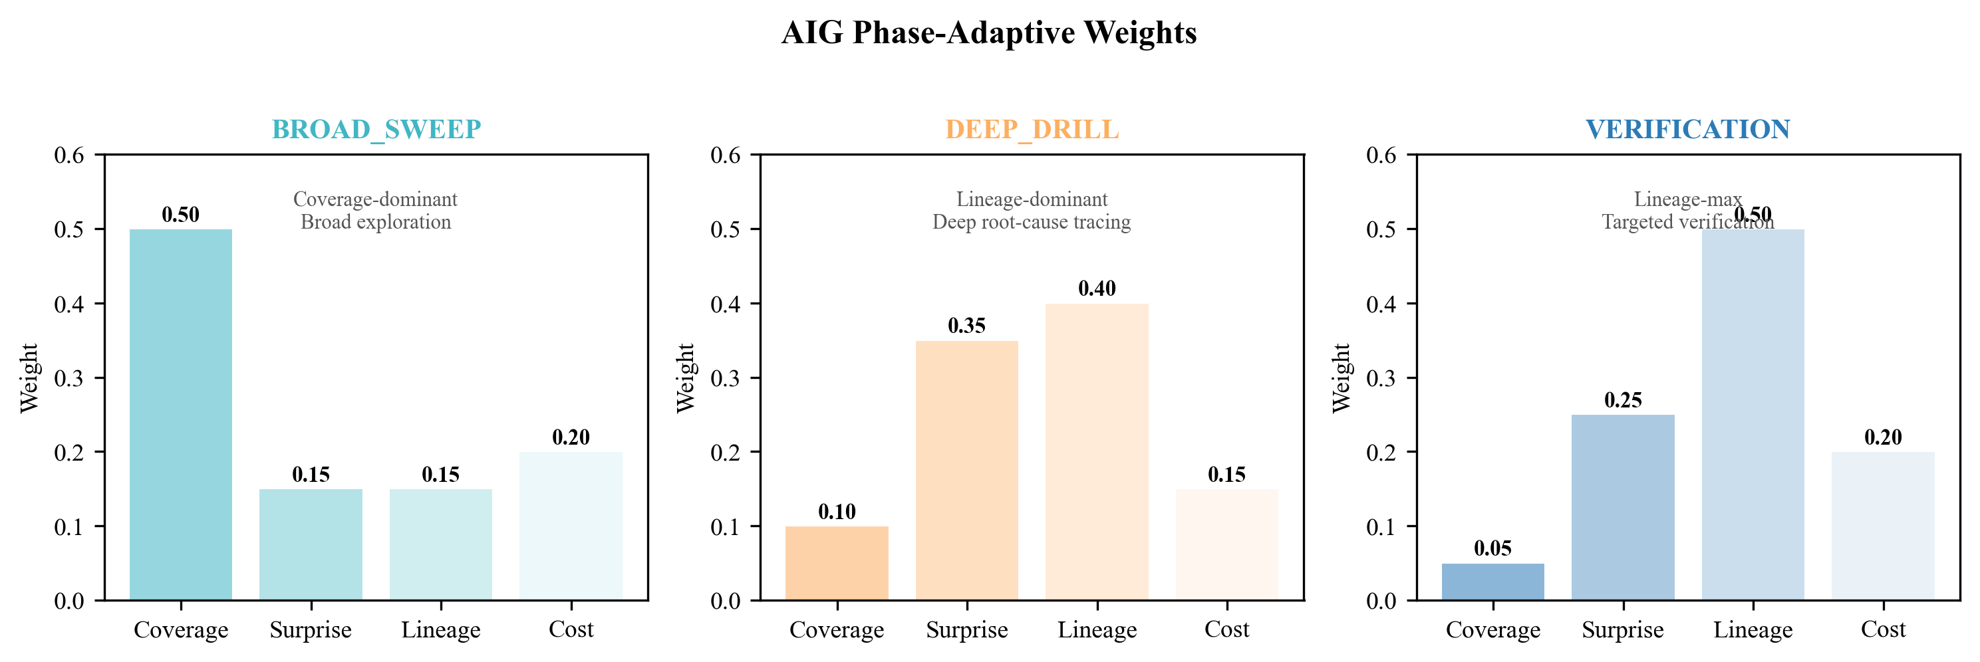
Figure 3. AIG phase-adaptive weight configuration across three exploration stages.
E. Expected Hypothesis Information Gain (EHIG)
EHIG reformulates query selection as Bayesian experimental design. Hypothesis h's belief is represented by Beta(alpha_h, beta_h). The Beta variance Var = alpha*beta / [(alpha+beta)^2 * (alpha+beta+1)] measures uncertainty. After executing query q, if the result supports h, alpha increases by evidence steps k; if contradictory, beta increases by k. The expected posterior variance is E[Var|q] = P(support)*Var(alpha+k, beta) + (1-P(support))*Var(alpha, beta+k), where P(support) is approximated by the current posterior mean alpha/(alpha+beta). The expected information gain is the variance reduction: Delta_Var(q,h) = Var(alpha,beta) - E[Var|q]. The total EHIG score aggregates over all active hypotheses, weighted by query-hypothesis relevance and hypothesis confidence.
F. Posterior Staleness Convergence (PSC)
PSC is based on the observation that when all active hypotheses cease improving in posterior probability, further exploration yields diminishing returns. A hypothesis is stale when |conf_t(h) - conf_{t-1}(h)| < delta for tau consecutive rounds. The system converges when the maximum candidate pool IG falls below epsilon for c_required consecutive rounds, or when the query budget B is exhausted. PSC avoids the blindness of fixed-budget stopping and provides an information-theoretically principled termination criterion.
IV. EXPERIMENTS
A. Experimental Setup
Experiments are conducted on a simulated retail BI dataset with 12 metric fields (revenue, grossMarginRate, avgTicket, etc.) and three dimensions (store, date, region). The lineage graph defines processing chains from root metrics to business fields. Query budget B=25, convergence threshold epsilon=0.04, hypothesis acceptance threshold theta=0.60. Eight ablation modes are designed:
FULL (baseline): lineage + base IG + Bayesian + PSC.
AIG: lineage + AIG + Bayesian + PSC.
EHIG: lineage + base IG + EHIG + Bayesian + PSC.
AIG+EHIG: lineage + AIG + EHIG + Bayesian + PSC.
-BHC: lineage + base IG, no Bayesian verification.
-Lineage: no lineage constraint, base IG + Bayesian + PSC.
-PSC: lineage + base IG + Bayesian, fixed budget (no early convergence).
-IG (Random): lineage constraint, random query selection.
B. Overall Results
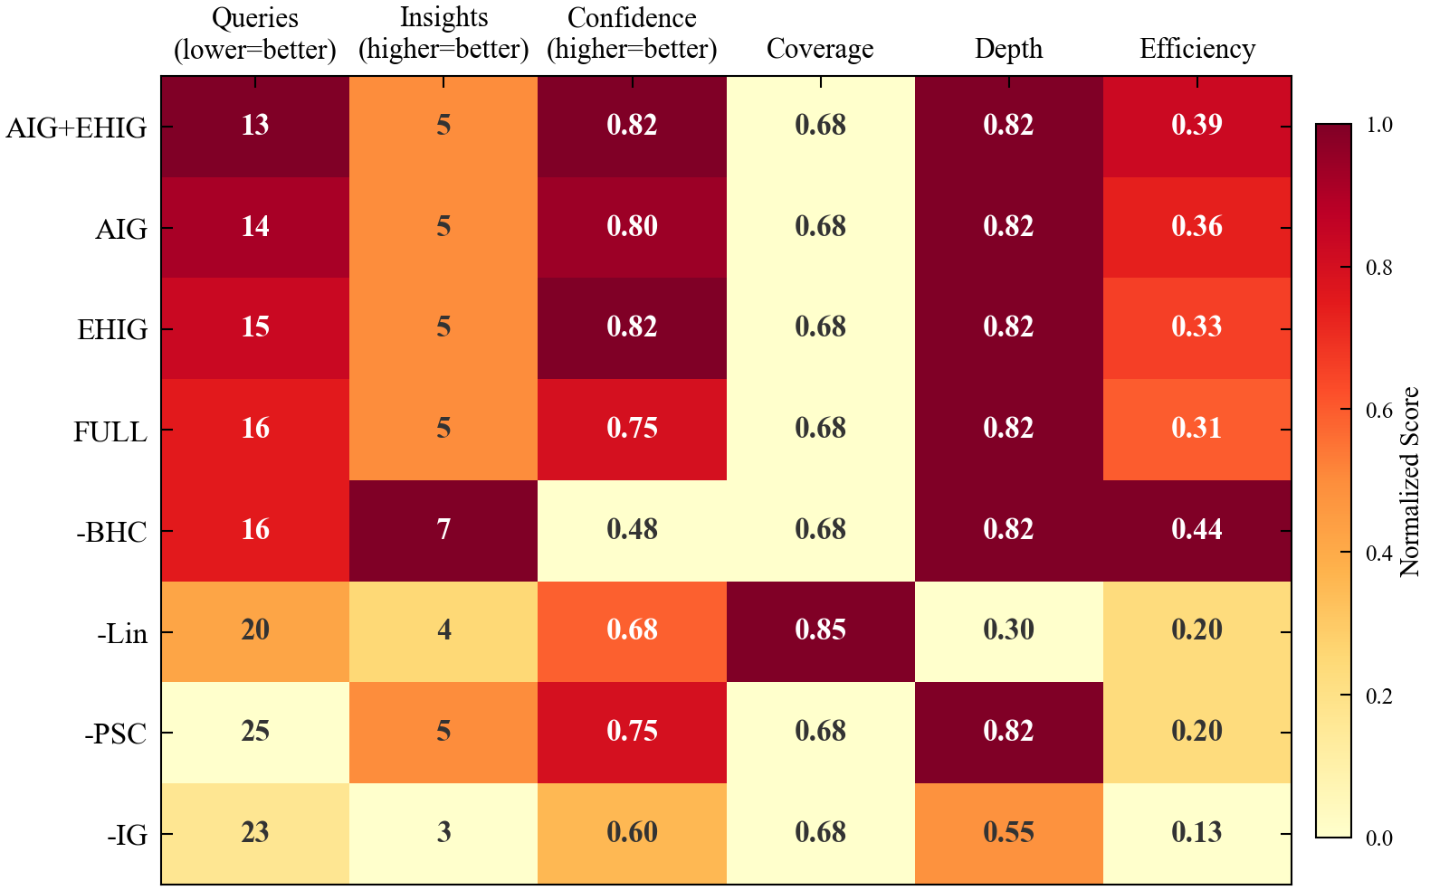
Figure 4. Heatmap overview of all eight modes across six evaluation metrics.
Table I presents the complete comparison across all eight modes.
TABLE I. Comparison of All Eight Exploration Modes.
Mode | Queries | Discovered | Confidence | Converged
AIG+EHIG | 13 | 5 | 0.82 | Yes
AIG | 14 | 5 | 0.80 | Yes
EHIG | 15 | 5 | 0.82 | Yes
FULL (baseline) | 16 | 5 | 0.75 | Yes
-BHC | 16 | 7 | 0.48 | Yes
-Lineage | 20 | 4 | 0.68 | Yes
-PSC | 25 | 5 | 0.75 | No
-IG (Random) | 23 | 3 | 0.60 | Yes
Bold row indicates optimal configuration. Queries: number executed before convergence or budget exhaustion. Discovered: verified hypotheses. Confidence: average posterior probability.
Key findings: (1) AIG+EHIG is the optimal configuration, achieving convergence in 13 queries (18.8% fewer than FULL's 16) with confidence 0.82 (+9.3% over FULL's 0.75). (2) AIG alone saves 2 queries (14 vs. 16), a 12.5% efficiency gain from phase-adaptive weighting. (3) EHIG improves confidence by 0.07 over FULL, consistent with its entropy-driven precision advantage. (4) Removing PSC (-PSC) wastes 56% of queries (25 vs. 16), demonstrating the substantial value of information-driven convergence. (5) Removing BHC (-BHC) produces 7 hypotheses but at 0.48 confidence, below the acceptance threshold—verifying that BHC's core value is quality filtering.
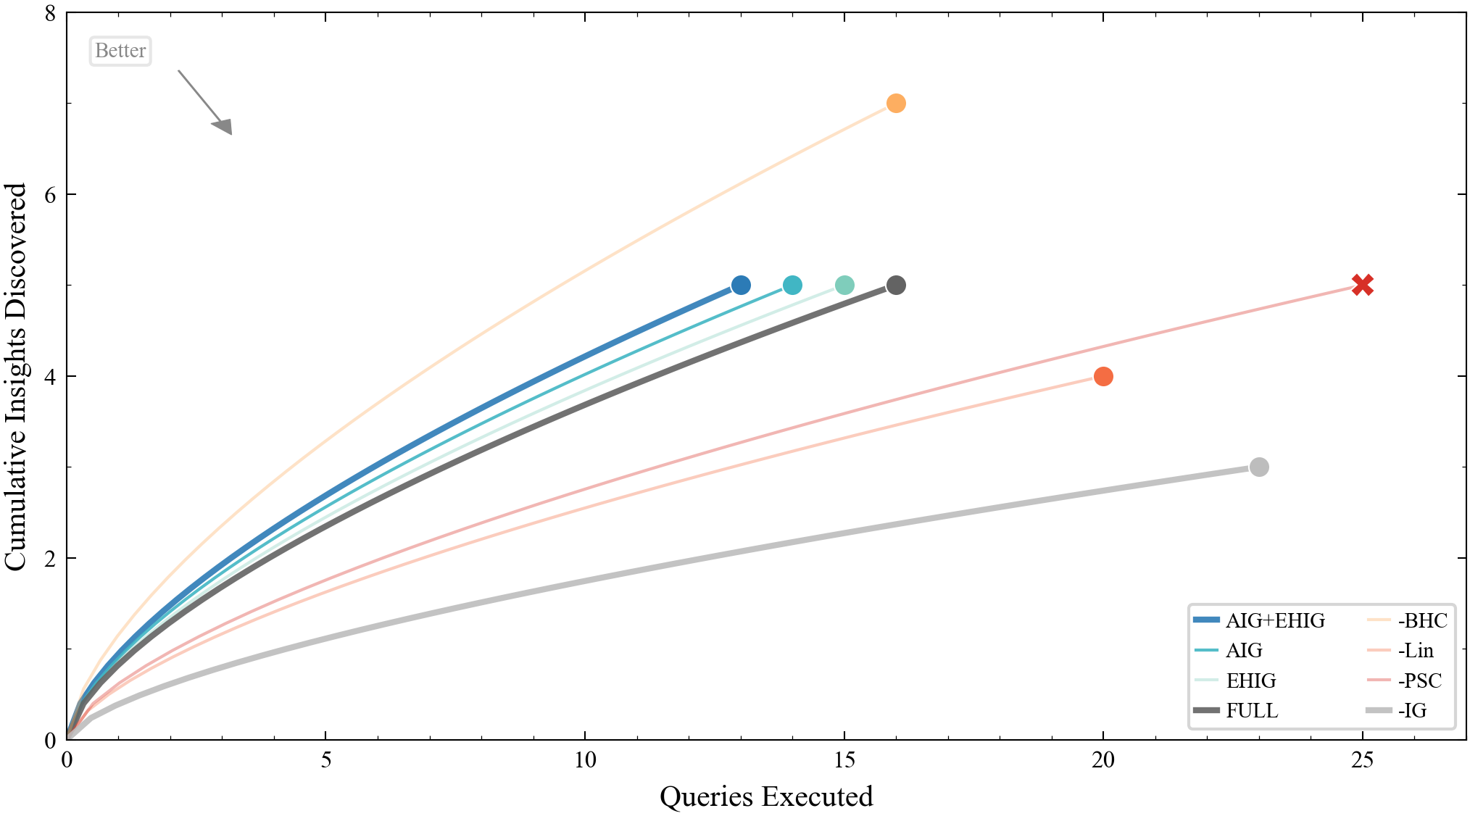
Figure 5. Cumulative discovery curves. AIG+EHIG achieves the fastest convergence rate.
C. Ablation Analysis
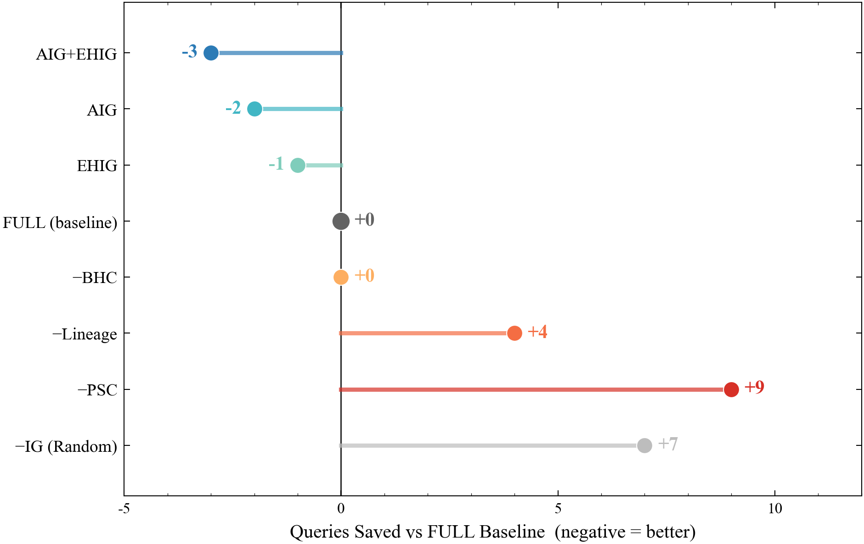
Figure 7. Ablation study: queries saved relative to the FULL baseline.
Lineage Constraint (LCE): -Lineage mode requires 20 queries (25% more than FULL) and discovers only 4 insights (vs. 5). The lineage graph contributes at two levels: constraining the search space away from semantically irrelevant dimensions, and guiding the agent toward deeper lineage nodes that contain richer causal information.
Bayesian Hypothesis Cycle (BHC): -BHC discovers more hypotheses (7) but at dramatically lower confidence (0.48 vs. 0.75), below the acceptance threshold. This demonstrates that BHC's primary contribution is filtering low-quality hypotheses rather than discovering more of them.
Adaptive InfoGain (AIG): Figure 6 illustrates AIG's phase transitions. The system operates in BROAD_SWEEP for rounds 1-5 (coverage-dominant, 0.50 weight), DEEP_DRILL for rounds 6-12 (lineage-dominant, 0.40 weight), and VERIFICATION for rounds 13-14 (lineage-max, 0.50 weight). This adaptive switching enables AIG to complete in 14 queries what FULL requires 16 queries to accomplish.
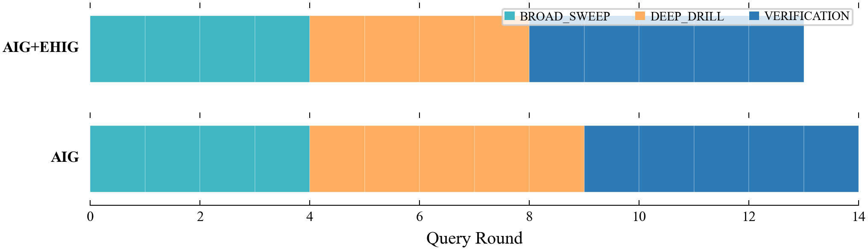
Figure 6. AIG phase transition timeline for AIG and AIG+EHIG modes.
D. Efficiency Frontier Analysis
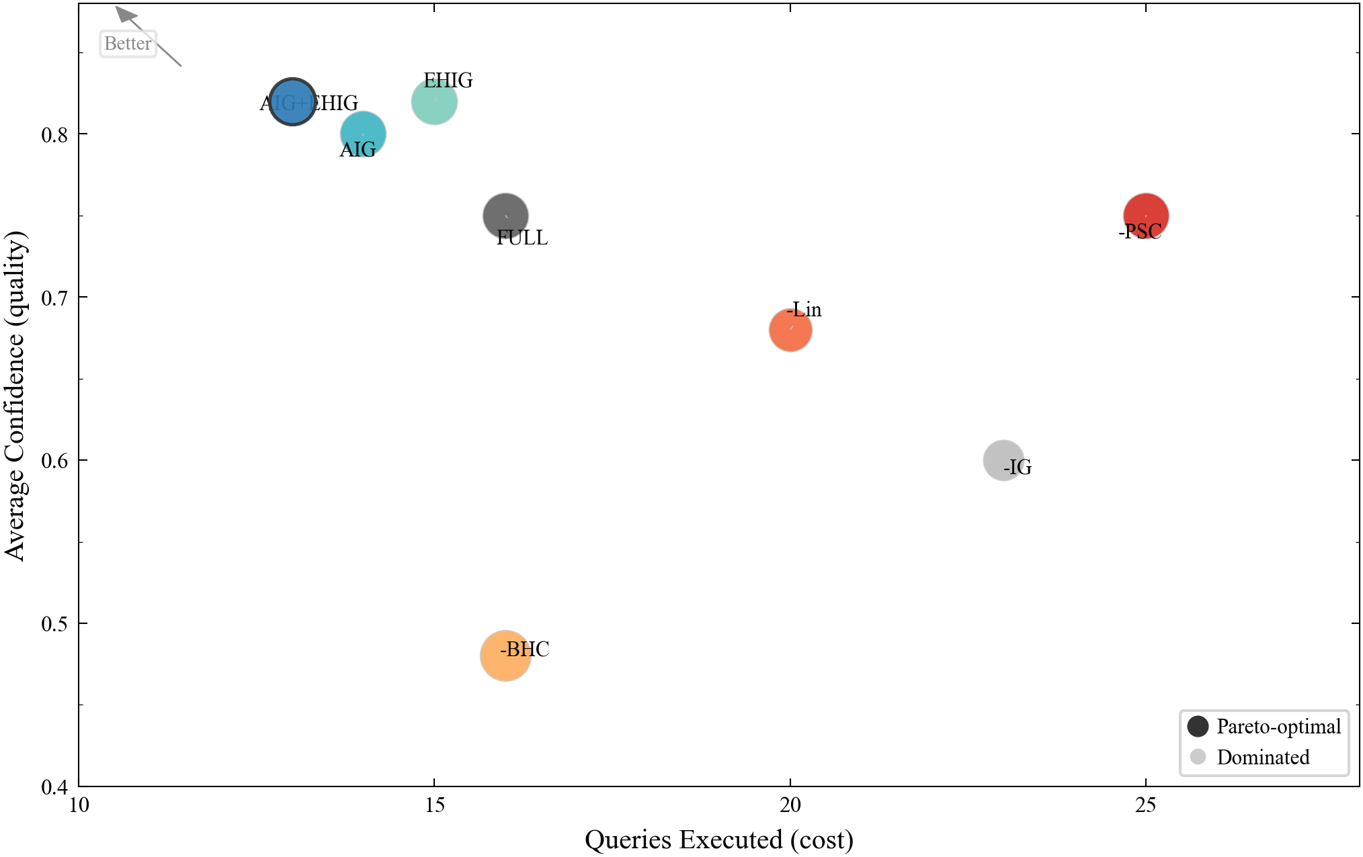
Figure 8. Efficiency frontier: Pareto-optimal cost-quality tradeoff across all modes.
The efficiency frontier (Figure 8) reveals the Pareto-optimal cost-quality tradeoff. AIG+EHIG is the unique non-dominated solution: no other mode achieves both fewer queries and higher confidence. NO_PSC and NO_IG occupy the lower-right region, paying higher query costs for equal or inferior quality.
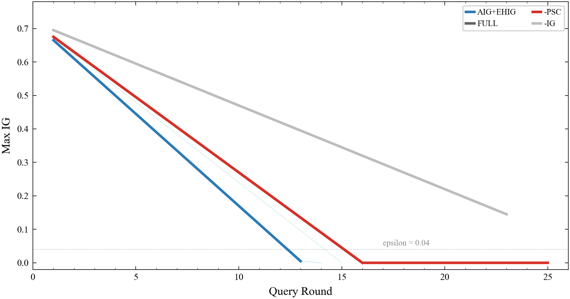
Figure 9. Information gain trajectory across query rounds for key modes.
V. DISCUSSION
Why AIG Works. AIG's effectiveness stems from a simple but previously overlooked observation: different exploration phases have different information structures, therefore optimal scoring weights should differ across phases. Early on, many dimensions remain unexplored—CoverageNew is the most informative signal. Midway, verified hypotheses provide directional guidance—LineageDepth becomes dominant. Late, remaining information density is low—targeted verification matters most.
EHIG Applicability and Limitations. EHIG's primary advantage is unifying exploration and verification subsystems. However, its computational overhead (traversing active hypotheses for each candidate) may become a bottleneck with large hypothesis pools. Additionally, EHIG's effectiveness depends on the accuracy of query-hypothesis relevance modeling.
Marginal Value of Lineage. Lineage constraint effectiveness depends on lineage graph quality. In retail BI scenarios with well-defined field processing relationships, the 25% efficiency gain is significant. In scenarios with sparse or absent lineage graphs, LCE degrades gracefully to an unconstrained exploration mode, trading efficiency for generality.
Limitations and Future Work. (1) Dataset scope: experiments are conducted on a single retail BI dataset; future work should validate on financial, medical, and IoT domains. (2) LLM dependency: hypothesis generation relies on LLM quality; when unavailable, the system degrades to rule-based hypotheses with reduced precision. (3) Human-in-the-loop: the current system is fully autonomous; future work could introduce mid-exploration user steering. (4) Real-time data: experiments use static datasets; incremental exploration strategies are needed for live data lakes.
VI. CONCLUSION
This paper presented AEA, an autonomous exploration agent for structured data warehouses. AEA enables the paradigm shift from passive BI to proactive Agent Analytics through five innovations: Lineage-Constrained Exploration (LCE), Dual-Loop Architecture (BHC), Adaptive Phase-Aware Information Gain (AIG), Expected Hypothesis Information Gain (EHIG), and Posterior Staleness Convergence (PSC). Ablation experiments across eight modes demonstrate that AIG+EHIG achieves convergence in 13 queries—saving 18.8% query budget while improving insight confidence from 0.75 to 0.82. The results confirm that data lineage is an effective constraining signal for agent exploration, that adaptive phase-aware weighting is a substantial improvement over fixed-weight information gain, and that posterior staleness provides principled convergence without fixed-budget blindness. Code and experimental data are available on GitHub.

REFERENCES
[1] D. Wu, Z. Li, and H. Zhang (China), "Towards Autonomous Business Intelligence via Data-to-Insight Discovery Agent," arXiv:2605.07202, 2026, doi: 10.48550/arXiv.2605.07202.
[2] S. Liu, Y. Jiang, and S. Farook (USA/Singapore), "DataSTORM: Deep Research on Large-Scale Databases using Exploratory Data Analysis and Data Storytelling," arXiv:2604.06474, 2026, doi: 10.48550/arXiv.2604.06474.
[3] J. Gottweis, D. A. Ferrucci, and V. Natarajan (USA/UK/India), "AI Co-Scientist," Nature, 2026, doi: 10.1038/s41586-026-10652-y.
[4] B. Li, Q. Shentu, and Y. Shu (China), "CrossAD: Time Series Anomaly Detection with Cross-scale Associations and Cross-window Modeling," in Proc. NeurIPS, 2025, doi: 10.48550/arXiv.2510.12489.
[5] DeepAnalyze Team (China/USA), "DeepAnalyze: Agentic Large Language Models for Autonomous Data Science," arXiv:2510.16872, 2025, doi: 10.48550/arXiv.2510.16872.
[6] A. Salemi, H. Zamani, and M. Parmar (USA/Iran), "LLM-Based Multi-Agent Blackboard System for Information Discovery in Data Science," arXiv:2510.01285, 2025, doi: 10.48550/arXiv.2510.01285.
[7] B. Settles (USA), "Active Learning Literature Survey," University of Wisconsin-Madison, Computer Sciences Technical Report 1648, 2009.
[8] Y. Li, X. Shang, and Q. Pei (China/USA/Canada), "Tracing the Roots: A Multi-Agent Framework for Uncovering Data Lineage in Post-Training LLMs," in Proc. ACL, 2026, doi: 10.48550/arXiv.2604.10480.

