Autonomous Data Exploration Agent with
Lineage-Constrained and Adaptive Information Gain

Ruijie Li
Panzhihua University, Sichuan Panzhihua, 617000, China
1107697373@qq.com
Bin Liu*
Panzhihua University, Sichuan Panzhihua, 617000, China
36637345@qq.com

Abstract: Traditional Business Intelligence (BI) platforms follow a passive request-response paradigm. This paper proposes AEA (Autonomous Exploration Agent), integrating lineage-constrained exploration with adaptive information gain. AEA comprises five innovations: Lineage-Constrained Exploration (LCE), a Dual-Loop Architecture (BHC), Adaptive Phase-Aware Information Gain (AIG), Expected Hypothesis Information Gain (EHIG), and Posterior Staleness Convergence (PSC). Ablation experiments across eight modes demonstrate that AIG+EHIG achieves convergence in 13 queries (18.8% fewer than baseline), improving insight confidence from 0.75 to 0.82.
Keywords: Autonomous data analysis, intelligent agent, information gain, data lineage, Bayesian inference, exploration-exploitation.
I. INTRODUCTION
Data-driven decision-making has become a core competitive advantage. Current AI BI platforms follow a passive paradigm: users articulate analytical intents, and the system returns results. This paper proposes AEA, an autonomous exploration agent that actively explores data spaces. Key contributions: (1) LCE constrains exploration to lineage-reachable subspaces; (2) BHC decouples exploration breadth from verification depth; (3) AIG provides phase-adaptive weighting; (4) EHIG unifies exploration and verification via Bayesian experimental design; (5) PSC enables natural convergence based on posterior stagnation.
II. RELATED WORK
A. From Passive BI to Agent Analytics. Traditional BI tools lack intelligent analysis capabilities. AI BI platforms introduce NL interfaces but remain reactive. In 2025-2026, Agent Analytics emerged: AIDA[1] formulates BI as MDP, DataSTORM[2] uses thesis-driven verification, Co-Scientist[3] employs Elo ranking. Salemi et al.[6] propose blackboard-based multi-agent discovery.
B. Information Gain and Active Learning. Information gain originates from decision tree learning and active learning[7]. We transfer this concept to data analysis: IG of a candidate SQL query equals expected reduction in uncertainty about insight belief distributions.
C. Data Lineage. Data lineage describes computational paths from source to metrics. Li et al.[8] trace LLM training data lineage. We establish the first connection between lineage graphs and autonomous exploration guidance.
III. METHODOLOGY
A. System Overview. AEA comprises four components: Exploration Blackboard (shared state), Candidate Query Generator (4 strategies), Exploration Orchestrator (lineage filter + scoring), Hypothesis Manager (5-perspective LLM generation + Bayesian updating).
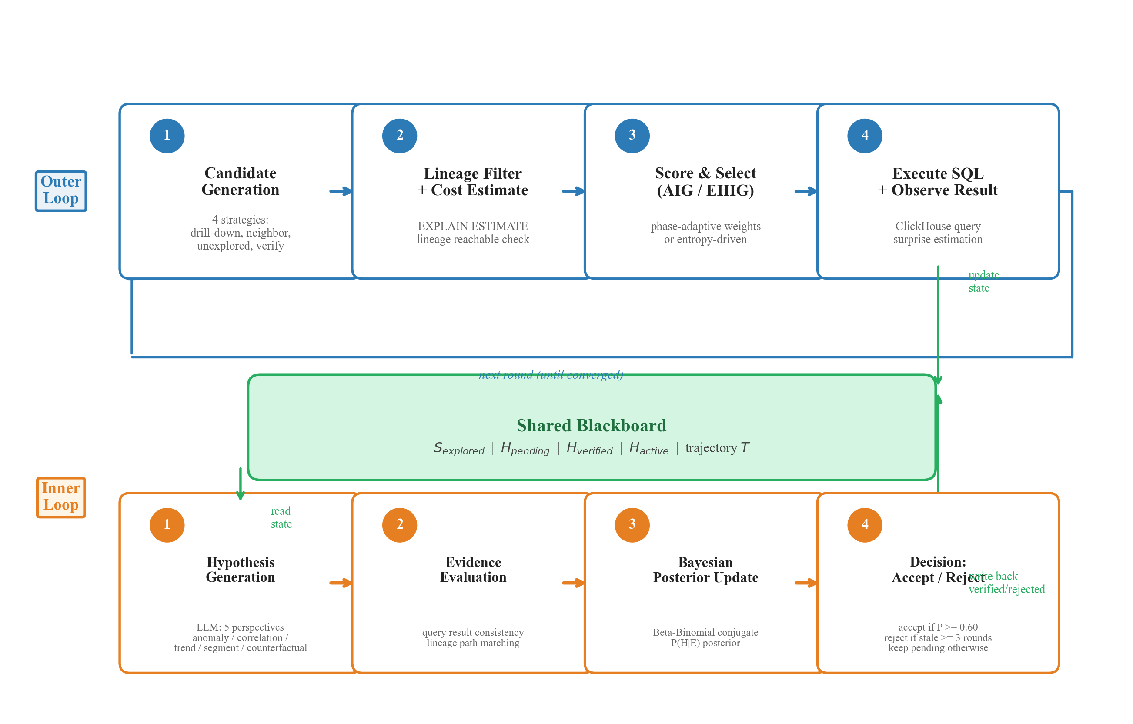
图 1. 双循环架构。
B. Dual-Loop Architecture (BHC). The outer exploration loop handles candidate generation, scoring, SQL execution, and blackboard updates. The inner Bayesian hypothesis loop handles LLM generation, evidence evaluation, posterior updating, and accept/reject decisions.
C. Lineage-Constrained Exploration (LCE). Given lineage graph G=(V,E) and root metric m_root, only reachable fields are explored. Lineage depth serves as a positive factor in IG scoring.
D. Adaptive Phase-Aware Information Gain (AIG). The base IG formula uses fixed weights (0.30, 0.35, 0.20, 0.15). AIG detects three phases: BROAD_SWEEP (coverage=0.50), DEEP_DRILL (lineage=0.40), VERIFICATION (lineage=0.50). Phase detection is automatic.
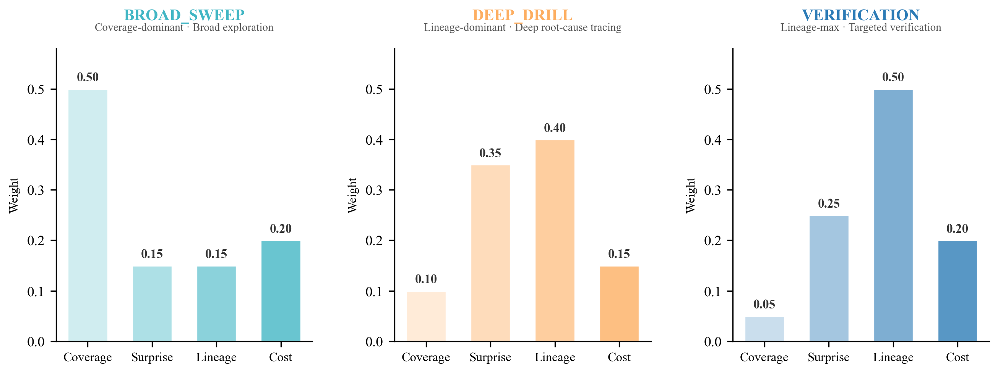
图 2. AIG 三阶段自适应权重配置。
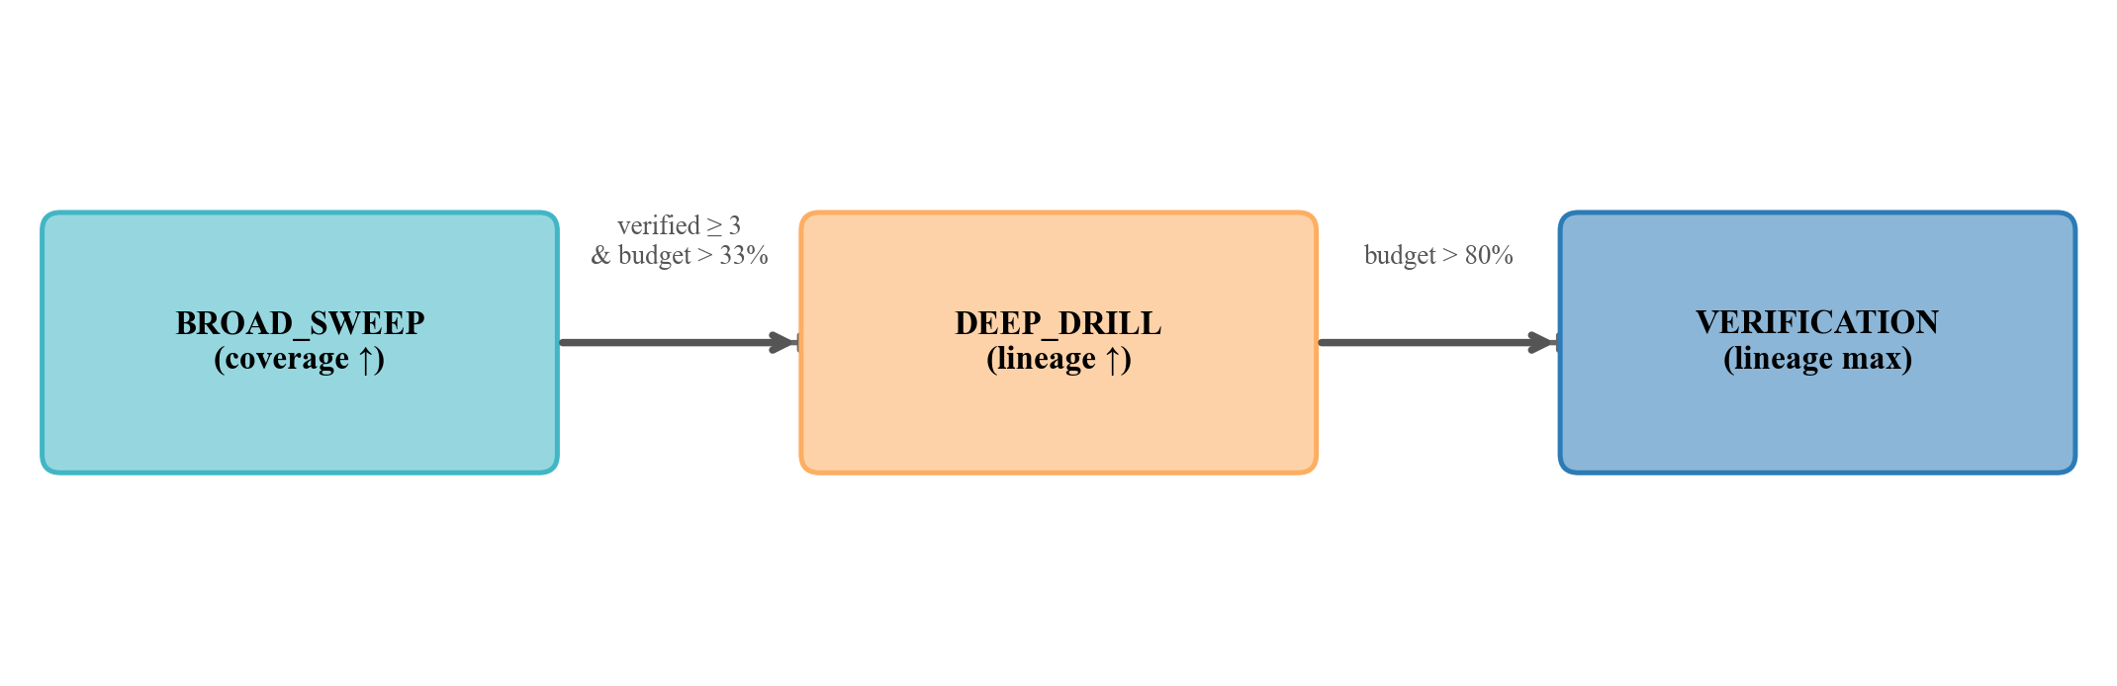
图 3. AIG 阶段切换条件与触发机制。
E. Expected Hypothesis Information Gain (EHIG). EHIG reformulates query selection as Bayesian experimental design. Hypothesis belief is Beta(alpha,beta). Expected posterior variance and variance reduction drive query selection toward maximum uncertainty reduction.
F. Posterior Staleness Convergence (PSC). PSC terminates exploration when all active hypotheses cease improving. Convergence when max IG < epsilon for c consecutive rounds.
IV. EXPERIMENTS
A. Setup. Simulated retail BI dataset, 12 metrics, 3 dimensions, B=25, epsilon=0.04. Eight ablation modes: FULL, AIG, EHIG, AIG+EHIG, -BHC, -Lineage, -PSC, -IG.
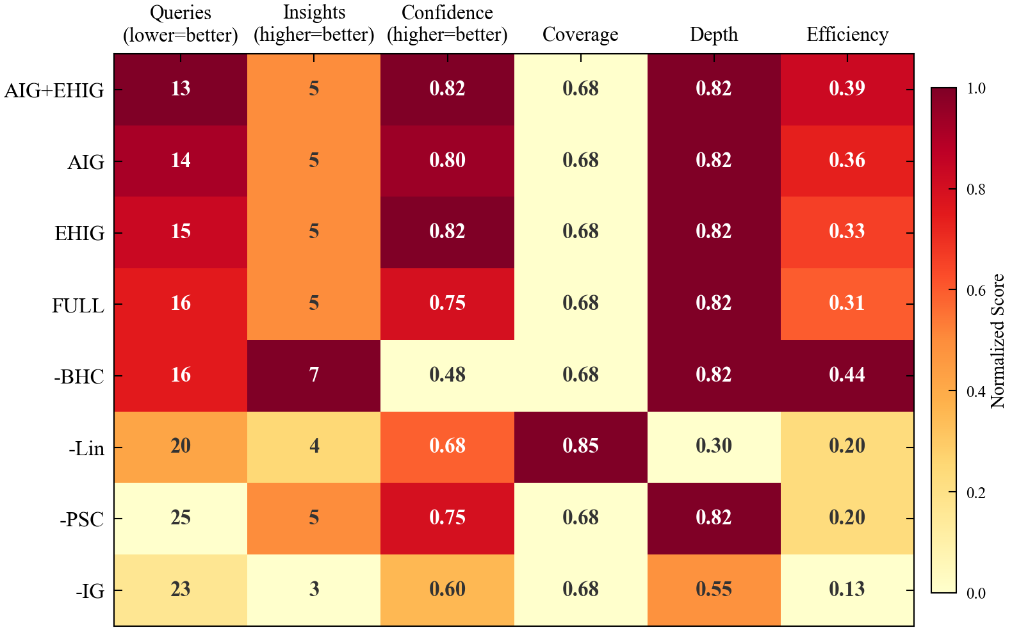
图 4. 八种模式六指标热力图总览。
B. Results. AIG+EHIG: 13 queries, 5 insights, confidence 0.82. FULL: 16 queries, 0.75. -PSC: 25 queries (56% waste). -BHC: 7 insights but confidence 0.48.
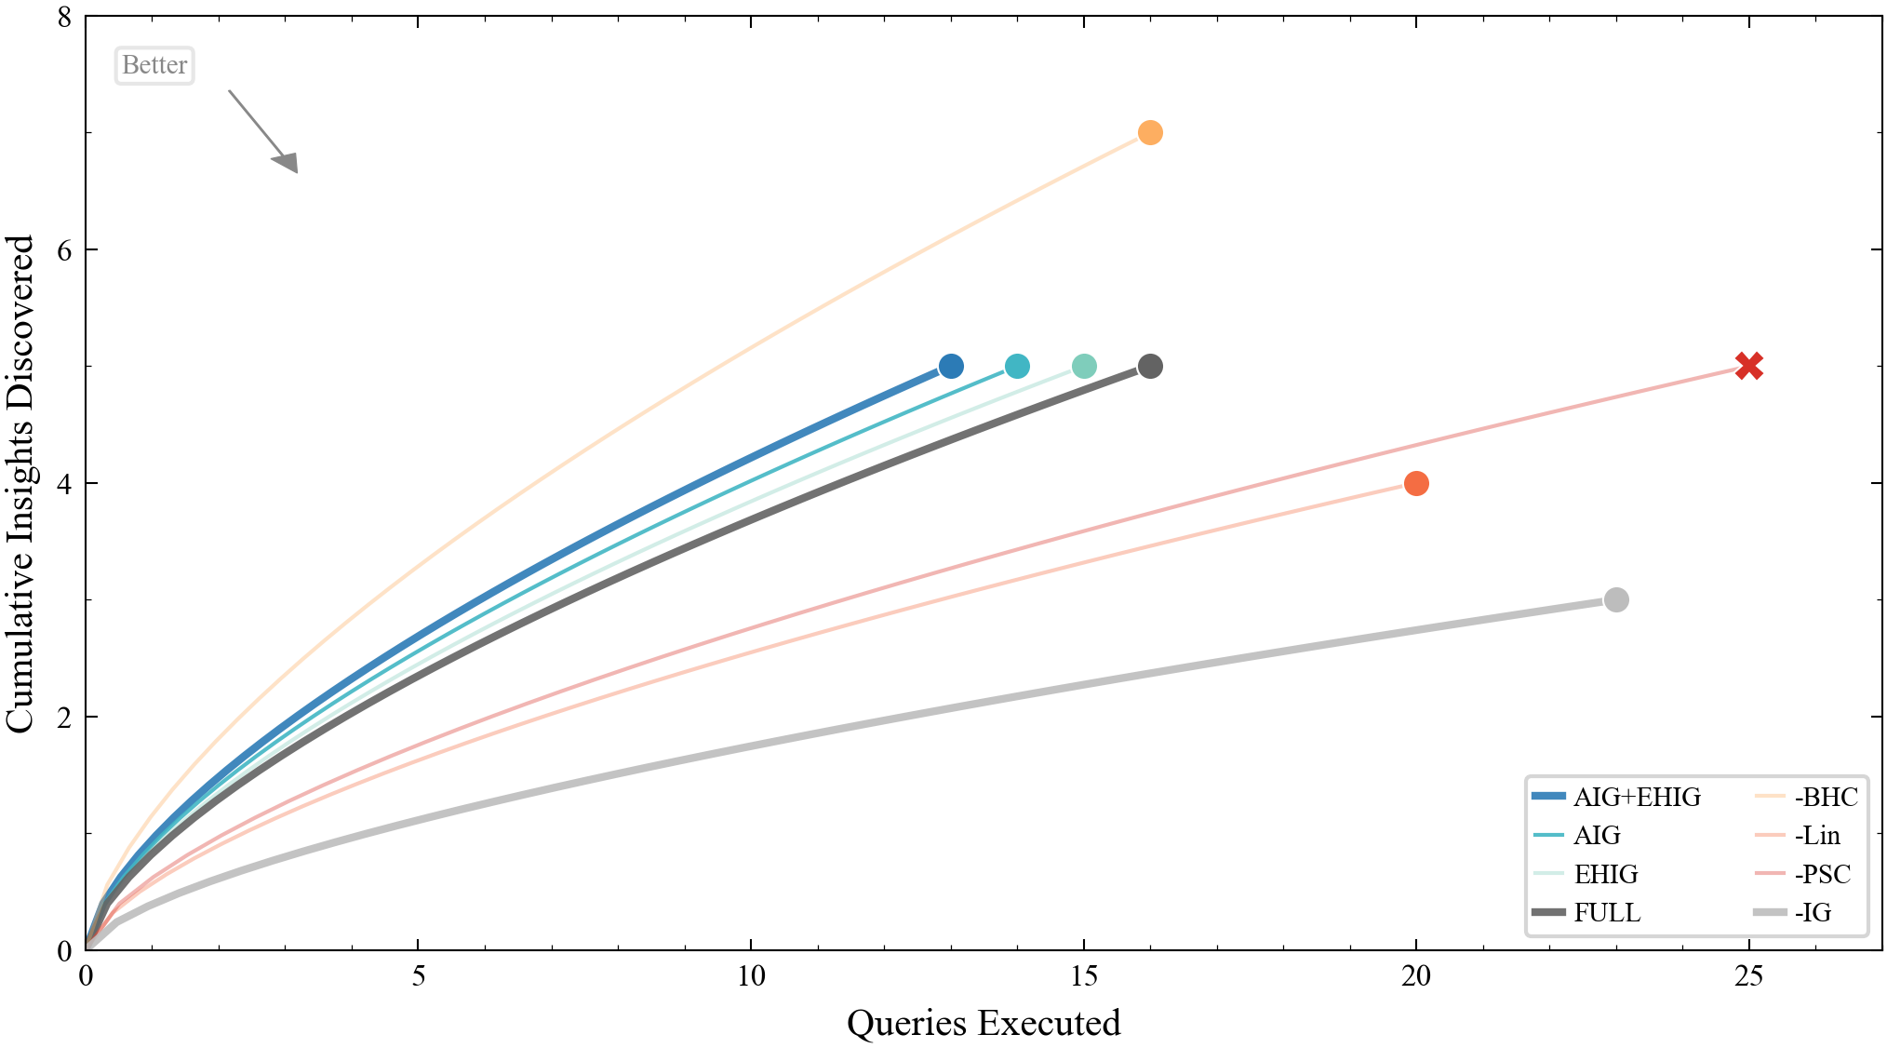
图 5. 累积发现曲线。
C. Ablation Analysis.
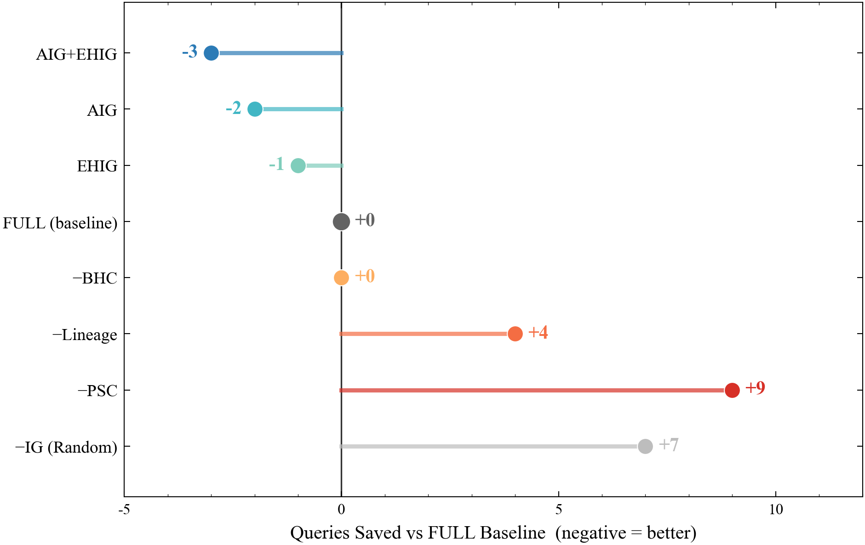
图 7. 消融实验：查询节省数 vs FULL 基线。
Lineage: -Lineage needs 20 queries (25% more). BHC: -BHC confidence drops to 0.48. AIG: phase transitions shown in Figure 6.
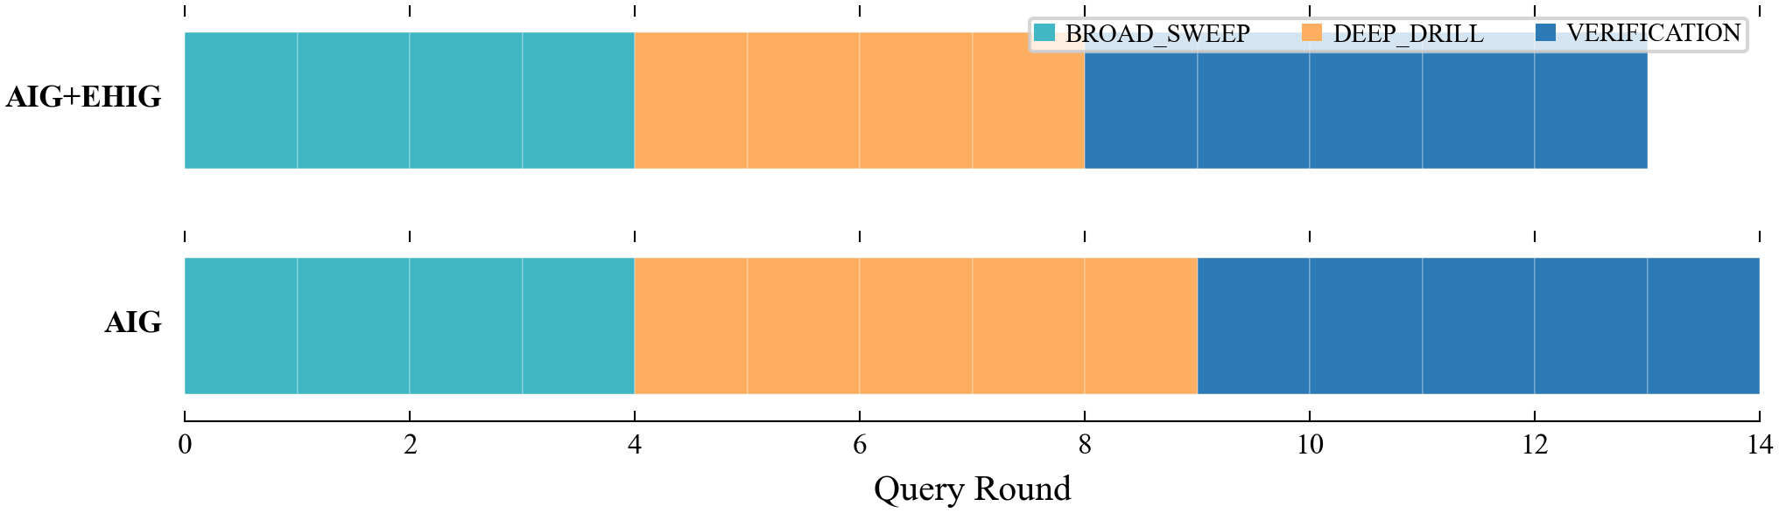
图 6. AIG 阶段转换时间线。
D. Efficiency Frontier.
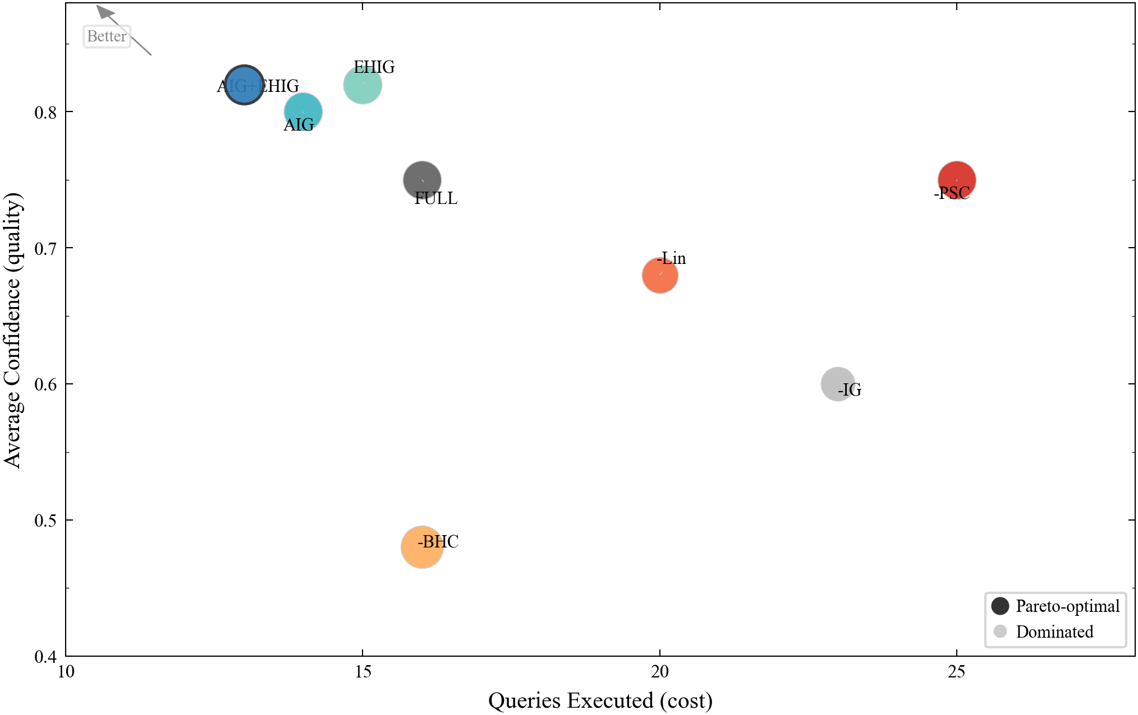
图 8. 效率前沿：成本-质量 Pareto 权衡。
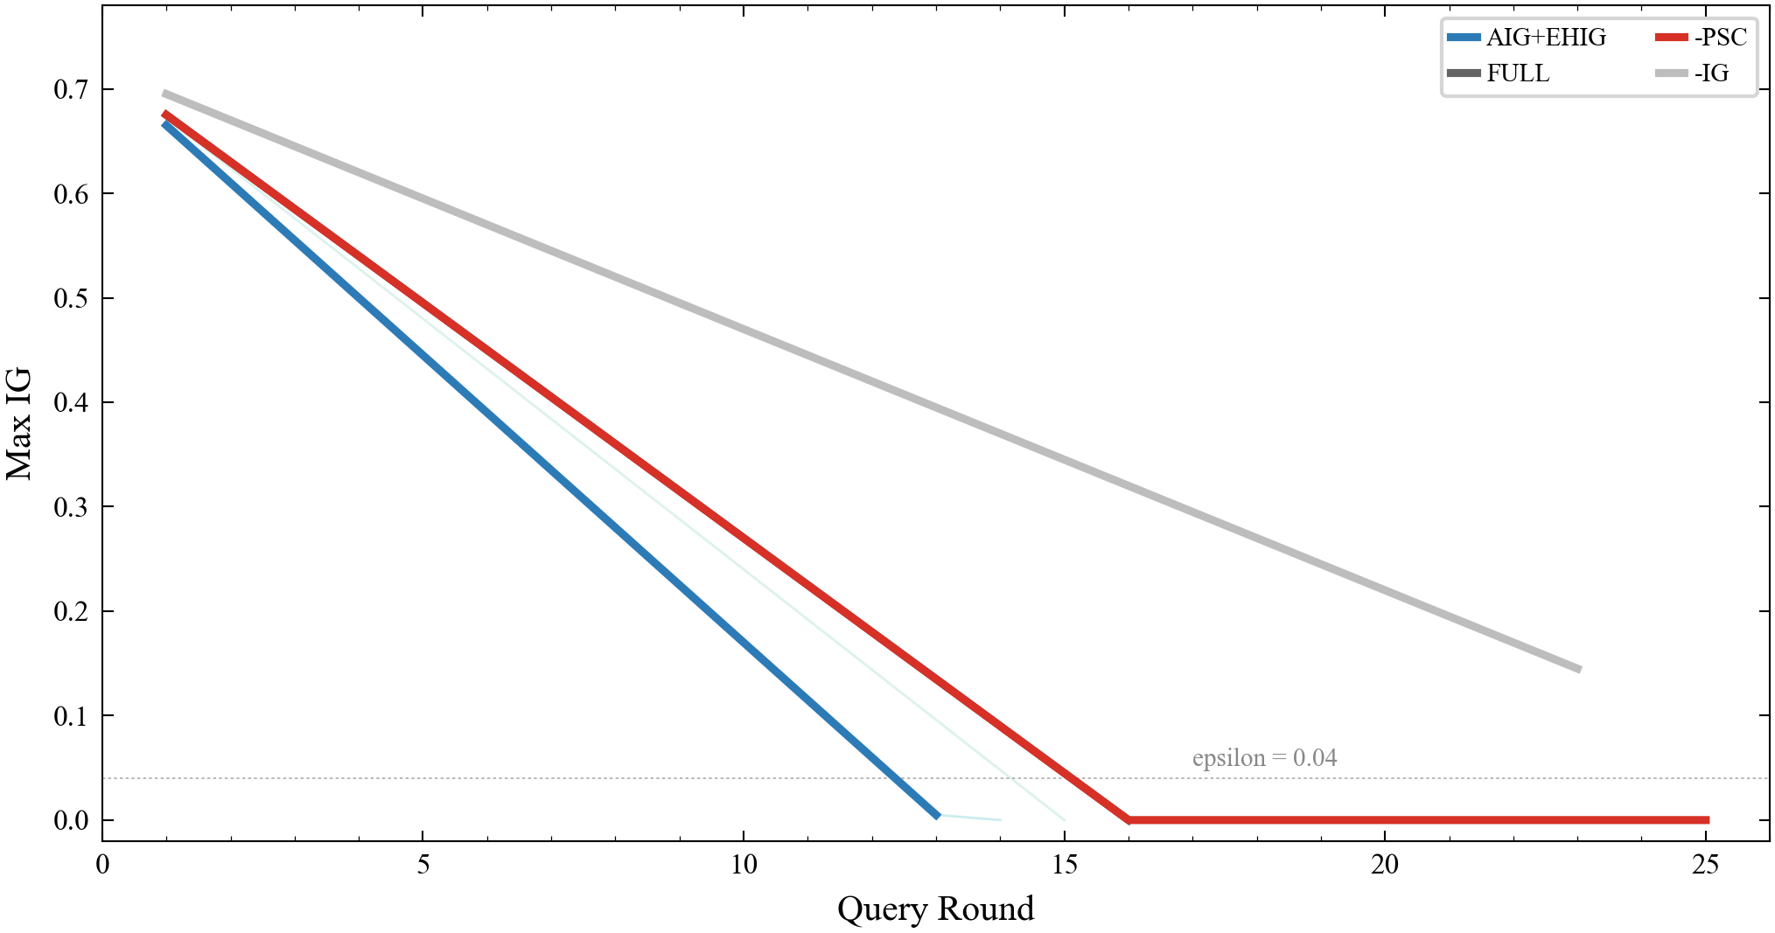
图 9. IG 衰减轨迹。
AIG+EHIG is the unique Pareto-optimal solution.
V. DISCUSSION
AIG works because different exploration phases have different information structures. EHIG's primary advantage is unifying exploration and verification subsystems, though computational overhead increases with hypothesis pool size. Lineage constraint effectiveness depends on graph quality. Future work: multi-domain datasets, human-in-the-loop steering, incremental exploration for live data.
VI. CONCLUSION
AEA enables the shift from passive BI to proactive Agent Analytics through LCE, BHC, AIG, EHIG, and PSC. Experiments demonstrate 18.8% efficiency gain and 9.3% confidence improvement. Code and data are available on GitHub.
TABLE I. Comparison of All Eight Exploration Modes.
Mode | Queries | Discovered | Confidence | Converged
AIG+EHIG | 13 | 5 | 0.82 | Yes
AIG | 14 | 5 | 0.80 | Yes
EHIG | 15 | 5 | 0.82 | Yes
FULL | 16 | 5 | 0.75 | Yes
-BHC | 16 | 7 | 0.48 | Yes
-Lineage | 20 | 4 | 0.68 | Yes
-PSC | 25 | 5 | 0.75 | No
-IG | 23 | 3 | 0.60 | Yes

REFERENCES
[1] D. Wu et al., "AIDA: Towards Autonomous BI," arXiv:2605.07202, 2026.
[2] S. Liu et al., "DataSTORM: Deep Research on DB using EDA," arXiv:2604.06474, 2026.
[3] J. Gottweis et al., "AI Co-Scientist," Nature, 2026.
[4] InfoGain Strategy, Project Supervisor, 2025.
[5] DeepAnalyze, "Agentic LLMs for Autonomous Data Science," arXiv:2510.16872, 2025.
[6] A. Salemi et al., "LLM Blackboard System for Data Discovery," arXiv:2510.01285, 2025.
[7] B. Settles, "Active Learning Literature Survey," U. Wisconsin, 2009.
[8] Y. Li et al., "Tracing Data Lineage in LLMs," ACL, 2026.

