% Jeff Houston
% AEE 472 - Synthesis of Aerospace Systems
% Aircraft Conceptual Design
% 2/4/20
close all; clear all; clc
% References
% (1) http://airfoiltools.com/airfoil/details?airfoil=naca2408-il
% (2) https://www.engineeringtoolbox.com/air-absolute-kinematic-viscosity-d_601.html
% (3) https://en.wikipedia.org/wiki/Lifting-line_theory
% getting approximation of aircraft weight based on HBZ 3100 Kit
W_water = 1.5; % weight of water in rocket [lbs]
W_rocket = 122/453.59; % weight of rocket [grams] -> [lbs]
W_rocket = W_rocket + W_water; % weight of water & rocket [lbs]
W_battery = 110/453.59; % weight of battery [grams] -> [lbs]
W_HBZ3100 = 735/453.59; % weight of total HBZ3100 aircraft [grams] -> [lbs]
W_aircraft = W_rocket + W_HBZ3100;
W_aircraft = 4.00; % weight of aircraft [lbs]
% assumed characteristics
S = 5; % wing area [ft^2]
c = 10./12; % chord length [ft]
b = S./c; % wing span [ft]
AR = b.^2./S; % aspect ratio
e = 0.8; % oswald eff. factor
% simulation 1 - bassline
Output = simulate(S, c, b, AR, e, W_aircraft);
P = Output(1,:)
V_inf = Output(2,:)
score = Output(3,:)
% simulation 2 - change in WING AREA
S_array = linspace(0.5*S,1.5*S,100);
Output2 = simulate(S_array,c,b,AR,e,W_aircraft);
score_2 = Output2(3,:);
parameter_change_2 = S_array./S;
sensitivity_score_2 = score_2./score;
% NOTE: Chord length was found to leave score unchanged.
% % simulation 3 - change in CHORD LENGTH
% c_array = linspace(0.5*c,1.5*c,100);
% Output3 = simulate(S,c_array,b,AR,e,W_aircraft);
% score_3 = Output3(3,:);
%
% parameter_change_3 = c_array./c;
% sensitivity_score_3 = score_3./score;
% simulation 4 - change in ASPECT RATIO
AR_array = linspace(0.5*AR,1.5*AR,100);
Output4 = simulate(S,c,b,AR_array,e,W_aircraft);
score_4 = Output4(3,:);
parameter_change_4 = AR_array./AR;
sensitivity_score_4 = score_4./score;
% simulation 5 - change in OSWALD EFFICIENCY FACTOR
e_array = linspace(0.5*e,1.5*e,100);
Output5 = simulate(S,c,b,AR,e_array,W_aircraft);
score_5 = Output5(3,:);
parameter_change_5 = e_array./e;
sensitivity_score_5 = score_5./score;
% simulation 6 - change in OSWALD EFFICIENCY FACTOR
W_aircraft_array = linspace(0.5*W_aircraft,1.5*W_aircraft,100);
Output6 = simulate(S,c,b,AR,e,W_aircraft_array);
score_6 = Output6(3,:);
parameter_change_6 = W_aircraft_array./W_aircraft;
sensitivity_score_6 = score_6./score;
% plot sensitivity results
figure(1)
hold on
plot(parameter_change_2.*100,fliplr(sensitivity_score_2).*100)
plot(parameter_change_4.*100,fliplr(sensitivity_score_4).*100)
plot(parameter_change_5.*100,fliplr(sensitivity_score_5).*100,'--')
plot(parameter_change_6.*100,fliplr(sensitivity_score_6).*100)
hold off
grid on
axis([50 150 50 150])
title('Parameter-Score Sensitivity')
xlabel('Percent Change in Parameter')
ylabel('Percent Change in Score')
legend('location','northwest','Wing Area','Aspect Ratio','Oswald Eff. Factor','Aircraft Weight')
function Output = simulate(S, c, b, AR, e, W_aircraft)
% This function executes a simulation to output key parameters in
% determining their respective sensitivities.
% known values
g = 32.2; % acceleration due to gravity [ft/s^2]
rho_a = 2.471e-3; % density of air @ 39ºF [slug/ft^3]
mu_a = 3.622e-6; % dynamic viscosity of air @ 39ºF [lbf-s/ft^2]
% NACA 2408 Airfoil (from Ref. 1: |CL/CD|max=37.4 at ?=5.5° for Re ~= 500,000)
% NOTE: input different |CL/CD|max for varying Re, until Re corresponds
% to the one in Ref. 1
alpha = 5.50; % angle of attack [º]
CL_CD_max = 37.4; % |CL/CD|max at given alpha
C_l_alpha = (0.65--0.30)/(4.0--4.0); % Clalpha from Ref. 1 [deg^-1]
C_l_0 = 0.10; % Cl0 from Ref. 1 [deg^-1]
C_L_alpha = C_l_alpha./(1+(57.3.*C_l_alpha./(pi.*e.*AR))); % CLalpha [deg^-1]
C_L_0 = C_l_0; % CL-alpha graph has same intercept as Cl-alpha graph
C_L = C_L_alpha.*alpha + C_L_0; % CL
% for SLUF
V_inf = (2.*W_aircraft./(rho_a.*S.*C_L)).^0.5; % freestream velocity [ft/s]
Re = rho_a.*V_inf.*c./mu_a; % Reynolds Number
C_D_i = C_L.^2./(pi.*e.*AR); % induced drag coeff.
C_D_0 = C_D_i; % zero lift drag coeff. CD0=CDi for max range
C_D = C_D_0 + C_D_i; % drag coeff.
D = 1/2*rho_a.*V_inf.^2.*S.*C_D; % drag force [lbf]
L = W_aircraft; % lift force (equal to W for SLUF) [lbf]
L_check = 1/2*rho_a.*V_inf.^2.*S.*C_L; % double check to make sure L=W
% while it is known that P = TV, T = D for SLUF
P = D.*V_inf; % power used during flight [ft-lb/s]
% P = P./550 % [ft-lb/s] -> [hp]
% assuming at baseline conditions the aircraft can fly for 3 minutes
t_flight = 3*60;
% E = t_flight.*P;
d = t_flight.*V_inf; % distance traveled [ft]
R = 15; % turn radius [ft]
d_lap = 30 + pi*R + 60 + pi*R +30; % distance for approx. one lap [ft]
laps = d./d_lap;
score = laps;
Output = [P ; V_inf ; score];
end
P =
8.5279
V_inf =
33.5678
score =
28.2020
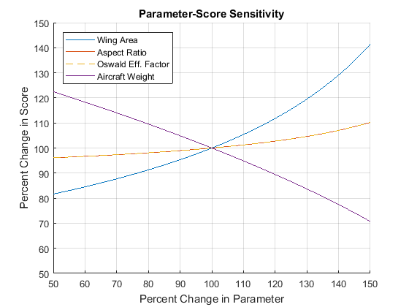
Published with MATLAB® R2017a

