% Jeff Houston
% AEE 472 - Synthesis of Aerospace Systems
% Bottle (Mottle) Rocket Simulation
% 1/20/20
close all; clear all; clc
% REFERENCES:
% (1) https://www.nablu.com/2017/07/the-water-numerical-calculations.html
% (2) https://www.grc.nasa.gov/WWW/k-12/VirtualAero/BottleRocket/airplane/rktvrecv.html
% (3) http://www.engineeringtoolbox.com/drag-coefficient-d_627.html
% Bottle Physical Dimensions/Mass
% Rocket Volume Capacity: 2 L
% Water Volume: 0.7 L
% Pressure: 50 psi
% Nozzle Size: 28 mm
% Nozzle Loss Factor: 0.16
% Bottle Diameter: 110 mm
% Drag Coefficient: 0.35
% Dry Mass: 122 g (Bottle: 42 g, Rocket Fins/Cone/Parachute: 80 g)

Baseline Conditions
% simulation settings
t_span = [1 ; 40]; % time span [s]
dt = 0.01; % time interval [s]
n = t_span(end)/dt; % number of intervals
t(1) = 0; % time stamp [s]
% known values
g = 32.2; % acceleration due to gravity [ft/s^2]
rho_w = 1.940; % density of water @ 39ºF [slug/ft^3]
rho_a = 2.471e-3; % density of air @ 39ºF [slug/ft^3]
% bottle physical properties (Mtn. Dew)
d_noz = 0.75; % nozzle diameter [in] %% NEEDS UPDATING %%
A_noz = pi*(d_noz/2)^2/12^2; % nozzle area [ft^2]
d = 5; r = d/2/12; % diameter of bottle, radius, [in] -> [ft] %% NEEDS UPDATING %%
S = pi*r^2; % area of bottle's main cross-section [ft^2]
m_rocket = 42 + 80; m_rocket = m_rocket/14594; % mass o rocket + fins,etc. [g] -> [slug]
% drag coeff.
C_D_i = 0; % CD,i = CL^2/pieAR -> assume CL = 0
C_D_0 = 0.10; % zero lift-drag coeff.
C_D = C_D_0 + C_D_i; % drag coeff.
% initial fuel/pressure conditions
V_bottle = 2; % volume of bottle [L]
V_bottle = V_bottle*1000/(100^3)*(3.281^3); % convert [L] -> [cm^3] -> [m^3] -> [ft^3]
fill = 0.35; % percentage of bottle volume INITIALLY filled with water (0-1)
V_w(1) = fill*V_bottle; % volume of water [ft^3]
m_w(1) = V_w(1)*rho_w; % fuel mass [slug] %% NEEDS UPDATING %%
V_a(1) = V_bottle-V_w(1); % volume of air [ft^3]
m_a(1) = V_a(1)*rho_a; % air mass [slug]
h(1) = V_w(1)/S; % height of water in rocket [ft]
P_atm = 2.0783*12*12; % atmospheric pressure @ 500' ASL [psi] -> [lbf/ft^2]
P_armed = 50*12*12; % bottle pressure at liftoff [psi] -> [lbf/ft^2]
P(1) = P_armed;
V_armed = V_w(1);
% initial conditions based on fuel/pressure conditions
m(1) = m_rocket + m_w(1) + m_a(1); % mass of fuel/rocket/air [slug]
F(1) = P(1).*A_noz; % force due to pressure [lbf]
D(1) = 0; % initial drag force [lbf]
a_y(1) = F(1)/m(1) - g - D(1); % total initial acceleration [ft/s^2]
Cv = 0.90; % losses due to bottle friction
v_w_ex(1) = Cv*(2*(a_y(1)*h(1) + (P(1)-P_atm)/rho_w))^0.5; % initial exhaust velocity [ft/s]
V_w_dot(1) = v_w_ex(1)*A_noz; % water volume rate of change [ft^3/s]
m_w_dot(1) = rho_w*V_w_dot(1); % water mass rate of change [slug/s]
F_w(1) = m_w_dot(1)*v_w_ex(1);
% physical initial conditions
v_y(1) = 0;
y(1) = 0;
% parachute design
v_des = 4; % descent velocity [ft/s]
% C_D_des = 1.75; % typical drag coeff. for parachute (according to NASA)
C_D_des = 1.42; % drag coeff. for hollow semi-sphere (according to Eng. Toolbox)
A_req = 2*m_rocket*g/(rho_a*v_des^2*C_D_des); % area required to descend at stated velocity [ft^2]
r_req = (A_req/pi)^0.5; % radius [ft]
d_req = 2*r_req; % diameter [ft]
for i = 2:n
t(i) = t(i-1) + dt;
P(i) = P_armed*(V_armed./(V_bottle - V_w(i-1)))^1.4;
h(i) = V_w(i-1)/S; % height of water in rocket [ft]
m_w(i) = rho_w*V_w(i-1);
m_a(i) = rho_a*V_a(i-1);
m(i) = m_w(i-1) + m_a(i-1) + m_rocket; % total mass [slug]
v_w_ex(i) = Cv*(2*(a_y(i-1)*h(i-1) + (P(i-1)-P_atm)/rho_w))^0.5; % initial exhaust velocity [ft/s]
V_w_dot(i) = v_w_ex(i-1)*A_noz; % water volume rate of change [ft^3/s]
m_w_dot(i) = rho_w*V_w_dot(i-1); % water mass rate of change [slug/s]
F_w(i) = m_w_dot(i-1)*v_w_ex(i-1);
if m_w(i) > 0 && v_y(i-1) > 0
a_y(i) = F_w(i-1)/m(i-1) - D(i-1)/m(i-1) - g;
elseif m_w(i) > 0 && v_y(i-1) < 0
fprintf('Something went wrong, friend...\n')
elseif m_w(i) < 0 && v_y(i-1) > 0
m_w(i) = 0;
a_y(i) = -g - D(i-1)/m_rocket;
elseif m_w(i) < 0 && v_y(i-1) < 0
m_w(i) = 0;
a_y(i) = -g + D(i-1)/m_rocket;
elseif i <= 1/50*n
if m_w(i) > 0 && v_y(i-1) == 0
a_y(i) = F_w(i-1)/m(i-1) - D(i-1)/m(i-1) - g;
end
end
v_y(i) = v_y(i-1) + a_y(i)*dt;
y(i) = y(i-1) + v_y(i-1)*dt + 1/2*a_y(i)*dt^2;
D(i) = 1/2*rho_a*v_y(i)^2*C_D*S;
V_w(i) = V_w(i-1) - V_w_dot(i)*dt;
V_a(i) = V_bottle - V_w(i);
if m_w(i) == 0 && v_y(i-1) < 0
m_w(i) = 0;
a_y(i) = 0;
v_y(i) = -v_des;
end
if y(i) < 0
break
end
end
figure(1)
plot(t,y)
grid on
title('Altitude-Time Plot')
xlabel('Time (s)')
ylabel('Altitude (ft)')
figure(2)
plot(t,v_y)
grid on
title('Velocity-Time Plot')
xlabel('Time (s)')
ylabel('Velocity (ft/s)')
figure(3)
hold on
plot(t,a_y,'-')
temp = ones(length(t))*-g; plot(t,temp,'-');
hold off
grid on
title('Acceleration-Time Plot')
xlabel('Time (s)')
ylabel('Acceleration (ft/s^2)')
legend('location','northeast','a(t)','-g')
figure(4)
plot(t,F_w)
grid on
title('Thrust-Time Plot')
xlabel('Time (s)')
ylabel('Thrust (lbf)')
figure(5)
hold on
plot(t,P./144,'-')
temp = ones(size(t))*P_atm./144; plot(t,temp,'-');
temp = ones(size(t))*P_armed./144; plot(t,temp,'-');
hold off
grid on
title('Pressure-Time Plot')
xlabel('Time (s)')
ylabel('Pressure (psi)')
legend('-DynamicLegend','location','northeast','P(t)','P_a_t_m_o_s_p_h_e_r_i_c','P_l_a_u_n_c_h')
figure(6)
hold on
plot(t,m,'-')
temp = ones(length(t))*m_rocket;
plot(t,temp,'-')
plot(t,m_w,'-')
plot(t,m_a,'-')
hold off
grid on
title('Mass-Time Plot')
xlabel('Time (s)')
ylabel('Mass (slug)')
legend('-DynamicLegend','location','northeast','m(t)','m_r_o_c_k_e_t','m_w(t)','m_a(t)')
fprintf('With the bottle filled to %2.1f percent of its volume capacity, the rocket will fly for approximately:\n\n %2.1f s\n\n',100*fill,t(end))
fprintf('At at a volume of %2.1f L initially filled with water, the water will weight approximately:\n\n %2.1f lbs\n\n',2*fill,m_w(1)*g)
Warning: Imaginary parts of complex X and/or Y arguments ignored
Warning: Imaginary parts of complex X and/or Y arguments ignored
Warning: Imaginary parts of complex X and/or Y arguments ignored
Warning: Imaginary parts of complex X and/or Y arguments ignored
With the bottle filled to 35.0 percent of its volume capacity, the rocket will fly for approximately:
21.9 s
At at a volume of 0.7 L initially filled with water, the water will weight approximately:
1.5 lbs
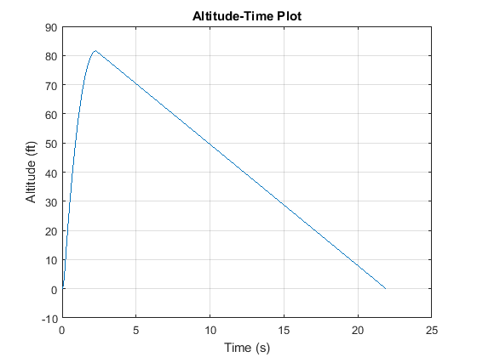
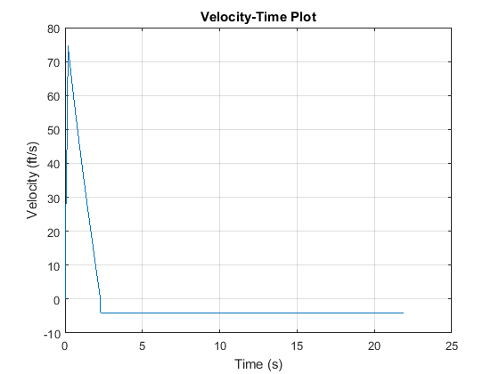
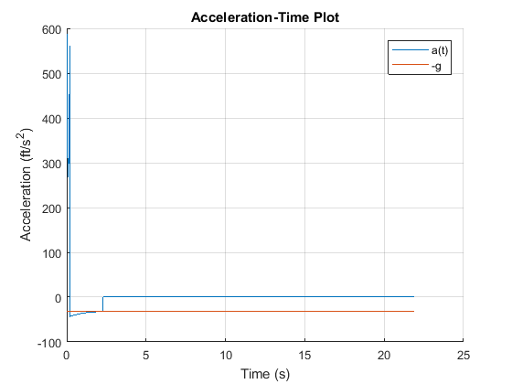
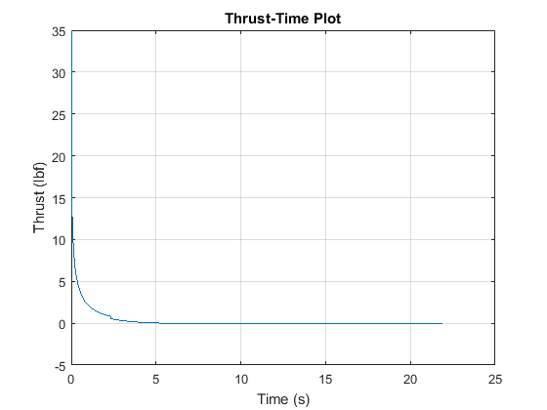
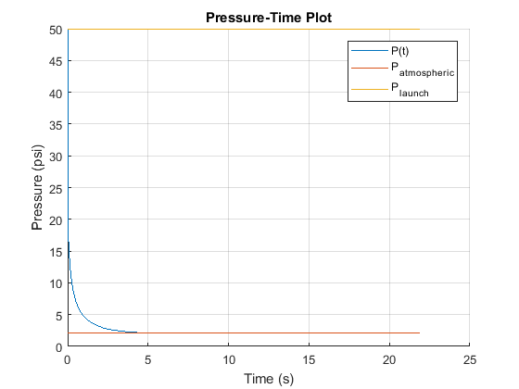
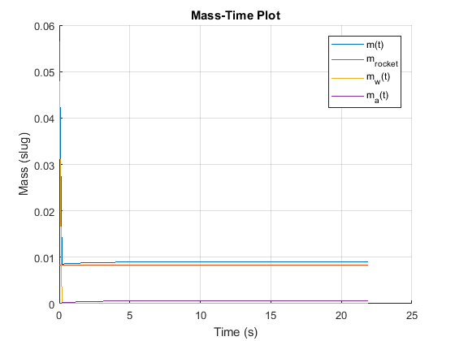

Sensitivity Study
score = t(end)
close all; clearvars -except score; clc
steps = 100;
fill = 0.35 % percentage of bottle volume INITIALLY filled with water (0-1)
m_rocket = 42 + 80; m_rocket = m_rocket/14594 % mass o rocket + fins,etc. [g] -> [slug]
Cv = 0.9; % losses due to bottle friction
% simulation 1 - change in BOTTLE FILL
fill_array = linspace(0.5*fill,1.5*fill,steps);
for j = 1:steps
Output1(j) = simulate(fill_array(j), m_rocket, Cv);
end
score_1 = Output1(1,:);
parameter_change_1 = fill_array./fill;
sensitivity_score_1 = score_1./score;
% simulation 2 - change in ROCKET MASS
m_rocket_array = linspace(0.5*m_rocket,1.5*m_rocket,steps);
for j = 1:steps
Output2(j) = simulate(fill, m_rocket_array(j), Cv);
end
score_2 = Output2(1,:);
parameter_change_2 = m_rocket_array./m_rocket;
sensitivity_score_2 = score_2./score;
% simulation 3 - change in NOZZLE LOSS COEFF (Cv)
Cv_array = linspace(0.5*Cv,1.5*Cv,steps);
for j = 1:steps
Output3(j) = simulate(fill, m_rocket, Cv_array(j));
end
score_3 = Output2(1,:);
parameter_change_3 = Cv_array./Cv;
sensitivity_score_3 = score_3./score;
% plot sensitivity results
change_1 = polyfit(parameter_change_1,sensitivity_score_1,2);
change_2 = polyfit(parameter_change_2,sensitivity_score_2,2);
change_3 = polyfit(parameter_change_3,sensitivity_score_3,2);
change_1 = polyval(change_1,parameter_change_1);
change_2 = polyval(change_2,parameter_change_2);
change_3 = polyval(change_3,parameter_change_3);
figure(1)
hold on
plot(parameter_change_1.*100,change_1.*100)
plot(parameter_change_2.*100,change_2.*100)
plot(parameter_change_3.*100,change_3.*100,'--')
hold off
grid on
axis([50 150 50 150])
title('Parameter-Score Sensitivity')
xlabel('Percent Change in Parameter')
ylabel('Percent Change in Score')
legend('location','northwest','Percent Water in Rocket','Mass of Rocket','Bottle Loss Coeff.')
function [Output] = simulate(fill, m_rocket, Cv)
% simulation settings
t_span = [1 ; 40]; % time span [s]
dt = 0.01; % time interval [s]
n = t_span(end)./dt; % number of intervals
t(1) = 0; % time stamp [s]
% known values
g = 32.2; % acceleration due to gravity [ft./s.^2]
rho_w = 1.940; % density of water @ 39ºF [slug./ft.^3]
rho_a = 2.471e-3; % density of air @ 39ºF [slug./ft.^3]
% bottle physical properties (Mtn. Dew)
d_noz = 0.75; % nozzle diameter [in] %% NEEDS UPDATING %%
A_noz = pi.*(d_noz./2).^2./12.^2; % nozzle area [ft.^2]
d = 5; r = d./2./12; % diameter of bottle, radius, [in] -> [ft] %% NEEDS UPDATING %%
S = pi.*r.^2; % area of bottle's main cross-section [ft.^2]
% drag coeff.
C_D_i = 0; % CD,i = CL.^2./pieAR -> assume CL = 0
C_D_0 = 0.10; % zero lift-drag coeff.
C_D = C_D_0 + C_D_i; % drag coeff.
% initial fuel./pressure conditions
V_bottle = 2; % volume of bottle [L]
V_bottle = V_bottle.*1000./(100.^3).*(3.281.^3); % convert [L] -> [cm.^3] -> [m.^3] -> [ft.^3]
V_w(1) = fill.*V_bottle; % volume of water [ft.^3]
m_w(1) = V_w(1).*rho_w; % fuel mass [slug] %% NEEDS UPDATING %%
V_a(1) = V_bottle-V_w(1); % volume of air [ft.^3]
m_a(1) = V_a(1).*rho_a; % air mass [slug]
h(1) = V_w(1)./S; % height of water in rocket [ft]
P_atm = 2.0783.*12.*12; % atmospheric pressure @ 500' ASL [psi] -> [lbf./ft.^2]
P_armed = 50.*12.*12; % bottle pressure at liftoff [psi] -> [lbf./ft.^2]
P(1) = P_armed;
V_armed = V_w(1);
% initial conditions based on fuel./pressure conditions
m(1) = m_rocket + m_w(1) + m_a(1); % mass of fuel./rocket./air [slug]
F(1) = P(1).*A_noz; % force due to pressure [lbf]
D(1) = 0; % initial drag force [lbf]
a_y(1) = F(1)./m(1) - g - D(1); % total initial acceleration [ft./s.^2]
v_w_ex(1) = Cv.*(2.*(a_y(1).*h(1) + (P(1)-P_atm)./rho_w)).^0.5; % initial exhaust velocity [ft./s]
V_w_dot(1) = v_w_ex(1).*A_noz; % water volume rate of change [ft.^3./s]
m_w_dot(1) = rho_w.*V_w_dot(1); % water mass rate of change [slug./s]
F_w(1) = m_w_dot(1).*v_w_ex(1);
% physical initial conditions
v_y(1) = 0;
y(1) = 0;
% parachute design
v_des = 4; % descent velocity [ft./s]
% C_D_des = 1.75; % typical drag coeff. for parachute (according to NASA)
C_D_des = 1.42; % drag coeff. for hollow semi-sphere (according to Eng. Toolbox)
A_req = 2.*m_rocket.*g./(rho_a.*v_des.^2.*C_D_des); % area required to descend at stated velocity [ft.^2]
r_req = (A_req./pi).^0.5; % radius [ft]
d_req = 2.*r_req; % diameter [ft]
for i = 2:n
t(i) = t(i-1) + dt;
P(i) = P_armed.*(V_armed./(V_bottle - V_w(i-1))).^1.4;
h(i) = V_w(i-1)./S; % height of water in rocket [ft]
m_w(i) = rho_w.*V_w(i-1);
m_a(i) = rho_a.*V_a(i-1);
m(i) = m_w(i-1) + m_a(i-1) + m_rocket; % total mass [slug]
v_w_ex(i) = Cv.*(2.*(a_y(i-1).*h(i-1) + (P(i-1)-P_atm)./rho_w)).^0.5; % initial exhaust velocity [ft./s]
V_w_dot(i) = v_w_ex(i-1).*A_noz; % water volume rate of change [ft.^3./s]
m_w_dot(i) = rho_w.*V_w_dot(i-1); % water mass rate of change [slug./s]
F_w(i) = m_w_dot(i-1).*v_w_ex(i-1);
if m_w(i) > 0 && v_y(i-1) > 0
a_y(i) = F_w(i-1)./m(i-1) - D(i-1)./m(i-1) - g;
elseif m_w(i) > 0 && v_y(i-1) < 0
fprintf('Something went wrong, friend...')
elseif m_w(i) < 0 && v_y(i-1) > 0
m_w(i) = 0;
a_y(i) = -g - D(i-1)./m_rocket;
elseif m_w(i) < 0 && v_y(i-1) < 0
m_w(i) = 0;
a_y(i) = -g + D(i-1)./m_rocket;
elseif i <= 1./50.*n
if m_w(i) > 0 && v_y(i-1) == 0
a_y(i) = F_w(i-1)./m(i-1) - D(i-1)./m(i-1) - g;
end
end
v_y(i) = v_y(i-1) + a_y(i).*dt;
y(i) = y(i-1) + v_y(i-1).*dt + 1./2.*a_y(i).*dt.^2;
D(i) = 1./2.*rho_a.*v_y(i).^2.*C_D.*S;
V_w(i) = V_w(i-1) - V_w_dot(i).*dt;
V_a(i) = V_bottle - V_w(i);
if m_w(i) == 0 && v_y(i-1) < 0
m_w(i) = 0;
a_y(i) = 0;
v_y(i) = -v_des;
end
if y(i) < 0
break
end
end
% if j > 40
%
% end
Output = t(end);
end
score =
21.9100
fill =
0.3500
m_rocket =
0.0084
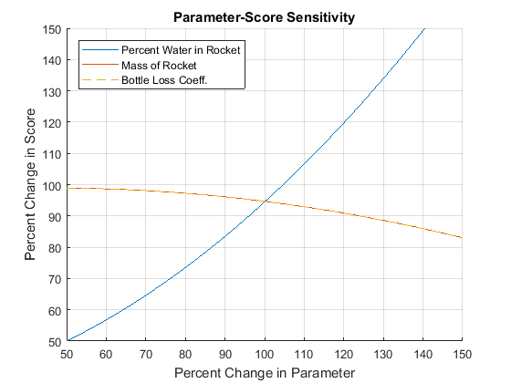
Published with MATLAB® R2017a

