

|  |
| --- |
| CRED Salesforce Payment Module |
| Installation Guide Version 1.0.0  Prepared by ITG Software Engineering  Monday, July 12, 2021 |

|  |
| --- |
|  |

# Installation Steps

Here we will guide you through the installation process as well as the configuration of our extension as following:

1. We need to install the custom payment cartridge from the Marketplace, below steps to add the cartridge to your site:  
    1) get app_custom_payment cartridge from the Marketplace   
    2) In BM from Administration > Sites > Manage Sites choose the required site and  
    add the payment cartridge “app_custom_payment” to cartridge path, please note below screen shot:  
    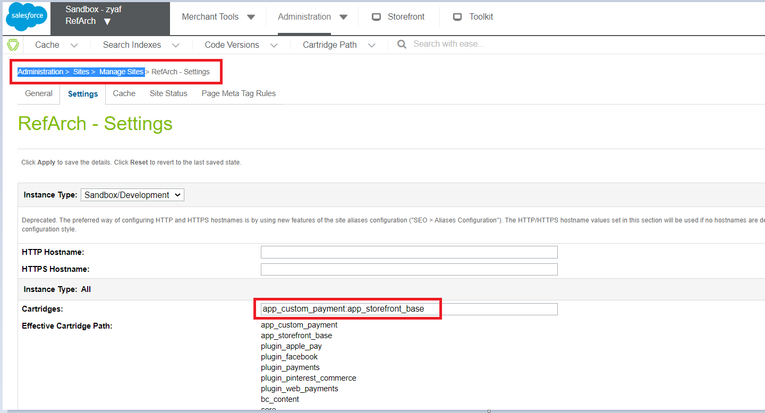
2. Now navigate to your custom payment cartridge specially in “configuration” folder and do the following:
   1. In BM Go To Merchant Tools > Ordering > Import & Export and upload the PaymentMethod.xml file and import that file  
      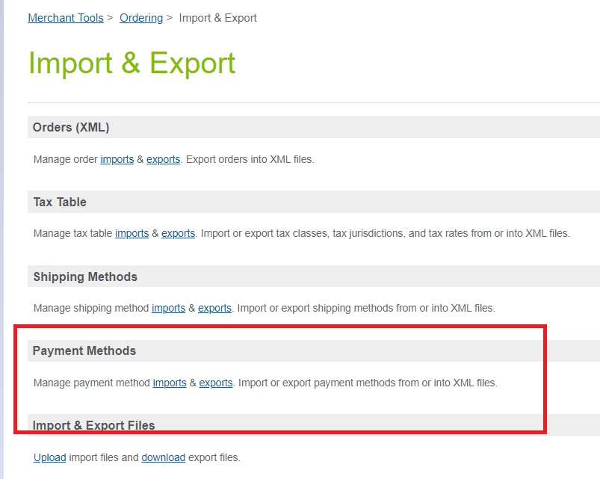
   2. In BM Go To Administration > Site Development > Import & Export and upload the “systemObjectTypes.xml” file and import that file.  
      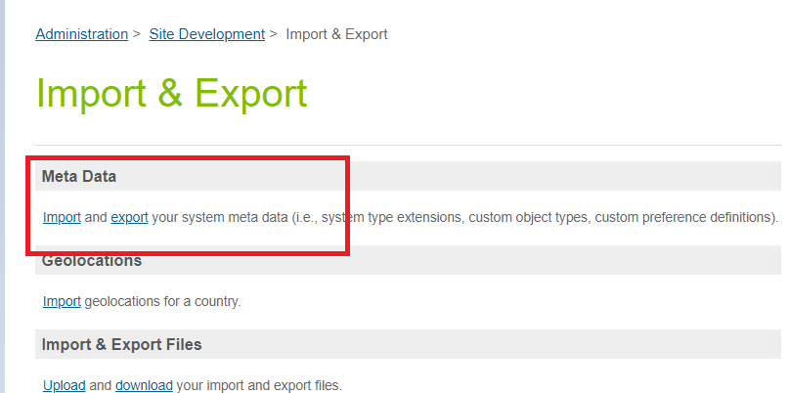
   3. The “preferences.xml & payment-processors.xml” in the configurations will be imported via BM from Administration > Site Development > Site Import & Export  
      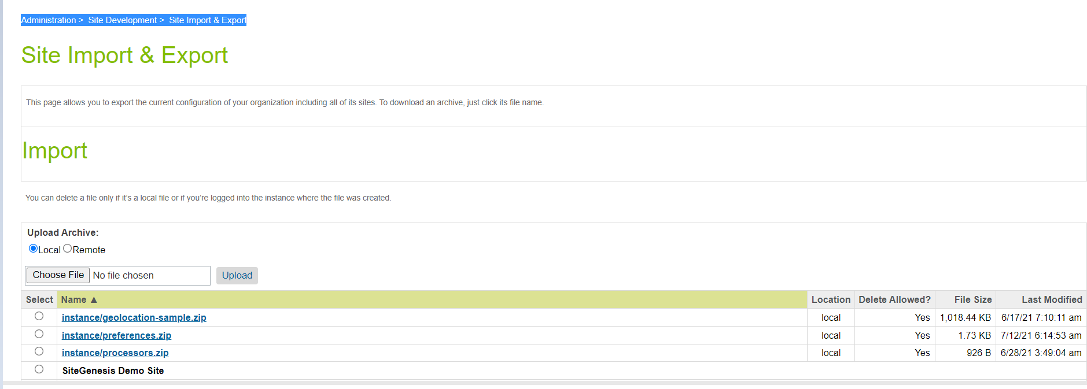
   4. Service configuration:  
      at this part you should upload and import the service.xml file that locate in configuration folder inside the payment cartridge below screenshot for more clarification:

