

|  |
| --- |
| CRED Salesforce Payment module |
| User Guide Version 1.0.0  Prepared by ITG Software Engineering  Monday, July 12, 2021 |

Contents

Introduction 2

Configuration 2

Required Settings: 3

Customer Experience Settings 4

Storefront 4

Order Status 7

Possible Issues 7

# Introduction

The purpose of this manual is to guide the user through the configuration settings and the general use of the Payment Module Extension for the Salesforce ecommerce platform.

After completing the steps provided in the “ITG_Salesforce_Payment_Plugin_Installation_Guide” documentation, you will be able to review/modify the related configuration in the Custom preferences and start using the new payment in the checkout page - storefront.

# Configuration

You need to modify some configuration some system fields to start using the payment:

1. Log into your Sandbox (BM).
2. Navigate to Merchant Tools > Ordering > Payment Methods and change the payment method Name to the desired name.
3. Navigate to Merchant Tools > Site Preferences > Custom Site Preference Groups and enter to CredPayment and contact Jifity to take the values for below configurations:  
   a – credPaymentToken  
   b- LenderId  
   c- MerchantId  
   d- storeId  
   f- callBackURL: this url should be modified to add the site id instead of the base one  
   below configurations have a default value for cred payment to work in a proper way
4. Identify the Payment Methods in Sales and select our Payment method.

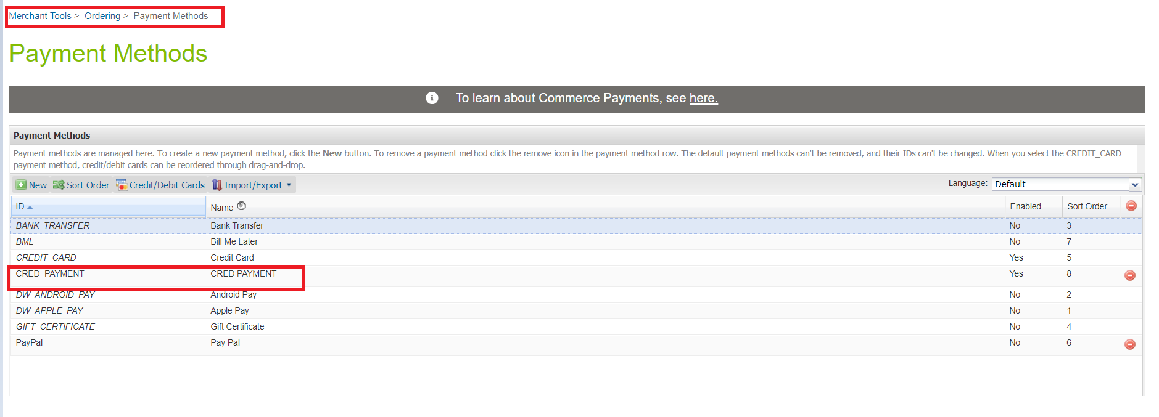

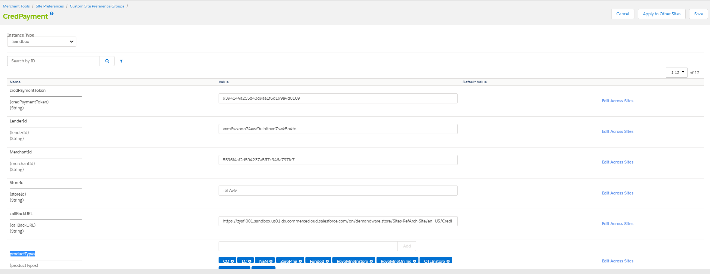

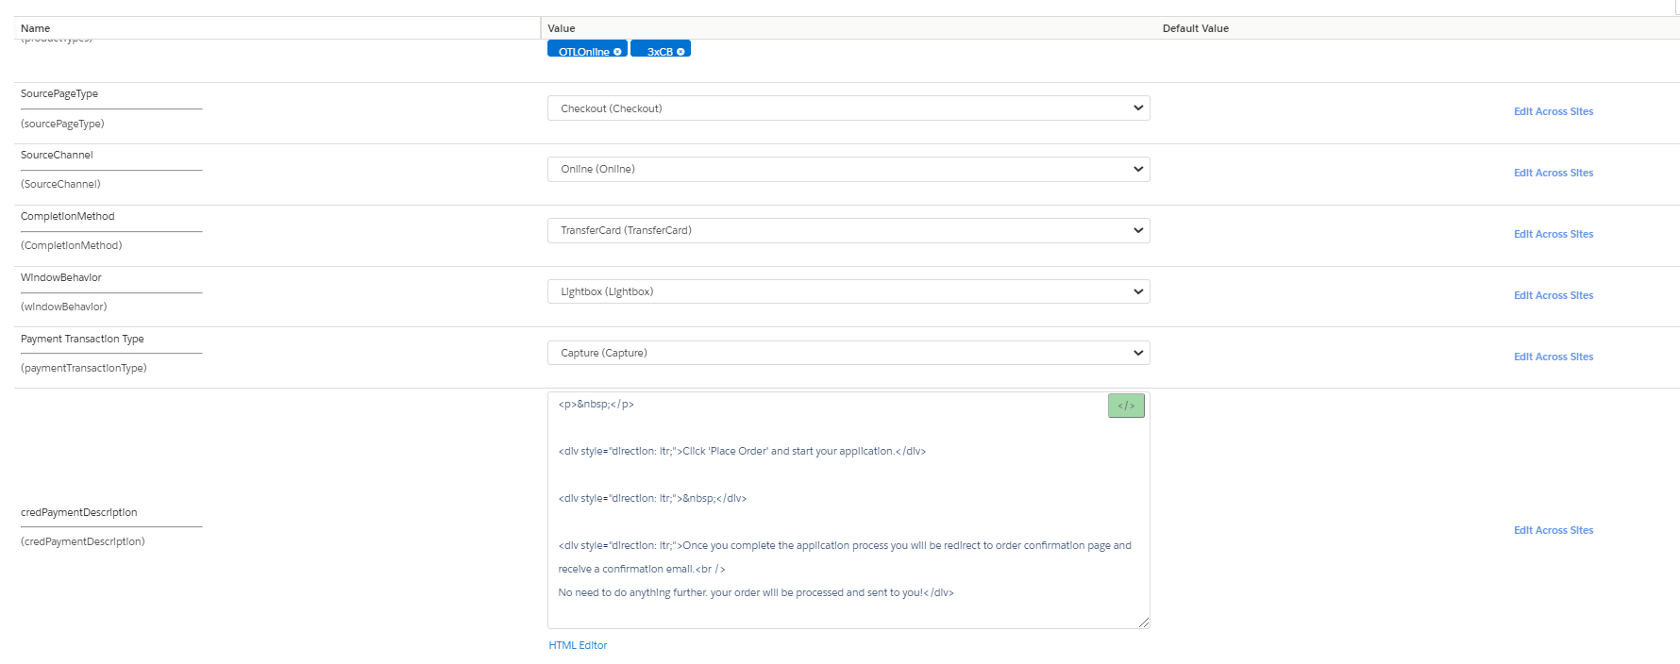

Required Settings:

* Completion Method: Indication if the flow should end in displaying the card to the customer, returning the card (or other payment token) back to the hosting website (default if not sent), completing the purchase internally, or just creating the credit account.  
    
  You can set the Completion Method to be one of the following values:
  + None
  + DisplayCard
  + TransferCard (Selected By Default)
  + CompletePurchase
  + CreateAccount
* Allowed Product Types: Determine the financial product type, you can select multi values of the following: **CO, LC, NaN, ZeroPing, Funded, RevolvingInstore, RevolvingOnline, OTLInstore, OTLOnline, _3xCB**

## Customer Experience Settings

* Payment Name: The Title of the payment method that will be displayed in the Checkout Page.
* credPaymentDescription: The Description of the payment displayed under the payment title in the checkout page.
* Window Behavior: Determines how the new flow opens, and you can choose one of these values: NewTab, SameTab or Lightbox

# Storefront

At front end, customer can add the items into shopping cart by clicking the Add to Cart button, then, going to the checkout page, Customer fills in their shipping address and selects the payment method (the title as you defined in the configuration).

Application Flow will be displayed, and after the customer completes the flow, they will be redirected to the confirmation page in case all good, or the customer will be redirected back to the checkout page with displaying a failure popup for lightbox case or out of the box error in case new and sane tabs.

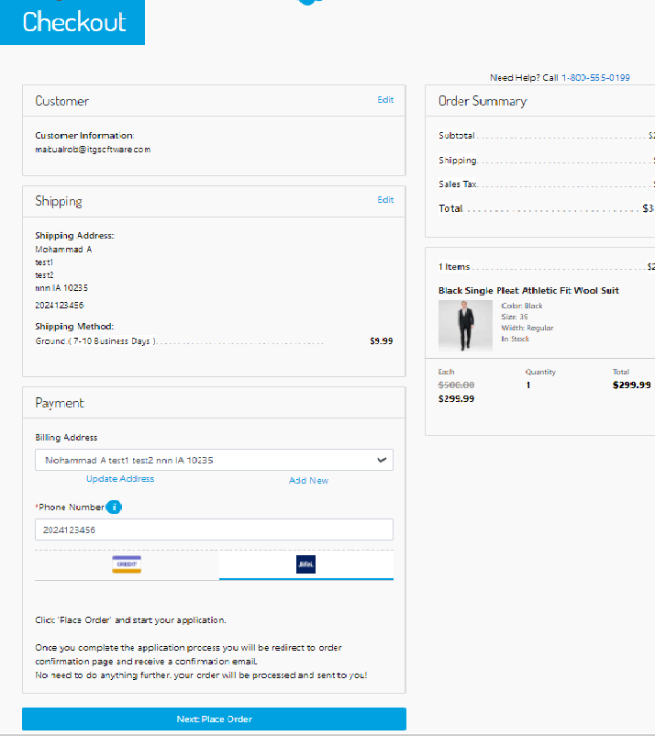

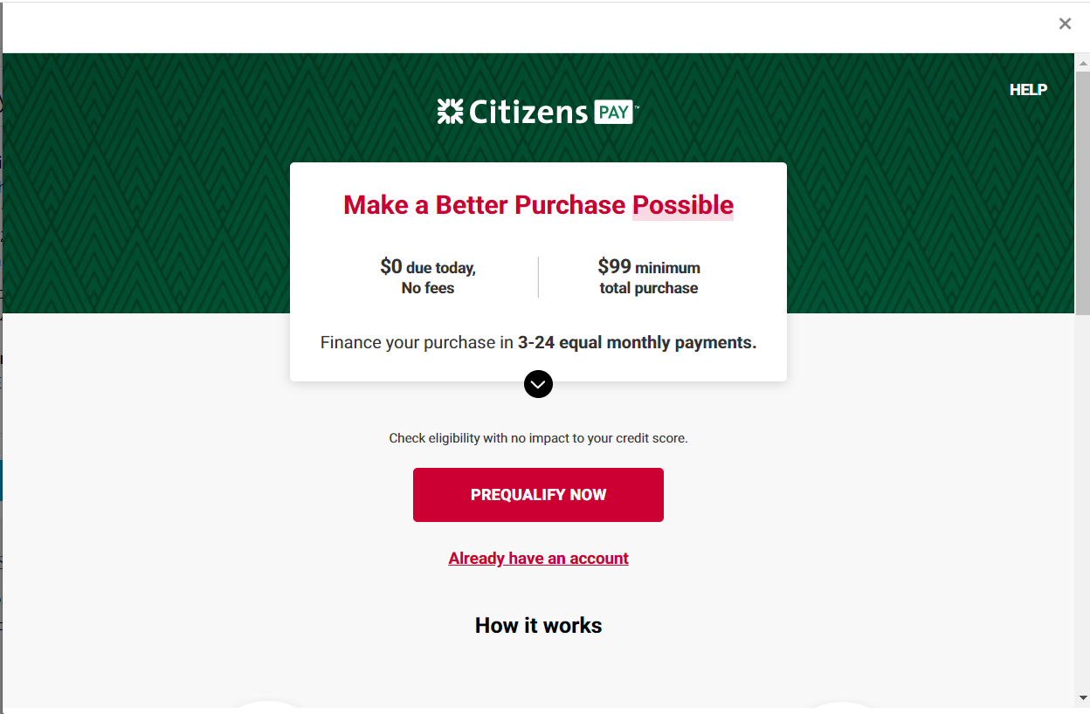

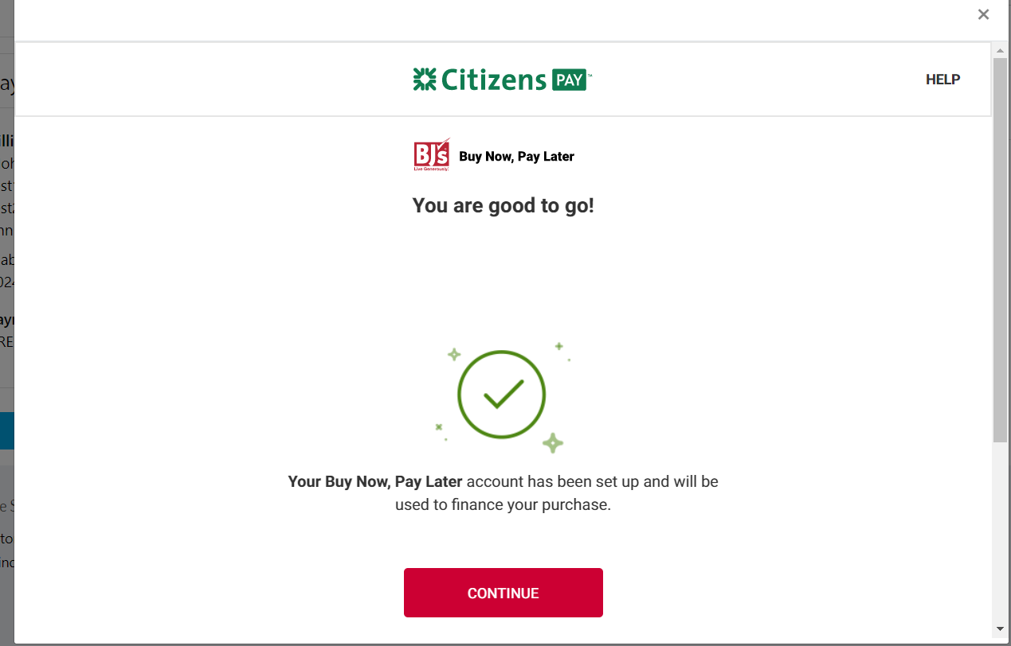

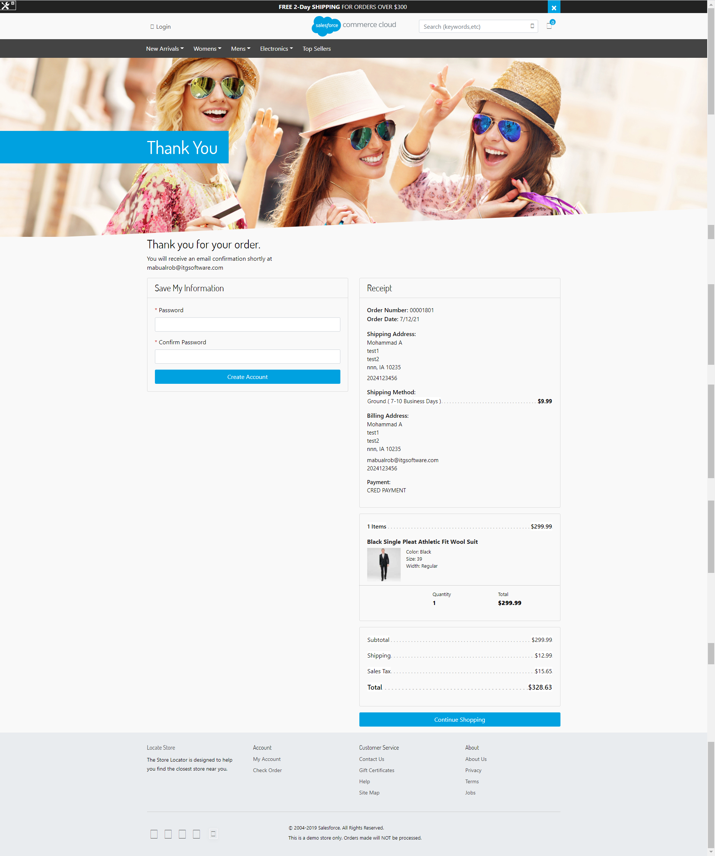

Example of the UX for an unsuccessful application here:

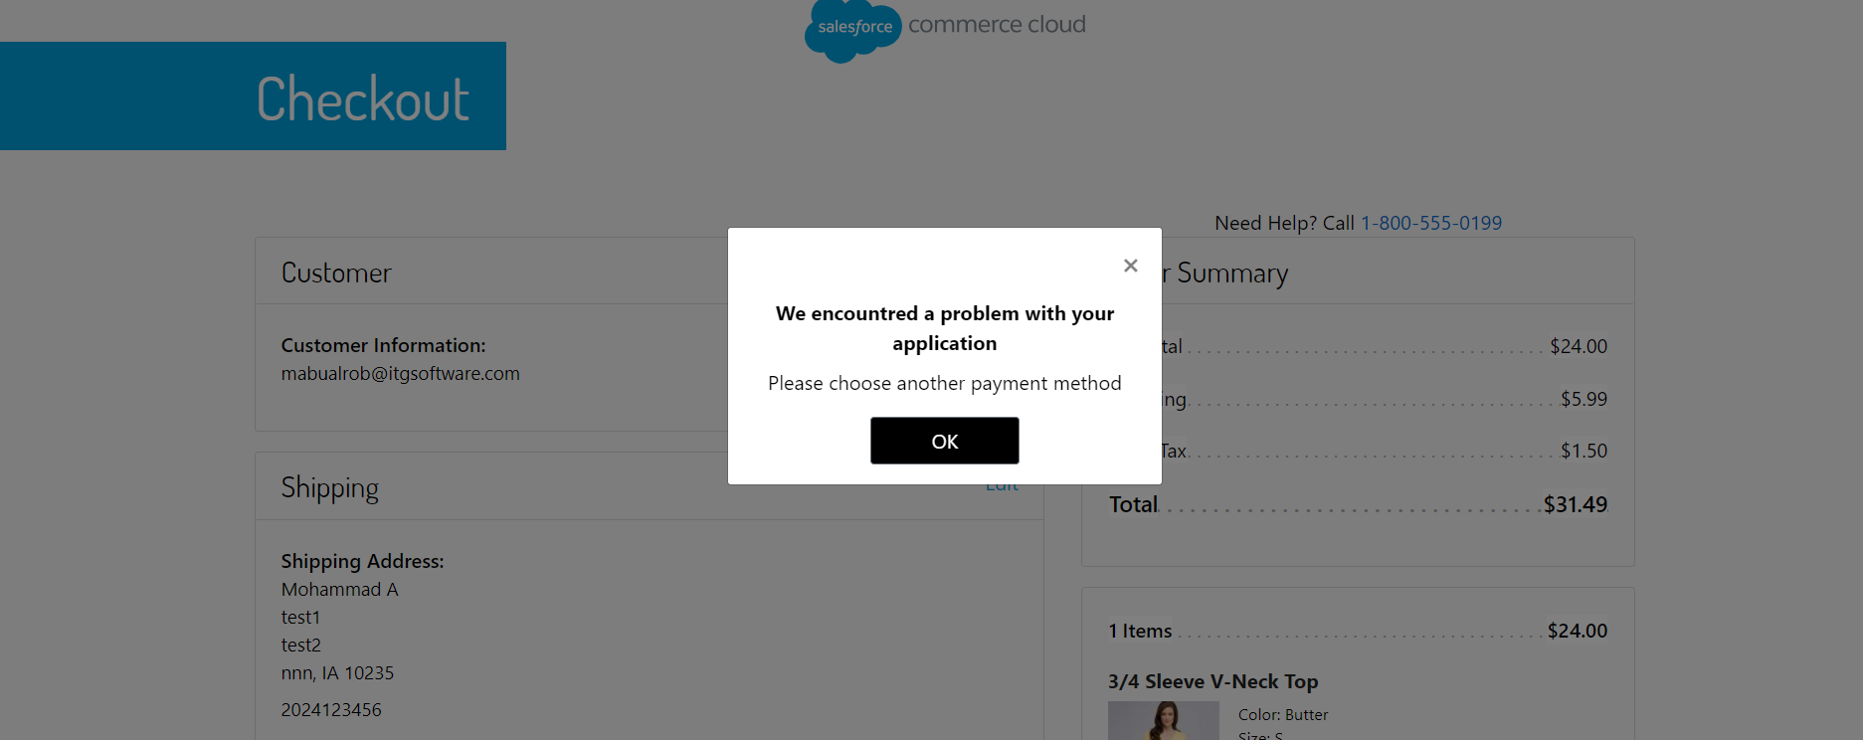

Order Status  
After the payment is approved, a new order will be created with a “NEW” status

# Remaining open items

* The payment process will fail and the customer will be redirected to the checkout page if the user requests a loan less than the minimum purchase.
* The customer may face some issues when the merchant selects a value other than the “TransferCard” in “Completion Method” at system configuration.