Here's a summary of your requested changes:

1. There is no error measurement for ETS model, but there is for ARIMA model and it can be measured using MSE metric. ETS is used to break any time series into 3 components. let me explain: we have a time series, so we apply ETS model and we get trend, seasonal and error data. Then we model each component separately. Then we combine the results from each component and reconstruct the predicted time series.

If you run all the cells of jupyter notebook i provided, you will see something like this:

In this image, you can see we selected the best arima model with the lowest MSE error for best accuracy.

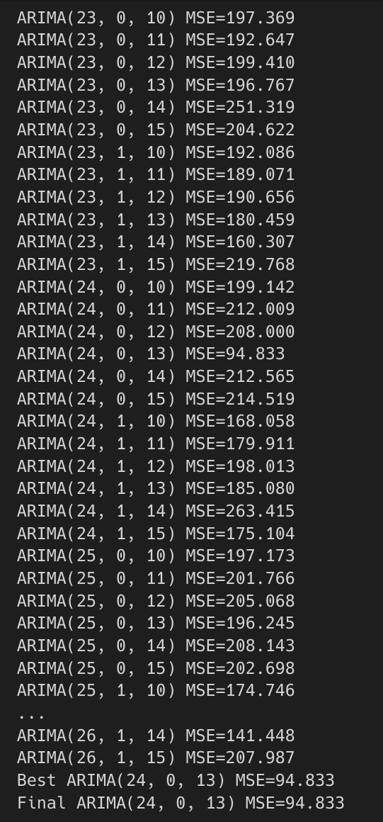

2. I have added the code to check the stationarity of the seasonal training data. Please check the updated notebook. And see the image below:

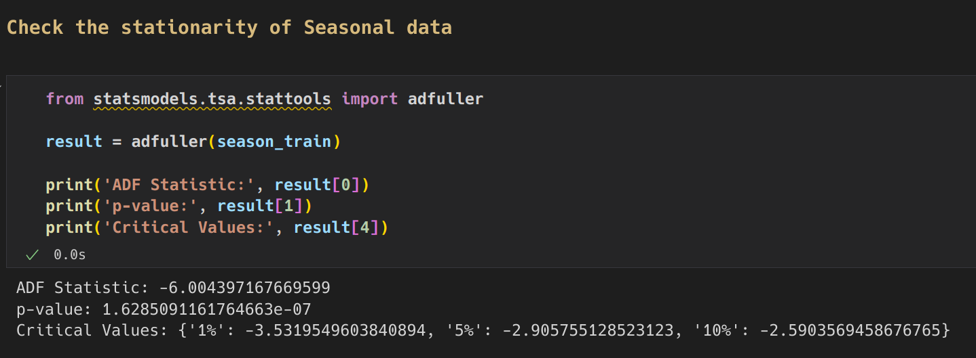

3. After applying the ETS model to the given dataset. We will model the trend, seasons and error separately. For each component we will develop one Arima model each for a total of 3 models and using hyper-parameter tuning we will select the best model which has lowest MSE error. Please check my jupyter notebook to see something like this:

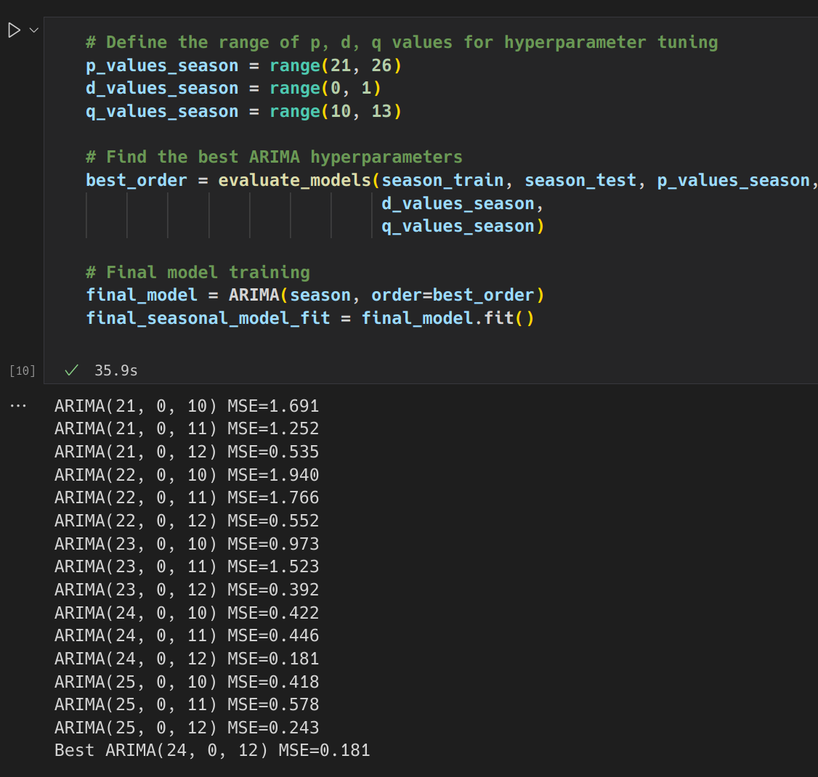4. Yes, there is only one image for ETS model. This model is only used to breakdown a time series into Trend, Season and Residue time series. After that ARIMA model is developed.

5. If you run all the cells of my jupyter notebook, you can see the results of hyper-parameter-tuning. It will look like the image below:

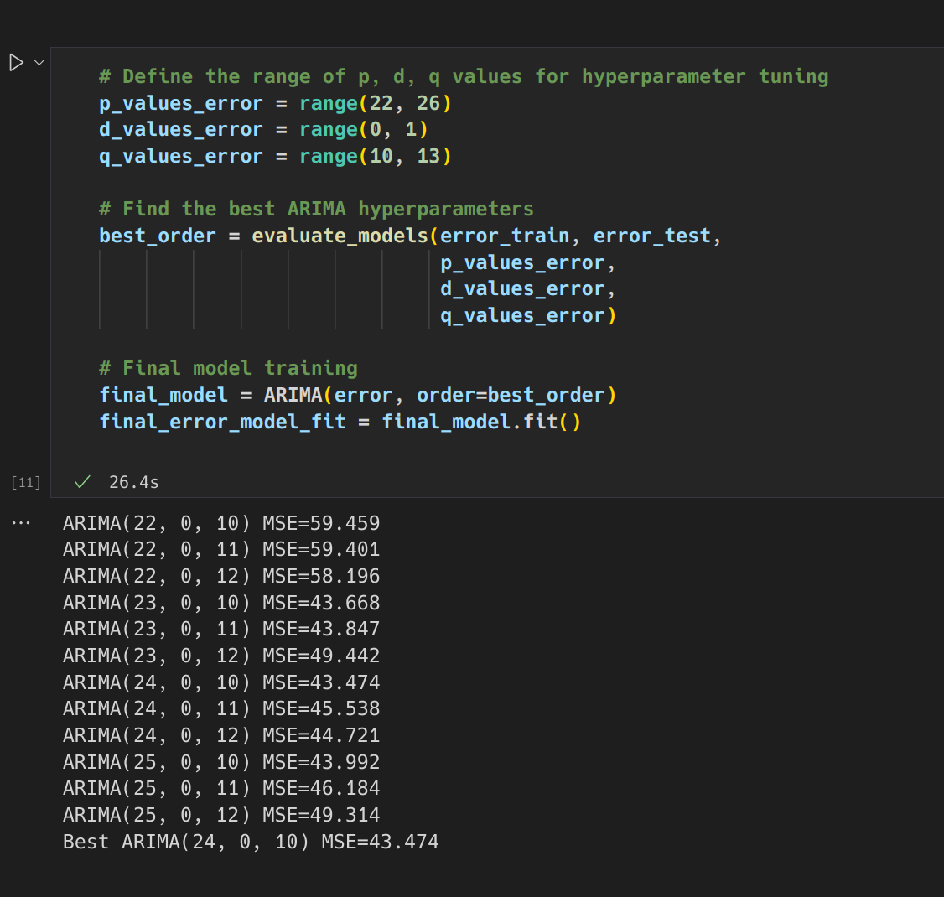6. Ratio of training vs test data is 80:20. You can verify in the notebook I have provided. Please check. It will look like this:

