A

Project-I Report On

Android Application for Waste food Management and Donation Submitted in partial fulfilment of the requirements for the award of degree of **Bachelor of Technology**

in

# Computer Engineering

by

# Jigar (20001016023)

under the supervision of

# Dr. Preeti Sethi



**Department of Computer Engineering**

**J. C. BOSE UNIVERSITY OF SCIENCE & TECHNOLOGY, YMCA FARIDABAD-121006**

**TABLE OF CONTENT TABLE OF CONTENTS**

CANDIDATE’S DECLARATION 2

CERTIFICATE 3

CHAPTER 1: INTRODUCTION

* 1. Introduction 5
  2. Basic Terminology 6
  3. Motivation & Problem Statement 7
  4. Objectives and Scope 8

CHAPTER 2: LITERATURE REVIEW 9

CHAPTER 3: DESCRIPTION & METHODOLOGY 10-12

CHAPTER 4: SOFTWARE AND HARDWARE REQUIREMENTS 13

CHAPTER 5: RESULTS (SCREENSHOTS) 14-37

CHAPTER 6: CONCLUSION 38

**CHAPTER 1: INTRODUCTION**

## Introduction

Access to good food is necessary in today’s world for survival;Food that contains good amount of nutritions and good amount of fibre. Our country has a population of about 138 crores and everyone is not in a proper position , to achieve that state of nutrition in their daily food.According to the NFHS -5 the percentage of stunted child is 35.5% and that of underweight is 32.1% .This shows the level of malnutrition that is prevailing currently in this country.This conundrum worsens when this child, who is the prey of this dreary malnutrition, get caught by some fatal disease.In this case chances of survival of this child are much less than those who have got proper nutrition.

Moreover, every age group of individual is likely to be in a predicament when caught when they are carrying the tag of malnutrition.A proper addressing to this problem should have to done to contribute towards reducing this percentage of malnutrition to as low as possible and in the best case completely purge out our country from this gloomy problem.To achieve this goal to purge

the mass out from the tenebrous malnutrition, we have created an application to solve the problem by moving this food from one place who has its excess to the other place who has deficit. Our application creates a link between the restaurants, party halls and all those places where their is surplus of food and the NGO’s who are dedicated towards helping people, by providing good food supplies to them.The application has an interactive interface for live messaging so that these people who have excess food supplies could inform these NGO’s about this and these NGO’s could take appropriate steps to fetch the food supplies from these places.It allows only the NGO’s to shown

in the application’s page ,who are verified by the administrator of this application.So, it provides a simple one to one messaging feature for having conversations in realtime.

## Basic Terminology

**Firebase -** It is an Backend-as-a-service it provide developers variety of tools with which they can build good quality apps .Their services include Firebase Authentication, Firebase Realtime Database and Firebase Storage.Firebase authentication can be used to authenticate the validity of user by several means ,some of them are Google account authentication, Github account authentication,Phone Number authentication and Twitter account authentication.By authenticating the client or user we can get some data, if available, related to that account and when the user is authenticated they are given unique id’s which can be used to refer to their data.Firebase Realtime Database is a very helpful service by which we can change the data in the devices in the realtime, also the data incoming from the devices can be stored and changes can be made to other devices.

Firebase Storage can be used to store the relevant data of the user like photo which can be saved in realtime database by converting that into a web link.

**Glide Library**- It is a Library which can be used to Load image efficiently in our application. **CircleImageView Library**- It is Library that is used to get a circular image View instead of a conventional rectangular Image View.

**Recycler View** - A better way to implement a group of view ,which we can to scroll, better than List View.

**Bottom Navigation View**- It is used to move within a application by clicking on the items of the bottom navigation View.

**Fragments** - Fragments can be replaced on clicking an item of the bottom navigation View by the help of Fragment manager.

## Problem Statement and Motivation

We have seen around us how the food is being wasted in weddings at an enormous amount and at the same time there are those people also who might not have ate anything on that day. This is certainly a big contrast that one has excess of food and the other has deficit.According to the

NFHS-5 the percentage of stunted child is 35.5% and that of underweight is 32.1% .This shows the level of malnutrition that is prevailing currently in this country.This conundrum worsens when this child, who is the prey of this dreary malnutrition, get caught by some fatal disease.In this case chances of survival of this child are much less than those who have got proper nutrition. A proper addressing to this problem should have to done to contribute towards reducing this percentage of malnutrition to as low as possible and in the best case completely purge out our country from this gloomy problem.Moreover, there are NGO’s who are working in the direction providing the needy one’s adequate food supplies and if there can be a continuous direct link between these NGO’s and the people who are with excess supplies of food. Then there will be an efficient network which would help to overcome the problem of malnutrition. Also, an UN report says that even after the surplus production of food 190 million people in India are Undernourished and the total food waste is estimated to be around. Approximately 84.7% of the total food waste find their places in the dustbin and the remaining percentage and of the wasted food in the dustbin ,a significant proportion of the that was still edible . India is at 103rd place in the Global Hunger Index.

## Objective and Scope

To achieve this goal to purge the mass out from the tenebrous malnutrition, we have created an application to solve the problem by moving this food from one place who has its excess to the other place who has deficit. Our application creates a link between the restaurants, party halls and all those places where their is surplus of food and the NGO’s who are dedicated towards helping people, by providing good food supplies to them.The application has an interactive interface for live messaging so that these people who have excess food supplies could inform these NGO’s about this and these NGO’s could take appropriate steps to fetch the food supplies from these places.It allows only the NGO’s to shown in the application’s page ,who are verified by the administrator of this application.So, it provides a simple one to one messaging feature for having conversations in realtime.The major objectives of this application is to continuous direct link between these NGO’s and the people with excess supplies of food. There is an immense scope if improvement in the area resource distribution that can be made since larger amount of food is being going to bin than to the stomach of the needy.

**CHAPTER 2: LITERATURE REVIEW**

Layout can be created in xml in android studio which can used as UI for the application.also there are other frontend tools like colours.xml to add different colours for their use in application. strings.xml can be used to store the Strings values and by just giving their reference in other xml files they can be fetched.ImageView are used to display image. Vector and Image assets can also be used with the ImageView.AlertDialogBox are created with three buttons positive, negative and neutral.onClickListener can be used to handle the clicks.Different fragments can be used to display different FrameLayout by handling the click int the Bottom navigation items.which are created with the help of resource type menu.Recycler View is an efficient way of displaying similar viewGroup or View with a Scrolling or repeating pattern.Intent can be used to take a value from one activity to another.Layout inflater can be used to inflate a view model Firebase is an effective tool which can be used to build good quality applications.Firebase Authentication is used to authenticate the user by any means be it by Phone ,or by any account like Google account, twitter account and Github account.Every user is given an unique UID which can be used for individually separating the data of each user in the database.Firebase Realtime Database is used to change the state of messages in the RecyclerView in the realtime when a message is sent or received.Firebase Storage is used store files.It can also be used effectively to store photos of user, which can then be converted into links and saved in the realtime database.

## References

Google.(n.d).Documentation for app developers.https://developer.android.com/docs Google.(n.d).Firebase Documentation.https://firebase.google.com/docs

**CHAPTER 3: DESCRIPTION AND METHODOLOGY**

* 1. **PHASE-I**

When the project was started, it was kept in mind that it should have a proper layout .So, in the First Phase we created an activity named MainActivity,Three fragments for holding different View Groups.First Fragment whose item name in menu is home consists of a RecyclerView ,the second fragment whose item name in menu is community consists of a Recycler view and the Third Fragment whose item name in menu is profile.which is empty.Finally we added an SplashScreen as an activity with a delay time of 2400 ms.which will lead to Main Activity.

* 1. **PHASE-II**

In second Phase of the project we mainly worked with the firebase.First of all we created an activity for signing in then we added Login Text View at the Top with two other text views with title

,name and Phone Number and two edit texts to fill in the information of the user.This is followed by a Login Button.We previously also had Google SignIn method for signing in the user. However ,we removed it later on since we have to create assemble user data according to the Phone Number and every Google Account need not to have a Phone Number. When the user sign in using his phone number and when he clicks on the login button then the visibility of all the Views currently appearing will be gone and Views whose visibility was set to be gone become visible which includes verify ,EditText for OTP and back button .Toasts are also provided for better interaction with the user .The user’s data which user fills is saved in the realtime database as soon as the verification is completed.Then there is menu item which has an icon of logout in the mainActivity whose show as action is set to always, clicking which a dialog box appears to confirm the user if we

wants to logout. We also added an vector asset to an ImageView in the First Fragment.We connected our application with the realtime database and realtime Storage.We added View Model to

the Recycler view of the First Fragment which consists of a circle Image view and two textViews to view each of the added contact.In the third fragment we added two text Views with title, name and Phone number and simple Spinner which describes the role of the user.Also we have an image View in the Third Fragment in which user can upload his photo.Also there are two text views to tell about the aim of the application. Moreover, there is a save button which saves the profile photo, name and the role of the user which is displayed ,in front of the textviews namely name and phone

number ,respective edit texts are present which displays the current status of phone number and name.The fillip of the second fragment will be done when the acceptor (NGO’s) joins each ego will be displayed with their phone number name and other details and a list will be displayed in the form of the recycler View.When we press the add button a new activity which was created namely addContact will open which have a text View displaying “add your contact here” .Two edit texts for filling the name and phone number of the new contact.Also there is a save Button clicking which,

A new node is created as a child of the phone number of the user.The name and phone number of the new contact will be created as a child of the new contact phone number, which is itself a child of the user phone number.As soon as the contact is added, it will be displayed in the first fragment containing all the contacts since and onDataChange method is called which notifies whenever a new Child is added to the user’s contact.So, finally when we click on any contact’s information an intent will be passed onto the new activity named chatDetail which which gets the value of the name and the phone number of the user and displays the name of the contact on the action bar .In the chatDetail Activity there is a recycler view which has a View model containing single text view of message. When the user send the message then in the Text view name will be displayed “You” and when the contact send some message then the name in text view which will be displayed is the

name which contact has initially saved while logging in.Finally there is a Block and unblock menu items. On clicking these the status of the user’s contact changes to ‘unblocked’ and ‘blocked’

respectively and when the contact is blocked. No further message will be received by the user from that contact.Thus also ensuring that no unnecessary messages will come.So, this is how we created our project to connect the donators of the food supplies to the acceptor of the food supplies.

**CHAPTER 4: HARDWARE AND SOFTWARE REQUIREMENTS**

Hardware and software requirements are a must for any project, to do the work efficiently and completely.Software and Hardware Requirements of this project are as follows:

# SOFTWARE REQUIREMENTS

* + 1. Android Studio
    2. Web Browser

# HARDWARE REQUIREMENTS

* + 1. A Computer
    2. Operating System- Windows 10 or higher
    3. 128GB Disk Space
    4. 4GB RAM
    5. Good Internet Connection

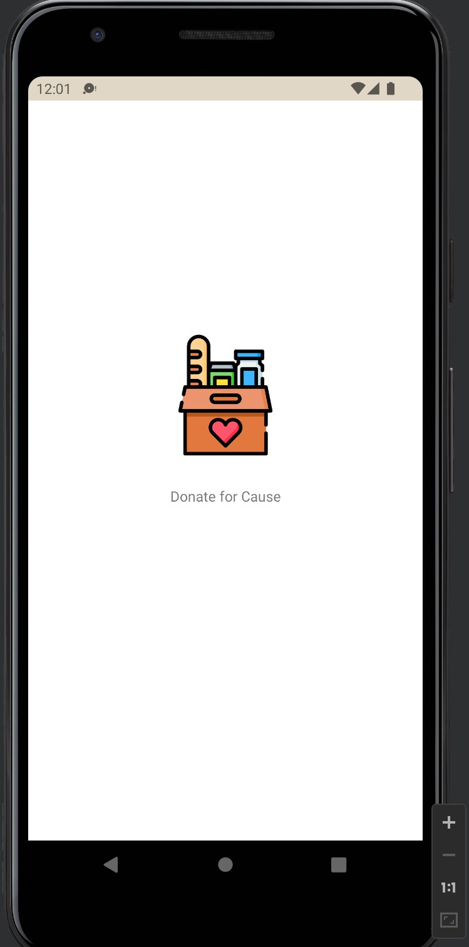**CHAPTER 4: RESULT**

**SplashScreen**

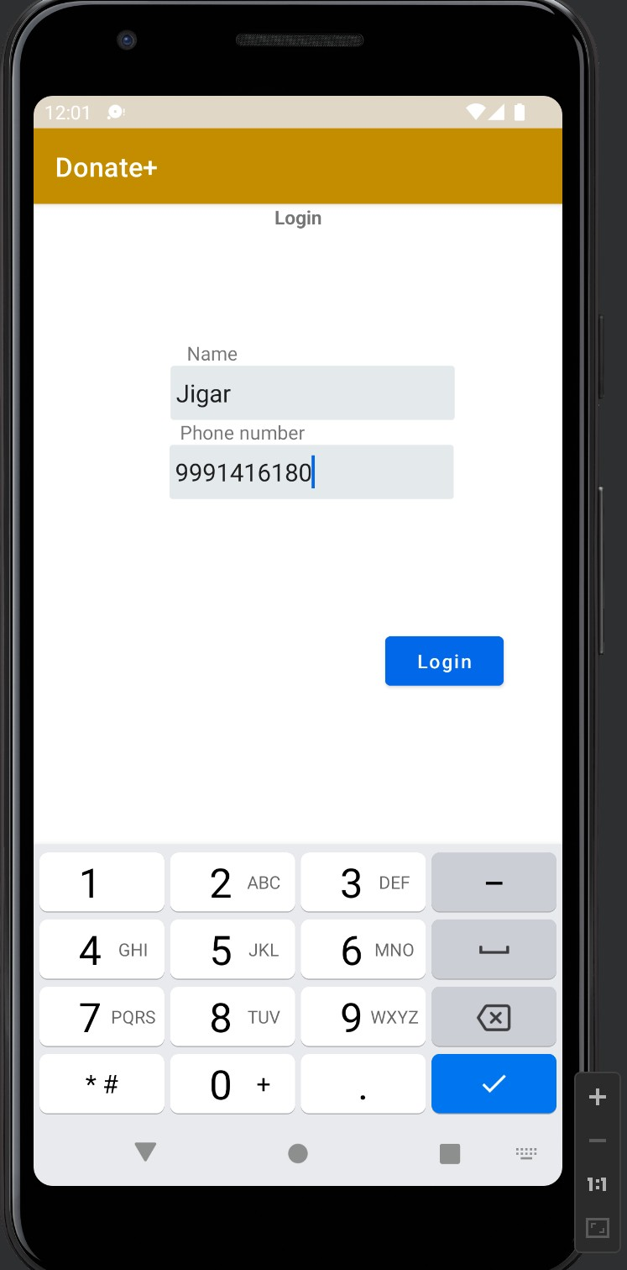**SignIn Activity**

**SignIn Activity**

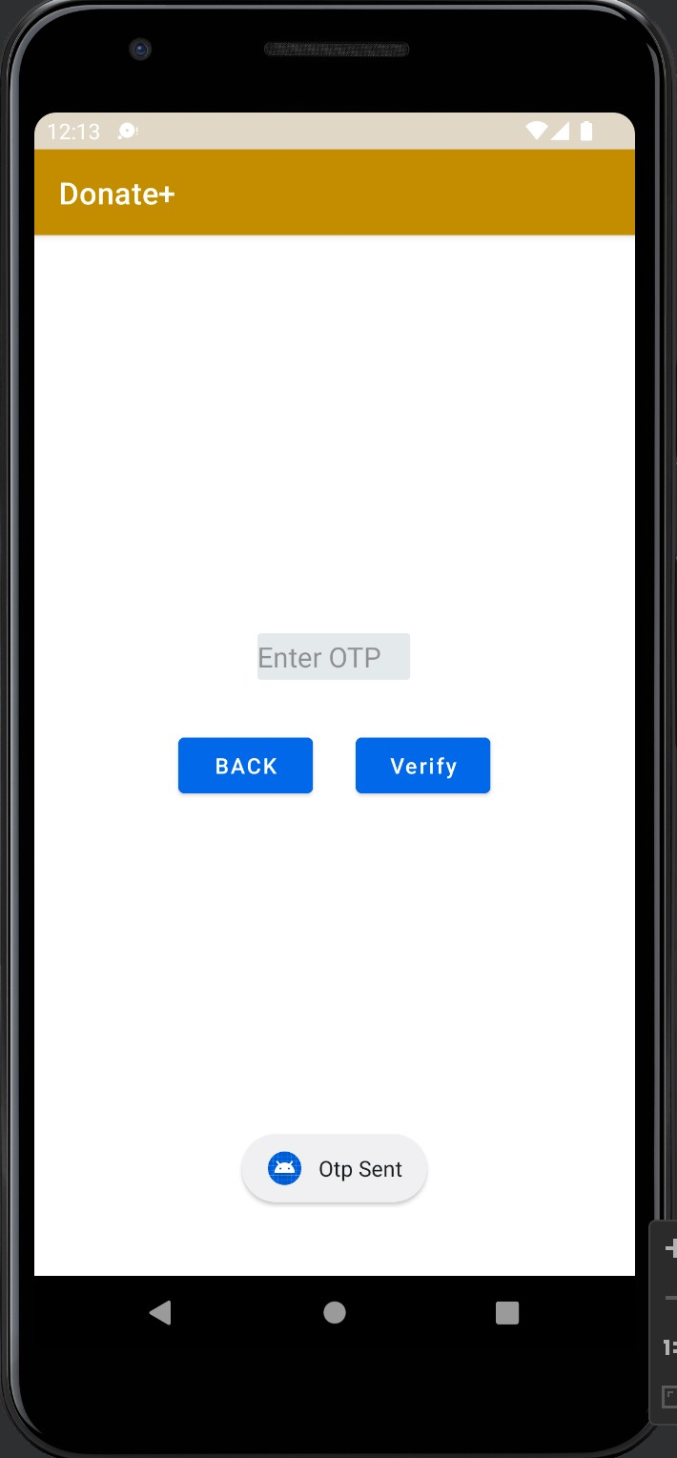**OTP Sent**

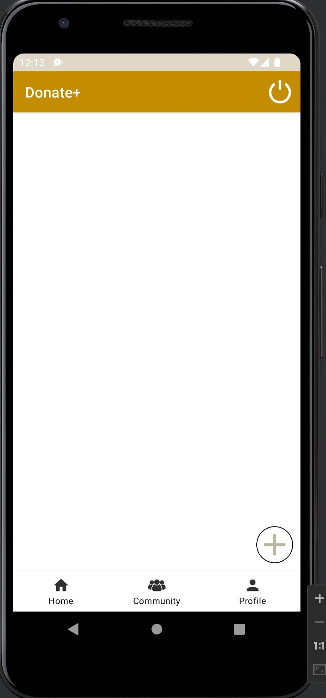**Main Activity**

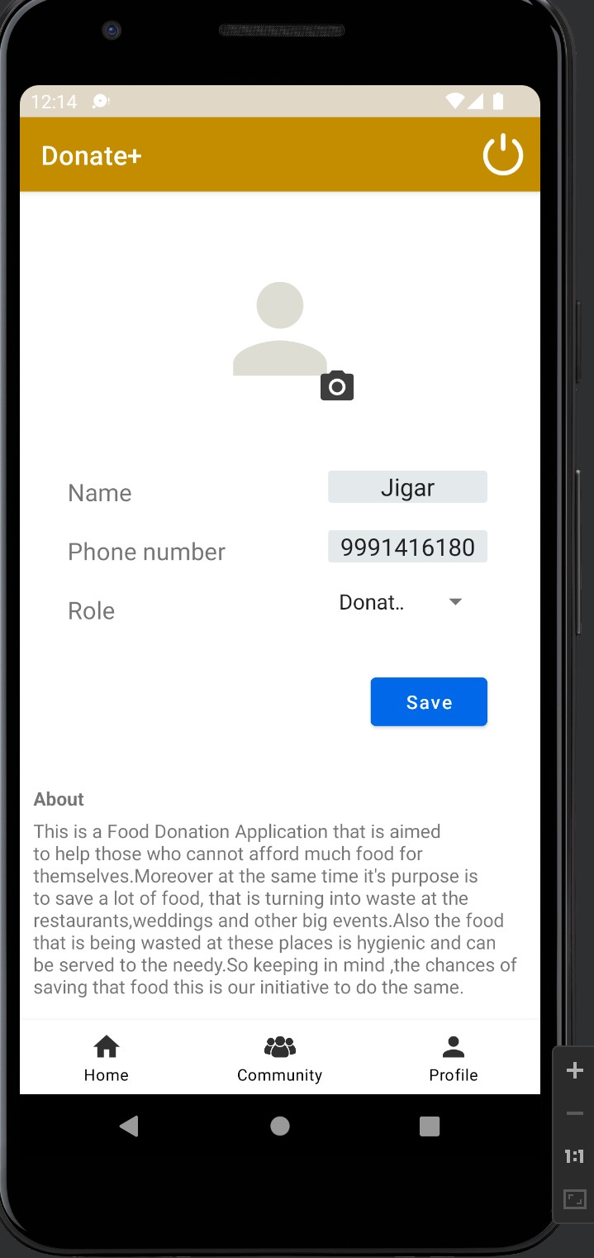**Profile**

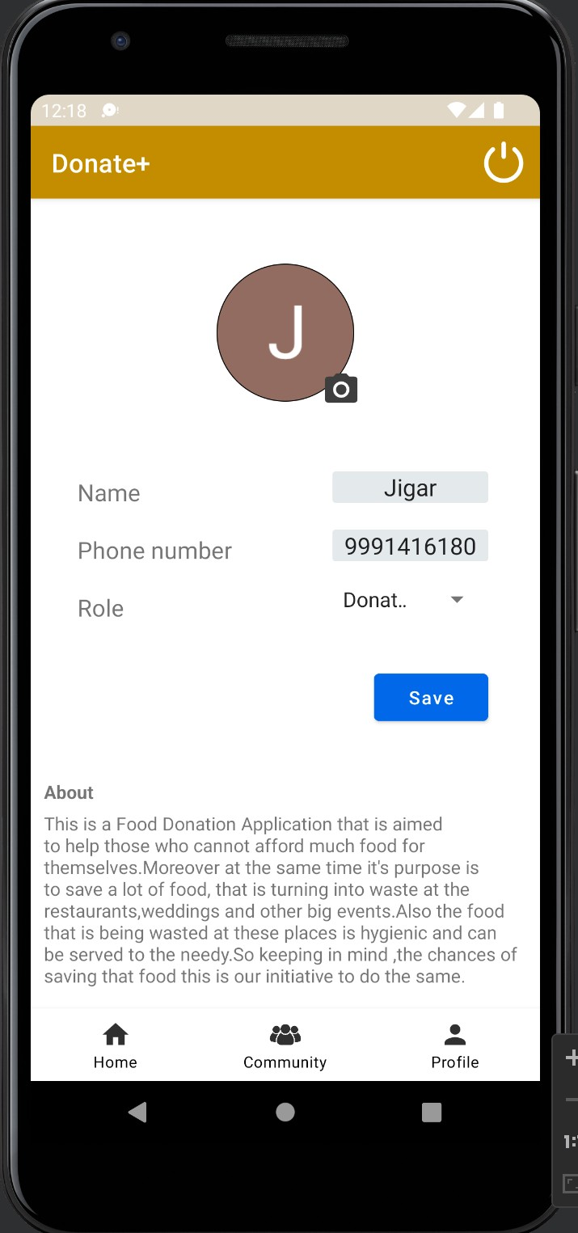**Profile Photo Updated**

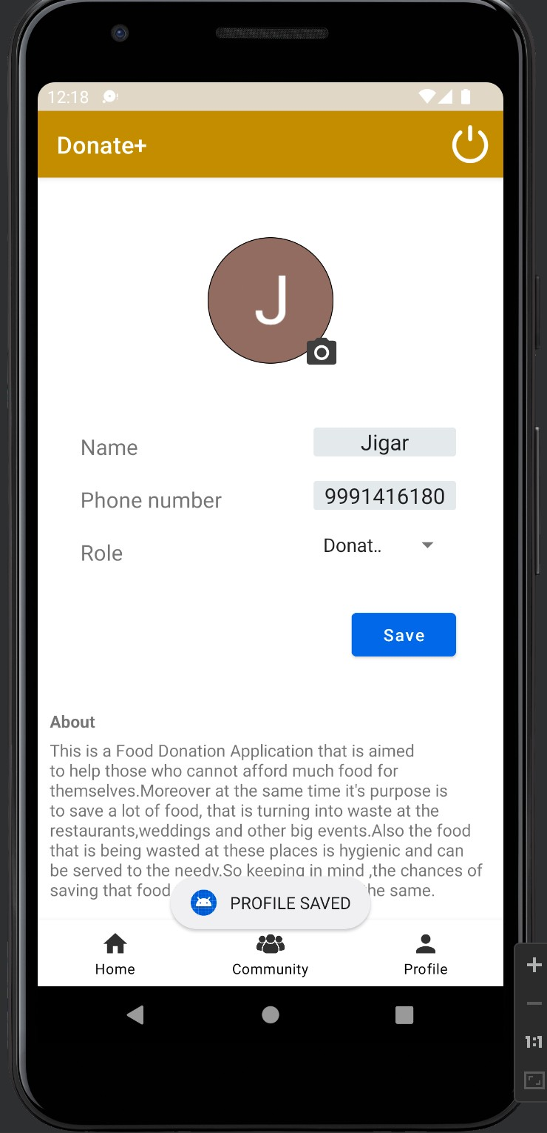**Profile Saved**

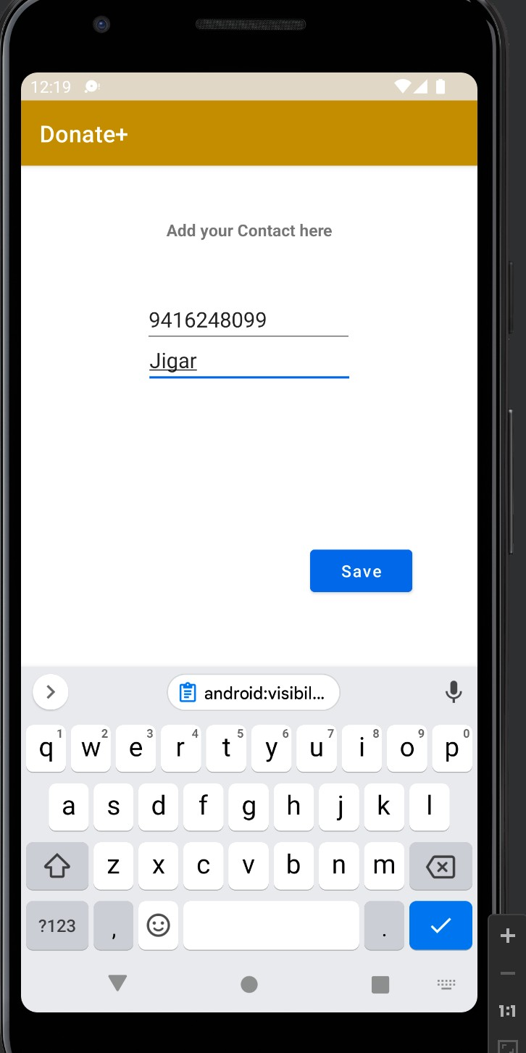**Adding new Contact**

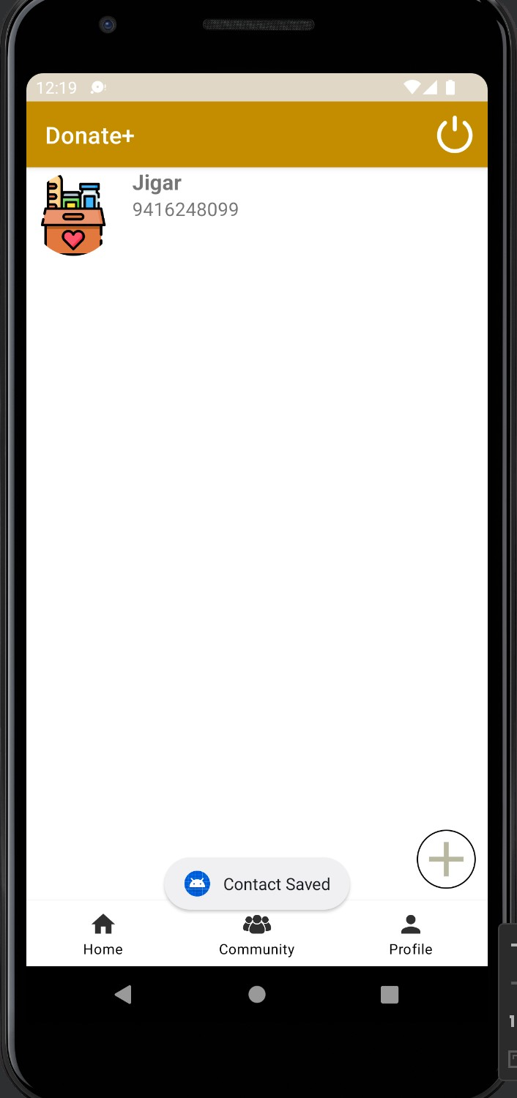**New Contact Saved**

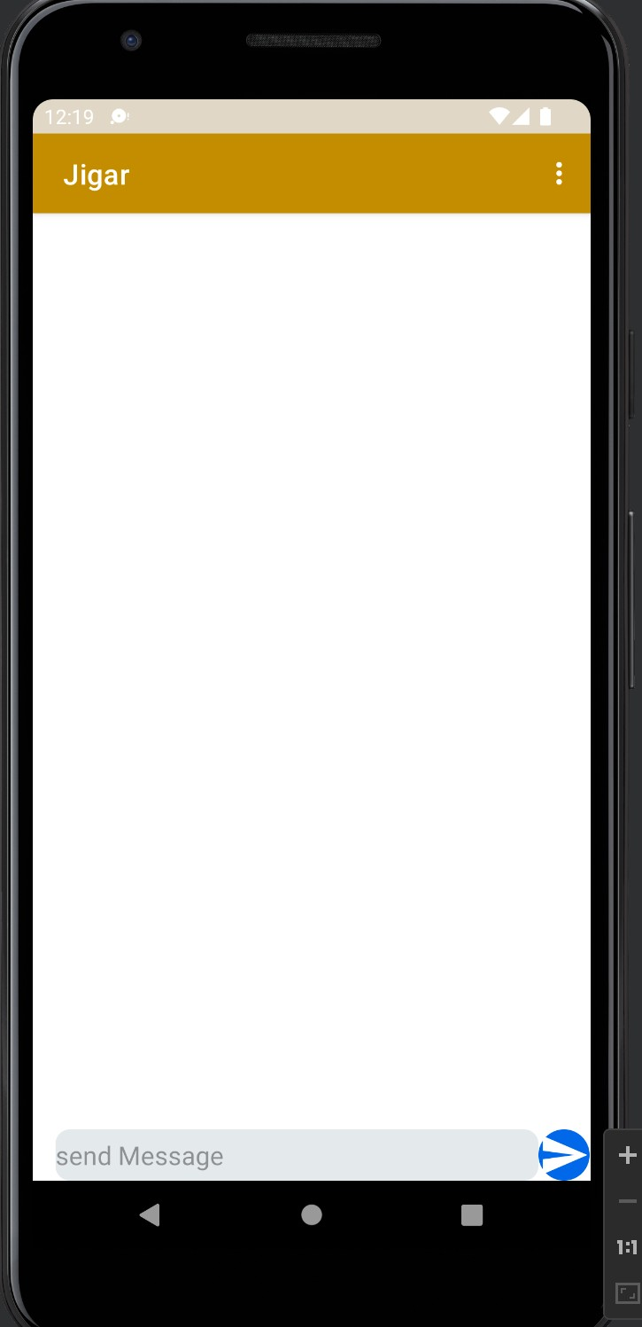**Chat Detail Activity**

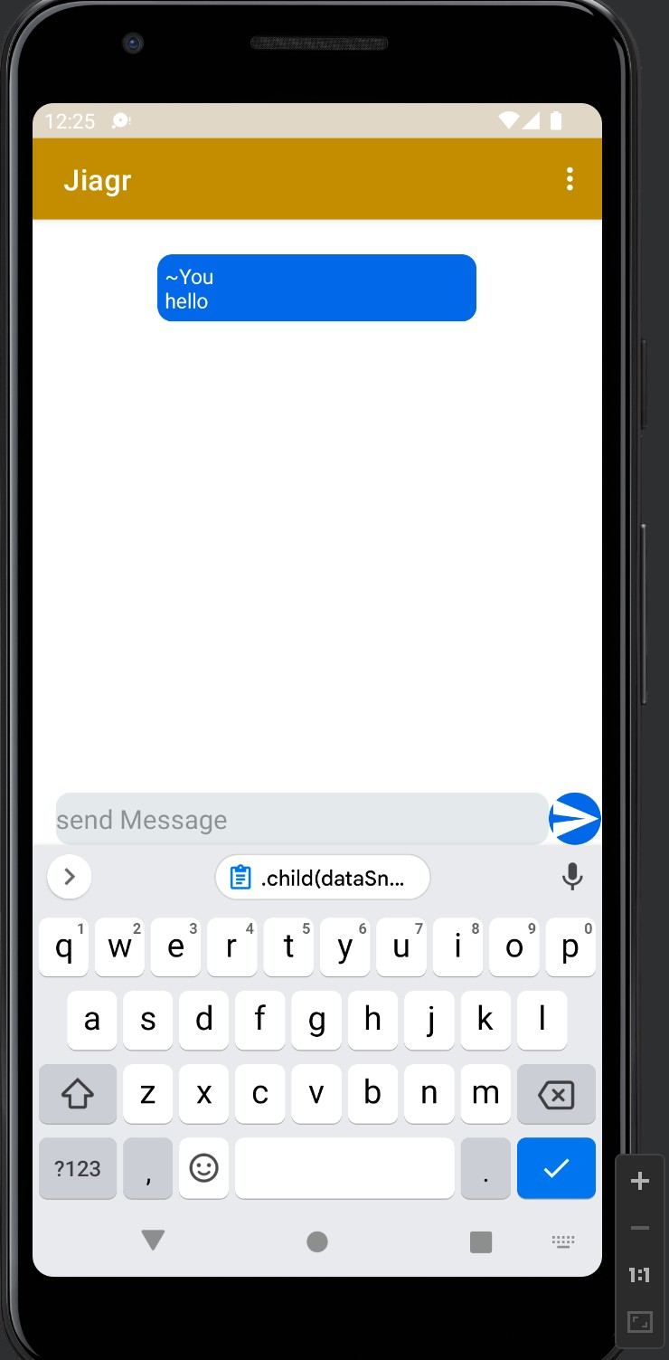**Message Sent**

**Changes made in Realtime Database when the new user was created and his Profile is saved**

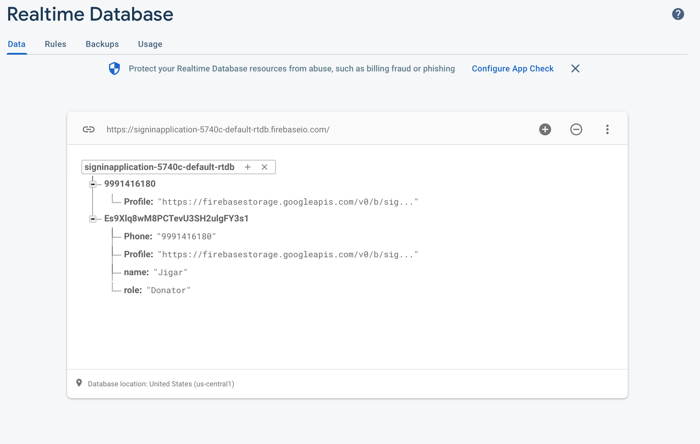

**When the message is sent it is reflected in both sender and receiver Messages**

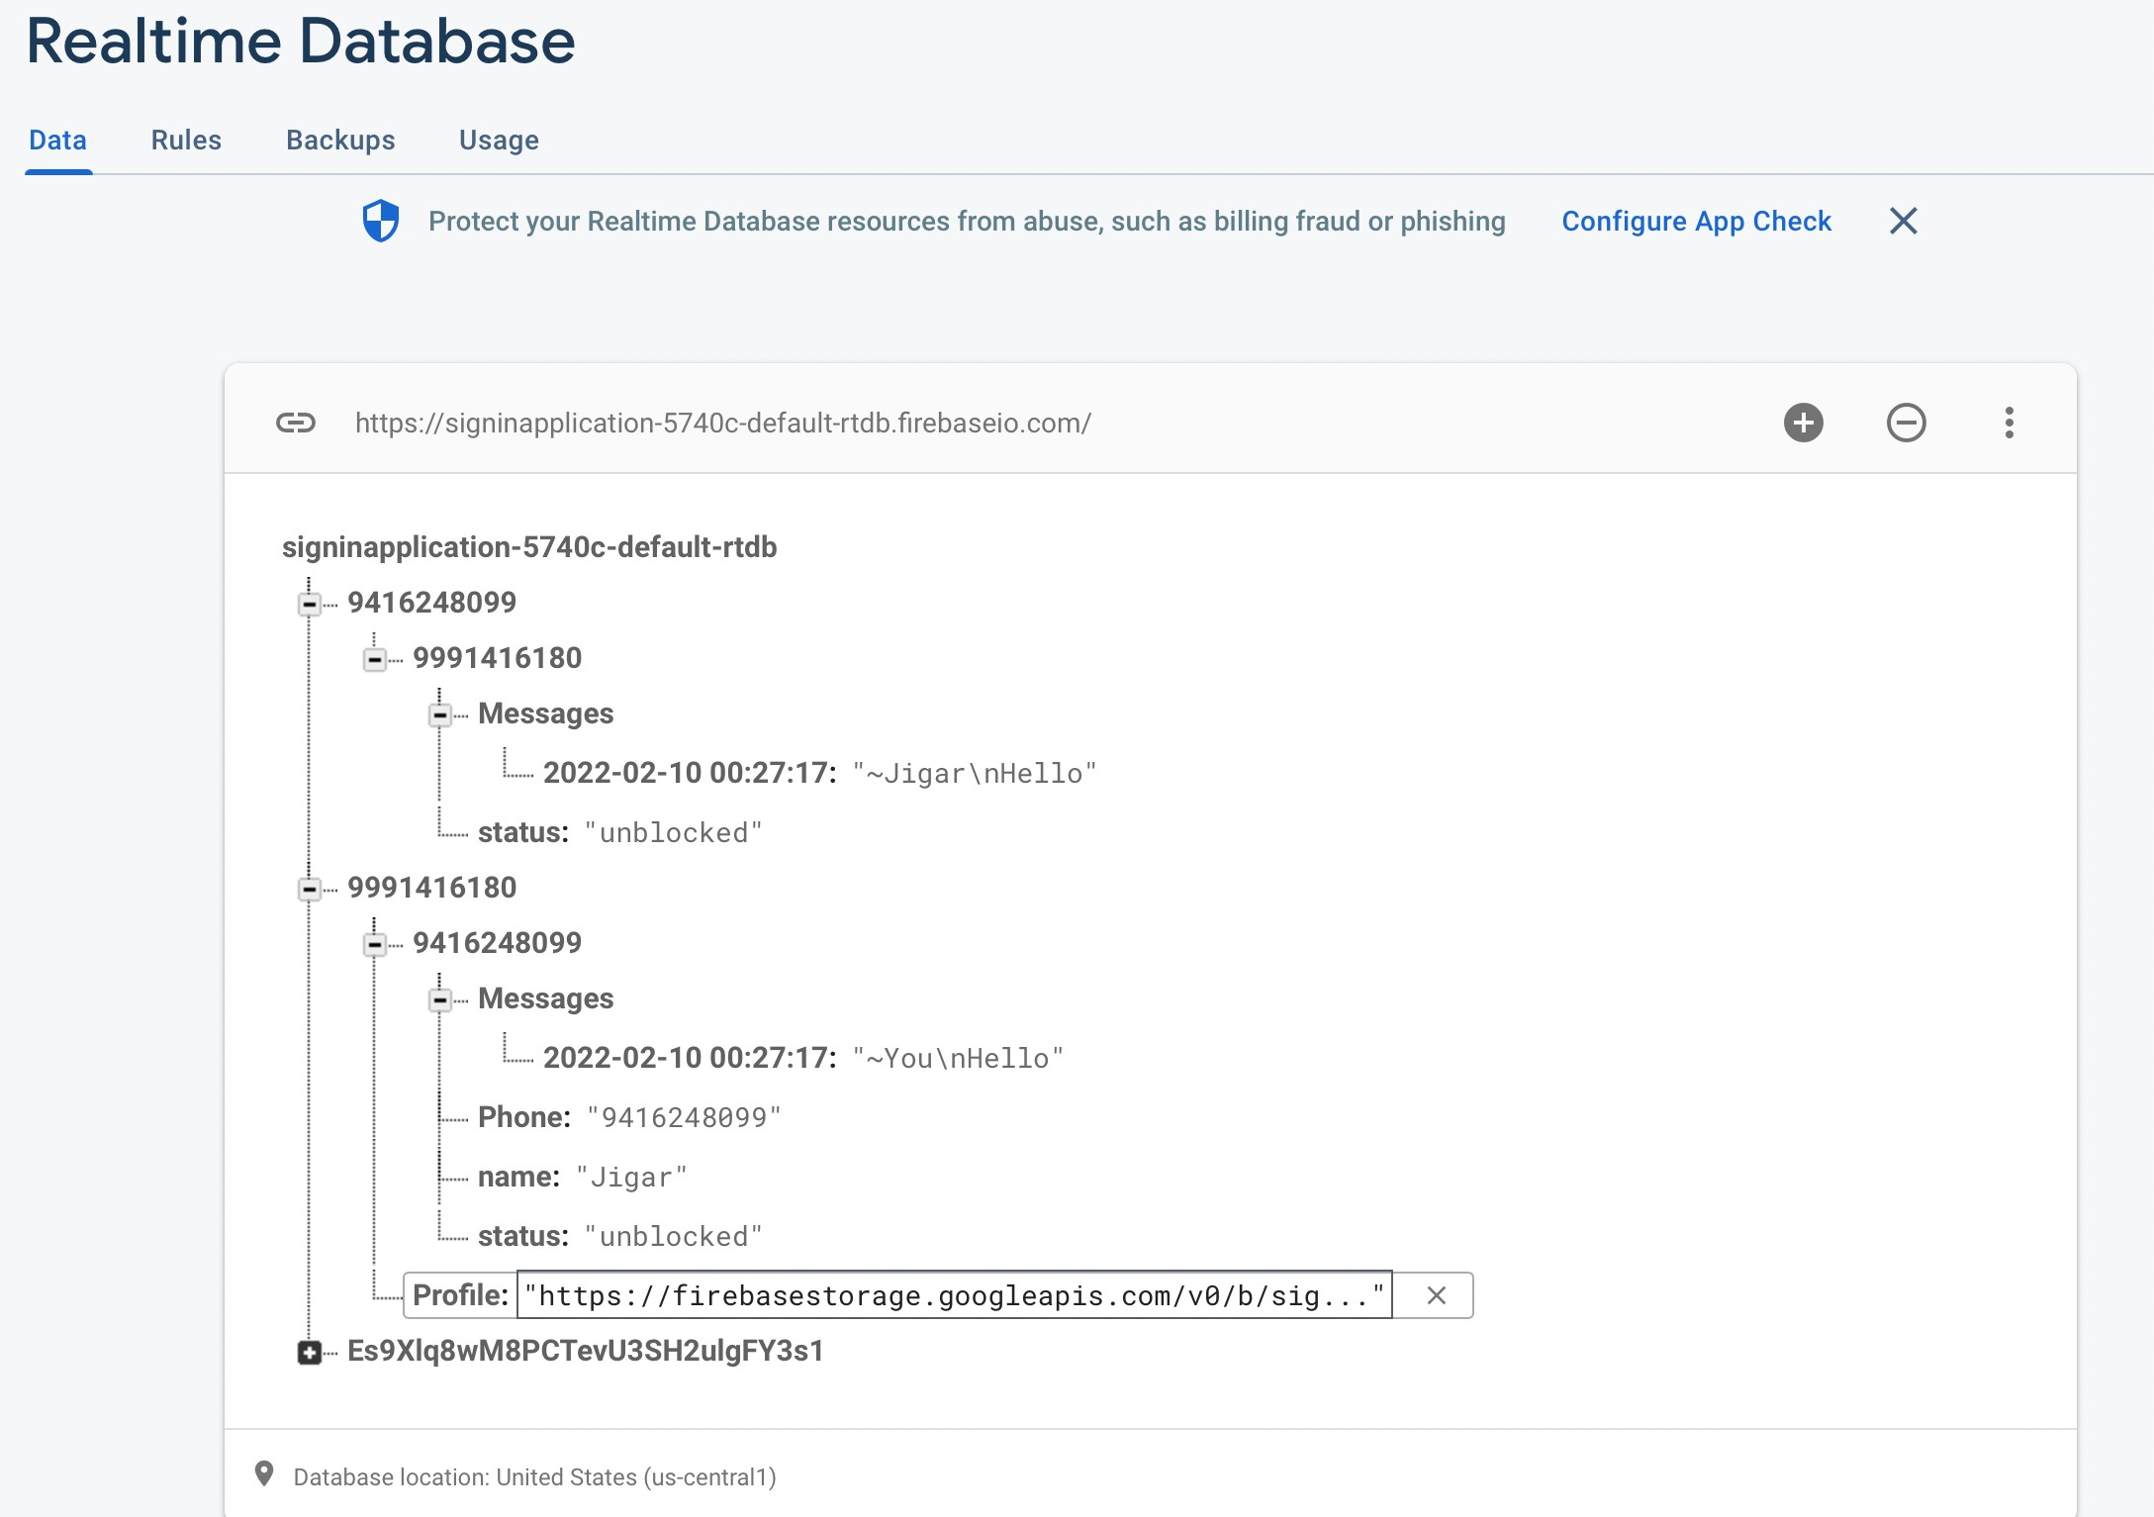

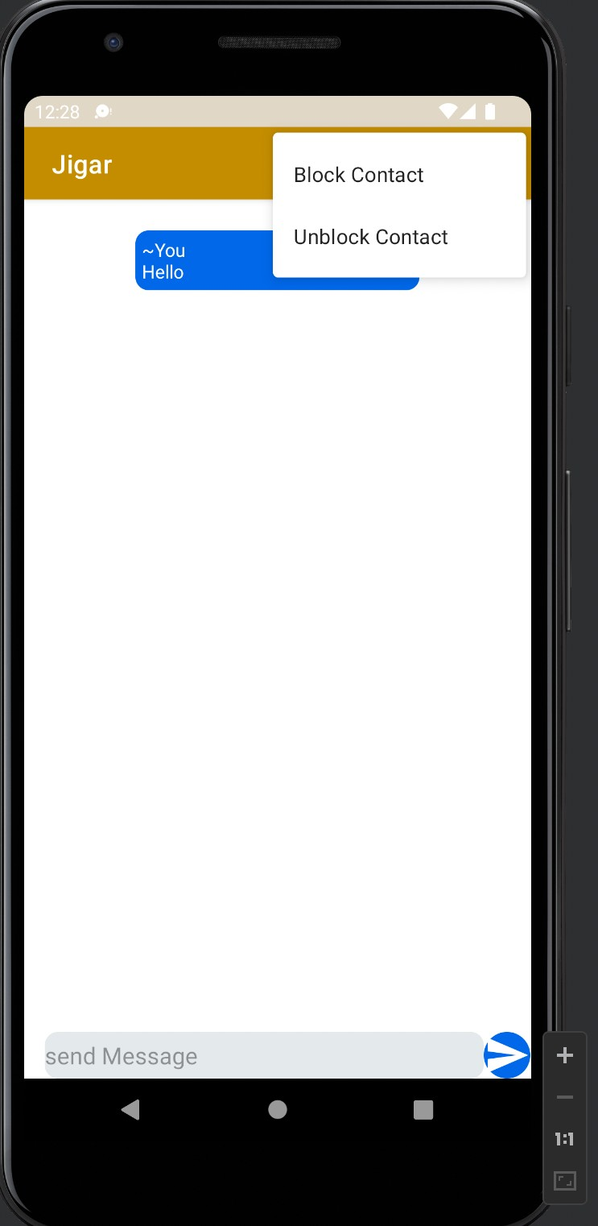**Menu items for Blocking or Unblocking**

**a Contact**

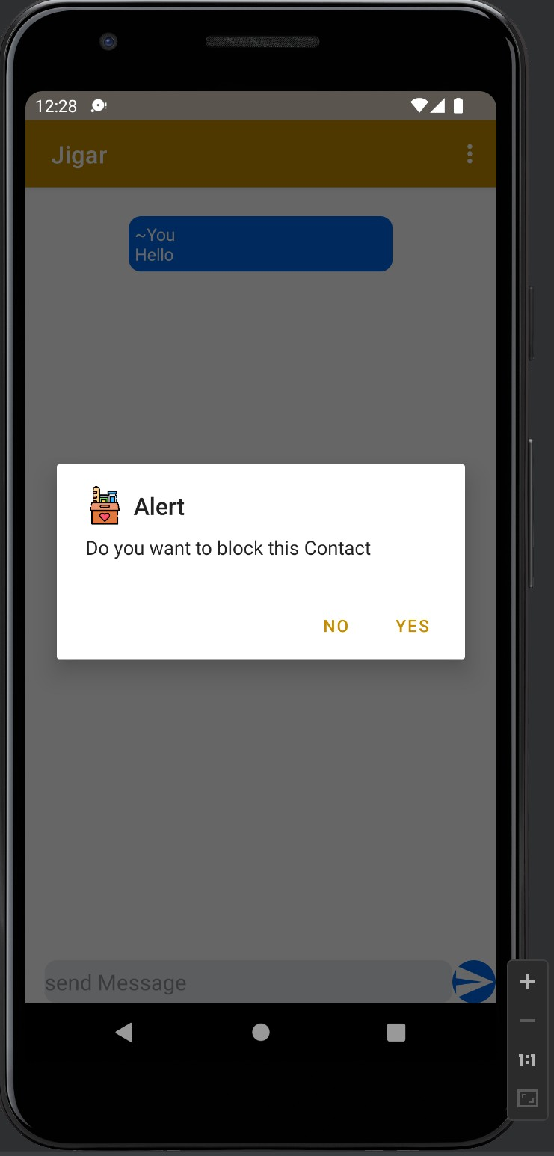**Alert Dialog Box When the user is Blocking someone**

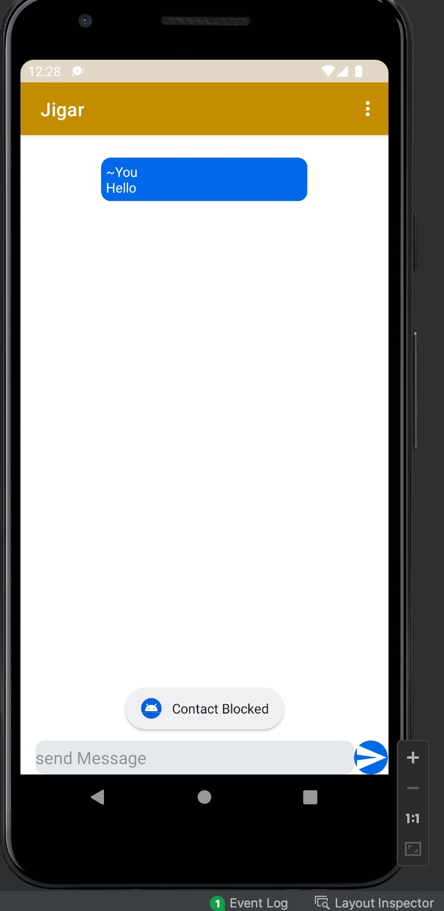**Message when The Contact is Blocked**

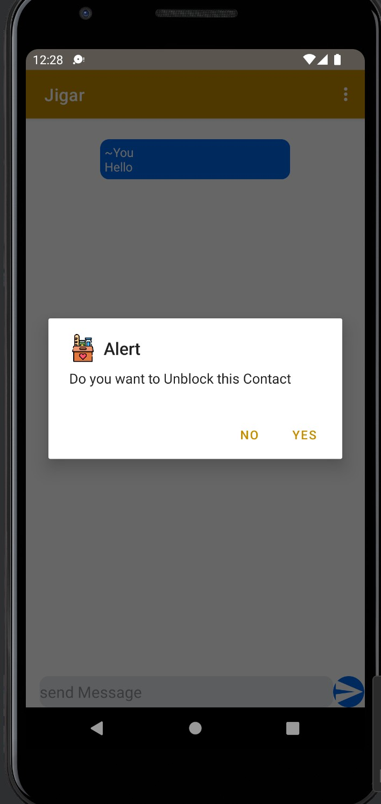**Alert Dialog box for unblocking**

**a Contact**

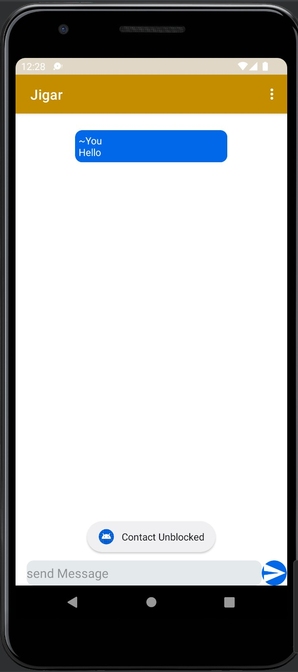**Message when the contact is unblocked**

**Changes are reflected in realtime database when the User Block the Contact**

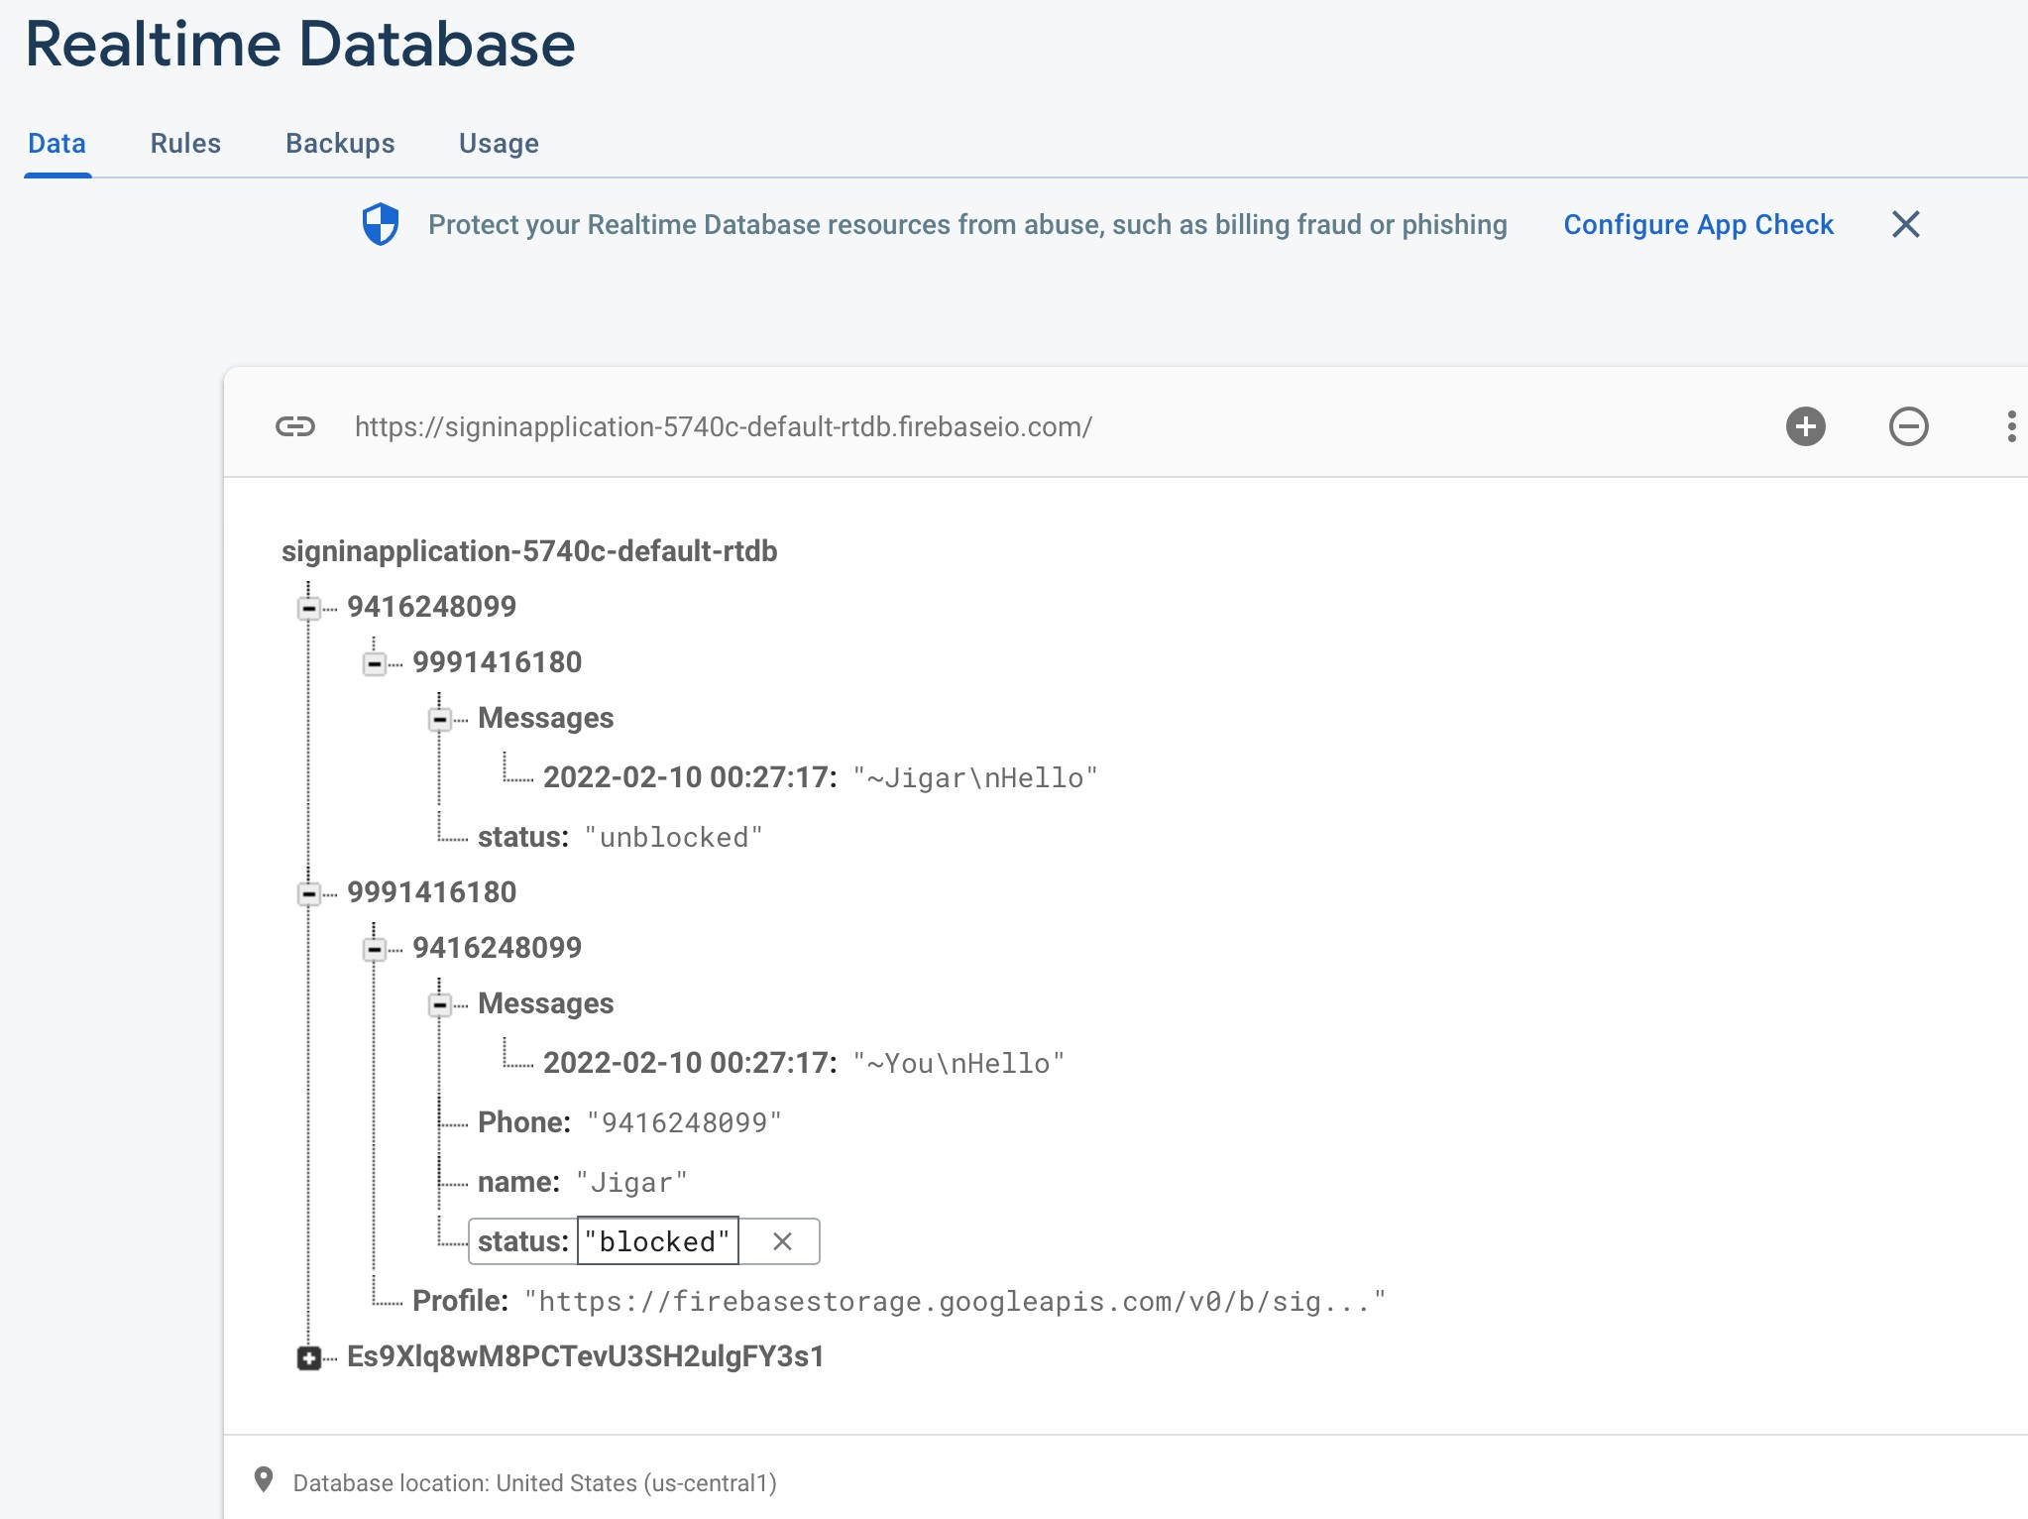

**When the Contact Blocks the user**

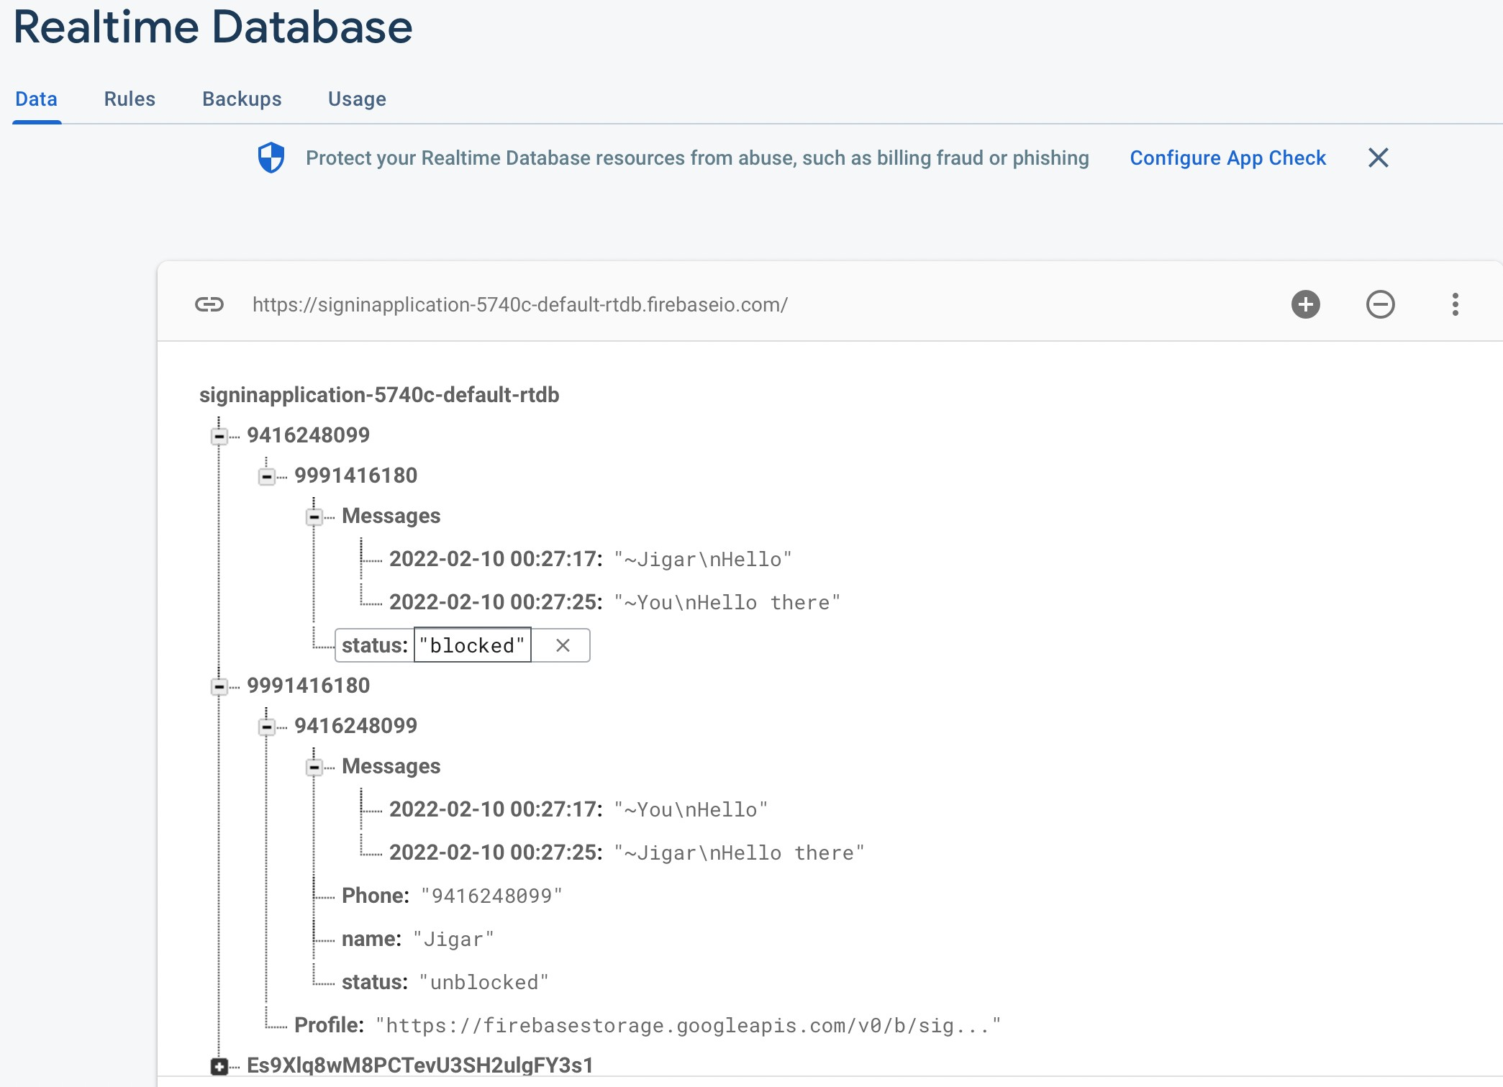

**When the contact block the user his messages are not being displayed int the Contact’s Messages**

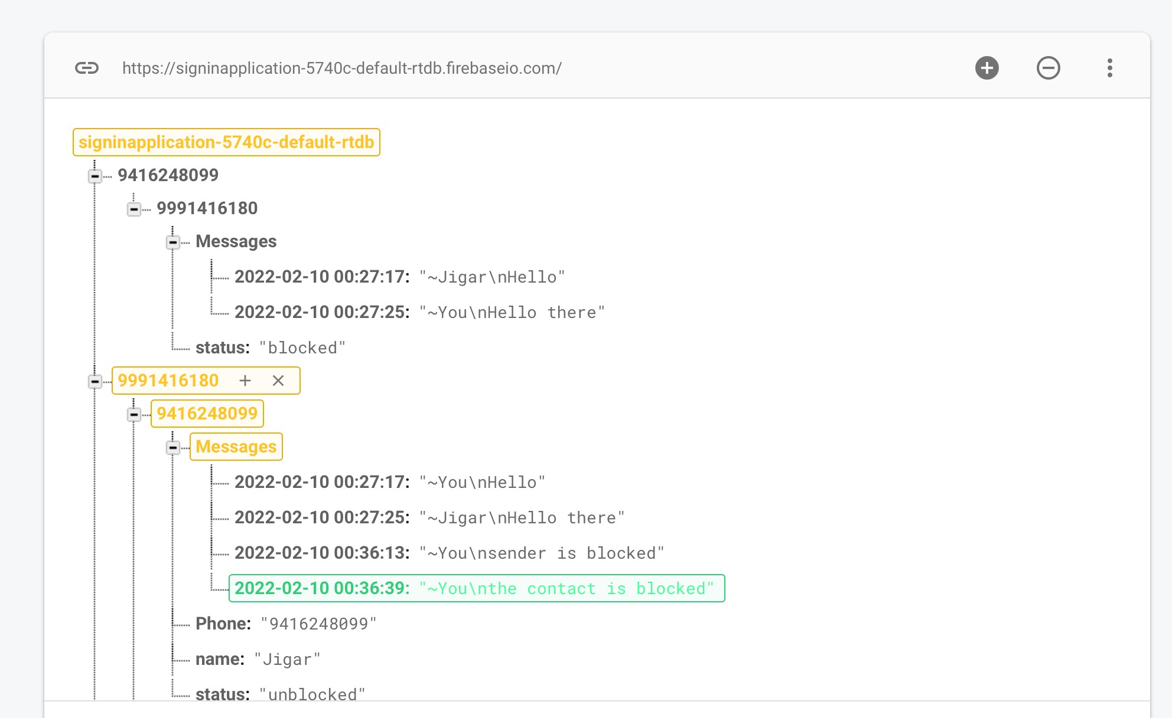

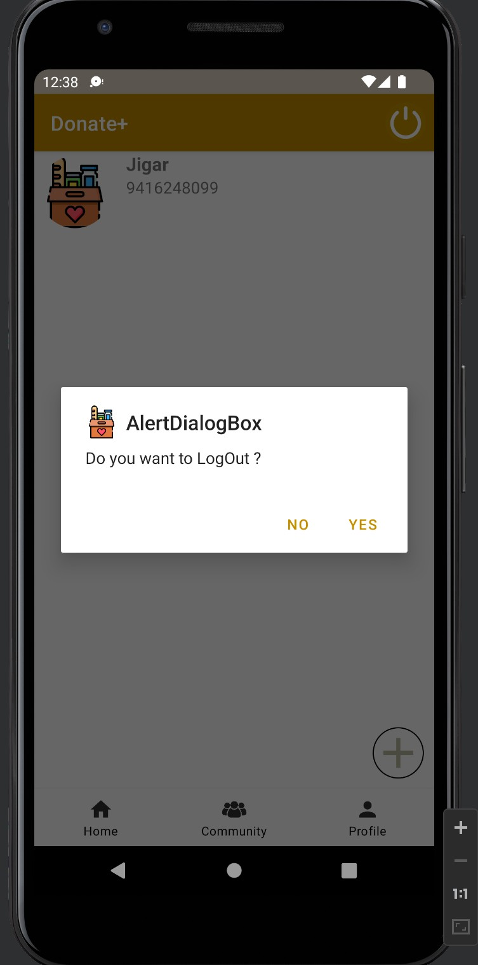**Alert Dialog Box when the log out Menu item is pressed**

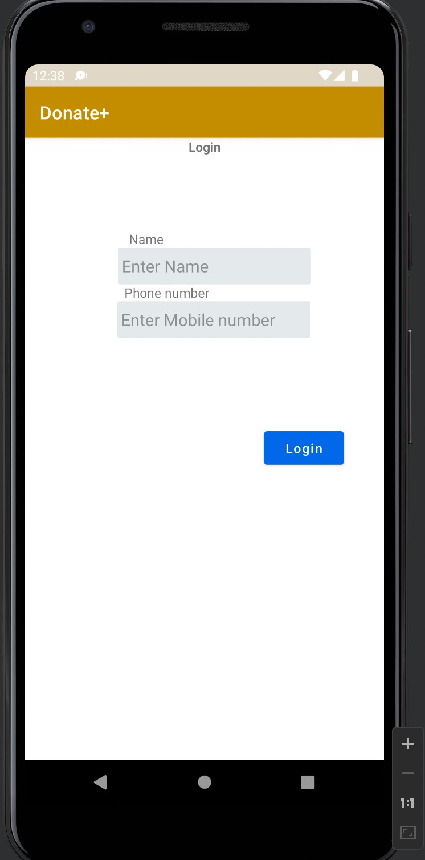**After logOut user is send to Sign in Activity**

**CHAPTER 6: CONCLUSION**

With the completion of this project we have been able to build an application that can perform an end to end messaging from Donator to Acceptor of the food supplies.By this application we will be able to form a bridge between the two, which would result in fulfilling our purpose of Donation of food by the one who has excess of it to the one who has deficit.

So, we have learnt a lot while working on this project.We are thankful to our mentor Dr.Preeti Sethi and our Supervisor Dr. Anuradha Pillai for their efforts and contribution in this learning process.

# BREIF PROFILE OF STUDENT

**Name** Jigar

**Roll no** 2001016023

**Branch** Computer Engineering

# Email id [20001016023@jcboseust.ac.in](mailto:20001016023@jcboseust.ac.in)

**Brief about Project :**

Looking at the current scenario of the country as well as the world the percentage of eatable food that is finding its place in the bin is very high and ironically the number of people with malnutrition is also increasing.Our application is aimed to bridge the gap between those who have excess of food supplies and those who’s have deficit.By having an end to end messaging model we can join potential donators and acceptors(NGO’s),who are working to help people with getting good food.Thus with this project we are trying to achieve the goal of reducing malnutrition percentage to as low as possible.

# Future Scope :

With the addition of certain other features to this application and also by using different technology it’s performance and efficiency can be improved to a great extent. Since ,more the features will be added more the helpful the application is the more