CLIAS: CHARUSAT Learning Intelligence & Assessment System
An Integrated University Platform for In-Browser Coding Tests, Code Plagiarism Detection, AI Assisted Exam Integrity Monitoring, and Adaptive Practice

Project Overview

What is CLIAS?
CLIAS is an integrated academic assessment, coding, and learning-intelligence platform designed for university engineering departments. It brings coding assessments, exam integrity monitoring, adaptive practice, plagiarism analysis, and academic outcome reporting into a single campus-oriented platform.
CLIAS brings all these essential academic workflows into a single, secure campus platform with five core functionalities:
- In-Browser Coding Lab & Automated Judge: Students write, compile, and test code in C++, Java, and Python directly inside their web browser without installing any compilers.
- Structural Code Plagiarism Detection: An automated engine that detects copied programming assignments, even if students rename variables, change function names, or alter formatting.
- AI-Assisted Exam Integrity Monitoring: Monitors exam-related anomalies such as tab switching, fullscreen exits, missing faces, and multiple faces, generating an interpretable incident log and Trust Score for faculty review.
- Adaptive Practice with Socratic AI Hints: Diagnoses student weak areas topic-by-topic and provides guiding hints when they make a mistake, rather than just revealing the answer.
- 1-Click CO Attainment & Accreditation Support Reports: The system automatically generates CO direct-attainment matrices and supporting reports for academic accreditation workflows.

Foundational References
To ensure accuracy, the platform uses established industry and academic algorithms:
- Winnowing Fingerprinting (Schleimer et al., ACM 2003) for token-level code similarity and fingerprint generation.\
- Abstract Syntax Tree (AST) normalization and structural comparison for logic-level similarity that remains robust against identifier renaming.
- Client-Side Facial Landmark Tracking (Google MediaPipe, 2019) for lightweight, in-browser face detection.

Problem and Solution Statement

The Real Practical Problems in University Labs
- Cheating in Coding Labs (Variable Renaming): Students easily fool standard plagiarism checkers by taking a classmate's code and renaming variables (e.g., changing int count = 0; to int total = 0;). Faculty cannot manually check 120 code submissions line by line.
- Cheating During Online Quizzes: During computer-lab tests, students may switch browser tabs or windows to access external resources, including search engines or AI tools, making conventional browser-based assessments difficult to monitor.
- Quizzes Only Give Scores, Not Learning: A score of 14/20 does not explain why the student failed or which concept they misunderstood.
- Massive Faculty Paperwork for NBA Attainment: At the end of every semester, professors spend weeks manually computing Course Outcome (CO) attainment formulas across hundreds of student mark sheets.

The Functional Solutions in CLIAS

1. In-Browser Coding Arena & Sandbox Judge
- Interactive Code Editor: Monaco-powered in-browser code editor supporting C++20, Java 21, Python 3.11, and JavaScript.
- Instant Execution & Test Case Validation: Students click "Run Code", the execution service will apply resource limits and process isolation to prevent submitted programs from affecting the host system, returning runtime, memory usage, and verdicts (ACCEPTED, WRONG ANSWER, TIME LIMIT EXCEEDED).

2. Structural AST Code Plagiarism Checker
- Logic-Level Comparison: CLIAS converts submitted programs into Abstract Syntax Trees (ASTs) and strips away user-defined variable names.
- Robustness to Identifier Renaming: When variable names are changed without changing the underlying program structure, normalized AST representations can remain substantially similar, allowing the system to identify potential copied submissions.
- Faculty Audit Diff Viewer: Displays a side-by-side synchronized comparison pane with matching code blocks highlighted in red, allowing professors to verify and mark violations (FLAGGED or CLEARED) with one click.

3. Real-Time In-Browser Exam Proctoring
- Zero Software Download: Runs 100% inside Google Chrome or Microsoft Edge using the student's existing webcam.
- Live Anomaly Detection:
  - Logs every TAB_SWITCH and WINDOW_BLUR event.
  - Detects when a student exits full-screen mode.
  - Uses computer vision to flag NO_FACE_DETECTED or MULTIPLE_FACES_DETECTED.
- Initial Trust Score (0–100):
Trust Score = 100 − (5 × Tab Switches) − (10 × Fullscreen Exits) − (10 × Missing Face) − (25 × Multiple Faces)
- These weights are configurable initial parameters and will be calibrated during the departmental pilot based on observed false-positive and false-negative cases. The Trust Score is intended to prioritize submissions for faculty review and does not independently determine academic misconduct.
- Invigilator Review Console: If the Trust Score falls below an initial configurable threshold (default: 65), the attempt is flagged for faculty review with a second-by-second incident timeline.
4. Socratic AI Teaching Assistant & Mastery Tracking
- Topic Mastery Bars: Tracks student understanding across topics (e.g., Arrays: 85%, Trees: 42%, Graphs: 30%) and alerts them when topics are forgotten over time.
- Socratic Distractor Hints: When a student picks a wrong answer, the AI explains the conceptual flaw in that specific choice and asks guiding questions to help them reach the right answer.

5. 1-Click NBA / NAAC Course Outcome Attainment
- Every assessment question is mapped to specific Course Outcomes (CO1..CO4) and Bloom's Taxonomy levels.
- The system automatically generates the final CO direct attainment matrix, saving professors hundreds of hours of manual Excel calculations.

Benchmark (How this solution is better?)
- The table below compares CLIAS with the tools commonly used in universities today.
- The following comparison highlights the specific capabilities CLIAS aims to integrate for a university engineering department. It is not intended to claim that CLIAS provides the full feature set or scale of each commercial platform.
Functional Feature | Moodle / Google Classroom | LeetCode / HackerRank | Commercial Proctoring (Mettl) | CLIAS (Proposed Solution)
In-Browser Coding Runner | None | Yes | None | Yes (Multi-language sandbox with test cases)
Code Plagiarism Detection | None / basic text diff | None | None | Yes (AST-level structural comparison designed to remain robust against identifier renaming)
Exam Proctoring | None | None | Requires heavy desktop .exe installation | 100% In-Browser (Detects tabs, face absence, multiple faces)
Socratic AI Hints on Mistakes | None | None | None | Yes (Explains conceptual pitfalls without leaking answers)
Topic Mastery Progress Bars | Raw grades only | Simple problem count | None | Yes (Dynamic topic percentage with memory decay alerts)
NBA Accreditation (CO-PO) | 100% manual spreadsheets | None | None | 1-Click automated attainment matrices for HOD
Cost & Deployment | Complex setup | Paid subscription | ₹200–₹500 per test/student | Ultra-lean: ₹9,800 estimated initial pilot infrastructure

Implementation strategy

System Workflow

Student Workflow
- Logs in using verified college email (@charusat.edu.in).
- Takes assigned coding practicals or MCQ assessments.
- Sees instant test case verdicts, structural hints, and dynamic mastery curves.

Faculty Workflow
- Creates assessments with time limits, randomized questions, and test cases.
- Views the live exam-integrity monitor to review suspicious events and anomalies during exams.
- Opens the Plagiarism Studio to inspect suspicious lab submissions.
- Downloads the completedCourse Outcome report at semester-end.

Technical Architecture
- Frontend (Next.js 14): Clean, modern web portal with dedicated consoles for Students, Faculty, and HODs.
- Backend API (NestJS 10): Secure gateway handling student authentication, role permissions, and test submissions.
- AI Microservice (FastAPI): Handles the AST code plagiarism comparison, Socratic hint generation, and RAG lecture note search.
- Database (MySQL 8.0): Securely stores student attempts, code files, question banks, and proctoring audit logs.
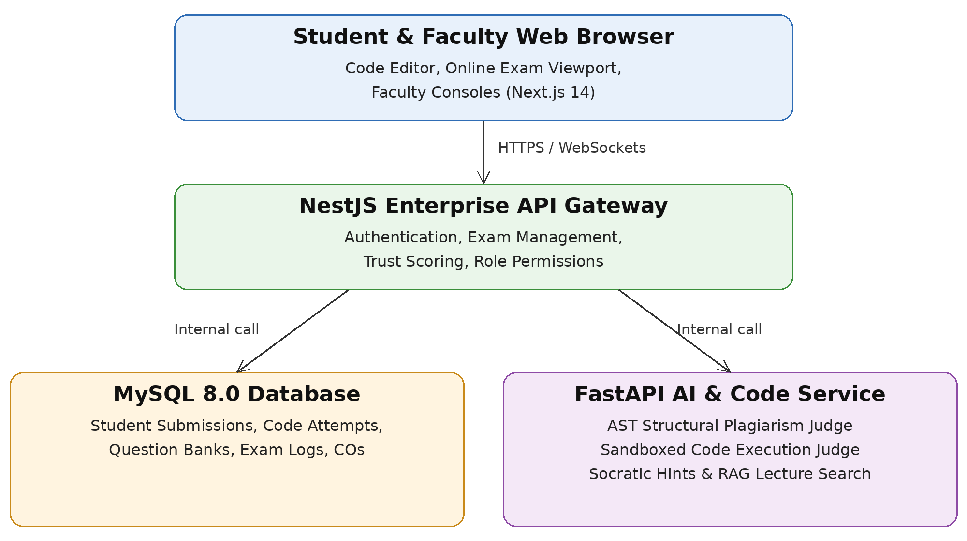

Milestones(Project divided into small parts)
Sr No | Description/ Name of work | Expected time required (No of hours) | Expected date of completion
1 | Core Platform and Deployment: Setting up the Linux cloud server, deploying the Next.js web portal, NestJS API, and MySQL database with college email login. | 120 Hours | Month 2 (Nov 2026)
2 | Adaptive Practice, RAG & Socratic AI Tutor: Building topic mastery progress bars, weak-area detection, and AI hints that guide students through incorrect answers. | 160 Hours | Month 4 (Jan 2027)
3 | In-Browser Coding Arena & Secure Code Execution: Implementing the online code editor (C++, Java, Python) with automated test case validation and runtime metrics. | 180 Hours | Month 6 (Mar 2027)
4 | Structural Code Similarity & Plagiarism: Analysis: Building the syntax tree comparison engine that catches copied lab code, along with the faculty side-by-side diff viewer. | 160 Hours | Month 8 (May 2027)
5 | AI-Assisted Exam Integrity Monitoring: Adding webcam face-tracking, tab-switch alerts, the real-time Trust Score, and the faculty live monitoring dashboard. | 180 Hours | Month 10 (July 2027)
6 | Departmental Pilot, Evaluation & CO Attainment: Running a live test with 50+ students in Data Structures, gathering faculty feedback, and generating automated Course Outcome (CO) reports. | 120 Hours | Month 12 (Sep 2027)
 | TOTAL PROJECT DURATION | 920 Hours | 1 Year Tenure

Estimated Prototype/Pilot Funding Requirement
Sr No | Description/ Name of work | Name of Product/service needed | Approximate cost
1 | Production Cloud Host (Milestones 1, 3, 4, 5) | 1-Year Dedicated Linux Cloud VPS (8GB RAM, 4 vCPU) to host the website, code runner, and proctoring event streaming online. | ₹5,400
2 | AI Usage Token Pool (Milestones 2, 4) | Google Gemini API prepaid developer token quota for Socratic hints and question generation across student practice tests. | ₹3,800
3 | Secure Database Backup Storage (Milestones 1, 5, 6) | S3-Compatible Encrypted Cold Storage (50GB) for daily student database backups, code files, and exam audit logs. | ₹600
 |  | Total | ₹9,800

Contributors
Sr No | Name | Roll no | Contact No | Email
1 | Param Shah | 24CS093 | +91 93161 52114 | 24cs093@charusat.edu.in
2 | Jigar Sakhia | 24CS090 | +91 83207 44800 | 24cs090@charusat.edu.in
3 | Himanshu Varotariya | 24CS106 | +91 95109 78334 | 24cs106@charusat.edu.in

Mentor’s Details
Name: Prof. Dhara Solanki
Department: Department of Computer Science & Engineering
Contact Number: +91 83284 48451
EmpID: 8396
Email id: dharasolanki.cse@charusat.ac.in

