**MONEY MANAGER**

**A Perfect Investment Solution**

**MSIS637/CMPT460  
Team Project**

**By,**

**Deepika Katake**

**Sai Sindhu Gorle**

**Jigar Parmar**

**Abstract**

We have developed an application or a real time solution of an investment problem using linear programming to have a uniform distribution of a certain investments which can be channelized and restricted to various conditions based upon an individual’s likings or ability to invest under certain criterion. This could also be a fixed amount amongst the various productive sectors. Our model illustrates how to allocate money to different bonds to obtain a maximum total return.

**Motivation of the Project**

In today’s world investment is like an extra income which can be generated by investing in various kinds of investments. But it has many risks as one cannot predict the future.

Our first motivation came from our own family. When it comes to money everyone tends to manage their expenses such that less amount of money is spent, and more amount is either saved or invested in some form of investments, for instance real estate, shares, jewelry, insurance or whatever it is that gives good returns for our investments, in future.

Here the key lies on how much to invest on diverse types of investments, calculating the returns and the risks involved in each investment.

Any individual whether he/she is has a job or owns a business or is earning ample amount of money or even on an average scale he/she needs to decide where exactly to invest and make sure that the investments they made are wise, safe and possibly will generate an extra source of income.

This tendency of people has led to our motivation to build this linear predictive model.

**Introduction to Optimization**

Optimization problems usually deal with real world problems that we encounter in our daily lives that pertain to various fields of study like mathematics, engineering, science, business and economics. In this kind of problems, we find the optimal solution or most efficient way of using the available limited resources to achieve the final objective. Here objective cannot just be limited to maximizing profit, minimizing cost, minimizing expense, minimizing total distance travelled etc. Any optimization problems consist of following three components.

* Decision variables: The decisions of the problem are represented using symbols such as X1, X2, X3,..,Xn
* Objective Function: It is expressed as a mathematical expression in decision variables. Here objective can be maximizing the profit, minimizing the cost, distance, time, etc.
* Constraints: This are the limitations or requirements of the problem which are expressed as inequalities or equations in decision variables.

**Introduction to Linear Model on Investment Problem**

Here our main objective is to create a model that illustrates how to invest money into several types of bonds in order to maximize the total returns while minimizing the risks. By risks we mean losses associated with these investments as investing in high returns bonds also bring high risks and high returns also means high taxation.

This model will keep track of the variations in the money invested in the form of bonds and the tax associated or not associated in it.

Attributes are crucial factors in one’s model and therefore we have defined them as follows:

**Attributes**

* Bonds: This column includes different type of bonds. We have researched on the diverse types of investments one can possibly make and we have added them in this column.
* Annual Return: This column contains the annual return of each bond mentioned in the above column respectively.
* Maturity: We have defined maturity basically into three types long-term and short-term and medium-term. This column contains the maturity period of each bond.
* Risk: This column contains risk associated with each type of bond. It is of three type’s medium-risk, high-risk and low-risk which is defined based on the annual return and maturity of the bond. For example, if the returns are high and the maturity of the bond is low the risk is high.
* Tax-free: This column contains information about the tax associated with a bond. For example, if the bond is exempted from tax or no.

**Investment Optimization**

The following table depicts the several types of bonds available for investment:

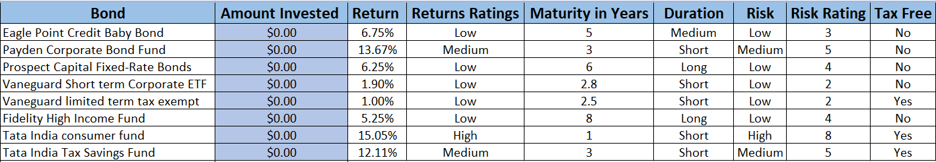

Our spreadsheet consists of real time bonds with their returns, maturity (durations), risks levels associated and whether it is tax-free or not.

To create model, we have started with the individual who wants to make an investment of $100,000 in 7 to 8 different types of bonds. We have decided for the following types of constraints:

* The individual wants to invest at least 50% of the money in short term issues and no more than 30% in high-risk bonds.
* The individual wants at least 40% of the funds should go in tax-free investments, and at least more than $40,000 in long term investments.

Here the decision variables are the amount of money to be invested in each type of bonds based on the constraints mentioned above.

* C10 = Amount of money to invest in Bond A
* C11 = Amount of money to invest in Bond B
* C12 = Amount of money to invest in Bond C
* C13 = Amount of money to invest in Bond D
* C14 = Amount of money to invest in Bond E
* C15 = Amount of money to invest in Bond F
* C16 = Amount of money to invest in Bond G
* C17 = Amount of money to invest in Bond H

Objective function: Here our objective is to maximize the total annual returns. So from the above data we have formulate out objective function as follows.

Max f(C10, C11, C12, C13, C14, C15, C16, C17) = 6.75%C10 + 13.67%C11 + 6.25%C12 + 1.90%C13 + 1%C14 + 5.25%C15 + 15.05%C16 + 12.11%C17

Also, as we can see that the spreadsheet table consists of 3 columns which are categorical (Maturity, Risk, Tax-Free). So, we have converted each of them to flag (1/0) to make data more readable.

Constraints:

Total investment: C10 + C11 + C12 + C13 + C14 + C15 + C16 + C17 = $100,000.

At least 50% of the money goes into short term issues: C11 + C13+ C14+ C16+ C17 <= 50,000.

No more than 30% of the money should go to elevated risk issues: C11 + C16 + C17 <= 50,000.

At least 40% of the money should go to tax free investments: C14 + C16 + C17 >= 30,000.

The return on investment on the tax-free bonds should be greater than or equal to 40% of the total return of investments.

1.00%C14 + 15.05%C16 + 12.11%C17>= 40%(6.75%C10 + 13.67%C11 + 6.25%C12 + 1.90%C13 + 1%C14 + 5.25%C15 + 15.05%C16 + 12.11%C17)

Non-negativity constraints (all the variables should be nonnegative): C10, C11, C12, C13, C14, C15, C16, C17 >= 0.

Complete linear programming model:

Max: 6.75%C10 + 13.67%C11 + 6.25%C12 + 1.90%C13 + 1%C14 + 5.25%C15 + 15.05%C16 + 12.11%C17

Subject to: C10 + C11 + C12 + C13 + C14 + C15 + C16 + C17 = $100,000.

C11 + C13+ C14+ C16+ C17 <= 50,000.

C11 + C16 + C17 <= 50,000.

C14 + C16 + C17 >= 30,000

**Categorization of Optimization Factors**

The following table describes all kind of combination which is possible between the Returns and Duration based on which we have categorized and rated the Risk involved in that bond:

|  |  |  |  |
| --- | --- | --- | --- |
| **Returns** | **Duration** | **Risk rating** | **Risk** |
| Low | Short | 1-2 | Low |
| Low | Medium | 3 | Low |
| Low | Long | 4 | Low |
| Medium | Short | 5 | Medium |
| Medium | Medium | 6 | Medium |
| Medium | Long | 7 | Medium |
| High | Short | 8 | High |
| High | Medium | 9 | High |
| High | Long | 10 | High |

The range for returns to be Low, Medium and High are as follow:

|  |  |
| --- | --- |
| 1% - 7% | Low |
| Above 7% - 14% | Medium |
| Above 14% | High |

Similarly, the range for Duration to be Short, Medium, long are as follow:

|  |  |
| --- | --- |
| 1yr – 3yr | Short |
| Above 3yr – 5yr | Medium |
| Above 5yr | Long |

By adding this kind of range, we tried to make our model as dynamic as possible. By this we mean that the user/customer must just define the percentage of returns and maturity in years associated with the bond and model will automatically generate the ratings on the basis of above described ranges.

**Spreadsheet model and Solver implementation**

Implementing the problem in an Excel spreadsheet and Solver formulation produces the following spreadsheet and Solver parameters. The cells C10 through C17 represent the five decision variables. The cell C22 represents the objective function. The no negativity constraint is not implemented in the spreadsheet and it can be implemented in the Solver. The complete set of constraints, target cell (objective function cell), variable cells (changing cells) and whether to maximize or minimize the objective function are identified in the Solver parameters box.

The following is the first stage of our implementation.

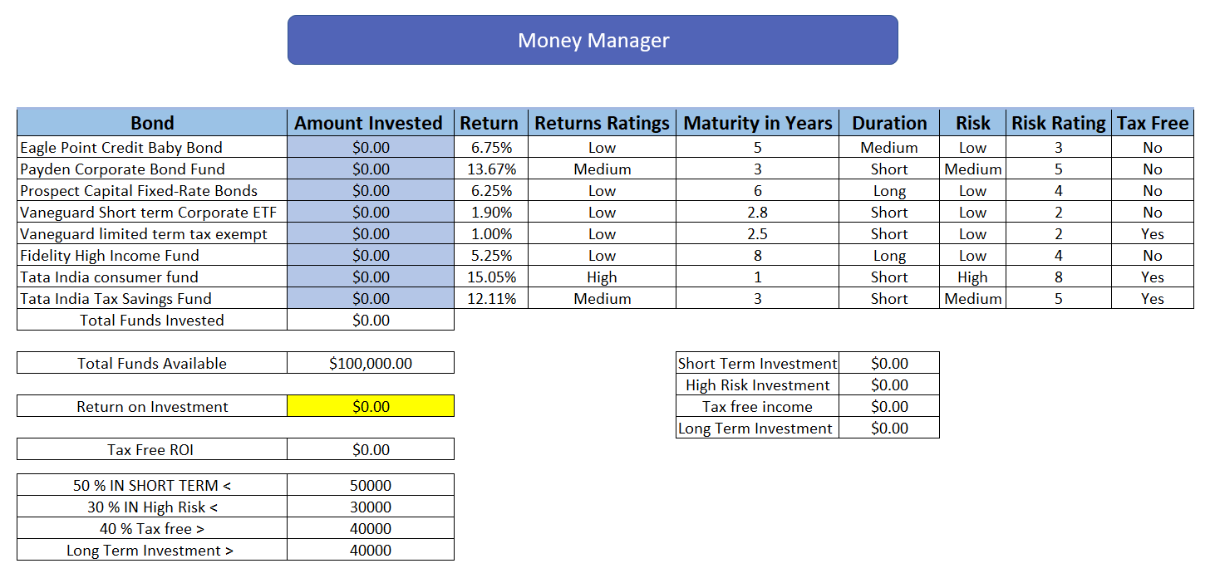

*Fig 1: Spreadsheet implementation*

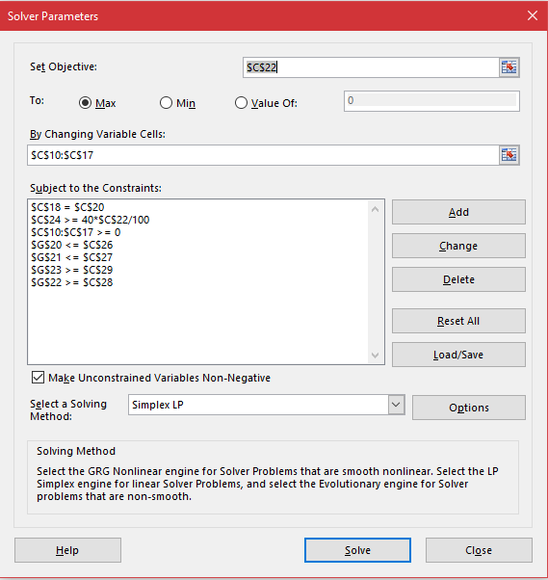

*Fig 2: Solver implementation*

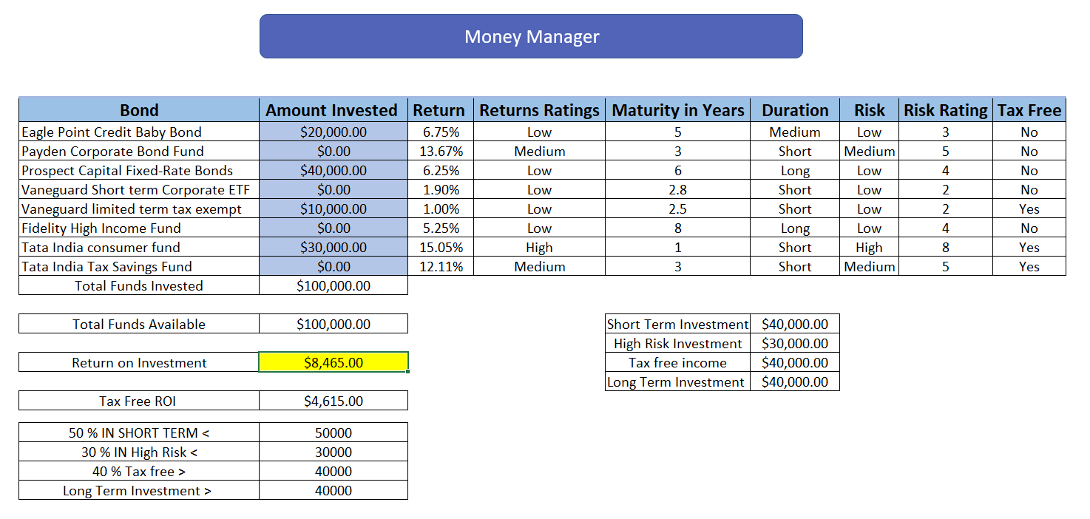

*Fig 3: Spreadsheet with Optimal Solution*

Optimal money allocation:

Amount invested in Bond A = C10 = $20, 000.

Amount invested in Bond B = C11 = $0.

Amount invested in Bond C = C12 = $40,000.

Amount invested in Bond D = C13 = $0.

Amount invested in Bond E = C14 = $10,000.

Amount invested in Bond F = C15 = $0.

Amount invested in Bond G = C16 = $30,000.

Amount invested in Bond H = C17 = $0.

The maximum return on investment is **$8,465.00** out of which Tax-Free Return on Investment is **$4,615.00**

**Future Advancements**

Apart from this model, we can also add portfolio optimization in which we can diversify our investments among multiple markets like US based or international market e.g. SENSEX or real estate investment, etc. based on individual’s capability and inclination of investing money.

**Application of the Model**

This model could be used by company or financial organizations who wants to invest their money into investments like for instance how much money to be spent on different projects or how much money to be spent on the same project for additional research and development, merchandise etc. so that the output of project gives maximum profit.

This model can also be applied to our daily life for example how we manage our earnings by investing in the form of shares, real estate etc. while making sure that at last we get the maximum return while interpreting and managing the risks involved in these kinds of investments.

**Advantages:**

* The facilities of spreadsheets make calculations easier to understand by displaying stages of the development of any expression.
* Investment advising
* Best investment solutions
* Future prediction
* Helps in decision-making
* Provides customization.
* Profile optimization.

**Conclusion**

We are being data analysts, are confident enough that the model we created will help not only individuals but also organizations in managing their investments in terms of projects but also in terms of bonds. We designed this spreadsheet model in a very simplest way that any individual who has a basic knowledge of excel and investments can make use of it to the fullest.

**References:**

<https://www.analytics-tuts.com/solve-linear-programming-problem-using-excel/>

<https://www.ablebits.com/office-addins-blog/2014/12/03/excel-if-function-iferrror-ifna/>

<https://www.investopedia.com/university/beginner/beginner2.asp>

<https://www.investopedia.com/university/beginner/beginner5.asp>

<https://www.investopedia.com/university/beginner/beginner6.asp>

<https://s3.amazonaws.com/sitebooks/Long+Term+Investing/Investment+Analysis+and+Portfolio+Management+(2012).pdf>

<https://www.math.ucla.edu/~tom/LP.pdf>

Spreadsheet Modeling & Decision Analysis: A Practical Introduction to Business Analytics, 8th Edition by [Cliff Ragsdale](https://www.amazon.com/s/ref=dp_byline_sr_book_1?ie=UTF8&text=Cliff+Ragsdale&search-alias=books&field-author=Cliff+Ragsdale&sort=relevancerank)

<https://www.whitman.edu/Documents/Academics/Mathematics/lewis.pdf>

<https://www.kiplinger.com/article/investing/T052-C007-S001-the-5-best-bond-funds-to-invest-in-today.html>

https://www.investopedia.com/articles/bonds/08/bond-yield-convention-conversion.asp