Assignment

**1. Are the HTML tags and elements the same thing?**

-HTML and tags and element are lot different.

-HTML tags have starting point and ending point (like= <p></p>)

-Elements in HTML enclose the content in between the tags. (like=<p>This is my first web page </p>)

<p> JIGAR VEKARIYA</p>

Opening tag Closing tag

Content

Element

**2.What are tags and attributes in HTML?**

-Tags and attributes are different things.

**Tags:** HTML tags have starting point and ending point (like= <p></p>).

-HTML Element holds the content.

**Attributes:** HTML attributes are found only in the starting tag.

Tags starts with < and end with>.

**3.What are void elements in HTML?**

-void elements do not have end tags.

-void elements can have attributes.

-examples of void element is area, br, hr, img, input, link, dbase, command

Meta, col, wbr.

**4.What are HTML Entities?**

-some characters are reserve in HTML

-if you use less then (<) or greater than (>) sign in your HTML text,

the browser mixes them with tags.

List Of Entity Values

|  |  |
| --- | --- |
| Non-breaking space | &nbsp; |
| Less-than sign < | &lt; |
| Greater-than sign > | &gt; |
| Ampersand & | &amp; |
| Quote " | &quot; |
| Apostrophe ' | &apos; |
| Copyright © | &copy; |
| Degree ° | &deg; |
| Euro € | &euro; |
| Bullet character • | &bullet; |

Ex. &it; Jigar &gt;

Output: <Jigar>

**5.What are different types of lists in HTML?**

There are 3 types of lists in HTML.

1. OL: ordered list/ numbered list
2. UL: unordered list / bullets list
3. DL: description list /definition list

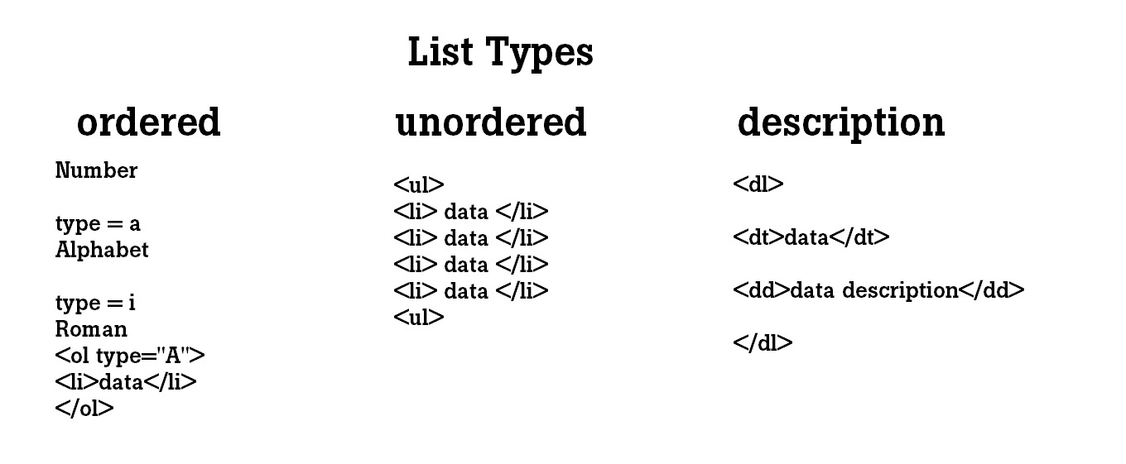

**6.What is the ‘class’ attribute in HTML?**

-The class attribute specifies one or more class names for an element.

-The class attribute can be used on any HTML element.

-class name is case sensitive.

ex.<html>

<head>

<style>

. Paris

{

Color: hot pink;

}

</style>

</head>

<P class=” Paris”>Paris is a capital of France. </p>

<html/>

**7.What is the difference between the ‘id’ attribute and the ‘class’ attribute of HTML elements?**

-class can be applied to multiple elements.

-id is a uniquely identifies one element

-accessed in CSS with .example selector.

-accessed in CSS with #example selector.

-written as class="one"

-written as id="one"

ex of class. <h1 class="city">Rajkot</h1>

<P>Rangilu Rajkot</p>

ex of id. <h1 id="Jay">Mango</h1>

<P>King of fruits </>

8. what are the various formatting tags in HTML?

- There are many formatting tags in HTML

|  |  |
| --- | --- |
| <b> | Bold text |
| <strong> | Important text |
| <i> | Italic text |
| <em> | Emphasized text |
| <mark> | Marked text |
| <small> | Smaller text |
| <del> | Deleted text |
| <ins> | Inserted text |
| <sub> | Subscript text |
| <sup> | Superscript text |

9. How is Cell Padding different from Cell Spacing?

-Cell padding is an attribute

-Cell spacing is also an attribute

-It is mainly meant for a single cell

-Cells spacing can get subjected to more than one cell

-It specifies the space between the border of a table cell and its contents

-It specifies the space between adjacent cells

Ex. **Cell padding:**

<head>

<style>

Td, th

{

Padding: 10px;

}

</style>

</head>

**Cell spacing:**

<head>

<style>

th,td

{

Border-spacing: 10px;

}

</style>

</head>

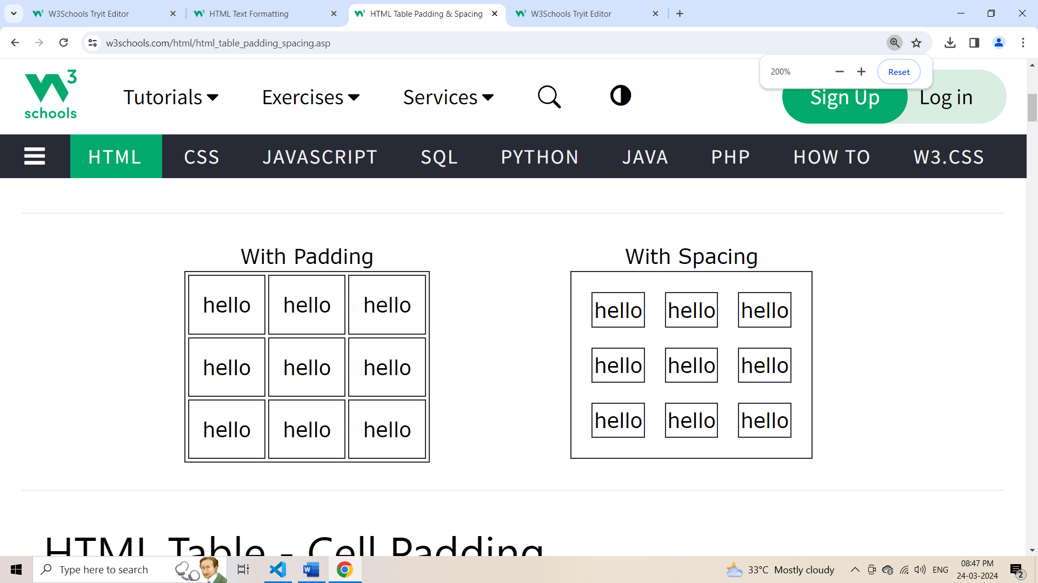

**10. How can we club two or more rows or columns into a single row or column in an HTML table?**

-To merge two or more row cells, use the **row span** attribute.

If you want to combine the first two cells in the first column,

you can use the **Col span="2"** attribute in the first tag.

The number represents how many cells to use (merge) for the tag.

Ex.

**Row span:**

<table>

<tr>

<th>Name</th>

<th>city</th>

<th>country</th>

</tr>

<tr>

<td>Jigar</td>

<td>Rajkot</td>

<td row span=”2”>India</td>

</tr>

<tr>

<td>Jay</td>

<td>Morbi</td>

</tr>

</table>

**Output:**

**Output:**

|  |  |  |
| --- | --- | --- |
| **Name** | **city** | **Country** |
| Jigar | Rajkot | India |
| Jay | Morbi |

**Col span:**

<table>

<tr>

<th>Name</th>

<th>Balance</th>

</tr>

<tr>

<td>Jigar</td>

<td>50,000</td>

</tr>

<tr>

<td>Jay</td>

<td>10,000</td

</tr>

<tr>

<td Col span=”2”>Total:60,000</td>

</tr>

</table>

**Out Put:**

|  |  |
| --- | --- |
| **Name** | **Balance** |
| Jigar | 50,000 |
| jay | 10,000 |
| Total: 60,000 | |

11. What is the difference between a block-level element and an inline element?

**Block-Level:** Block Elements occupy the full width irrespective of their sufficiency.

Ex.  **<div>Hello Jigar</div>**

**<p>Hello Jigar</p>**

**Inline -element:** Inline elements occupy only sufficient width required.

Ex. 1) <span>Hello Jigar </span>

**Notes:** - Inline elements don't start in a new line.

-Block elements always start in a line.

12. How to create a Hyperlink in HTML?

-The <a href=” link”>tag defines hyperlink, which is a used to link from one page to another page.

- The most important attribute of the <a> element is **href** attribute which indicate the link is destination.

Ex

<a href= <https://www.instagram.com/?hl=en>> Go to Instagram</a>

13. What is the use of an iframe tag?

-An inline frame (iframe) is a HTML element that loads another HTML page within the document. It essentially puts another webpage within the parent page. They are commonly used for advertisements, embedded videos, web analytics and interactive content.

Generally, this tag used to some another site page implement in your site.

<iframe src="https://www.google.com/maps/embed?pb=!1m18!1m12!1m3!1d3691.680062594596!2d70.77238027559142!3d22.29010607969391!2m3!1f0!2f0!3f0!3m2!1i1024!2i768!4f13.1!3m3!1m2!1s0x3959ca248c77c099%3A0xdf5ac10af64ac8ee!2sTOPS%20Technologies!5e0!3m2!1sen!2sin!4v1714642291933!5m2!1sen!2sin" width="600" height="450" style="border:0;" allowfullscreen="" loading="lazy" referrerpolicy="no-referrer-when-downgrade">

</iframe>

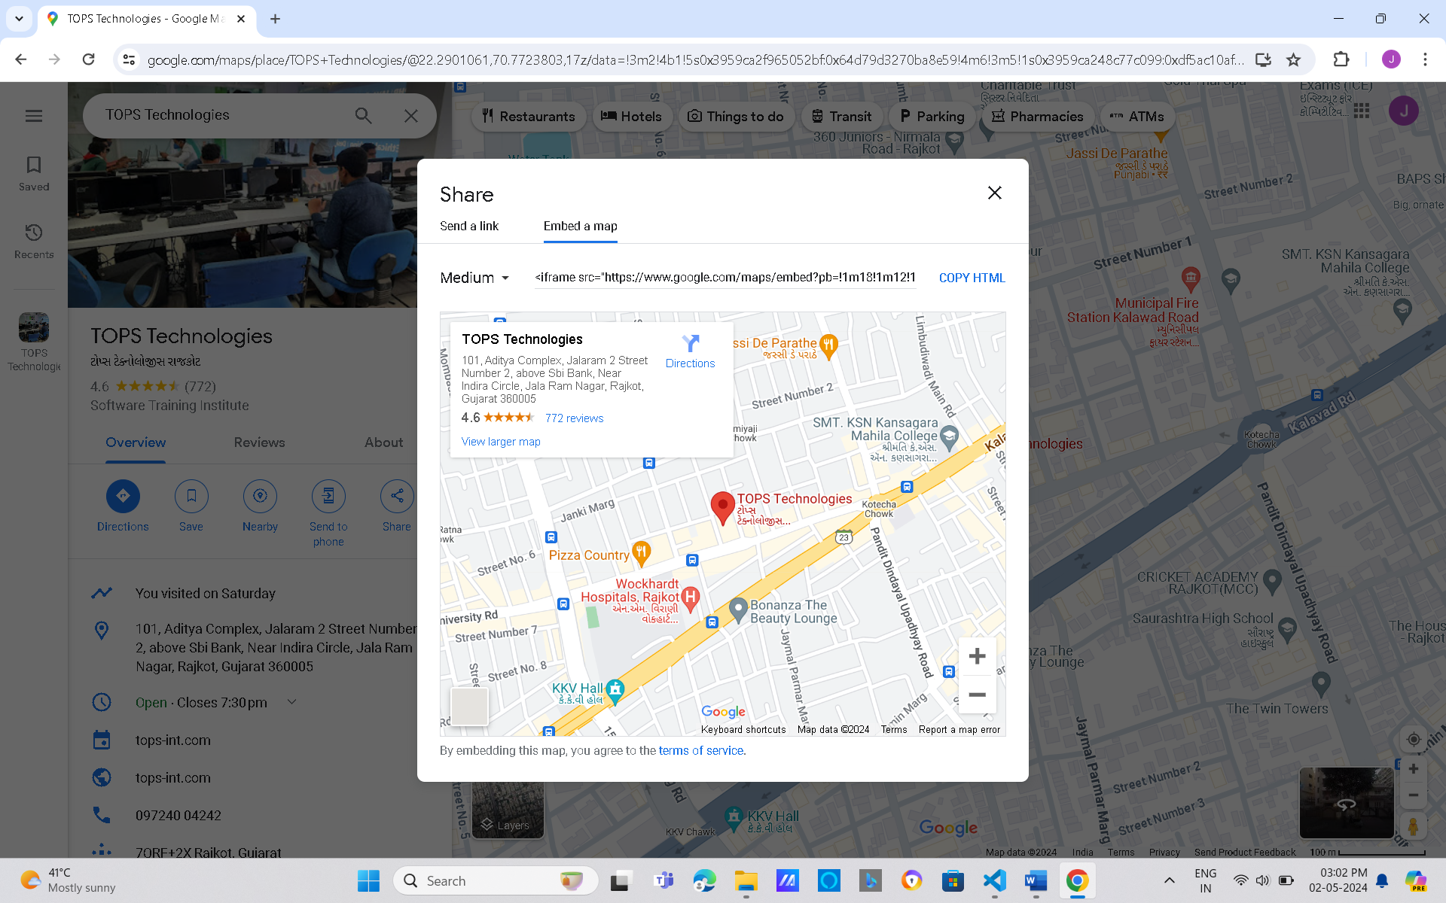

**14**. **What is the use of a span tag? Explain with example?**

- In HTML, the span tag is generic inline container element you can use this element to wrap selection of text for styling purpose or to add attribute to a section to text without a creating a new line content.

- It’s similar but not same as <div> tag.

Ex.

<p> my name is

<span style=” colour: sky blue;”>Jigar</span>

**Output:**

My name is Jigar

**15. How to insert a picture into a background image of a web page?**

- To add a background image on a HTML element, use the HTML style attribute and the CSS background-image property.

In element:

<p style=” background-image: url(‘jigar.jpg’);”>

In body:

<style>

Body

{

Background-image: url(‘jigar.jpg’);

}

</style>

**16. How are active links different from normal links?**

-Normal links are links which are there on the page and have not been clicked yet.

- A normal link is a just a line of code that contains a pointer to another resource.

-Active links are those links, which have just been clicked at that instant.

- active links means you can hold cursor on link (hold click on particular link.)

Ex.

<style>

a: link

{

Color: blue;

}

a: active

{

Color: red;

}

</style>

**Output:**

instagram.com

Instagram.com

**17. What are the different tags to separate sections of text?**

-<br> tag -it is used to separate the line of text.

-In HTML we have <section> tag for create section for text.

<section>Contant</section>.

**18. What is SVG?**

-SVG (Scalable Vector Graphics)

-which can be directly embedded in HTML pages.

-SVG used to define vectors-based graphics for web.

-SVG integrates with other standards such as CSS, DOM, XSI & JavaScript.

19. What is difference between HTML and XHTML?

-HTML can ignore small errors.

-XML does not allow errors.

-HTML is not Case sensitive.

-XML is Case sensitive.

-HTML tags are predefined tags.

-XML tags are user-defined tags.

-In HTML, closing tags are not necessary.

-In XML, closing tags are necessary.

20. What are logical and physical tags in HTML?

-In HTML the formatting tags are divided into two categories.

**Physical Tags:** These tags are used to provides the visual appearance to the text.

**Logical Tags:** These tags are used to add some logical pr semantic value to the text.

**Logical Tage:**

<abbr>

<acronym>

<city>

<code>

<blockquotes>

<del>

<ins>

<q>

<samp>

<var>

**Physical Tags:**

<b>

<big>

<i>

<small>

<sup>

<sub>

<u>.