# Efficient Grid Connected Photovoltaic System using Matlab Simulink

Project report

Submitted in the partial fulfillment of the requirements for the award of the degree of

# Bachelor of Technology

# in

**Department of Electronics and Communication Engineering**

By

|  |  |
| --- | --- |
| B. Jignesh | 190040050 |
| K.Jagadeesh | 190040128 |

Under the supervision of

# Dr.C.S.Preetham Reddy

(Associate Professor)



**Department of Electronics and Communication Engineering**

K L E F, Green Fields,

Vaddeswaram- 522502, Guntur(Dist), Andhra Pradesh, India.

March, 2023

# Declaration

The Term Paper/Project Report entitled “ Efficient Grid Connected Photovoltaic System using Matlab Simulink“ is a record of bonafide work of B.Jignesh, K.Jagadeesh under the guidance of Dr.C.S.Preetham Reddy, submitted in partial fulfillment for the award of B.Tech in Electronics and Communication Engineering to the K L University. The results embodied in this report have not been copied from any other departments/University/Institute.

B.Jignesh-190040050

K.Jagadeesh-19004012



# Certificate

This is to certify that the (Term Paper/Project) Report entitled “ Efficient Grid Connected Photovoltaic System using Matlab Simulink” is being submitted by,B.Jignesh, K.Jagadeesh, submitted in partial fulfillment for the award of B.Tech in Electronics And Communication Engineering to the KL University is a record of bonafide work carried out under our guidance and supervision.

The results embodied in this report have not been copied from any other departments/ University/ Institute.

### Signature of the Supervisor

**Dr.C.S.Preetham Reddy (Associate.professor)**

**Signature of the HOD Signature of the External Examiner Dr M.Suman**

# Acknowledgement

We are greatly indebted to Dr. M.Suman, Head - Department of Electronics And Communication Engineering for giving us moral support and also permitting us to do this project based on lab experiments.

We would like to express our gratitude for: Dr.C.S.Preetham Reddy, our guide, for his perpetual moral support. Without his guidance, it would have been impossible for us to complete this project.

We are also thankful to the management and our colleagues at the K L University, for their moral support and encouragement.

|  |  |
| --- | --- |
| B.Jignesh | -190040050 |
| K.Jagadeesh | -190040128 |

# Abstract

An efficient grid-connected solar power system using MATLAB Simulink is a simulation-based model that evaluates the performance of a solar power system in real-time. The abstract of such a system would cover the main aspects of its design and simulation, including the use of MATLAB Simulink to model and simulate the system's components and the analysis of its performance under different conditions. The system includes components such as photovoltaic modules, inverters, and the grid connection. The Simulink model can help optimize the design of the system, ensuring that it operates at maximum efficiency while reducing costs and environmental impact.

To generate a minimum heat loss by using power MOSFET’s with high a switching duty cycle and maximum a output waveform with a Boost converter to increase the output voltage to the given input.

To support the suggested controller for the grid-connected PV system, a thorough simulation and implementation of a three-phase grid-connected inverter are shown.

**Keywords: Solar System, Boost Converter, Inverter,**

**LCL Filter**

# LIST OF CONTENTS

1. Introduction
2. Literature Review
3. Theoretical Analysis
   1. Proposed MATLAB/SIMULINK platform
   2. Grid Connected (PV) System
   3. Photovoltaic Circuit Model using Matlab/Simulink
   4. Maximum Power Point Tracker (MPPT) Curves.
4. Experimental Investigation
   1. DC-DC Boost Converter
   2. Modelling of DC-AC 2-Phase Inverter
   3. Other Devices- Filter Circuit & Load
   4. Photovoltaic System Components
5. Methodology & Working
6. Discussion Of Results

6.1 Simulation of PV-System with low AC Output

6.2 Output feuded to Residential Buildings

1. Summary, Conclusions And Recommendations
   1. Conclusion
   2. Boosted Input DC Waveform
   3. Final Simulation of PV-System Output
   4. Future Work
2. References/Bibliography

# Introduction

Due to the quantity of solar radiant energy and sustainability, grid-connected photovoltaic systems are commonly employed. However, despite the fact that solar energy is abundant and cost-free, the price of photovoltaic cells is relatively high, making them an unaffordable option for most people. In light of this, the initial cost of solar energy will be very expensive. The solar cell, which transforms solar irradiance into direct current, is the fundamental component of a PV system. An effective converter is needed to convert the low DC voltage from the PV system's grid connection into AC.

To ensure the security of the PV installer and the dependability of the utility grid and to efficiently utilize the generated power, the technical requirements from both the utility grid side and the PV system side must be met. The connectivity between the PV system and the grid requires the development of an interface mechanism. The system must be modeled and simulated in order to make sure it will function as intended and to examine its impact under various circumstances.

PV model which is connected to the grid having maximum power point tracking (MPPT) by the use of MATLAB/Simulink software. The characteristic of photovoltaic cell/array/ module solar systems is necessary to gain Maximum Power under various conditions.

Reduction in the cost of the PV model; • The system operates without emitting any pollutants (harming no ecosystems);

• It can meet the demand of AC loads;

• The PV system provides the grid with active power. As a result, the grid's load demand is reduced.

As a result, the control technique has the following benefits:

• The power factor is nearly unity at all solar radiation levels; the UPS runs with any kind of load; and the energy flux between the grid and the photovoltaic system may be managed.

To ensure the security of the PV installer and the dependability of the utility grid and to efficiently utilise the generated power, the technical requirements from both the utility grid side and the PV system side must be met. The connectivity between the PV system and the grid requires the development of an interface mechanism. The system must be modelled and simulated in order to make sure it will function as intended and to examine its impact under various circumstances. This work makes a modest addition to the field, but more research and initiatives are needed before grid-connected PV systems and smart grids can be implemented.

Therefore, the primary goal is to create a power electronics interface for a three-phase grid connected PV that can extract the maximum amount of power from the PV arrays at all levels of solar radiation. The inverter is then implemented to change the dc output voltage to a voltage that is compatible with the utility grid and household appliances.

Both transformer-based and transformer-free PV systems. As seen in Fig. 1, single phase transformer-less inverters are frequently utilised in grid integration systems because they are more affordable, more dependable, and efficient for solar PV applications.

# Literature Review

The model of a single PV cell forms the basis of every simulation model for PV systems. which explains the connection between the current and voltage that a PV cell produces. The Grid connected system has been researched and produce clean electricity close to the point of use, without the need for batteries or transmission and distribution losses. A stand-alone system doesn't communicate with a utility grid in any way. Technical shelter climate and energy performance under various circumstances. The simulation of a grid-connected solar photovoltaic system using the computer software package PV system and their performance was assessed.

Standalone method of operation of the solar power plant. For battery sizing and PV sizing, the plant's capacity is determined based on the load survey and the utilisation factor.

The sizing of a solar PV power plant is done using PVSYST. A brand-new, highly modular simulation tool called "PVLab," created by the GREMAN laboratory. Its purpose is to help the designer size PV (photovoltaic) installations. The simulation of a grid-connected solar photovoltaic system using the Matlab/Simulink software and their performance was assessed.

Three distinct panel arrangements that will reduce PV loss due to temperature and increase power generation were investigated as the main parameters that influence the performance of the solar PV module. By reviewing the literature, it is evident that a comparison of various thermal parameters and PV systems is necessary for the effective use of PV systems.

Even though a solar panel can only convert 30–40% of incoming radiation into usable electrical energy, tests have shown that different types and brands of solar panels have efficiencies ranging from .3% (amorphous grade silicon solar cells) to 25% (single crystal silicon solar cells)

## THEORETICAL ANALYSIS

**3.1 Proposed Matlab/Simulink platform:**

Power from the PV is not sufficient to supply load during bad Weather Condition.

Ripple factor reduction by capacitor. LC/LCL Passive filter for exact AC output(from pulsated DC) The excess power generated by PV System is loss during Summer days. Power Up/Down due to Hot-spots and Shadowing on the Solar Panels. Constant Power supply to the load from the Photo Voltaic System is not achieved.

The main objective of this Project is to utilize the Maximum Power from the Solar PV System through MPPT Charge Controller i.e(Maximum Power Point Tracking).

It provides constant Power supply at all undesirable weather conditions, shading, hot-spots.

Power MOSFET are used to increase the duty cycle.

A photovoltaic array (PV system) is a network of modules made up of several PV cells connected in series or parallel. Since a single module cannot produce enough power for commercial use, several modules are linked together to form an array.

The primary components of a photovoltaic conversion system include solar modules, converters, the utility grid, loads (both DC and AC), and inverters.

This design, known as a grid linked system without a battery backup, is utilised in PV standby power supply systems.

The reliability of the grid supply is a concern for systems with battery backup, although it is more difficult and expensive.

**3.2 Photovoltaic Circuit Model using Matlab/Simulink:**

Crystalline silicon is utilised as the primary semiconductor material in the production of the solar cell, a semiconductor device. The photovoltaic module is the collective name for the solar cells. The PV system's intricate mathematical modelling is provided in the references Diagram.

When MPPT is used, the PV panel can produce the most energy possible. Equation is used to assist in the construction of the PV array using the SIMULINK programme. A PV system with a single diode. Table I contains the PV system's specifications. With the aid of Matlab, the Sun Power SRP-305-WHT solar panel is chosen for modelling and simulation.

The power source for every photovoltaic installation is the solar panel. It is the end product of a collection of parallel and series photovoltaic cells. When sunlight interacts with semiconductor materials in the PV cells, the solar irradiance is directly converted into electricity in the form of dc.

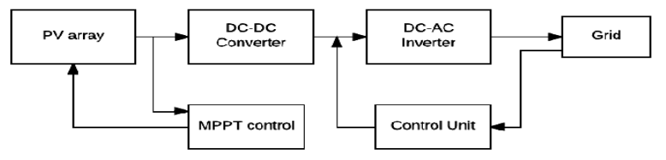 **Fig: [3.2] Photovoltaic Circuit Model using Matlab/Simulink**

**Equivalent PV circuit:**

It shows the nonlinear I-V characteristic can be inferred. Solar cells are then integrated to form "modules" to acquire the desired voltage and current (and consequently power). The cells are connected in series and parallel combinations to make an array with the desired voltage and power levels.

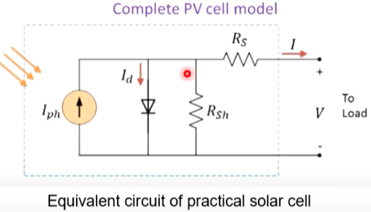

Boost converter connected across a PV panel. The photovoltaic cell uses a maximum power point tracker to generate electricity at a temperature of 25 °C and a level of 1000 W/m2.

**3.3) Photovoltaic Circuit Model:**

The DC/DC converter, also known as a boost converter, raises the PV system's generated voltage, or

voltage level, and then applies the raised voltage to the inverter or DC/AC converter once more.

The current source is (I). Iph stands for the photocurrent of the solar cell, and Rsh and Rs denote its shunt and series resistances, respectively.

The value of shunt Resistance (Rsh) is often very high in the solar system. Series resistance (Rs) has a low value. The term "PV array" refers to a collection of solar cells that have been connected in series or parallel to form larger units known as PV modules. Greater amounts of electricity are produced by the PV array.

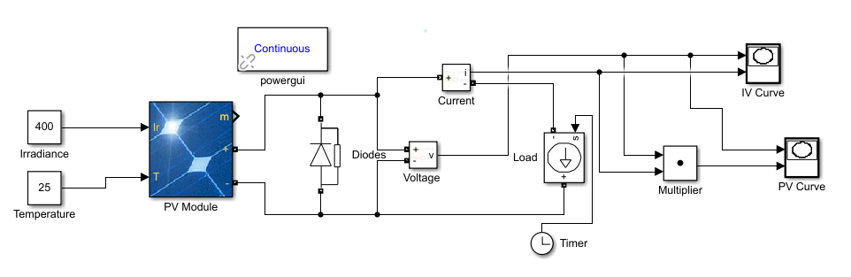

**Fig: [3.3] Photovoltaic Circuit Model**

**3.3.1) Photovoltaic Circuit Based on Equations:**

PV model which is connected to the grid having maximum power point tracking (MPPT) by the use of MATLAB/Simulink software.

The characteristic of photovoltaic cell/array/ module solar systems is necessary to gain Maximum Power under various conditions.

Power from the PV is not sufficient to supply load during bad Weather Condition. Ripple factor reduction by capacitor. LC/LCL Passive filter for exact AC output(from pulsated DC).

* PV Module is designed in Matlab/Simulink based on these Equations:

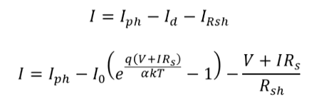

**Fig: [3.3.1] Photovoltaic Circuit Based on Equations**

## 3.3 Maximum Power Point Tracker (MPPT) Curves:

There are various MPPT control algorithms, however the Perturb and observe (P&O) method is the most frequently employed algorithm in commercial converters based on MPPT efficiency. Figure (8) depicts the algorithm flow diagram, with Vref standing in for the array voltage.

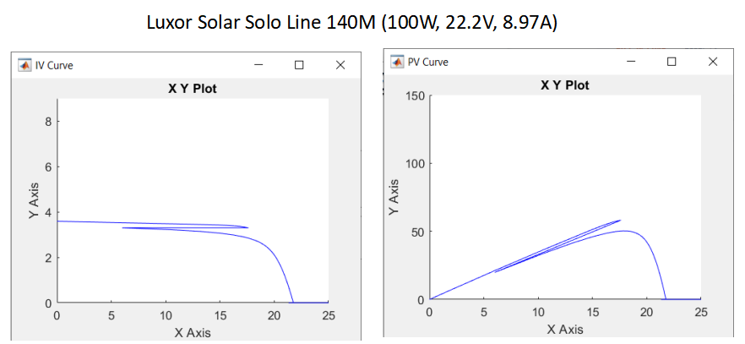

**Fig: [3.3] Maximum Power Point Tracker (MPPT) Curves**

The (P&O) technique is a widely used MPPT algorithm to increase array efficiency. The power is computed and compared to the earlier parameters. When both the power and voltage variances are positive or negative, duty cycle is decreased. If the voltage is positive and the power is negative or vice versa, the duty cycle is raised. The pulse generator receives the changed duty cycle in order to produce the switch's pulse.

Silicon and other semiconductor materials are used to make PV cells. A tiny semiconductor wafer is carefully processed to create a positive and negative electric field on one side for use in solar cells. Electrons in the semiconductor material are dislodged from their atoms when light energy strikes the solar cell. The electrons can be caught in the form of electricity if electrical conductors are connected to the positive and negative sides, creating an electrical circuit. The load can then be powered by this electricity.

In MATLAB, the P&O method was built and the Inputs to the MPPT controller were:

• The PV array's voltage and current.

• The highest, lowest, incremental value, and the initial duty cycle value.

## 3.4 Photovoltaic System Components:

**Photovoltaic cell:**

A photovoltaic cell, also known as a photoelectric cell, is a semiconductor device that functions essentially as a P-N junction diode to convert light into electrical energy. The generation of electron hole pairs, which are then affected by the internal electric field to produce a photocurrent, occurs when photon particles of light with energies larger than the valence electron's band gap bombard the junction. In a PV cell, current is mostly generated by variations in photons rather than voltage.

**PV module:**

To meet the demand for consumption, it is made up of numerous P cells that are arranged in series, parallel, or a combination of the two. The market offers PV modules made of a variety of materials, with improved efficiencies, in the desired sizes.

**PV modelling :**

A current source linked in parallel to an inverted diode can typically be used to imitate a solar cell. The series and shunt resistance are unique to the PV cell. Parallel resistance is the result of electron hole recombination before the current reaches the load, whereas series resistance is caused by diode resistance (of the bulk material) and resistance of metal contacts.

It takes into account a series resistance (Rs), a diode, and a current source (I). The parallel shunt resistance (Rsh) is extremely high, has no impact, and can be disregarded. The photovoltaic array's output current can be provided by,

**I=ISC – Id ---eqn 1**

**Id=I0(eqVd/kT -1) ---eqn 2**

Where k is the Boltzmann constant (1.38 * 10-19 J/K), T is the junction temperature in Kelvin, q is the electron charge, Vd is the voltage across the diode, and Io is the reverse saturation current of the diode.

**I=Isc-I0(eqVd/kT -1) ---eqn 3**

**I=Isc-I0(eq((V+IRs/nkT -1) ---eqn 4**

Where I is the current flowing through the photovoltaic cell, V is the voltage, T is the temperature (in Kelvin), and n is the ideality factor for the diode. Although we can use a two-diode model to accurately simulate the solar panel, the single-diode model will do for the purposes of this project.

## EXPERIMENTAL INVESTIGATIONS

**4.1) DC-DC Boost Converter:**

The placement of the boost converter will enhance the entire photovoltaic installation and enable various system controls. Depending on the rule that is being used, the  panels will help ensure that the maximum amount of energy is delivered to  system or the amount of energy that is best for running them. the gain  converter is a means of performing power transmission. solar panel energy absorption and injection into the grid inverter. The process of absorbing and injecting energy is done by a combination of the following four elements: a diode, output, electrical switch, and an inductor, capacitor.

The Boost converter is used to Step-Up the source Voltage to higher level.

The Duty cycle is given by: **[Vo/Vi = 1/1-D]**

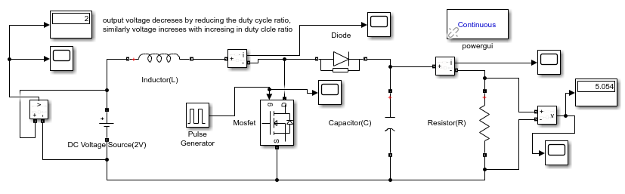

**Fig: [4.1] DC-DC Boost Converter**

**4.1.1) Simulink model of a Boost Converter 5v to 12v DC:**

Inductor current increases and energy is stored in inductor L when the switch is closed for time tl. The switching duty cycle an is defined as the ratio of the on duration to the switching time period so that the output voltage is equal to the input voltage if the switch is open for time t2 and the energy stored in the inductor is converted through diode D and inductor current falls.

The excess power generated by PV System is loss during Summer days. Power Up/Down due to Hotspots and Shadowing on the Solar Panels.

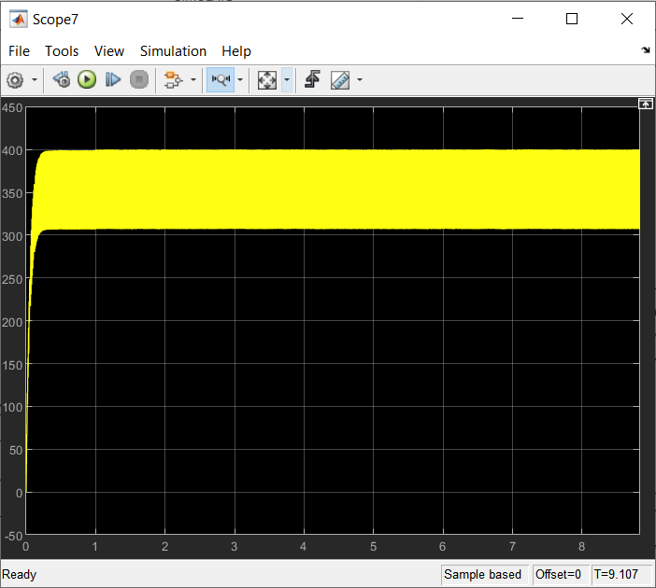

**Fig: [4.1.1] Simulink model of a Boost Converter 5v to 12v DC:**

**4.2) Working Of Boost-Converter**:

According to the duty cycle and device requirements, the input voltage of a boost converter is increased to a higher output voltage. In battery system applications and renewable energy systems, it is a converter that is frequently used. The boost converter topology.

Energy is stored in inductor L when the switch is closed for time tl, causing the inductor current to increase. The switching duty cycle an is defined as the ratio of the on duration to the switching time period, and if the switch is open for time t2, the energy stored in the inductor is converted through diode D and the inductor current decreases.

This causes the output voltage to equal the input voltage.

where Vin is the input voltage in Volts, V0 is the output voltage in Volts, D - Duty cycle, fs is the switching frequency in Hertz, L is inductance in Henry, C is the capacitance in Farad, IL is the input inductor-ripple current in Ampere, V0 is the output ripple voltage, I0 is the output current in Ampere, RL is the load resistance in Ohms, and P is the operating power in Watt.

The main drawback of a Buck type converter is that the switch is located at the PV panel's output, so when it is turned on, power is transferred, but when it is turned off, there is no output to the PV panel, indicating that the operating point is still close to the open circuit voltage, which results in a loss. The boost converter mechanism does not have this problem.

**4.2.1) Input Waveform of DC-DC Converter:**

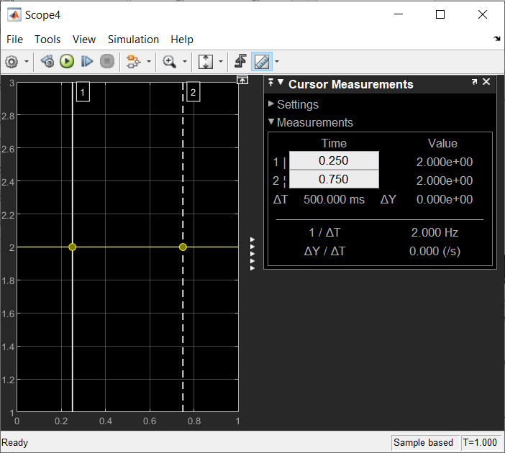

**Fig: [4.2.1] Working Of Boost-Converter**

* The Duty cycle is given by: **[Vo/Vi = 1/1-D]**

**4.2.2) Output Waveform of DC-DC Converter:**

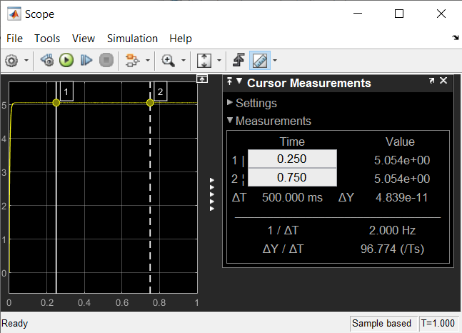

**Fig: [4.2.2] Output Waveform of DC-DC Converter**

**4.3) Modelling of DC-AC 2-Phase Inverter:**

The controller that produces the proper switching pulses to drive the inverter is the key component of the system, which comprises of semiconductor switches. In order to meet the utility grid's requirements for voltage and power quality, it converts the DC power generated by the PV array into AC electricity.The voltage source inverter is the inverter topology that was chosen for this design (VSI). A three phase VSI is schematically depicted in below figure.

It consists of six switches, SI through S6, with the middle of each "inverter leg" being connected to the output of each phase. In each phase, one leg is built using two switches. Controlling the semiconductor switches ON and OFF to get the required output yields the AC output voltage from the inverter.

Since the PV system's generated voltage is a DC voltage, an inverter is required before it can be connected to the grid to convert DC electricity to AC voltage. Using PWM approaches, a DC/AC 2-phase bidirectional converter is employed in this study. For this photovoltaic system, a converter with bi-directional characteristics is used.

The way the conduction intervals of the switches are adjusted has a direct impact on the shape and quality of the AC output waveforms. Sinusoidal pulse width modulation (SPWM), which enables modification of the resultant AC waveform's phase, amplitude, and frequency, was the method selected for this application.

Accordingly, it permits both active and reactive power flows from a load to a generator and from a generator to a load, depending on the applications. The flow control of both active and reactive power is well handled by the power switches.

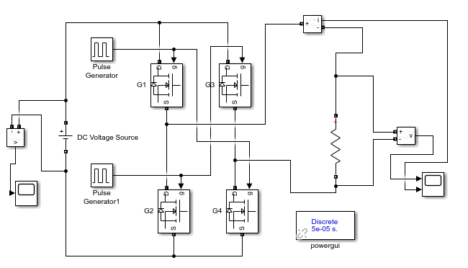

**Fig: [4.3] Modelling of DC-AC 2-Phase Inverter**

A high frequency triangular waveform known as the carrier signal and three reference sinusoidal waveforms (for three phase operation) at the same frequency as the desired output waveform are needed.

The method involves comparing the sinusoidal and triangular waveforms' magnitudes. The upper switch in the corresponding phase leg of figure (4) is engaged when the modulating signal's amplitude exceeds that of the carrier signal. This results in the output voltage matching the DC link voltage in magnitude, and vice versa.

Where ma is the modulation index and calculated as:

**Vrms = ma V_DC/2√ 2 ---eqn 1**

**Ma = Vm/Vcarrier ---eqn 2**

**4.3.1) Input Waveform of DC Converter:**

It is used to convert DC to AC current (Inverter), Single/Two phase Inverters.

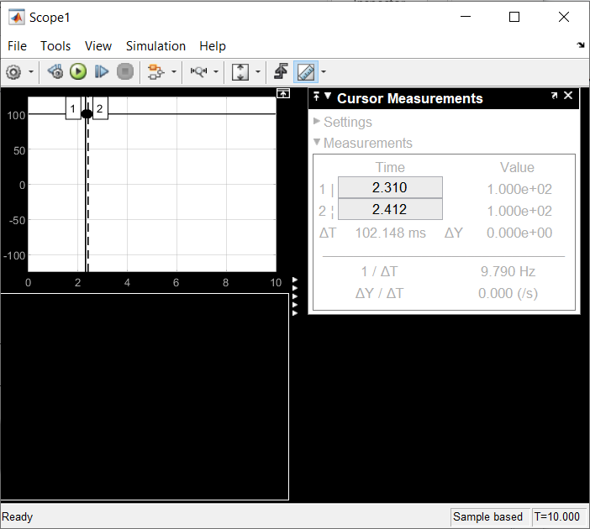

**Fig: [4.3.1] Input Waveform of DC Converter**

**4.3.2) Output Waveform of DC-Pulsated Converter:**

Generally Transistors(IGBT’s) are used to generate pulses.

Accordingly, it permits both active and reactive power flows from a load to a generator and from a generator to a load, depending on the applications. The flow control of both active and reactive power is well handled by the power switches.

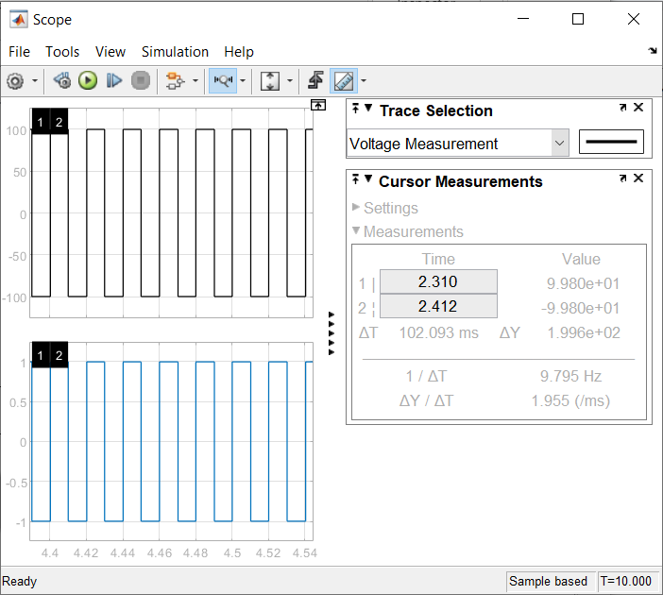

**Fig: [4.3.2] Output Waveform of DC-Pulsated Converter**

**4.4) Other Circuits:**

**4.4.1) FILTER CIRCUIT:**

A metre could be used to track the energy being extracted from or fed into the local supply network, just like a filter can be used for improved performance.

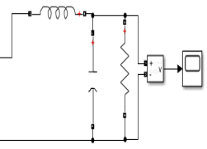

**Fig: [4.4.1] FILTER CIRCUIT**

**4.4.2) LOAD CIRCUIT:**

It is the element in charge of taking this energy and turning it into work.

**4.4.3) Band bass filter and Transformer** :

They are interconnected with the grid and the inverter. The filter type is an extremely narrow band pass filter with a 50 Hz centre frequency. to remove the system's injected harmonic distortion. The major purposes of the delta star transformer's introduction were to increase voltage and to capture triple order harmonics.

**4.4.4) Control circuit** :

For grid and PV voltage synchronisation, it uses grid parameters (voltage and current) and boost converter dc. A control circuit's goal is to generate a PWM signal for an inverter.

**Fig: [4.4.4] L,LC,LCL Control circuit**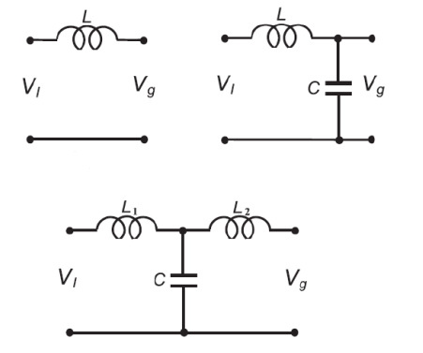

**4.4.5) Switching System** :

The system is not designed to inject power produced by the solar system to the house load instead

of the grid if the grid is offline in order to protect grid workers during maintenance and repair operations.

**4.4.6) Modulation technique for inverter** :

The inverter's switches must be turned on and off by the gate triggering pulses. DC signal to AC signal conversion. The pulses have been generalised using several technical methods.

Sinusoidal pulse width modulation and space vector based pulse width modulation the one that voltage source inverters use the most. The use of sine-wave pulse width modulation a part of this thesis.

**4.4.7) Pulse Width Modulation** :

With controlled magnitude and frequency, sinusoidal output is produced with the aid of PWM.

To create the sinusoidal output voltage, a triangular waveform and a sinusoidal control signal are compared. A triangular waveform's amplitude (Vtri) and switching frequency (fs) are typically kept constant. The triangle waveform's frequency served as the basis for the switching frequency. The duty ratio is moduled with the aid of the control signal Vcontrol. The fundamental frequency of the needed voltage is related to the frequency (f1) of the control signal (Vcontrol). As a result, f1 is also known as the modulating frequency. The fs is also known as the carrier frequency.

It is used to convert DC to AC current (Inverter), Single/Three phase Inverters.

Generally Transistors(IGBT’s) are used to generate pulses.

**5)Methodology and Working**

The following components make up the system:

A photovoltaic array converts solar radiation into dc voltage and current, and a DC-DC boost converter uses the (P&O) algorithm to follow the array's maximum power point. A three-phase inverter then changes the dc voltage to AC for grid interface or to serve a local load.

Before connecting to the utility grid, the delta star transformer steps up the output voltage and circulates zero sequences, and Control circuits are used to achieve MPPT control, synchronization, and switching. The band pass filter removes harmonic components from the inverter output.

The foundation for a computer simulation of a genuine system is modelling. Typically, it is founded on a theoretical examination of the physical structure of the cell.

The system's different physical processes in action, as well as every element affecting them. Models in mathematics are created and converted into computer codes for the simulation, detailing the system's properties.For a very long time, descriptions of the behaviour of solar cells have been provided by photovoltaic cell models.The most used model for predicting solar cell energy generation.

The single diode circuit model, which depicts the electrical behaviour of the pn-junction, uses modelling.

During the design of a solar generation system, the main area of attention is to determine the highest practical point. Another name for it is the maximal power point. It allows to ensuring that the PS system achieves the optimum level of output efficiency, which is typically being affected by the ambient factors, such as temperature and light intensity.

By using MPP tracking techniques, it is possible to determine the maximum operating point that corresponds to changes in the operational environment. The power converter is crucial in determining the PV system's maximum power operating point.

Utilizing the continuous power measurements is the algorithm. In order to reach the system's ideal operating point, the controller examines the input power signal to see if the system is using its maximum power point and then modifies the duty cycle accordingl

## 6) DISCUSSION OF RESULTS:

This paper presents a PV system which is connected to the grid where MATLAB/SIMULINK has been used for its simulation. The control system contains voltage control as well as current control schemes. The current control allows power factor control as well as voltage regulation of the DC link. However, PV model dynamics can be decoupled by current control from the distribution network and loads. The maximum power point tracking is achieved by voltage control and it also maximize the real output power of the PV panel. Photovoltaic (PV) system connected to the grid is designed by MATLAB/SIMULINK software that makes it easy to understand and also optimizes the design costs.

To start with, simulation test results have been presented for each PV module and for the entire PV array respectively. The PV array is shown in Figure 6-1; a total of 330 solar modules provide 100.7 kW under standard test and conditions (STC). The layout of the PV array consists of 66 parallel strings where each string has 5 series-connected SunPower modules (with specification SPR-305E-WHT-D as per Table 6-1). The PV array has an optimum capacity of 66*5*305.2 W = 100.7 kW at 25 ºC or STC

**6.1) Simulation of PV-System with low AC Output:**

**Using IGBT’s(Transistor for Swithching) & LC Filter,**

In this circuit model we will not get the boosted 230V-250V AC and perfect Sinosiodal waveform due to the LC filter which only filter some of the DC frequency(waveform).

Performance of PV system is analyzed in this case. PV system consists of PV array, boosttype DC/DC converter, VSC type DC/AC inverter, filter, coupling transformer and it is connected to load and grid as described in chapter 5. It has two parts – in Part (a), In this case, the irradiance and temperature assumed to be constant, the PV array generates electricity delivers power to the electrical load. The simulation starts assuming standard sunlight condition (1000 W/m2 and 25 ºC) when the maximum output power (100.7 kW) can be obtained from PV array. In Part (b), solar irradiance changes from 1000 W/m2 to 250 W/m2 . The output from the PV array drops to 24.3 kW. The simulation also considered the temperature variation from 25 ºC to 50 ºC; affecting output power varies PV array from 100.7 kW to 93 kW

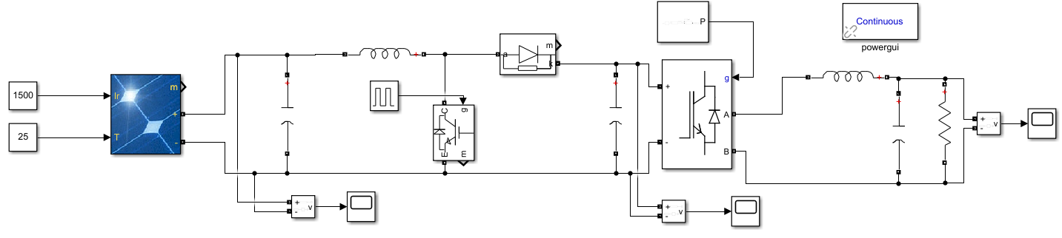

**Fig: [6.1] Simulation of PV-System with low AC Output**

**6.2) Output with Minimum and Distorted AC:**

The simulation result for Case 1 are obtained as follows:

1. Steady-state performance of PV system.
2. Performance of PV under varying operating conditions.

3. Simulation results of PV-BESS

The steady-state performance of PV system for Case 1 Part (a) is provided in Figure 6-7 to Figure 6-12. For this Simulation result, the irradiance and temperature are assumed to be constant for whole simulation time. From t = 0 sec to t = 0.05 sec, pulse to boost converter and VSC are blocked. PV voltage according to open circuit voltage reaches up to 321 V as shown in Figure 6-9. At t = 0.05 sec, the pulse to boost converter and VSC are de-blocked. Voltage is dc-link is regulated at 500v and duty cycle of the boost converter is fixed at 0.5.

Steady-state operation of PV reaches at t = 0.25 sec, where to power and voltage of PV array reaches at 96kw and 250v as seen in Figure 6-8 and Figure 6-9 simultaneously. However, the maximum power of specific PV array is 100.7 KW at 1000 w/m2 . The MPPT algorithm has been enabled at t = 0.5 to get the maximum output power of PV, it starts to regulate the voltage of PV by varying the duty cycle of the boost converter to get maximum power.

The maximum power (100.7kw) and voltage (274 V) are obtained at D = 0.545. The voltage and current are in phase at the 25kV bus

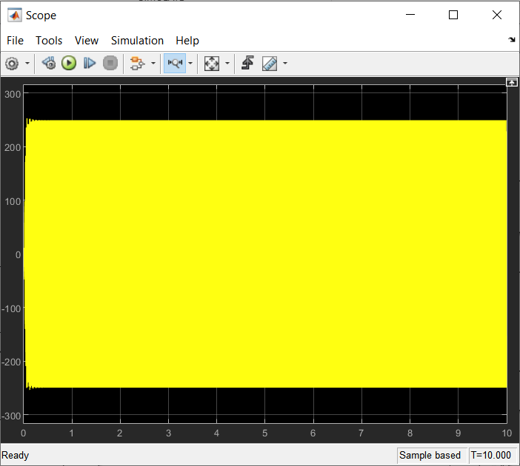

**Fig: [6.2] Output with Minimum and Distorted AC**

The Fig: [6.2] depicts that the output is distorted form of Alternating Current(AC) signal which cannot be feed into the residential, commercial, usage purposes, etc.

**6.2.1) Output fedded to Residential Buildings:**

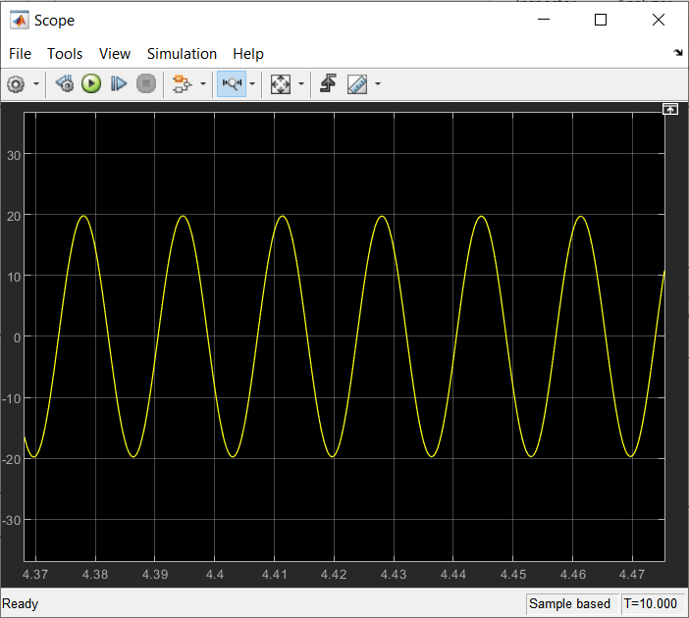

**Fig: [6.2.1] Output fedded to Residential Buildings**

## 7) DISCUSSIONS/SUMMARY:

**7.1) Conclusion:**

A practical case developed in MATLAB Simulink has been presented. Characteristics and Modelling of PV system is designed. Single/Three phase system of PV system has been analysed.

Inverter Transistors have been changed for better efficiency and dutycycle.

Overall model of PV system has been presented.

**Input Parameters** :

Temperature in deg Celsius =25

Incident Solar Radiation in Watt per meter square: - 1200

In this case, the irradiance and temperature are altered to see the behavior of PV system. In the case from the start of simulation to t= 0.6 sec, the irradiance is 1000 w/m2 . From t = 0.6 to t = 1.1 sec, the solar irradiance ramped down from 1000 w/m2 to 250 w/m2 and again from t = 1.2 sec to t = 1.6 sec, the solar irradiance ramped up from 250 w/m2 to 1000 w/m2 and temperature of PV array increased to 25 °C to 50 °C to observe the impact of temperature.

The output of PV array follows similar behavior as in case one until t = 0.6 sec, only the difference is MPPT algorithm enable immediately as the steady state output reaches at t = 0.25 sec to get maximum power. As the irradiance ramped down from 1000 w/m2 to 250 w/m2 during t = 0.6 sec to t = 1.1 sec and restored back from 250 w/m2 to 1000 w/m2 during t = 1.2 sec to t = 1.7 sec, the MPPT continue to track maximum power. At t = 1.2 sec, the duty cycle is 0.461, when the irradiance is decreased to 250 w/m2 , the output mean power and voltage are 268V and 24.3 KW. Impact of temperature has been analyzed when it is increased up to 50 °C at t = 2 sec, the output power decreases from 100.7 KW to 93 KW.

## 7.2) Boosted Input DC Waveform:

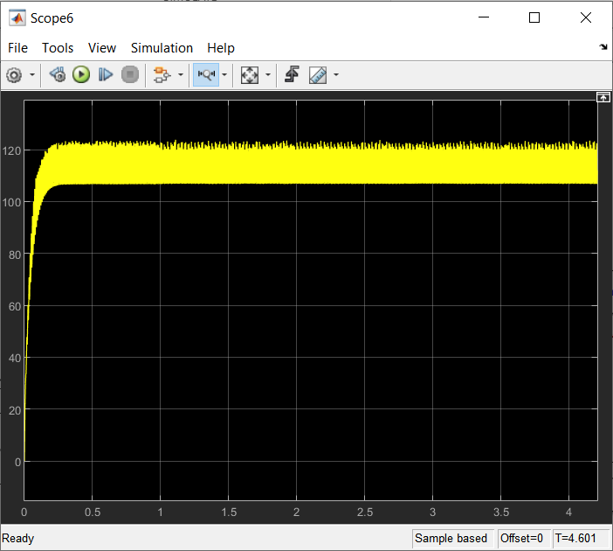

**Fig: [7.2] Boosted Input DC Waveform**

**7.3) Final Simulation of PV-System Output:**

Simulation test results of the proposed PV-BESS have been discussed in Chapter 6. MATLAB/Simulink has played a significant role to investigate the performance. The study showed that PV-BESS is a feasible approach to provide electric power to a load consistently in different irradiance conditions. Test results of PV-BESS have been recorded that exhibited a performance improvement over that of a PV system only that do not have any batteries. Further improvement in the controller of the BESS has been a suggestion to improve the overall power quality of PV-EBSS system. The simulation results provided in the thesis are taken for a short period of time because MATLAB takes a long time to run the simulation. But it provides the analogy with original changes in the atmosphere. The irradiance changes can be taken as an effect of moving clouds on the PV panel and thus the temperature.

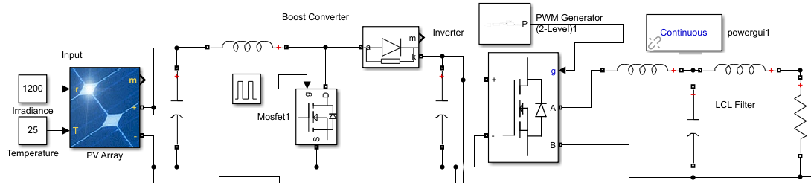

**Fig: [7.3] Final Simulation of PV-System Output**

**Circuit parameters Fig: [7.3]:**

R1 = 1 ohm

C= 0.002 F

Load resistance R = 1 ohm

Inductance L = 0.01 H

Duty Cycle (Switvhing Frequency): F(Hz) :50-70Hz ot Time(sec): 0.02sec (20ms)

Pulse width Modulation (PWM) & Pulse Generator : Square wave & Sinosiodal Waveform

The MATLAB/Simulink environment has been used in this thesis to carry out a wide range of simulations of the compound PV-BESS system. The design of the PV system model comprises the PV array, a boost-type DC/DC converter with a MPPT algorithm using incremental conductance and integral regulator technique,

three-phase VSC-type DC/AC inverter and its coupling transformer to connect to a load point and a point of common coupling of an equivalent power grid. The design of BESS model comprises the battery pack, a Cuk-type bi-directional DC/DC converter, a VSC-type DC/AC inverter and a coupling transformer connecting to the point of common coupling

**7.4) Final Output 230-240V AC:**

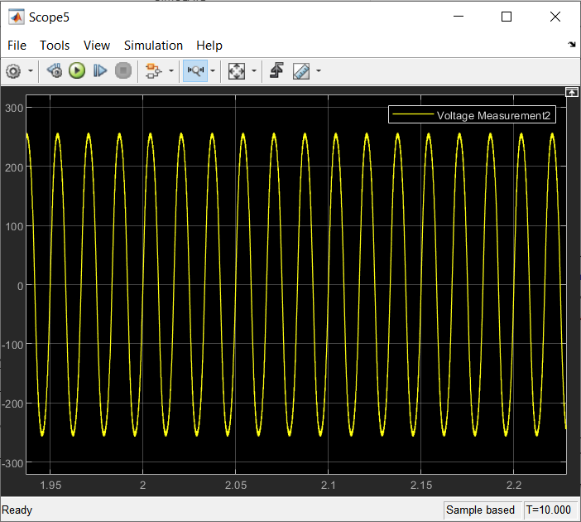

**Fig: [7.4] Final Output 230-240V AC**

**7.5) Future Work:**

The solar module's no-load voltage and short circuit current are discovered to be 85V and 12.7 A, correspondingly. the module's power output when a 1 ohm resistive load (which utilised was calculated to be (which resembled the output current and voltage waveforms) 150W. The DC power extracted was increased after connecting MPPT and boost converter.  to 320W. A repeating saw was used to set the operating frequency, which was 10 KHz.

generator for tooth Using a repeating sequence generator, the pulse signal was produced in the MPPT to supply the IGBT switch with a gate pulse.

Future work on this project will include the elimination of harmonics [12] in the grid connection system and operation of the PV system in a variety of physical and environmental situations, such as rapid changes in ambient temperature or variations in solar irradiance.

To further optimise and stabilise the energy curve, the energy exchange with the nearby electrical grid can be increased. Instead of utilising preset constant values, Simulink can be used to create more generalised solar cells with variable inputs for incident solar radiation and air temperature.

The research work reported in the thesis focuses mainly on active power compensation due to PV output power fluctuations. Scenarios of changes in active and reactive power requirements at the load point ought to be considered in any follow up research emanating from this thesis.

The changes in the environmental conditions assumed in this work are very contrived; future work should consider more realistic environmental scenarios of solar radiation and temperature on the PV panel and a measured daily demand curve at point of common coupling, where the load point is.

## 8) REFERENCES

1. 1. Sunil Kumar Goyal; Bhuwan Pratap Sungh, “Modelling and Simulation of a Solar PV System:
2. 10.1109/ICCAKM46823.2020.9051497,IEEE,2020.
3. 2.Nupur Yadav; D.K. Sambariya, “Mathematical Modelling and
4. Simulation of Photovoltaic Module Using MATLAB/SIMULINK”,
5. 10.1109/ICCCNT.2018.8494167, IEEE, 10-12 July 2018
6. 3.J. Ahmed and Z. Salam "An improved perturb and observe (P&amp;O) maximum power point tracking (MPPT) algorithm for higher efficiency" Applied Energy vol. 150 pp. 97-108 2015.
7. 4. C. Buccella C. Cecati H. Latafat and K. Razi "A Grid-Connected PV System with LLC Resonant DC-DC Converter" International Conference on Clean Electrical Power (ICCEP) pp. 777-782 June 2013.
8. 5.E. B. Ssekulima and A. A. Hinai, "Coordinated voltage control of solar PV with MPPT and battery storage in grid-connected and microgrid modes," 18th Mediterranean Electrotechnical Conference (MELECON), pp. 1-6, Lemesos 2016.
9. 6.Varshney A, Tariq A (2014) Simulink model of solar array for photovoltaic power generation system. Int J Electr Electr Eng 7(2):8
10. 7.Chedid, R.; Tajeddine, R.; Chaaban, F.; Ghajar, R., "Modeling and simulation of PV arrays under varying conditions,"in MediterraneanElectrotechnical Conference (MELECON), 2014 17th IEEE , vol., no., pp.536-542.
11. Kar, R. R., and Alam “Design and Modeling of High Power DC-DC Boost Converter for Solar Photovoltaic System”, In 2018 International Conference on Soft-computing and Network Security (ICSNS), pp. 1- 5 , February, 2018.
12. Sansare, V. A., Kasar, N. N., Gaikwad, A. A. “Design of standalone PV charging system for lead acid battery using controlled boost converter””,pp. 589-594, September 2017.
13. Patel, R. N. and Sinha, S. K. “Performance analysis of system integrated with boost converter for low power applications”. Advances in Interdisciplinary Engineering. ,pp. 879-890 , 2019.
14. Premalatha Kaliannan, Nandhini Jyothi and Kavitha Rangasamy, "Modeling and Analysis of Positive Output Luo Converter in Voltage Control Mode", Electrica, , 2021, Vol.21, No. 2, pp. 259-271.
15. Sunil Kumar Goyal; Bhuwan Pratap Sungh, “Modelling and Simulation of a Solar PV System: A Comprehensive Study”, 10.1109/ICCAKM46823.2020.9051497,IEEE,2020
16. Youness Ouberri, Hanane Yatimi; Elhassan Aroudam, “Industrial Automation PLC-based modeling and diode ideality factor impact on PV characteristics”, 10.1109/ICCSRE.2019.8807632,2019.
17. Nupur Yadav; D.K. Sambariya, “Mathematical Modelling and Simulation of Photovoltaic Module Using MATLAB/SIMULINK”, 10.1109/ICCCNT.2018.8494167, IEEE, 10-12 July 2018.





















 



 



















