DIY Digital Joystick

Atari CX-40 Compatible
Build Guide

Author: Justin Lane (atari2600@jigglesoft.co.uk)
Date: 2019-07-10 20:50
Version: 0.1.0

Table of Contents
Introduction 3
Requirements 4
Parts List / Bill-of-Materials 5
Parts Details 6
Enclosure 6
Joystick 7
Button 8
Cable Pre-Moulded DE-9 Female 9
Cable 10
Cable Connector 11
Crimp Connector 12
Cable Strain Relief 14
Rubber Feet 15
Step-by-Step Build Guide 16
Completed Item 17
First Version 17
Final Version 18
Initial Design 18
Final Item 19

Introduction
This document details the parts and build of a modern day version of the classic Atari CX-40 Joystick. This has been designed primarily for use in an Atari 2600 FPGA project, but will also have service on my Commodore 64.

After making the initial version I have been informed of several others most notibly:-
- Roman Kubat
  - https://ccomodore64.blogspot.com/2018/05/budowa-joysticka-typu-arcade-do.html

Requirements
- Atari CX-40 Joystick compatible.
- Dimensions and layout similar to the Atari CX-40 Joystick.
- Off the shelf components.
- Arcade quality parts.
- Cost effective (parts less that £20 GBP).
- 9-pin DE-9 connector (moulded if possible).
- Build simplicity and functionality over asthetics.

Parts List / Bill-of-Materials

Number OEM Part Number Name Description Cost URL

Enclosure
Joystick
Button
Cable Pre-Moulded DE-9
Cable
Cable Connector (6 position) 6A
Crimp connector
Washer
Screw
Grommit
Gromitt

Item | Description | Notes | Cost | Qty | Total
1 | Enclosure |  | £3.31 | 1 | £3.31
2 | Joystick | £8.78 each or £15.99 for two. | £8.89 | 1 | £8.89
3 | Button | £5.12 for a pack of ten. | £0.51 | 1 | £0.51
4 | Cable Pre-Moulded DE-9 Female | £4.99 for a pack of two. | £2.50 | 1 | £2.50
5 | Cable |  |  | 10
6 | Cable Connector !!!! | £1.15 for 1x12. 1x6 required. | £0.58 | 1 | £0.58
7 | Crimp Connector !!!!Fully Insulated Female Spade Terminals Crimp Connector & Male Tab Terminal Mix  Qty: 100  Colour: Red  Size: 4.8mm | £3.75 for a pack of 100. | £0.04 | 8 | £0.30
8 | Washer !!!!! |  |  | 4
9 | Screw!!!!! |  |  | 4
10 | Cable Strain Relief  Grommit / Strain Relief  Cable Protection Strain Hose Inner Holes 4mm Sleeve Power Relief Wire Black | £2.45 for a pack of 5. | £0.49 | 1 | £0.49
11 | Rubber Feet | £3.95 for a pack of 12. | £0.33 | 4 | £1.32
TOTAL |  |  |  |  | £17.90

Parts Details

Enclosure
Hammond 1591, Enclosure, IP54, 112.5 x 84.6 x 41.3mm
RS Stock No. 818-0501 Mfr. Part No. 1591XXSSBK Brand Hammond
https://uk.rs-online.com/web/p/products/8180501/
Price Each: £2.84 (exc. VAT), £3.41 (inc. VAT)

Joystick
Zippyy Long Shaft Ball Top Arcade Joystick 2/4/8 Way (Black) Zippy - MAME, JAMMA

https://www.ebay.co.uk/usr/extreme-hardware
£8.89 each or two for £15.99

Quite like the look of these.
£9.99 each or two for £15.99 with free delivery.
Unsure of dimensions and if they would fit the enclosure.
Baolian Korean Style Bat Top Arcade Joystick, 4/8 Way (Red) - MAME, JAMMA

Button
10pcs 24mm push buttons replace for arcade button games parts of 7 colors new UK
https://www.ebay.co.uk/usr/3706442
£5.12 each (pack of 10) (free delivery).

Cable Pre-Moulded DE-9 Female
2 Pack 9 Pin Extension Cable for Sega Genesis 2 3 Megadrive 2 Controller
https://www.ebay.co.uk/usr/importsportslover
£4.99 each (pack of 2) (free delivery).

It was cheaper to buy these extension cables and cut off the male end than to buy the specific

Joystick cables. They are slightly shorten in length though, but even buying two of them and using one as an extension is cheaper than a single specific Joystick cable.

Pin | Colour | Atari 2600 Joystick Signal [non-joystick signal] (cable colour)
1 |  | Up (white)
2 |  | Down (blue)
3 |  | Left (green)
4 |  | Right (brown)
5 |  | Not connected [B potentiometer]
6 |  | Button (orange)
7 |  | Not connected [+5 Volts]
8 |  | Ground (black)
9 |  | Not connected [A potentiometer]

Please check your own pin and cable assignments as they may differ to the above.

Cable

Cable Connector
5 Pcs X3-0512 400v 6a 12 Position 2 Row Plastic Screw Terminal Block FP
https://www.ebay.co.uk/usr/digital-paradise9

£2.07 (54p each)

!!!! 6A 2 x 12
1 x 12 Way Electrical Connector Strips Terminal Blocks Wire Joiner 3/5/15/30/60A
5A
https://www.ebay.co.uk/usr/zetmetltd

£1.15

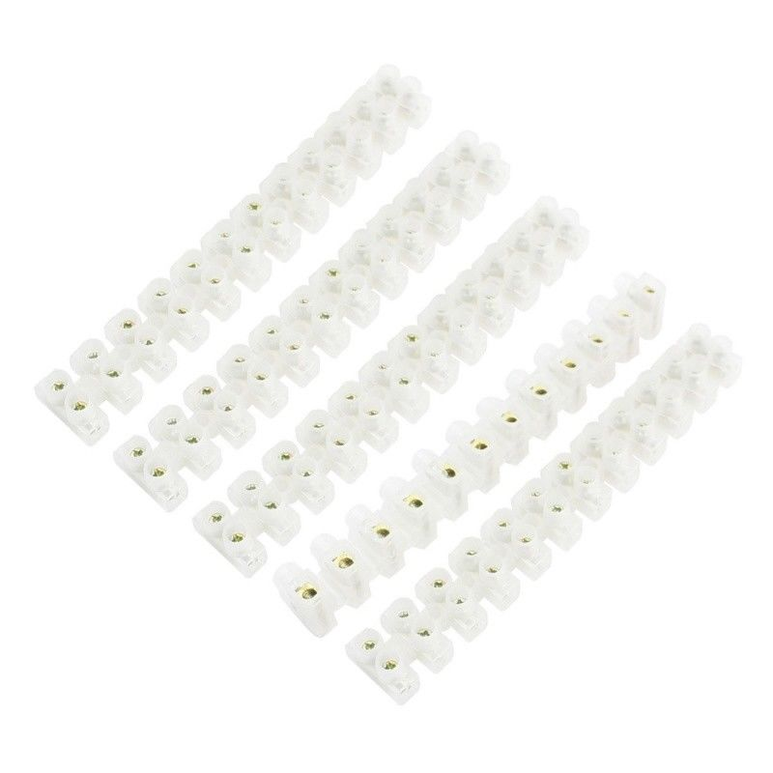

Crimp Connector
!!!!Fully Insulated Female Spade Terminals Crimp Connector & Male Tab

Terminal Mix
Qty: 100
Colour: Red
Size: 4.8mm
https://www.ebay.co.uk/usr/js-tradinguk?_trksid=p2047675.l2559
£3.75

Washer !!!!!

Screw!!!!!

Grommit / Strain Relief

Cable Strain Relief
Cable Protection Strain Hose Inner Holes 4mm Sleeve Power Relief Wire Black
https://www.ebay.co.uk/usr/m-house
£2.45 pack of 5.

Rubber Feet
RUBBER FEET Self-Adhesive Stick On Polyurethane Bumper Door Buffer Stop Bumpons
EZ102 12mm x 3.2mm (Black)
https://www.ebay.co.uk/usr/convertape
£3.95 pack of 12.

Step-by-Step Build Guide

TODO

Completed Item

First Version

Final Version

Initial Design

Final Item

