Lab 4 VibeCoding Chat History
Donkey Kong Repair Lab
Field | Details
SRN | PES2UG24AM110
Student GitHub | Paturu Naga Jignas
Source repository | https://github.com/SETAPESU26/30_donkeykong
Personal fork | https://github.com/JignasP/30_donkeykong

This document records the AI-assisted workflow used to inspect, repair, test, document, and push the Donkey Kong lab. The four required code tasks were completed as separate commits and pushed only to the personal fork. The native conversation link above provides the full shareable chat view; this document preserves the user requests, substantive responses, implementation evidence, and submission details in Word format.

Assignment Scope
The lab required the student to inspect the assigned Pygame repository, record the original behavior, fix one deliberate bug, add three features, verify the game, keep separate commits for each task, record the completed behavior, and avoid opening a pull request to the course repository.
Task | Required result
1 | Change barrel ladder descent from about 70 percent to about 30 percent.
2 | Implement a readable score-based background color.
3 | Show a short-lived effect when the player jumps over a barrel.
4 | Activate a numeric score multiplier during later gameplay.

Chronological Chat History

Repository and Prompt Request
User Provided Lab_4_VibeCoding_Student_handout.pdf and the assigned repository https://github.com/SETAPESU26/30_donkeykong, then asked for a prompt to complete the lab.
Assistant Reviewed the handout and repository README, identified the four tasks and submission constraints, and produced an implementation prompt. The full prompt is reproduced in Appendix A.

Lab Start and Fork Setup
User Asked to shorten the prompt, start the lab work, and create a submission checklist.
Assistant Cloned and inspected the repository without changing the code. Confirmed that the initial origin pointed to the course repository and stopped before editing so the required before video could be recorded.
User Asked to place the work in the user's GitHub fork.
Assistant Opened GitHub sign-in, created https://github.com/JignasP/30_donkeykong, configured the local origin to the personal fork, preserved the course repository as upstream, and set main to track origin/main.

Before Video
User Asked the assistant to record the video.
Assistant Installed Pygame in an isolated local environment, captured 12 seconds of the unmodified game at 800 by 600 and 30 frames per second, verified the video, and kept the repository unchanged.

Implementation and Verification
User Said continue after the prerequisite recording was complete.
Assistant Implemented each task in sequence, compiled and tested the code after every meaningful change, created four separate commits, ran a broader headless verification, recorded the completed game, and pushed the commits to the personal fork without opening a pull request.

Submission Export
User Said continue after the code and videos were complete.
Assistant Created the public conversation link https://chatgpt.com/s/cx_6abe00d41c18819193494051ccd8ebfb for the required chat submission.
User Asked to export the conversation in a Word document.
Assistant Created this Word export and verified its rendered pages before delivery.

Implementation Results
Task | Change | Commit
1 | Changed the Barrel probability check from 0.7 to 0.3. | a9a04d5
2 | Added a capped navy-to-warm background gradient from score 0 to 1500. | f6de36a
3 | Added a rising, fading jump label that expires after 0.8 seconds and clears on reset. | 6929efb
4 | Added 2x barrel-jump scoring at 500 points and accurate +100 or +200 labels. | b601625

Verification Results
- Python compilation completed without syntax errors.
- A 10,000-barrel simulation measured a 29.8 percent ladder descent rate.
- Player movement, slopes, jumping, gravity, ladder range, and platform traversal passed automated checks.
- The floating effect rendered, moved, faded, and expired without leaving stale effects.
- The multiplier returned 1x below 500 points and 2x from 500 points onward.
- Automated scenarios reached the win state and the zero-lives game-over state.
- The Git working tree was clean and main matched origin/main after the push.

Video Evidence
Both videos are 12 seconds long, use H.264 video at 800 by 600 resolution, and contain 360 frames at 30 frames per second.
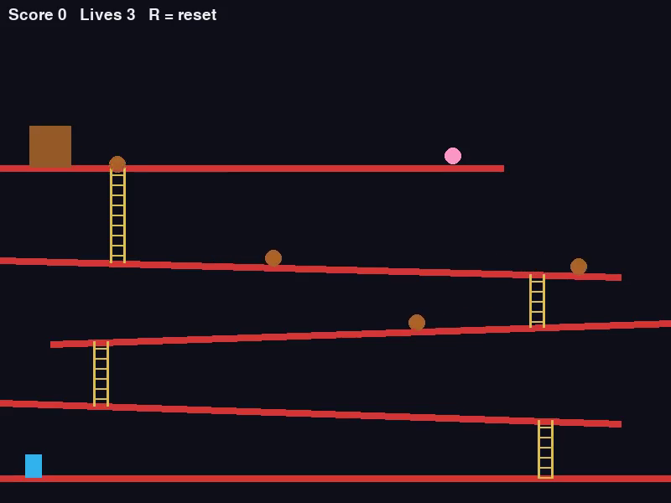
Figure 1 Before changes with the original barrel behavior
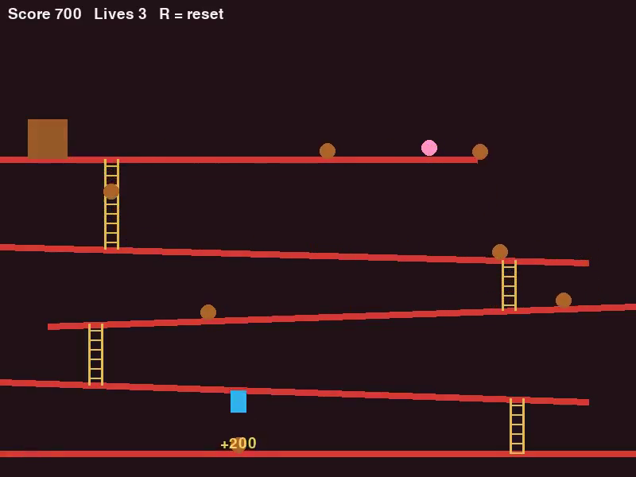
Figure 2 After changes showing the warmer theme and 2x jump bonus

Artifact | Local path
Before video | C:\Users\Jignas\Desktop\se-bananaaaa\Lab-4\before_changes.mp4
After video | C:\Users\Jignas\Desktop\se-bananaaaa\Lab-4\after_changes.mp4

Repository and Submission Status
Personal fork https://github.com/JignasP/30_donkeykong
Course repository https://github.com/SETAPESU26/30_donkeykong
Conversation link https://chatgpt.com/s/cx_6abe00d41c18819193494051ccd8ebfb

Submission Checklist
- [x] Before video recorded and verified
- [x] After video recorded and verified
- [x] Four separate task commits created
- [x] Code pushed to the personal fork
- [x] No pull request opened to the course repository
- [x] Conversation share link created
- [x] Chat history exported to Word
- [x] Upload the two videos and this Word file to the required Lab-4 submission location

Appendix A Implementation Prompt
The prompt below was prepared from the lab handout and repository README and then used as the working specification.
You are an autonomous coding assistant working on this repository:
https://github.com/SETAPESU26/30_donkeykong
Complete the Donkey Kong Repair Lab while preserving the existing game's behavior and structure.

Before Changing Anything
- Read README.md and inspect all of game.py.
- Check Git status and remotes.
- Record the required 10-second before video before editing.
- Never push to SETAPESU26/30_donkeykong or open a pull request against it.

Task 1 Fix the Ladder Descent Bug
- Find the probability check in the Barrel class.
- Correct it so barrels descend a ladder approximately 30 percent of the time instead of approximately 70 percent.
- Preserve barrel movement, platform collision, and ladder mechanics.
- Commit the task separately.

Task 2 Implement Theme Color
- Return a valid RGB tuple or None.
- Make the background gradually warmer as score increases while preserving contrast.
- Keep every component between 0 and 255.
- Commit the task separately.

Task 3 Implement Barrel Jump Effect
- Add a clear, short-lived effect such as a floating score label.
- Make the effect disappear automatically and avoid an unbounded collection.
- Keep the single-file design unless another file is necessary.
- Commit the task separately.

Task 4 Implement Score Multiplier
- Return a numeric multiplier or None.
- Use a documented score threshold that activates a 2x barrel-jump bonus.
- Ensure the result works with the existing 100-point bonus calculation.
- Commit the task separately.

Verification Requirements
- Install Pygame only if it is missing.
- Compile and run game.py.
- Verify movement, jumping, gravity, slopes, ladders, barrel platforms, scoring, win, game-over, and reset behavior.
- Measure barrel descent over a meaningful sample.
- Verify the theme, jump effect, and multiplier.
- Record the required after video.
- Report commit hashes, tests, manual checks, safe push commands, and the submission checklist.

Git and Submission Rules
- Create one commit for each task.
- Push only to the personal fork.
- Do not rewrite history or use destructive Git commands.
- Submit the before video, after video, updated code, and complete chat history.

