ROI_SETTLING and MONITORING
An in-depth walkthrough of the two Scene FSM states that do the actual work
Belt Loader Detection Pipeline

1. Introduction
This document explains, in depth, the two Scene FSM states that carry all of the pipeline's real work: ROI_SETTLING (establishing a trustworthy belt-axis fit before anything downstream is allowed to use it) and MONITORING (continuously verifying that fit while running the full bag-detection, tracking, and activity-classification pipeline). Every mechanism described here is drawn directly from the current implementation — scene/scene_fsm.py, roi/roi_manager.py, roi/belt_detector.py, roi/roi_health.py, scene/cover.py, scene/dock.py, and the relevant per-frame loop in main.py — not from the original design spec, so a few places note where the implementation goes beyond, or intentionally simplifies, that spec.
Three diagrams accompany the text: a compact Scene FSM overview showing where these two states sit relative to the other four, and a detailed per-frame flowchart for each of the two states in question.

2. Where These States Fit
The Scene FSM (scene/scene_fsm.py) has six states: INIT, NO_BELT, BELT_PRESENT, DOCKED, ROI_SETTLING, and MONITORING. Presence detection (is a belt loader visible at all) and dock detection (is it stationary, boom raised, adjacent to the aircraft) run every frame regardless of state — they are never paused, even inside ROI_SETTLING or MONITORING — because the pipeline must notice the belt departing or undocking at any time.
DOCKED transitions into ROI_SETTLING immediately, with no waiting period of its own (the code comment calls this “a pass-through, not a waiting period”) — all of the actual settling time is spent inside ROI_SETTLING itself, via its own stability window. This matters because it means “how long after docking does monitoring start” is entirely governed by ROI_SETTLING's own parameters (min_settle_s, window_s, and how quickly the belt-axis fit actually stabilizes), not by any separate dwell timer at the DOCKED stage.
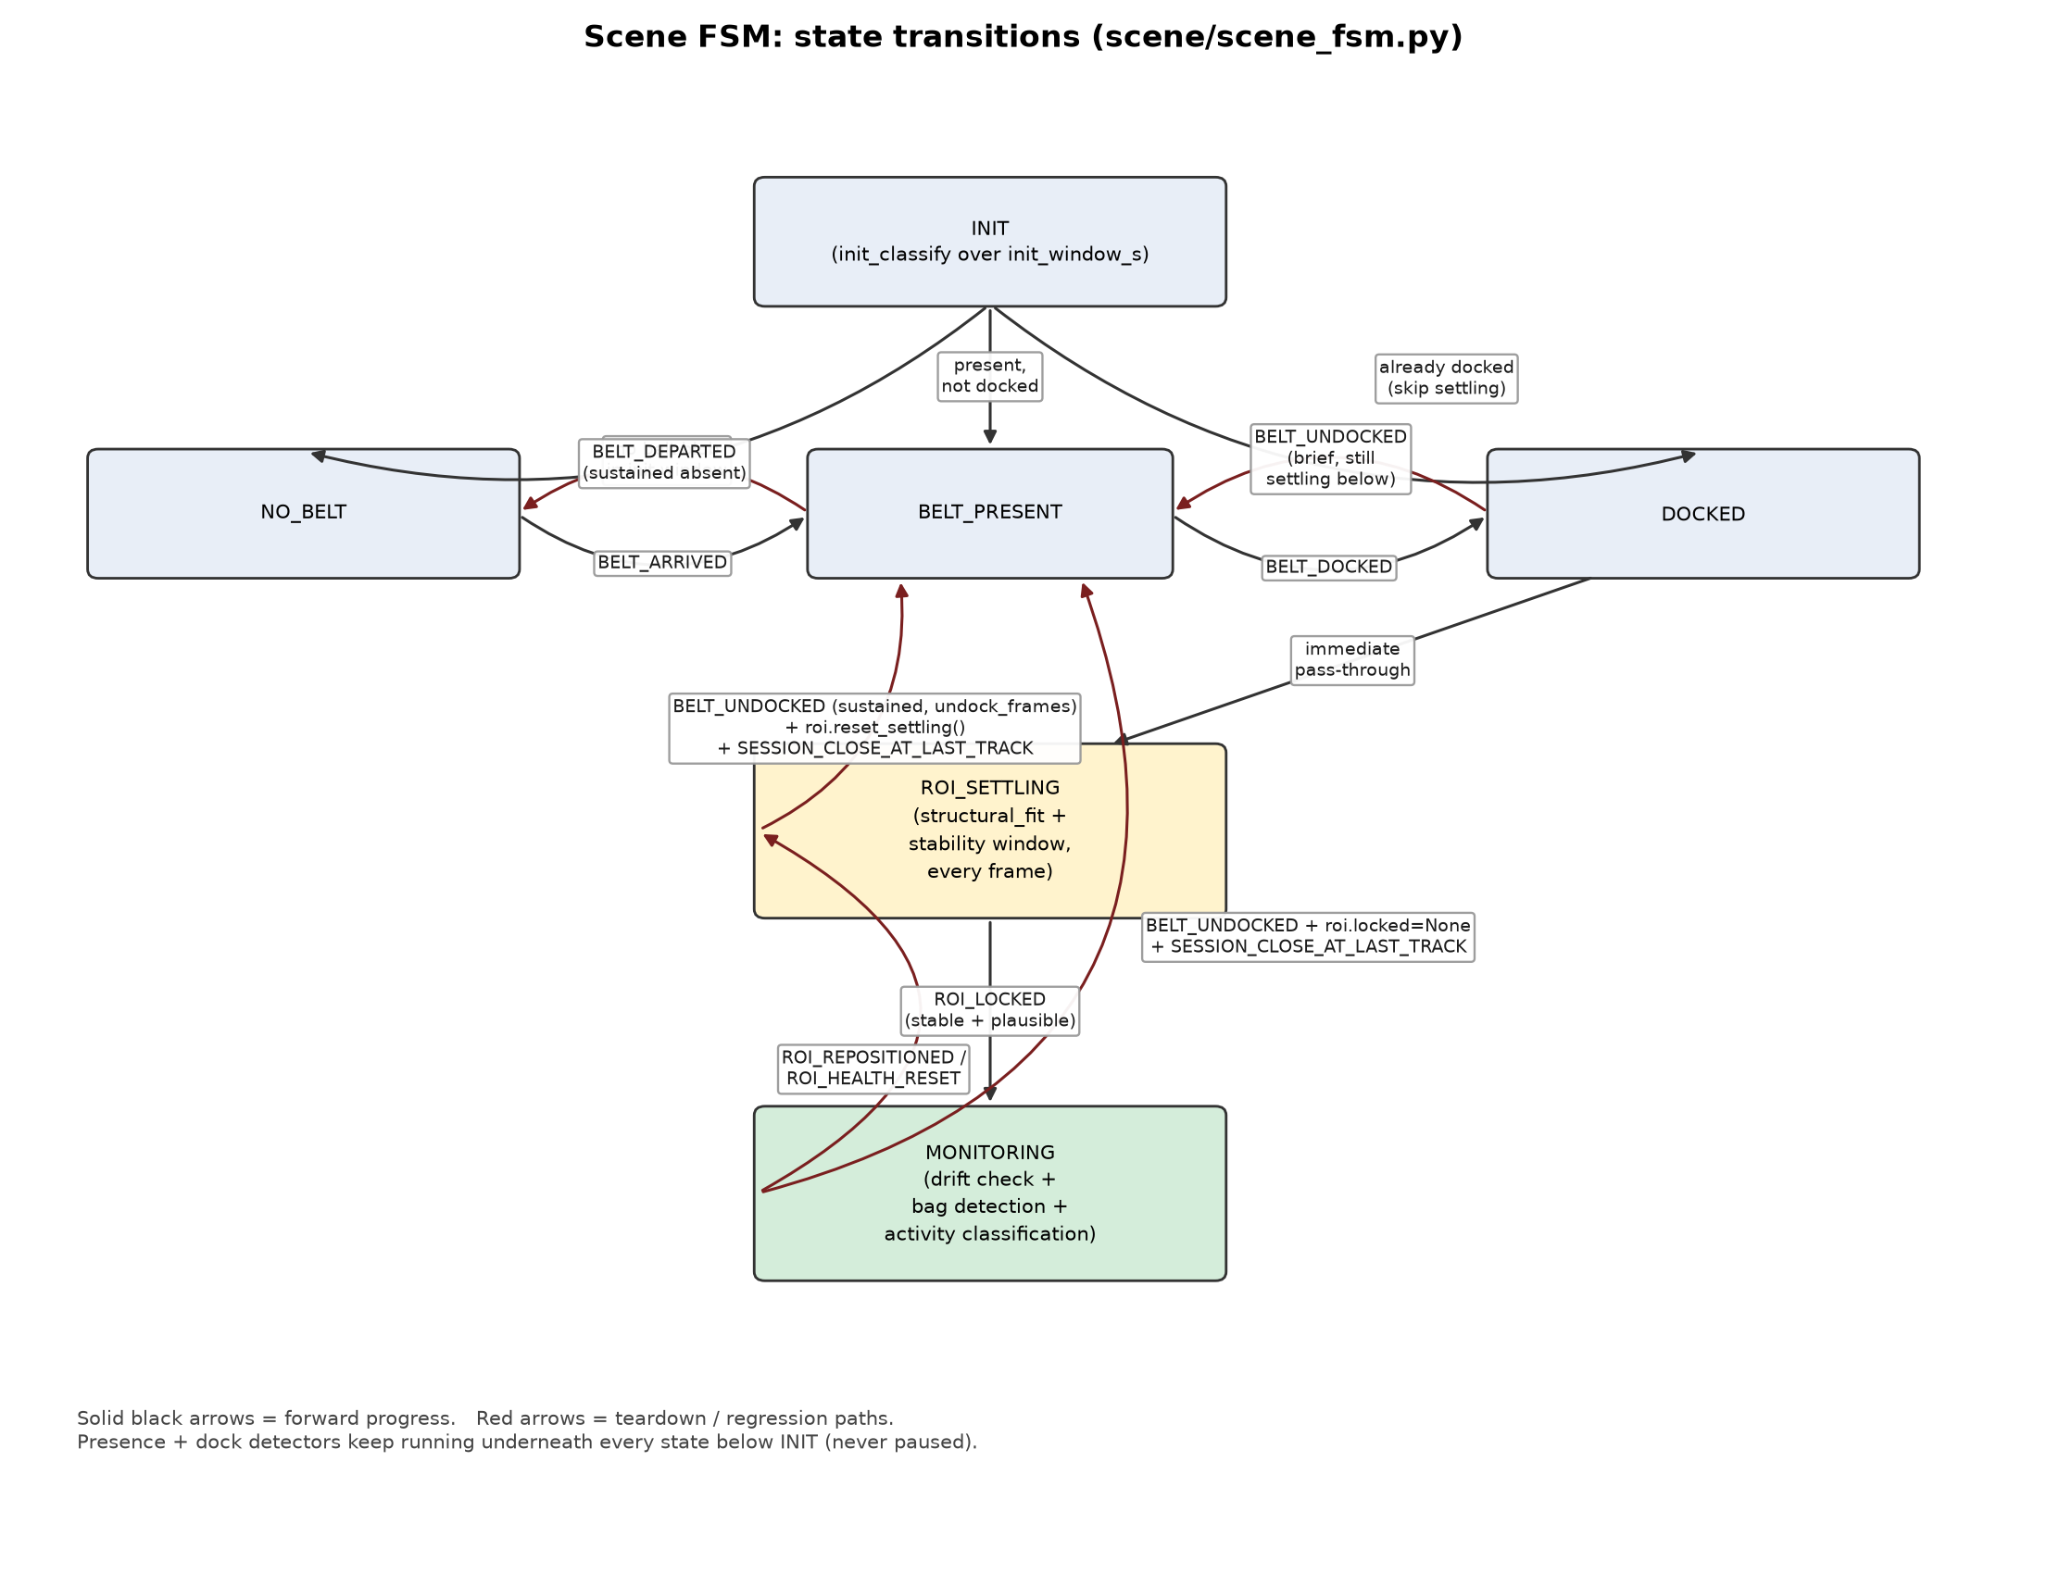
Figure 1 — Scene FSM state transitions. Black = forward progress, red = teardown/regression.
Two things are easy to miss on first reading and are worth calling out explicitly:
- Both ROI_SETTLING and MONITORING can fall all the way back to BELT_PRESENT (not just to each other) if the dock condition is lost for long enough — the belt doesn't have to unlock cleanly first.
- MONITORING can drop back to ROI_SETTLING for two independent reasons (ROI_REPOSITIONED from the drift monitor, or ROI_HEALTH_RESET from the health watchdog) — both re-run the exact same settling logic described in Section 3, they just arrive there from a different trigger.

3. ROI_SETTLING In Depth

3.1 Purpose
ROI_SETTLING exists because a single frame's belt-axis fit is not trustworthy enough to build a locked ROI from directly. At the resolutions these clips are shot at, one frame's Hough-line / color-blob fit has real noise (the same root cause documented repeatedly in this project's own calibration notes: “single-frame Hough rail fit noise at this resolution exceeds the shared defaults”). ROI_SETTLING's entire job is to keep re-fitting the axis every frame, accumulate a short window of those fits, and only commit to a lock once that window is both numerically stable and structurally plausible.

3.2 Per-frame mechanics
Every frame the Scene FSM is in this state, the following sequence runs (scene/scene_fsm.py's ROI_SETTLING branch, calling into roi/roi_manager.py):
1. Presence + dock update (always). Even while settling, presence.update() and dock.update() keep running — REQ-17 requires this so an undock or belt departure is never missed just because the ROI hasn't locked yet.
2. Docked check. If dock.docked is false this frame, not_docked_streak increments; once it reaches undock_frames (derived from dock.window_s), the state falls back to BELT_PRESENT, emits BELT_UNDOCKED, and calls roi.reset_settling() to discard whatever partial settling progress existed. If a session happened to be open (shouldn't normally happen pre-lock, but the code is defensive here), it is closed at its last-track timestamp, never at “now.”
3. RoiManager.structural_fit(frame, loader_bbox). Crops a padded region around the presence blob's bounding box and calls BeltDetector.detect_single() (roi/belt_detector.py) on that crop. This is the hypothesis-driven axis detector: only long, moderately inclined Hough segments (3–55°, with a parallel-line geometry filter so a lone curved fuselage/engine edge can't seed a false axis on its own merit) may propose a candidate axis; yellow rail-color evidence and frame-to-frame motion evidence only verify a proposal, scored as an absolute, capped vote, so ground paint or unrelated clutter elsewhere in frame can never outvote a genuine rail pair. The winning hypothesis gets a Huber-loss line fit (robust to residual outlier points) for direction, then its endpoints are re-derived from all evidence in a wider corridor around that axis, since a single seed line under-spans the belt due to perspective.
4. Is the fit None? If BeltDetector found no usable axis this frame (no qualifying segments, or the fit failed the 3–55° incline gate), this frame is simply skipped — no history update, no penalty, just wait for the next frame.
5. EMA-smooth and accumulate. A successful fit is exponentially smoothed (alpha=0.15) against the running estimate, then appended to a rolling history window sized by roi.window_s. This damps the same per-frame noise BeltDetector itself can't fully remove.
6. Minimum settle time elapsed? min_settle_s is tracked as elapsed wall/frame time since settling began, independently of whether the history deque has filled — by design, window_s is deliberately shorter than min_settle_s, so the deque filling up can never by itself satisfy this check. Both conditions (history full AND min_settle_s elapsed) must hold before the next check even runs.
7. Stability check. Once eligible, the standard deviation of center position, angle, and length across the whole history window is compared against center_std_px, angle_std_deg, and length_std_px (each scaled by the frame's px_scale, since the pipeline runs on eight differently-sized clips from one shared threshold set). If any one of the three is too noisy, settling simply continues — no penalty, no blacklist, just keep accumulating.
8. Plausibility check — _plausible(). A fit can be perfectly stable and still be wrong (locked onto the loader's chassis edge, or a ground marking, for instance). This check independently verifies: the fit's aspect ratio (length/width) sits inside aspect_band; its width (converted back to raw pixels via px_scale) sits inside width_band_px; if a boom angle is available from the dock detector, the fit's angle is within angle_band_deg of it; and the fit's rotated-rect polygon overlaps the presence blob's bounding box by at least overlap_min. (The check deliberately uses the loader's bounding box, not its raw color mask, since the color mask only captures the canopy's saturated top surface and systematically undershoots the loader's real footprint.) A stable-but-implausible fit clears the history and keeps settling — it is not blacklisted, since a nearly-right fit that clips a nearby edge is common and the correct fit usually lands close to a rejected one.
9. Lock. Once a fit is both stable and plausible, RoiManager builds a LockedRoi: the axis unit vector (oriented toward the aircraft per camera.aircraft_end's convention), the resolved aircraft-side and ground-side anchor points, the rotated rectangle polygon for rendering, and a generation counter that is bumped on every new lock or reposition-relock (this counter is what main.py later uses to know when the strip-warp mapping and its background model have gone stale — see Section 4.4). ROI_LOCKED is emitted and the Scene FSM transitions to MONITORING.
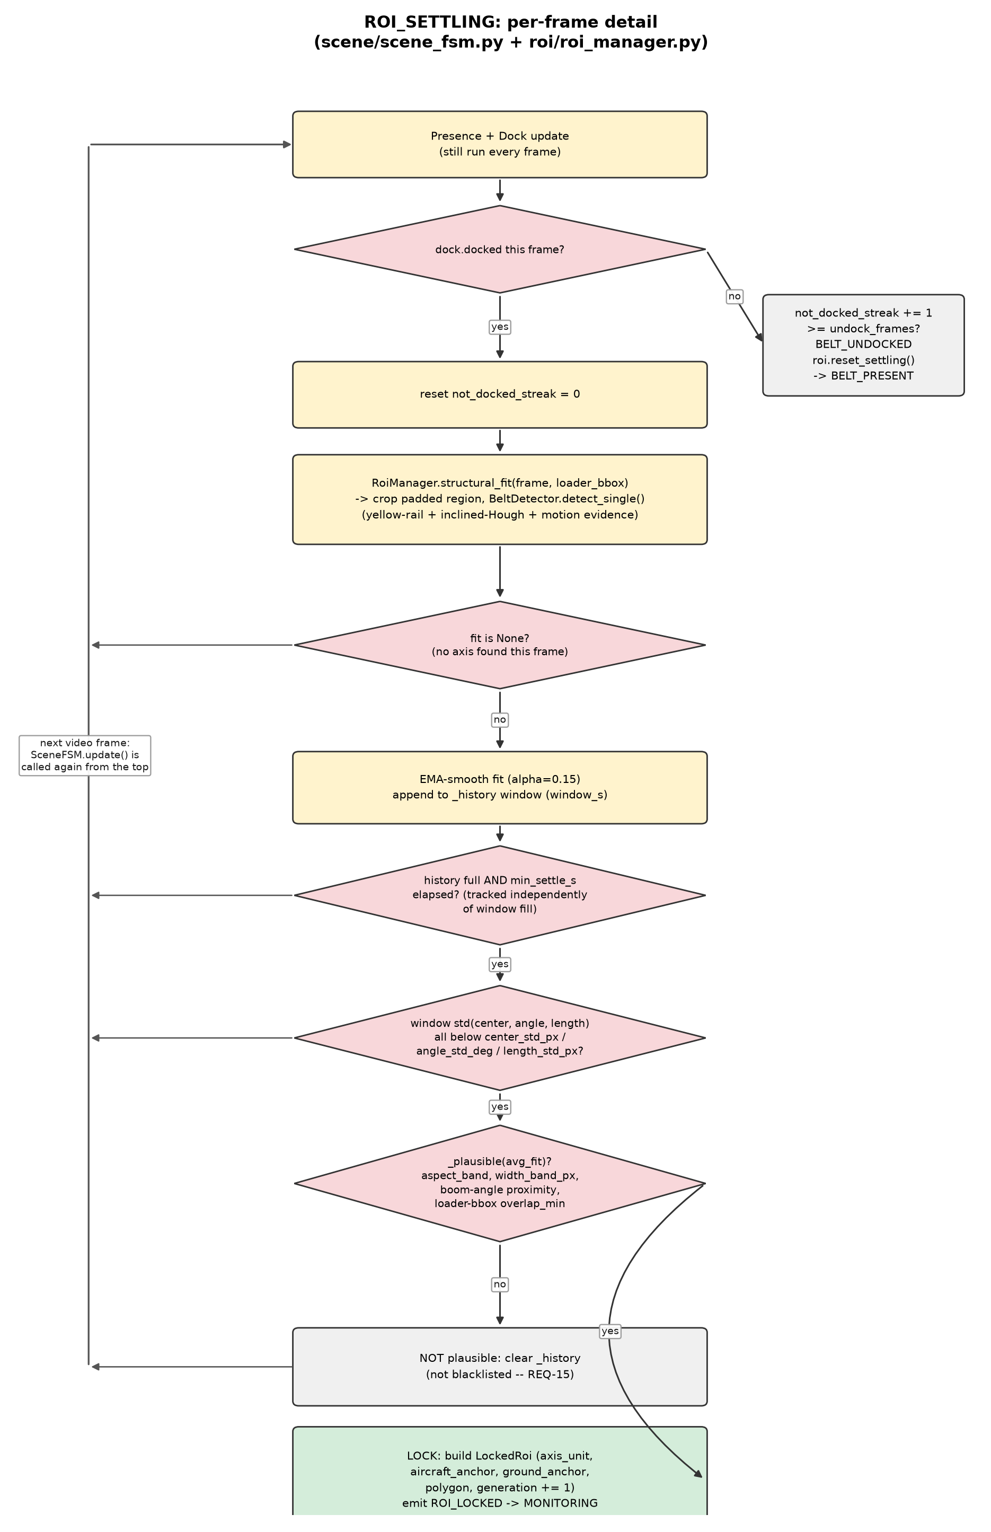
Figure 2 — ROI_SETTLING per-frame flow. Every “not yet” branch simply waits for the next frame's call rather than looping to some arbitrary earlier step — shown here as a shared bus back to the top.

3.3 Configuration reference (RoiConfig)
Field | Meaning
pad_px | Padding added around the fitted length/width when building the final RoiFit (before px_scale).
window_s | Length of the rolling stability-check window, in seconds.
min_settle_s | Minimum elapsed settling time before a lock is even considered, tracked independently of window fill.
center_std_px / angle_std_deg / length_std_px | Per-parameter noise tolerances for the stability check, scaled by px_scale.
aspect_band | [min, max] acceptable length/width ratio for _plausible().
width_band_px | [min, max] acceptable raw-pixel width for _plausible().
overlap_min | Minimum polygon/loader-bbox overlap fraction for _plausible().
angle_band_deg | Maximum allowed angle deviation from the dock detector's boom angle.
drift_check_s / drift_tolerance_mult / drift_consecutive | MONITORING-only — see Section 4.2.
rail_hsv_lo / rail_hsv_hi | [PER-CAMERA] yellow-rail color band consumed by BeltDetector.
roi_min_points | Minimum evidence points BeltDetector needs before attempting a Huber fit.
roi_halfwidth_frac | Belt half-width as a fraction of fitted length (a geometric ratio, not a direct rail-width measurement — this was the root cause of two oversized-ROI bugs found and fixed this project, on D01/N01 and separately on N02).
roi_hypo_band_frac | Co-linearity tolerance (as a fraction of frame width) used when scoring competing axis hypotheses.

In practice, nearly every calibrated clip in this project has needed its own center_std_px / length_std_px / angle_std_deg / width_band_px overrides in its configs/conv_full_<clip>.yaml — the shared defaults were sized for cleaner fits than this pipeline achieves in practice at these resolutions, and this is treated as expected per-installation calibration (analogous to the presence HSV band), not a bug to be fixed once for all cameras.

3.4 Exit paths
- ROI_LOCKED — stable and plausible → MONITORING.
- BELT_UNDOCKED — dock condition lost for undock_frames → back to BELT_PRESENT, settling state discarded.

4. MONITORING In Depth

4.1 Purpose
MONITORING is where the pipeline actually produces its output. Two largely independent concerns run every frame here: the Scene-FSM side keeps re-verifying that the locked ROI is still correct (drift, health, cover), while main.py's per-frame loop runs the full bag-detection → tracking → direction-vote → activity-classification → event-logging pipeline, but only once state == MONITORING and roi.locked is not None.

4.2 Scene-FSM-side verification
• Presence + dock, still running. Identical to ROI_SETTLING: if dock.docked goes false and stays false for undock_frames, the state falls back to BELT_PRESENT, roi.locked is cleared, roi.reset_settling() runs, and any open session is closed at its last confirmed-track timestamp (SESSION_CLOSE_AT_LAST_TRACK).
• structural_fit() runs again, every frame. The same BeltDetector call used during settling keeps running purely to feed the drift check below — MONITORING never stops asking “where does the belt axis look like it is right now.”
• _update_drift(). Every drift_check_s, the current fit is compared against the locked fit's center, angle, and length. Camera motion is compensated first (REQ-10a): the Stabilizer's accumulated (dx, dy) since the last check is subtracted from the raw center delta, via the camera_motion_fn passed into RoiManager at construction, so panning/shake isn't mistaken for the belt itself moving. A deviation beyond drift_tolerance_mult × the stability thresholds counts as one violation; it takes drift_consecutive consecutive violations (not just one noisy frame) before ROI_REPOSITIONED fires, roi.locked is cleared, and the state drops back to ROI_SETTLING to re-run the exact process in Section 3.
• motion_refine() — present in code, not currently wired up. roi/roi_manager.py implements a “Phase B” refinement that would let confirmed track centroids nudge the locked fit's center/length (shrinking or translating only, never rotating more than a few degrees, and never growing past the settling-time plausibility bands). This is honestly documented here as existing but unwired: main.py never calls it today, so it has no effect on current behavior. It's flagged rather than silently omitted because a future pass may wire it in.
• RoiHealthWatchdog. Solves a specific failure mode: if the lock is simply wrong, motion_refine() (even if wired in) would need confirmed tracks to correct it — but a wrong lock typically produces zero tracks, so the error can never self-correct. The watchdog instead dilates the locked polygon outward by health.annulus_px into an annulus ring, and — only while the Activity FSM is idle with zero confirmed tracks — checks what fraction of that annulus is foreground motion. If that fraction stays above health.motion_frac for health.sustain_s continuously, ROI_HEALTH_RESET fires: the current fit is blacklisted (so the next settling pass won't immediately re-lock onto the same wrong answer), and the state drops back to ROI_SETTLING.
• CoverClassifier. A purely appearance-based test — deliberately not motion/background-subtraction based, since a static physical cover over the belt is invisible to MOG2 by definition. It measures Canny edge-pixel density inside the locked polygon; below cover.edge_density_threshold is classified covered (a smooth tarp/hood has few edges), otherwise open. It runs once immediately at lock (exempt from the idle/zero-track gate, since no tracks can exist yet at that instant) and then is rechecked every cover.recheck_s, but only while idle with zero confirmed tracks — a bag actually on the belt would inflate the edge count and make the classifier flap mid-session. State changes emit BELT_COVERED / BELT_UNCOVERED. This is purely informational: it does not, on its own, force any Scene FSM transition.

4.3 main.py's per-frame bag-detection pipeline
Gated strictly on state == MONITORING and roi.locked is not None, the following runs every frame, in order:
1. Full-frame BgModel (unchanged, already running). This instance was created back at BELT_PRESENT entry and has been running the whole time — it exists purely to feed the burst-guard fg-ratio check and is untouched by anything below.
2. Lock-generation check. If locked.generation differs from the last generation main.py has seen, a brand new strip-scoped BgModel, BagDetector, and Tracker are built from scratch. This is necessary, not just tidy: a new lock or reposition defines a different pixel-to-strip mapping, so any prior background-subtraction history or in-flight track state is meaningless under the new geometry. Bag ID numbering continues uninterrupted, though, since track/tracker.py's ID counter is module-level, not tied to the Tracker instance.
3. Rectified strip warp. locked.strip_transform() produces the affine mapping this ROI band to an axis-aligned strip — ground/loader end at x=0, aircraft end at x=strip_w — and frame/gray are warped into it. Doing bag detection in this rectified space (rather than on the raw, rotated frame) means every downstream geometric filter measures along/across the belt axis directly, instead of being skewed by the belt's incline angle.
4. Strip BgModel + warm-up suppression. The strip-scoped background model is fed the warped frame. Because it always cold-starts exactly at lock time (unlike the full-frame model, which had a long run-up during BELT_PRESENT/DOCKED before MONITORING even began), detections are suppressed for the first bg.warmup_s seconds after every (re)lock to avoid a burst of false positives while the model settles.
5. BagDetector.detect(). Both strip ends are zeroed out (end_margin_frac) to exclude the loader zones. Remaining contours are filtered by position-scaled area band, solidity, aspect ratio, a full-strip-height-and-taller-than-wide check (a standing person spanning the belt's cross-axis width), a rotated-rect near-vertical check (person_rot_aspect, for a leaning/standing person oriented across rather than along the belt), and hi-vis vest color rejection (a blob whose foreground is mostly vest-colored is a worker, not a bag).
6. Tracker.update(). Greedy nearest-neighbor matching (closest track/detection pairs first, within max_dist_px), EMA-smoothed axis-projected velocity, and confirmation once a track's net displacement is coherent enough with the belt axis (axis_coherence) and has aged past min_age. Tracks that disappear near the aircraft-side “delivery zone” are pooled for reassociation (reassoc_s / reassoc_px) rather than immediately treated as lost, in case of a brief occlusion.
7. direction.frame_vote(). Each confirmed track votes +1 (toward the aircraft, loading) or -1 (unloading) if its net axis displacement exceeds min_disp_px and its EMA velocity exceeds min_speed; the frame's vote is the majority across all eligible tracks, or None if nothing is eligible or it's an exact tie.
8. ActivityFSM.update(). A sliding M-of-N window over per-frame votes drives IDLE/LOADING/UNLOADING transitions; separately, if there are zero confirmed tracks for idle_timeout_s, the state forces back to IDLE regardless of any stale vote history.
9. SessionManager. Opens a new session on a LOADING/UNLOADING transition, flips direction seamlessly if activity reverses without an intervening IDLE, closes sessions on IDLE (always using the last confirmed-track timestamp, never the transition instant), counts each unique confirmed track exactly once toward bag_count, marks a session truncated_start if it begins implausibly soon after lock, and — via reposition_grace_s — holds a session open across a brief ROI_REPOSITIONED/re-lock cycle so a genuine, continuous loading run isn't artificially split in two.
10. Render + log. Annotator.render() draws the (possibly inverse-warped, since strip-space track boxes are no longer axis-aligned once mapped back onto the original rotated frame) overlay for the live/video output; EventLogger appends to events.csv and sessions.csv.
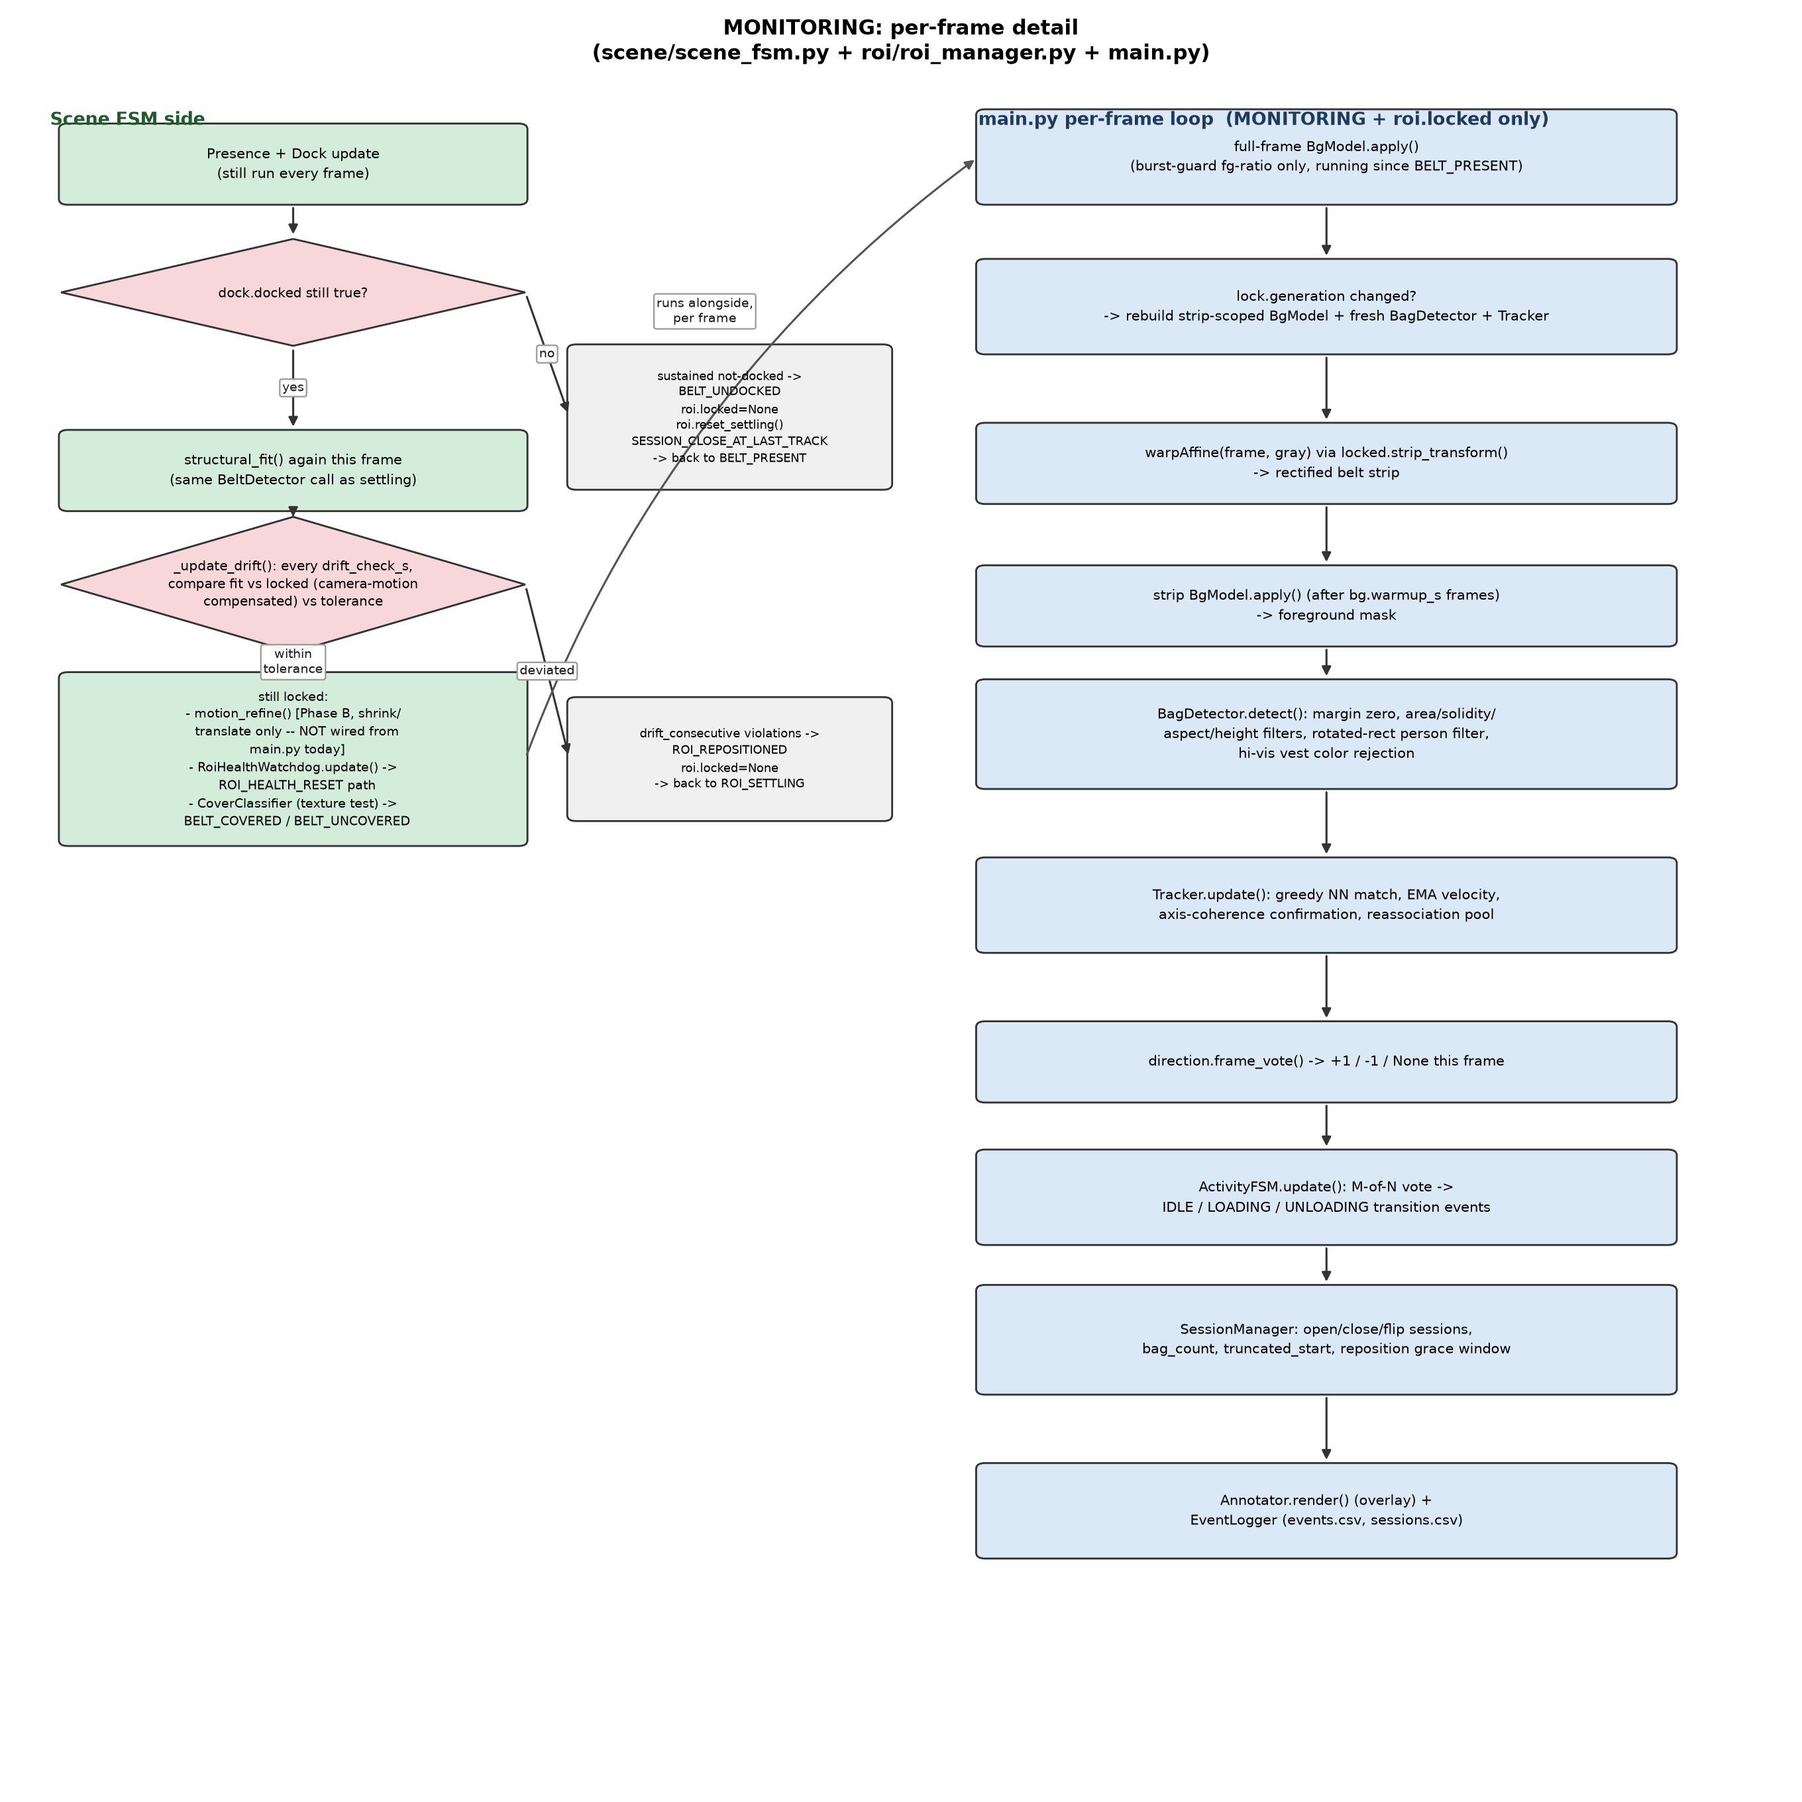
Figure 3 — MONITORING per-frame flow: Scene-FSM-side verification (left) and main.py's bag-detection pipeline (right), running concurrently.

4.4 Configuration reference (beyond RoiConfig)
Field | Meaning
health.annulus_px / motion_frac / sustain_s | RoiHealthWatchdog's annulus width, motion-fraction trigger, and required sustained duration.
cover.recheck_s / edge_density_threshold | CoverClassifier's recheck interval and covered/open edge-density cutoff.
bg.history / burst_frac / pause_speed / pause_s / warmup_s / use_gpu | MOG2 history length, burst-guard trigger fraction, belt-pause freeze threshold/window, post-lock detection warm-up suppression, and optional CUDA acceleration.
det.min_area_near / max_area_near / far_scale / solidity_min / aspect_lo / aspect_hi | Position-scaled area band and shape filters for bag contours, in strip coordinates.
det.end_margin_frac / bag_max_height_frac / person_rot_aspect / vest_hsv_lo / vest_hsv_hi / vest_reject_frac | Strip-space margin zeroing and the two person-rejection filters (rotated-rect, hi-vis vest).
trk.max_dist_px / max_disappeared / min_age / axis_coherence / ema_alpha / reassoc_s / reassoc_px | Tracker association distance, miss budget, confirmation age/coherence, velocity smoothing, and reassociation pool parameters.
dir.min_disp_px / min_speed | Minimum displacement/speed for a track to cast a direction vote.
fsm.idle_timeout_s / m_of_n_m / m_of_n_n / reposition_grace_s | Activity FSM's zero-track idle timeout, M-of-N vote window, and the session-continuation grace period across a reposition.

4.5 Exit paths
- BELT_UNDOCKED — sustained loss of dock → BELT_PRESENT, ROI unlocked, session closed at last track.
- ROI_REPOSITIONED — sustained drift beyond tolerance → ROI_SETTLING (re-lock from scratch, bag-detection generation bumps once re-locked).
- ROI_HEALTH_RESET — sustained unexplained motion just outside the ROI while idle → ROI_SETTLING, with the wrong fit blacklisted.

5. The Settle-Then-Monitor Handoff
The relationship between the two states is deliberately asymmetric: ROI_SETTLING's job is entirely about the fit itself (is it stable, is it plausible) and nothing else runs downstream of it — no bag detection, no tracking, no activity classification. MONITORING inherits a fit it can already trust and spends its effort on two different things: continuously re-verifying that trust hasn't eroded (drift/health/cover) while simultaneously running everything the pipeline actually exists to produce (bag counts, session timestamps, loading/unloading events). Both of MONITORING's failure paths (ROI_REPOSITIONED, ROI_HEALTH_RESET) route back through the exact same ROI_SETTLING logic described in Section 3 — there is no separate, lighter-weight re-lock path; a repositioned or health-reset ROI is treated with the same skepticism as a freshly-docked one.

6. Summary Comparison
Aspect | ROI_SETTLING | MONITORING
Belt-axis fitting (structural_fit) | Runs every frame, accumulating a stability window | Runs every frame, purely to feed the drift check
Bag detection / tracking / activity classification | Never runs | Runs every frame (via main.py, gated on roi.locked)
Presence + dock detectors | Always running | Always running
Can exit to BELT_PRESENT? | Yes (BELT_UNDOCKED) | Yes (BELT_UNDOCKED)
Can exit to ROI_SETTLING? | N/A (this is the settling state) | Yes (ROI_REPOSITIONED or ROI_HEALTH_RESET)
Can exit to MONITORING? | Yes (ROI_LOCKED) | N/A (already there)
Session/event output | None | events.csv, sessions.csv, live/recorded overlay

Generated from the current state of scene/scene_fsm.py, roi/roi_manager.py, roi/belt_detector.py, roi/roi_health.py, scene/cover.py, scene/dock.py, and main.py.

