Student Lead-CRM

Introduction
The Student Lead CRM Project is a Laravel-based Lead Management System for effective handling of student inquiries. The Lead Management System provides a means for administrators and counselors to manage an individual lead, track the status of that lead, assign the lead to another user and assess the overall effectiveness of the lead by using the dashboard.
The Student Lead CRM Project has been developed using the Modular Architecture. Each module has a purpose; Authentication, Role Based Access Control, Lead History Tracking, Lead Filtering and Lead Search.
The Student Lead CRM Project uses Krayin's (by Webkul) open source Laravel based CRM as the foundation to enable rapid development of Student Lead CRM. The use of an open-source system is a common practice for most software developers. A developer commonly starts with an existing framework and customizes it to suit their needs. This is especially true when developing commonly used software, such as authentication, a dashboard and data grids.

Reason for Using Krayin / Webkul Base
- Replaced all base UI assets with custom integers.
- New features added to support the Student Lead CRM Project.
- Modified the base system’s business logic to conform to the Student Lead CRM Project assignments.

Roles and Permissions
Admin
- Has complete access to the entire system and can create, edit, delete and assign any lead.
- Has access to view all leads and statistics from the dashboard.
Counselor
- Has access to view only leads that are assigned to him/her.
- Can update the status of any lead.
- Can create new leads.
- Cannot assign leads to other users.

Lead Management Module
Lead Fields
- Name
- Phone
- Email (unique)
- Lead History: The system keeps track of the following whenever the status or assigned user of a lead changes
- Lead ID
- Previous Status -> New Status
- Previous Assigned User -> New Assigned User
- Timestamp
Lead history is shown on the lead detail page.

Filters & Search
- The lead listing page has the following filters:
- Filter by Status
- Filter by Source
- Filter by Assigned User
- Search by Name, Email, or Phone

API Implementation
Endpoint:
- Code: POST /api/leads/create
Authentication:
- Laravel Sanctum (Token-based authentication)
Functionality:
- Validates the request data
- Stores the lead information
- Returns a JSON response

Sample Response
{
"success": true,
"lead_id": 1,
"message": "Lead created successfully"
}
Dashboard Features
Dashboard Displays
- Total Leads
- Leads Assigned to Logged-in User
- Leads by Status (Visual representation)
Demo data was added to ensure useful insights into the dashboard.
Technology Stack
- Backend: Laravel 10 (PHP 8.2)
- Frontend: Blade + Tailwind (Vite Build)
- Database: MySQL
- Authentication: Laravel Auth / Sanctum
- Server: XAMPP

Installation Steps
- Extract or clone the project
- Run composer install
- Copy .env.example to .env
- Set up database credentials
- Run php artisan key:generate
- Run php artisan migrate
- Run npm install and npm run build
- Start the server using php artisan serve
- Go to the admin panel at /admin/login

Output:
- Admin Login:
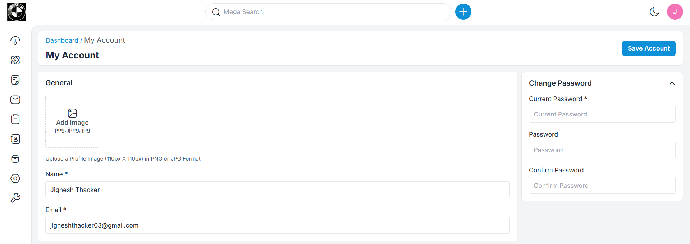

2. Main Home Page:
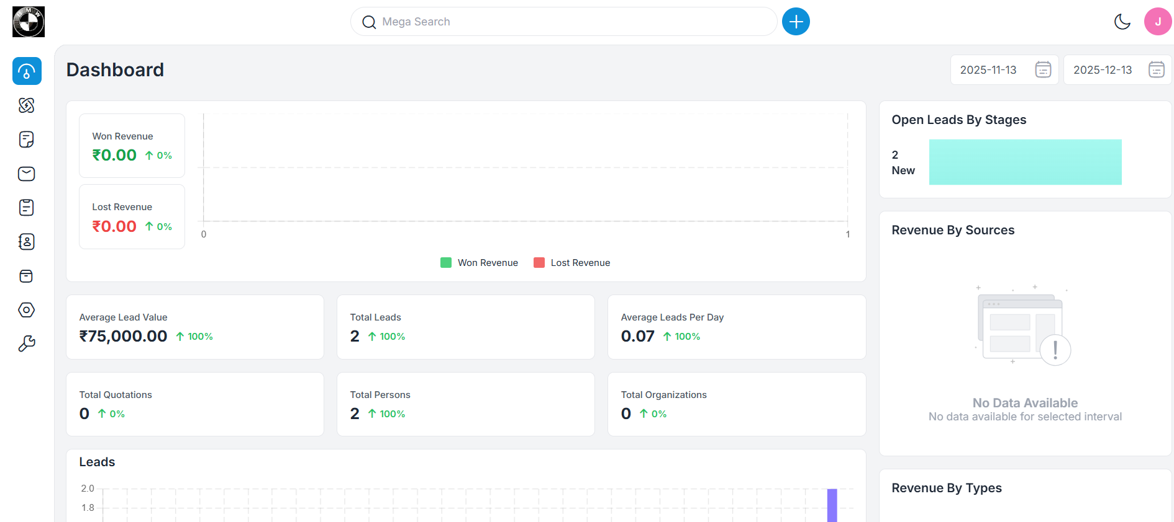
3. Side Bar
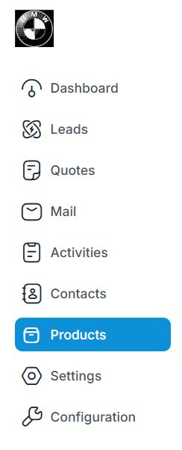
Conclusion
The Student Lead CRM shows practical Laravel development by building on top of an existing open-source CRM. Student Lead CRM demonstrates practical Laravel development by customizing an open-source CRM foundation to meet specific business requirements. The project showcases role-based access, lead tracking, API integration, and dashboard analytics, aligning with real-world software development practices.

