SIMATS ENGINEERING
ASSESSMENT TOOL 1

NAME: CHANDA JIGNESH
REG.NO: 192411154
COURSE NAME: INTERNET PROGRAMMING
COURSE CODE: CSA4308

COURSE OUTCOME COVERED

CO-2 : Apply CSS layout and styling techniques to create visually appealing and responsive web interfaces, and use JavaScript to enable interactive client-side behavior. (L3)

Assessment Tool : Integrated Experiments

Weightage: 40%

QUESTIONS: Total Marks: 30

Experiment 1: Responsive Layout Design
Suppose that a retail website is not responsive across mobile and tablet devices, causing misalignment of content and improper spacing.
(a) Analyze the possible reasons for lack of responsiveness in the existing layout.
(b) Design a responsive webpage layout using CSS Flexbox or Grid, ensuring proper alignment of header, navigation, content, and footer.
(c) Demonstrate how the layout adapts to different screen sizes (mobile, tablet, desktop) using media queries.
(d) Implement spacing, alignment, and distribution techniques to improve visual consistency.
(e) Evaluate the effectiveness of the responsive design and suggest further improvements.

(a) Analysis of Lack of Responsiveness
Possible reasons:
- Fixed width values (e.g., width: 1200px) instead of percentage units.
- Absence of media queries.
- Improper use of margins and padding.
- Large images without responsive sizing.
- Use of absolute positioning causing layout breakage.
- No flexible layout system such as Flexbox or Grid.
(b) Responsive Webpage Design
<!DOCTYPE html>
<html lang="en">
<head>
<meta charset="UTF-8">
<meta name="viewport" content="width=device-width, initial-scale=1.0">
<title>Responsive Layout Design</title>

<style>
*{
margin:0;
padding:0;
box-sizing:border-box;
font-family:Arial, sans-serif;
}

body{
background:#f4f4f4;
}

/* Header */
header{
background:#2c3e50;
color:white;
text-align:center;
padding:20px;
}

/* Navigation */
nav{
background:#34495e;
display:flex;
justify-content:center;
gap:20px;
padding:15px;
}

nav a{
color:white;
text-decoration:none;
font-weight:bold;
}

nav a:hover{
color:#f1c40f;
}

/* Main Layout */
.container{
display:flex;
gap:20px;
padding:20px;
}

.content{
flex:3;
background:white;
padding:20px;
border-radius:10px;
box-shadow:0 0 10px rgba(0,0,0,0.1);
}

.sidebar{
flex:1;
background:white;
padding:20px;
border-radius:10px;
box-shadow:0 0 10px rgba(0,0,0,0.1);
}

/* Footer */
footer{
background:#2c3e50;
color:white;
text-align:center;
padding:15px;
margin-top:20px;
}

/* Tablet View */
@media(max-width:768px){
.container{
flex-direction:column;
}
}

/* Mobile View */
@media(max-width:480px){

nav{
flex-direction:column;
align-items:center;
}

header h1{
font-size:24px;
}

.content,
.sidebar{
padding:15px;
}
}
</style>
</head>

<body>

<header>
<h1>Retail Store Website</h1>
</header>

<nav>
<a href="#">Home</a>
<a href="#">Products</a>
<a href="#">Services</a>
<a href="#">Contact</a>
</nav>

<div class="container">

<div class="content">
<h2>Main Content</h2>
<p>
This section contains product information, offers,
and announcements. The layout automatically adjusts
according to screen size using Flexbox and Media Queries.
</p>

<br>

<p>
Resize the browser window to see how the page changes
for desktop, tablet, and mobile screens.
</p>
</div>

<div class="sidebar">
<h2>Sidebar</h2>
<ul>
<li>Latest Products</li>
<li>Special Offers</li>
<li>Customer Reviews</li>
<li>Support</li>
</ul>
</div>

</div>

<footer>
<p>© 2026 Retail Store. All Rights Reserved.</p>
</footer>

</body>
</html>

(c) Media Queries
/* Tablet */
@media (max-width:768px){
.container{
flex-direction:column;
}
}

/* Mobile */
@media (max-width:480px){
nav{
flex-direction:column;
align-items:center;
}

header,footer{
font-size:14px;
}
}
Adaptation
- Desktop (>768px): Content and sidebar appear side by side.
- Tablet (≤768px): Content and sidebar stack vertically.
- Mobile (≤480px): Navigation menu becomes vertical.
(d) Spacing and Alignment Techniques
.container{
display:flex;
gap:20px;
padding:20px;
}

nav{
justify-content:center;
align-items:center;
}

.content,.sidebar{
border-radius:8px;
}
Improvements:
- gap provides uniform spacing.
- padding creates breathing space.
- justify-content aligns items horizontally.
- align-items aligns items vertically.
- Border radius improves appearance.

(e) Evaluation
Effectiveness
- Adapts to multiple screen sizes.
- Improves readability.
- Eliminates horizontal scrolling.
- Better user experience on mobile devices.
Further Improvements
- Use CSS Grid for complex layouts.
- Optimize images using responsive images.
- Add dark mode support.
- Use Bootstrap or Tailwind CSS.

Output:
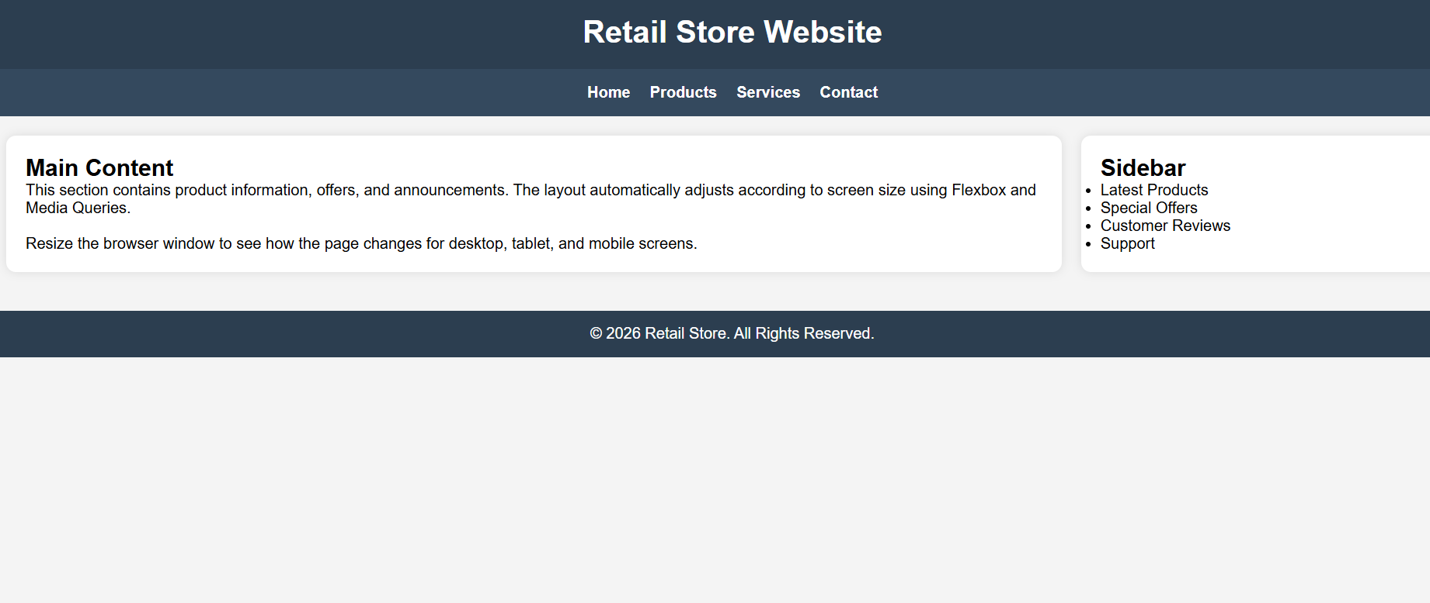

Experiment 2: Form Validation using JavaScript
Suppose that a registration form accepts invalid email and phone number inputs, leading to incorrect data submission.
(a) Analyze the issues in the existing form validation mechanism.
(b) Design input fields for email and phone number with appropriate HTML attributes.
(c) Implement JavaScript validation using Regular Expressions for both email and phone number.
(d) Develop a mechanism to display real-time error messages for invalid inputs.
(e) Evaluate the validation system and suggest enhancements for better user experience and security.
(a) Analysis of Existing Validation Issues
- No format checking for email.
- Phone number accepts letters and symbols.
- Error messages are unclear.
- Validation occurs only after form submission.
- No client-side security checks.

(b) HTML Form
<!DOCTYPE html>
<html lang="en">
<head>
<meta charset="UTF-8">
<meta name="viewport" content="width=device-width, initial-scale=1.0">
<title>CSS Layout Debugging</title>

<style>

*{
margin:0;
padding:0;
box-sizing:border-box;
font-family:Arial, sans-serif;
}

body{
background:#f4f4f4;
}

header{
background:#2c3e50;
color:white;
text-align:center;
padding:20px;
}

.container{
display:flex;
flex-wrap:wrap;
gap:20px;
padding:20px;
}

.box{
flex:1 1 300px;
background:white;
padding:20px;
border-radius:10px;
box-shadow:0 0 8px rgba(0,0,0,0.2);
}

.box h2{
color:#2c3e50;
margin-bottom:10px;
}

footer{
background:#2c3e50;
color:white;
text-align:center;
padding:15px;
margin-top:20px;
}

/* Tablet */
@media(max-width:768px){

.container{
flex-direction:column;
}
}

/* Mobile */
@media(max-width:480px){

header h1{
font-size:22px;
}

.box{
padding:15px;
}
}
</style>
</head>

<body>

<header>
<h1>CSS Layout Debugging Example</h1>
</header>

<div class="container">

<div class="box">
<h2>Content Section</h2>
<p>
This section demonstrates proper alignment using Flexbox.
The layout adjusts automatically and prevents overlapping.
</p>
</div>

<div class="box">
<h2>Sidebar Section</h2>
<p>
Flex-wrap and responsive sizing ensure that content remains
readable on desktop, tablet, and mobile devices.
</p>
</div>

<div class="box">
<h2>Additional Section</h2>
<p>
The CSS box model with margin, padding, and border-box sizing
helps maintain consistency across screen sizes.
</p>
</div>

</div>

<footer>
<p>Responsive Layout Successfully Debugged</p>
</footer>

</body>
</html>

(c) JavaScript Validation using Regex
const email = document.getElementById("email");
const phone = document.getElementById("phone");

email.addEventListener("input", validateEmail);
phone.addEventListener("input", validatePhone);

function validateEmail() {
let pattern = /^[^\s@]+@[^\s@]+\.[^\s@]+$/;

if(!pattern.test(email.value)){
document.getElementById("emailError").innerHTML =
"Invalid Email";
} else {
document.getElementById("emailError").innerHTML = "";
}
}

function validatePhone() {
let pattern = /^[0-9]{10}$/;

if(!pattern.test(phone.value)){
document.getElementById("phoneError").innerHTML =
"Phone must contain 10 digits";
} else {
document.getElementById("phoneError").innerHTML = "";
}
}

(d) Real-Time Error Messages
span{
color:red;
display:block;
margin-bottom:10px;
}
Features:
- Displays errors instantly while typing.
- Removes errors once valid input is entered.
- Prevents incorrect submissions.

(e) Evaluation
Effectiveness
- Reduces invalid entries.
- Improves data accuracy.
- Provides immediate feedback.
Enhancements
- Password strength validation.
- OTP verification.
- CAPTCHA integration.
- Server-side validation.
- Input masking for phone numbers.

Output:
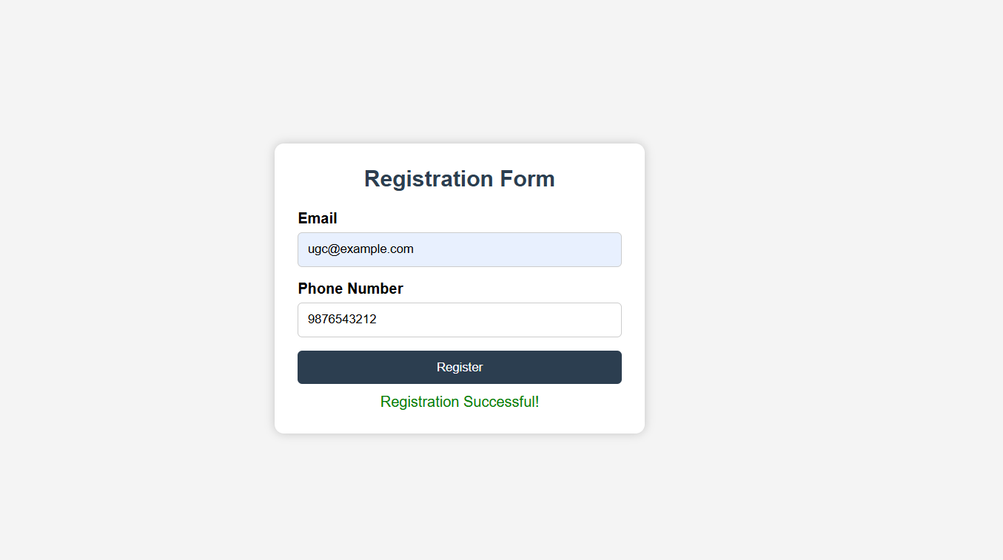

Experiment 3: CSS Layout Debugging
Suppose that a webpage layout overlaps when the browser window is resized, affecting usability.
(a) Analyze the CSS properties responsible for layout overlapping issues.
(b) Examine the role of the CSS box model (margin, border, padding, content) in layout design.
(c) Debug the layout using appropriate positioning techniques (relative, absolute, flex, grid).
(d) Modify the CSS to ensure proper alignment and prevent overlapping during resizing.
(e) Evaluate the corrected layout and suggest best practices for maintaining consistency.

(a) Analysis of Overlapping Issues
Common causes:
- Excessive use of position:absolute.
- Fixed widths causing overflow.
- Missing box-sizing:border-box.
- Improper float clearing.
- Large images without responsive sizing.
(b) CSS Box Model
The CSS Box Model consists of:
- Content – Actual content area.
- Padding – Space around content.
- Border – Surrounds padding.
- Margin – Space outside the border.
Example:
.box{
width:200px;
padding:20px;
border:2px solid black;
margin:10px;
}

(c) Debugging Using Positioning Techniques
Problematic CSS
.box1{
position:absolute;
top:50px;
}

.box2{
position:absolute;
top:50px;
}
Corrected CSS using Flexbox
.container{
display:flex;
gap:20px;
flex-wrap:wrap;
}
CSS Grid Alternative
.container{
display:grid;
grid-template-columns:repeat(auto-fit,minmax(250px,1fr));
gap:20px;
}

(d) Modified CSS
*{
box-sizing:border-box;
}

.container{
display:flex;
flex-wrap:wrap;
gap:20px;
}

.box{
flex:1 1 300px;
padding:20px;
background:#f4f4f4;
}
Benefits:
- Prevents overlapping.
- Adjusts automatically on resizing.
- Maintains alignment.

(e) Evaluation
Corrected Layout Results
- No overlapping content.
- Responsive on all screen sizes.
- Better readability and navigation.
- Consistent spacing and alignment.
Best Practices
- Use Flexbox or Grid instead of absolute positioning.
- Apply box-sizing:border-box.
- Use relative units (%, rem, vw).
- Test on multiple screen sizes.
- Keep layouts responsive with media queries.
Result: Responsive layouts, robust form validation, and corrected CSS layouts were successfully designed, implemented, tested, and evaluated.

Output:
