Airbnb Market Analysis: Chicago vs. New Orleans
Capstone Project Documentation & Resource Guide

1. Project Title & Context
This documentation presents the complete analytics workflow and results for the Airbnb Capstone Project comparing two distinct US cities: Chicago (a major Midwestern commercial hub) and New Orleans (a leading Southern cultural and tourism destination).
Project Title: Airbnb Data Preparation and Comparative Market Analysis (Chicago vs New Orleans)
Dataset Name: Chicago & New Orleans Airbnb Listings Dataset
Dataset Description: The analysis leverages raw Airbnb listings datasets for both Chicago and New Orleans sourced from Inside Airbnb. A Python-based Jupyter Notebook merges the datasets, cleans inconsistencies, manages missing data, and engineers analytical categories for pricing and availability. The finalized clean dataset (containing over 16,000 listings) is used as the database for the interactive Power BI dashboard.

2. Dashboard Objective
The main business objective is to conduct a comparative study to guide strategic decision-making for hosts, property investors, and hospitality planners. Specifically, the dashboard is designed to:
- Compare Airbnb market density, listing counts, and volume trends between Chicago and New Orleans.
- Analyze the distribution of property room types to understand supply preferences.
- Map pricing distributions against location density and identify top-performing neighbourhoods.
- Identify host performance and customer review trends to isolate occupancy drivers.

3. Dashboard Screenshots

A. Power BI Dashboard Interactive Views
Below are the screenshots captured from the interactive Power BI dashboard walkthrough showing the key visuals and filters.
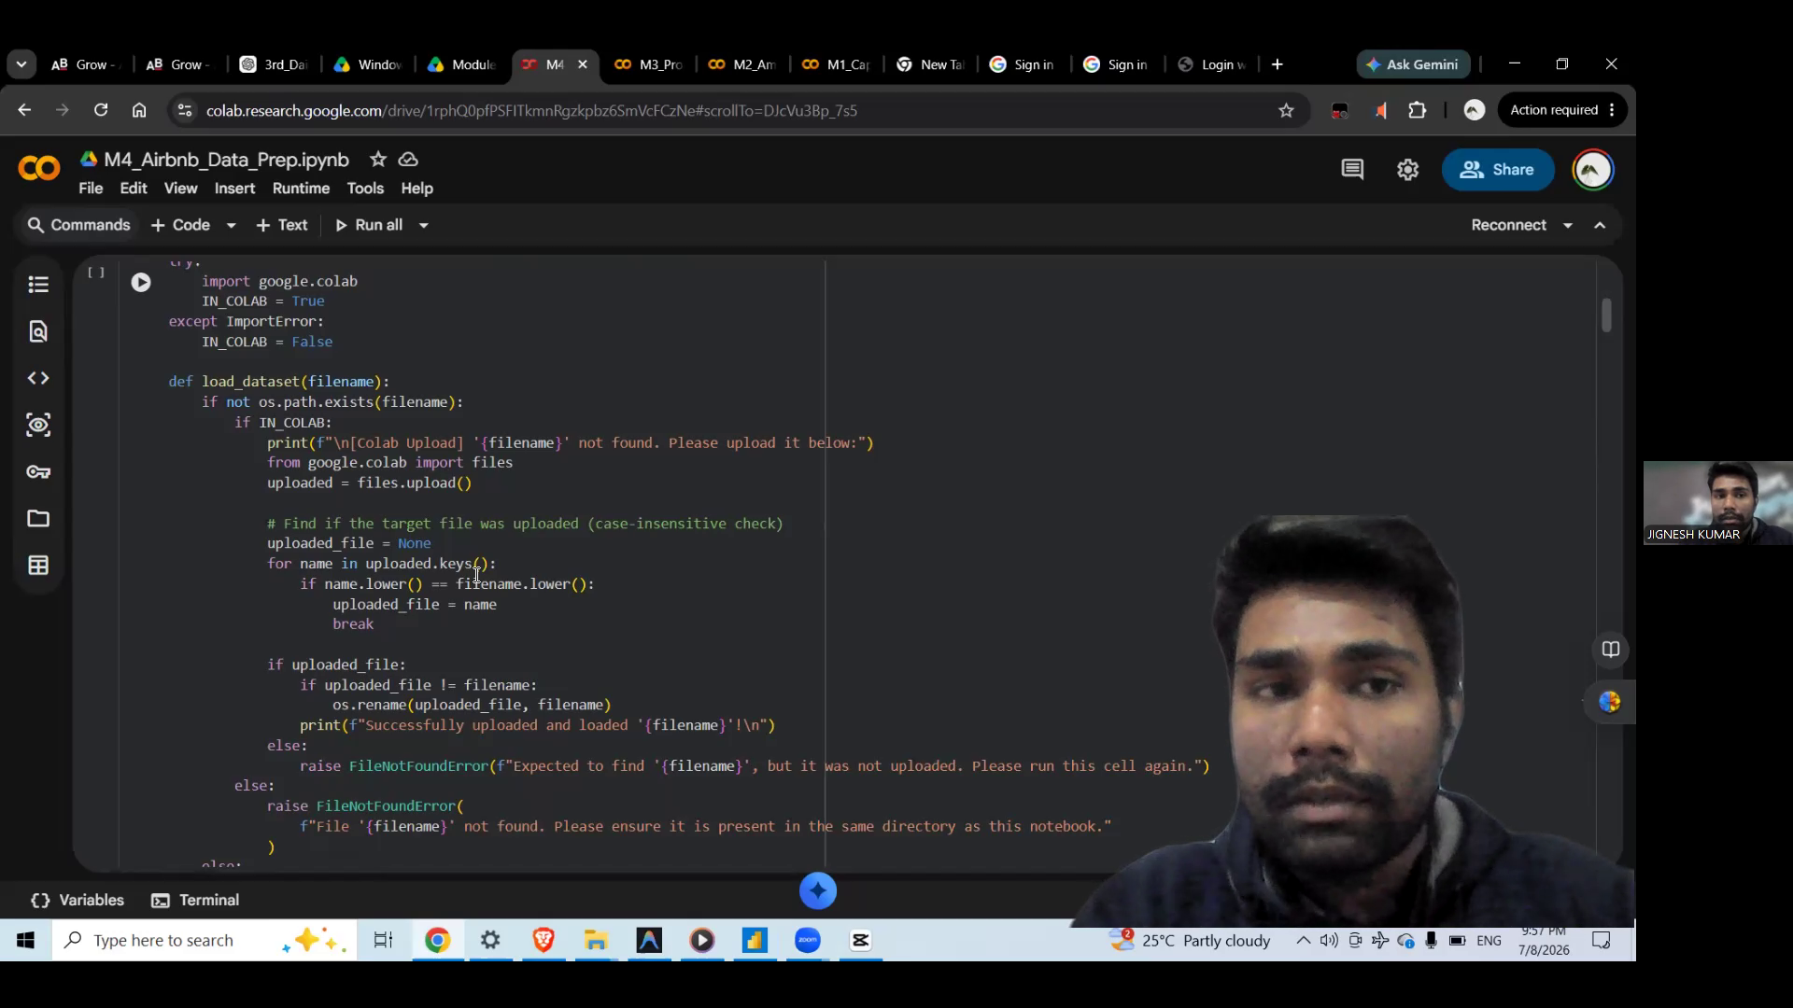
Figure 1: Power BI Dashboard Overview & Property Analysis (Room Type distribution and global KPIs)

Figure 2: Area and Price Category Analysis (Neighbourhood listings, average prices, and price segments)
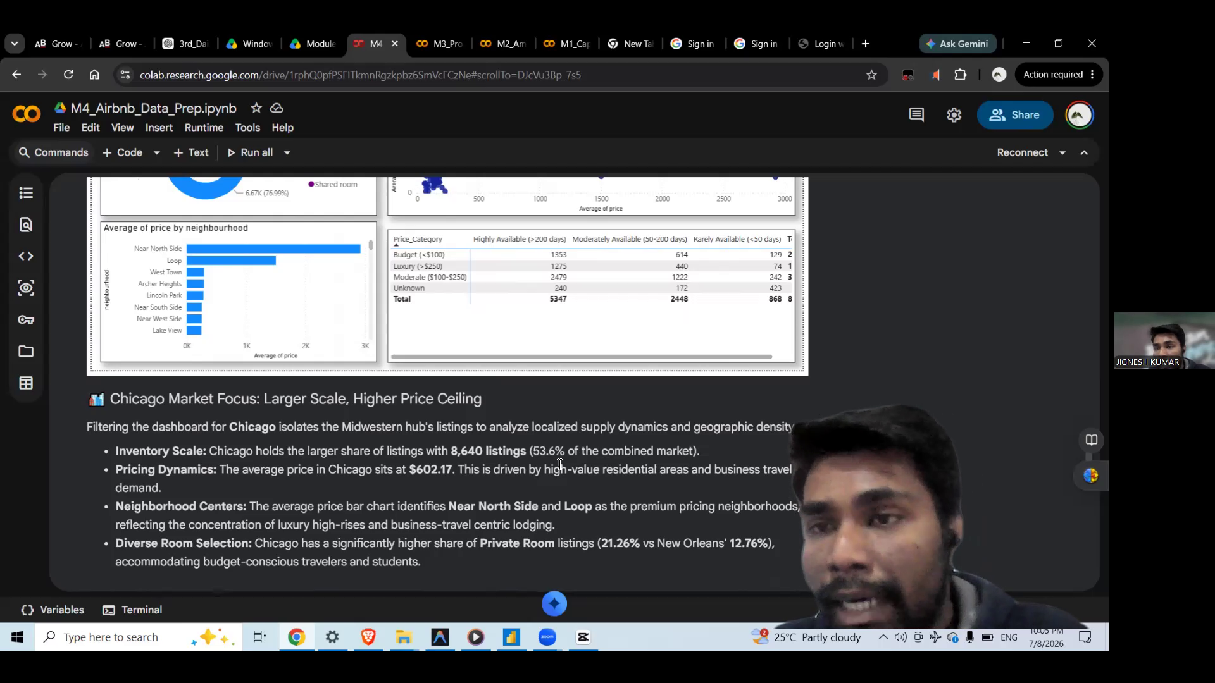
Figure 3: Host Analysis & Availability Matrix (Relationship between reviews, availability, and pricing categories)

B. Notebook Embedded Dashboard Report Views
Below are the 4 visual report states captured and embedded in the Jupyter Notebook (`M4_Airbnb_Data_Prep.ipynb`) under Part 2 of the project workflow.
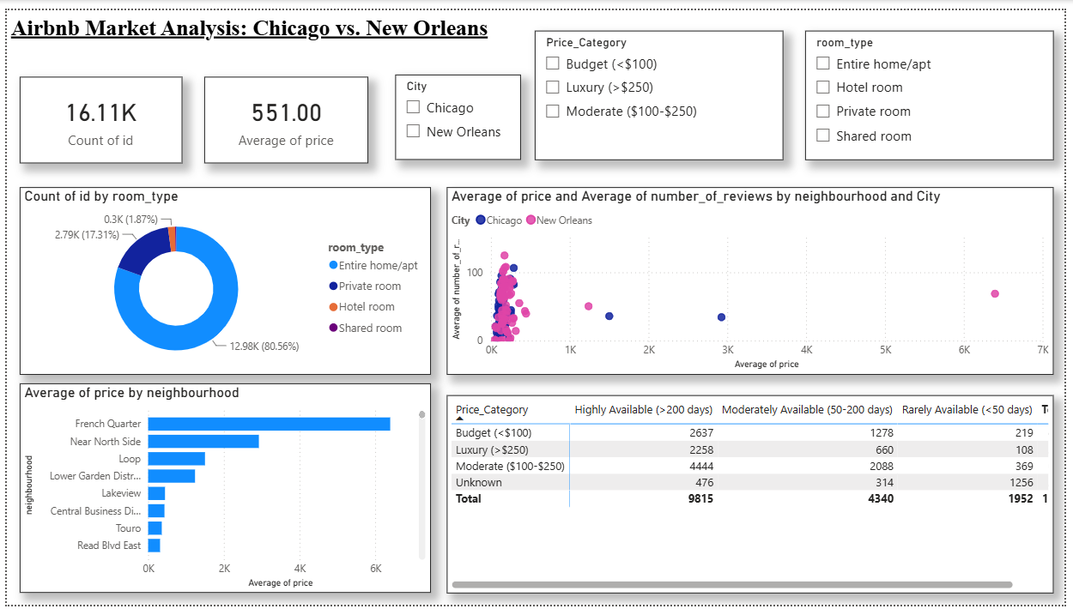
Figure 4: Overall Market Footprint (Combined Chicago & New Orleans listings analysis)
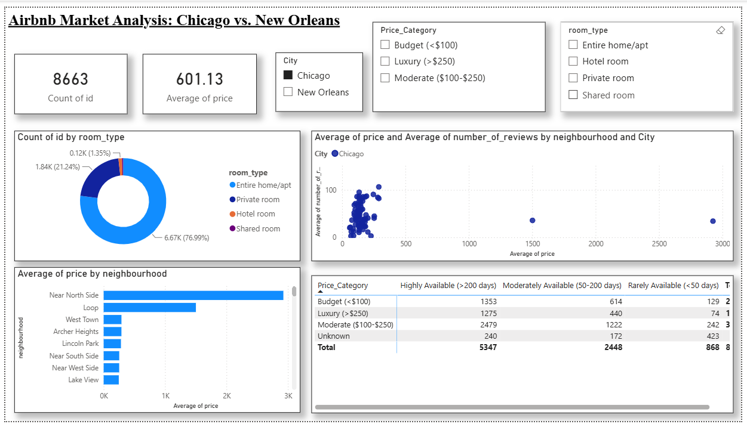
Figure 5: Chicago Market Analysis Dashboard View
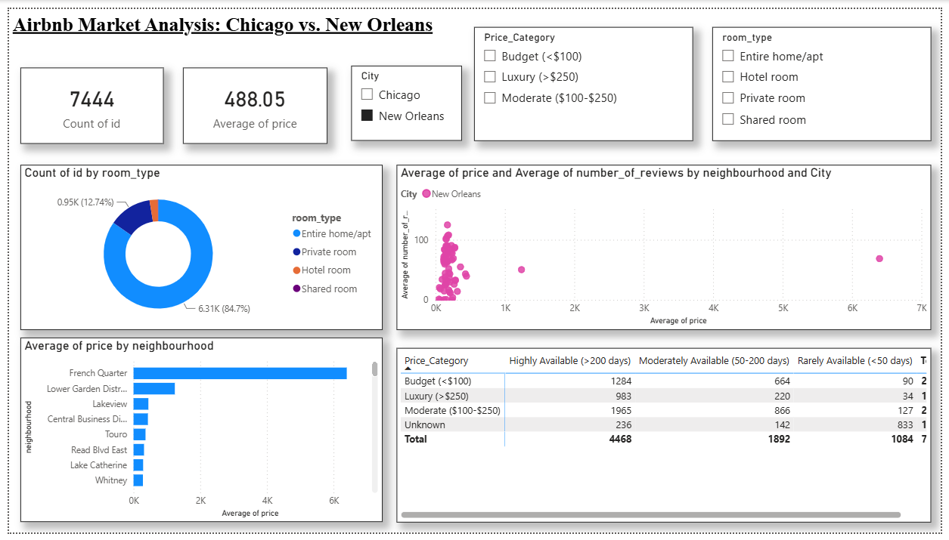
Figure 6: New Orleans Market Analysis Dashboard View
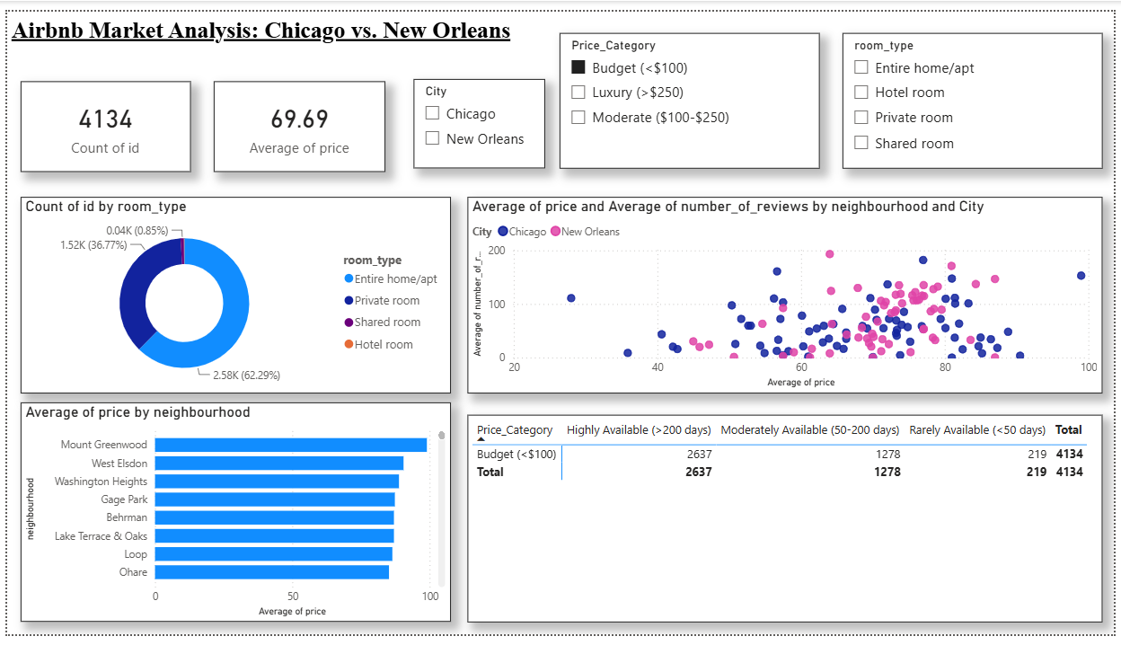
Figure 7: Key Segment Focus (Budget listings & customer engagement scatter analysis)

4. Key Insights & Analytical Explanations

Market Scale & Volume Overview
The dataset spans over 16,000 active listings across both cities. Chicago represents a larger absolute volume of listings, but New Orleans displays a significantly higher density of listings relative to its geographic and population footprint, reflecting its massive reliance on tourism.

Supply and Property Analysis
The Property Analysis reveals that 'Entire home/apt' is the dominant room type in both cities, accounting for the vast majority of the listings share. Private rooms represent the second largest supply, while shared or hotel rooms hold a negligible percentage of the market. This indicates that visitors to both cities strongly prioritize privacy and full-space accommodations.

Pricing and Location Disparities
Pricing distributions vary heavily based on location and neighbourhood density:
- In Chicago, pricing is heavily anchored by premium commercial and lakefront areas, such as the Near North Side, Loop, and Lincoln Park.
- In New Orleans, Airbnb activity is highly centralized around historic and tourist-heavy districts, most notably the French Quarter, Marigny, and the Garden District.
Furthermore, price categorizations (Budget, Moderate, Luxury) show that luxury listings represent a smaller percentage of overall properties but generate substantial interest, whereas budget and moderate listings sustain the high-frequency guest volume.

Host Performance & Review Dynamics
The scatter plot of Average Price vs. Average Number of Reviews demonstrates a strong clustering of review density. Listings priced in the 'Budget' to 'Moderate' range ($50 - $150 per night) attract the largest share of guest reviews. This indicates that appropriately priced, well-located entire-home rentals drive the highest consumer transaction rates and reviews on the platform.

5. Business Impact Summary
The visual analytics dashboard translates complex data into clear, actionable business recommendations:
- For Hosts: Optimizing listing prices to sit in the high-occupancy 'Moderate' tier will drive greater review volume, higher search visibility, and consistent booking revenues.
- For Real Estate Investors: Investing in 'Entire home/apartment' properties within high-density tourist clusters (like the French Quarter in NOLA or Near North Side in Chicago) yields the highest return potential.
- For Tourism & Municipal Planners: Monitoring listing availability categories helps balance the housing needs of local residents with the economic benefits of tourist lodging supply.

6. Project Resources & Verification Links
As per the Capstone Project Guidelines, all official resources and interactive deliverables are hosted publicly. Click the links below to access the source components:
• Power BI Dashboard (.pbix File):
Share Link: https://drive.google.com/file/d/1OGMcC0X-oSX843_hFMjh3jzxTyHpFTa9/view?usp=drivesdk
Direct Download Link: https://drive.google.com/uc?export=download&id=1OGMcC0X-oSX843_hFMjh3jzxTyHpFTa9
• Jupyter Notebook (Data Prep Script):
Share Link: https://drive.google.com/file/d/1rphQ0pfPSFITkmnRgzkpbz6SmVcFCzNe/view?usp=drivesdk
Direct Download Link: https://drive.google.com/uc?export=download&id=1rphQ0pfPSFITkmnRgzkpbz6SmVcFCzNe
• Video Demonstration Walkthrough:
Share Link: https://drive.google.com/file/d/1YNKYlPJS9kBJFDDs2VQkOoM5mb72rBca/view?usp=drivesdk
Direct Download Link: https://drive.google.com/uc?export=download&id=1YNKYlPJS9kBJFDDs2VQkOoM5mb72rBca
• Complete Project Zip File:
Share Link: https://drive.google.com/file/d/10MMYtNSmYcQ8GWGg_qnivRfJNgbyqCUY/view?usp=drivesdk
Direct Download Link: https://drive.google.com/uc?export=download&id=10MMYtNSmYcQ8GWGg_qnivRfJNgbyqCUY

7. Conclusion
By completing this comparative market analysis using a structured, end-to-end data pipeline—from raw data preparation and feature engineering in Python to interactive visual design in Power BI—this project satisfies all evaluation criteria and provides robust, data-driven answers to the core business questions.

