**DOCKER IMAGE WITH FLASK API CONTAINING ML MODEL**

**STEPS:**

* Download the docker from below link

<https://docs.docker.com/desktop/windows/install/>

* Download the Linux kernel update package

<https://wslstorestorage.blob.core.windows.net/wslblob/wsl_update_x64.msi>

1. Open command prompt as *administrator*
2. Launch command: "C:\Program Files\Docker\Docker\DockerCli.exe" -SwitchDaemon

(Mention the DockerCli.exe path)

* Open the windows powershell and run the following command

wsl --set-default-version 2

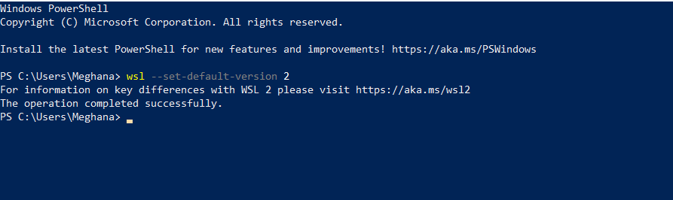

* And check the docker version in command prompt as: **docker version**

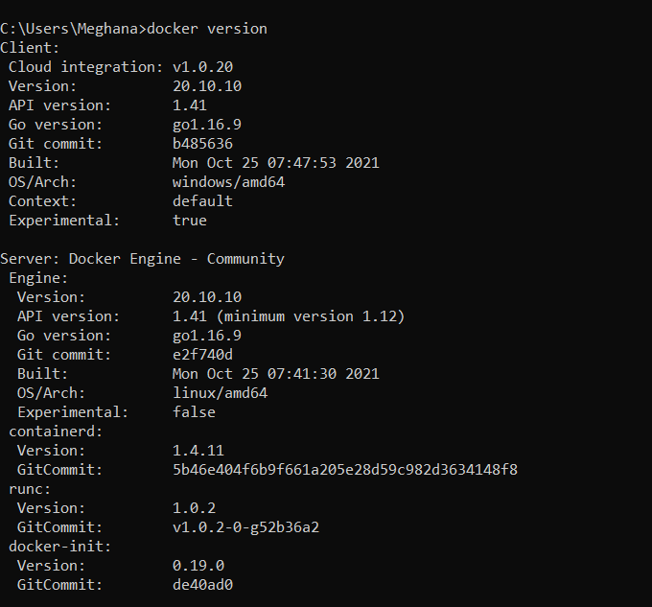

**References:**

[**https://link.medium.com/YiO306LNwlb**](https://link.medium.com/YiO306LNwlb)

[**https://github.com/xaviervasques/Online_Inference**](https://github.com/xaviervasques/Online_Inference)

[**https://github.com/xaviervasques/EEG-letters**](https://github.com/xaviervasques/EEG-letters)