Session 1: How to Solve Big Data

Assignment 1

1. Open the virtual Box and Start the VM:

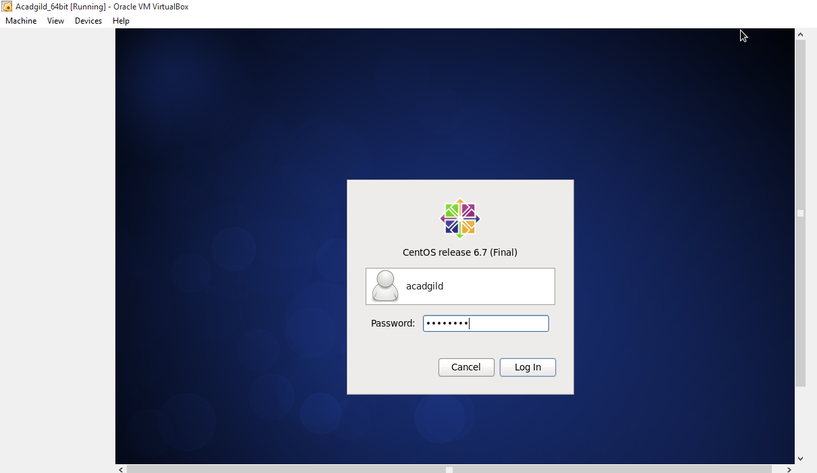

2. Open the terminal and type the command jps to check the list of daemons: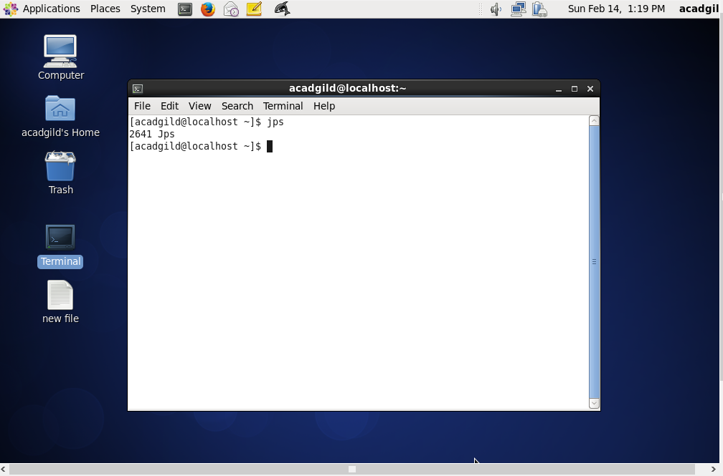

3. Open the terminal and start the ssh server. And Start all the daemons:



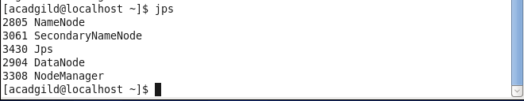

4. Start History Server:

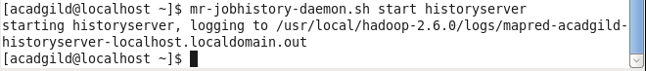

5. Start pig: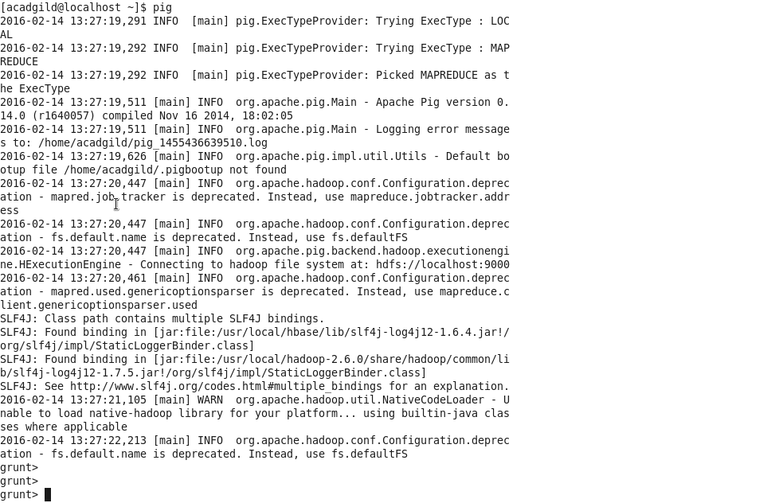

6. Start hive:



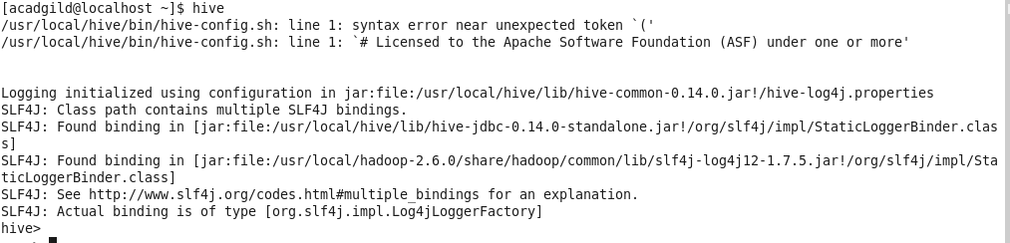

7. Start Hbase:

