Session 15: Hive OperationsAssignment 1

# Associated Data Files

Link: <https://acadgild.com/blog/file-formats-in-apache-hive/>

# Problem Statement

# Refer the above given link for File formats in Hive and implement all the file formats in Hive by using any publicly available data set of your choice.

1. **TEXTFILE:**

**Create table:**

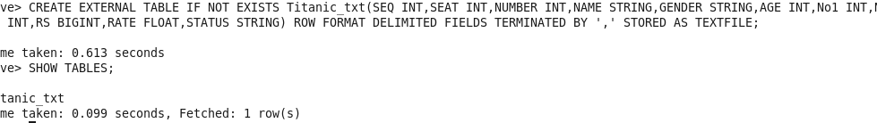

**Load Data:**

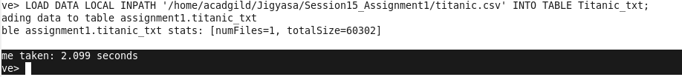

**Describe Table:**

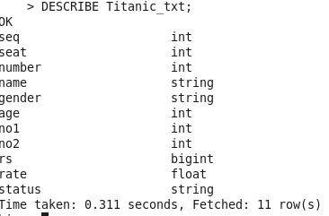

**Select Data:**

SELECT Seq FROM Titanic_txt;



1. **SEQUENCEFILE:**

**Create Table:**

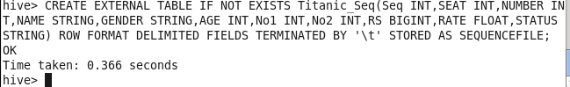

**Describe Table:**

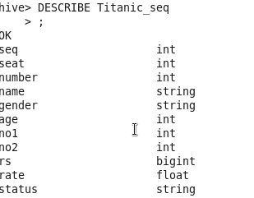

**Load Data:**



**Select Data:**

SELECT Seq FROM Titanic_seq;



1. **RCFILE:**

**Create Table:**

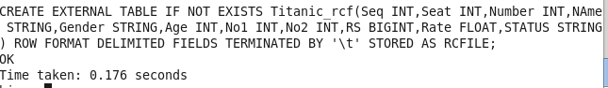

**Describe Table:**

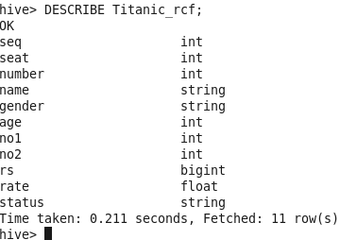

**Load Data:**



**Select Data:**

SELECT Seq FROM Titanic_rcf;



1. **ORCFILE:**

**Create Table:**



**Describe Table:**

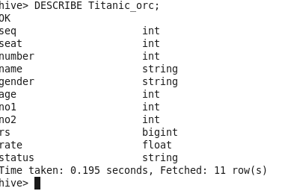

**Load Data:**



**Select Data:**

SELECT Seq FROM Titanic_orc;

