Session 16: Advanced Hive Assignment 1

# Associated Data Files

Link: **https://acadgild.com/blog/transactions-in-hive/**

# Problem Statement

Link: https://acadgild.com/blog/transactions-in-hive/

Refer the above given link for transactions in Hive and implement the operations given in the blog using your own sample data set and send us the screenshot.

**Soultion:**

**Step 1: Set Hive Properties**

set hive.support.concurrency=true;

set hive.enforce.bucketing=true;

set hive.exec.dynamic.partition.mode=nonstrict;

set hive.txn.manager=org.apache.hadoop.hive.ql.lockmgr.DbTxnManager;

set hive.compactor.initiator.on=true;

set hive.compactor.worker.threads=5; 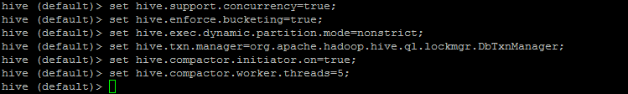

**Step2: Creating table**

CREATE TABLE Employee_Seesion16(Emp_id int,name string,company string,Desg string) clustered by (Emp_id) into 5 buckets stored as orc TBLPROPERTIES(‘transactional’=’true’);



Show tables;

**Step3: Inserting Data into Hive table**

INSERT INTO table Employee_Session16 values(1,’Jigyasa’,’Infosys’,’Senior System Engineer’), (2,’Pooja’,’HCL’,’Consultant’), (3,’Aditya’,’AON’,’Consultant’), (4,’Tarun’,’Dell’,’Architect’), (5,’Namrata’,’Apolo’,’Doctor’);

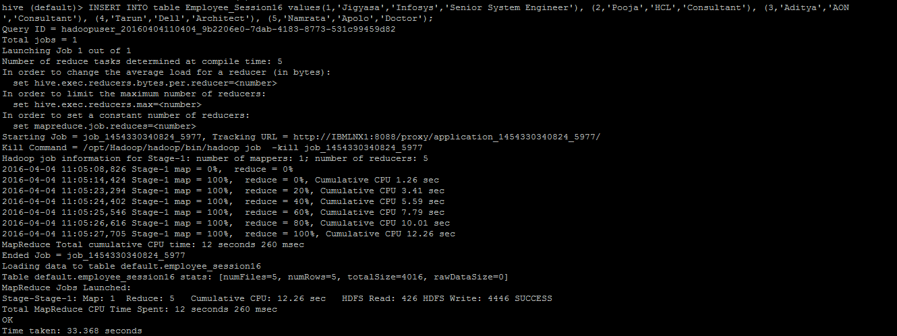

Select * FROM Employee;

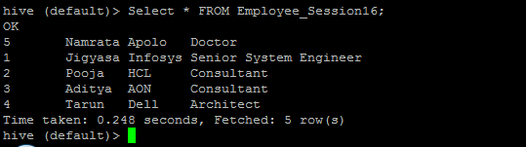

**Step4: Updating Data into Hive table**

Update Employee_Session16 set Company==’Ganga Ram’ where Emp_id=5;

Select * FROM Employee_Session16;

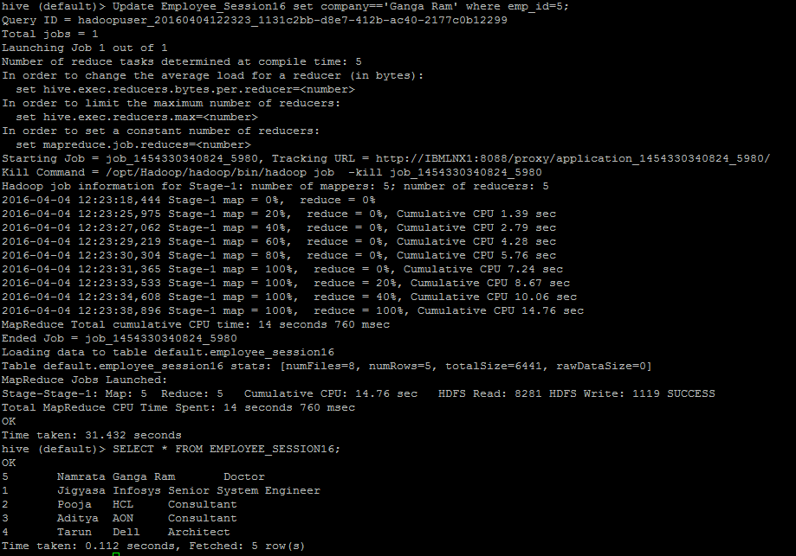

**Step5: Delete Data from Hive table**

Delete from Employee_Session16 where Emp_id=4;

Select * FROM Employee_Session16;

