Session 16: Advanced Hive Assignment 2

# Associated Data Files

Link: **https://acadgild.com/blog/transactions-in-hive/**

# Problem Statement

Link: https://acadgild.com/blog/transactions-in-hive/

Refer the above given link for transactions in Hive and implement the operations given in the blog using your own sample data set and send us the screenshot.

**Soultion:**

**Step 1: Set Hive Properties**

set hive.support.concurrency=true;

set hive.enforce.bucketing=true;

set hive.exec.dynamic.partition.mode=nonstrict;

set hive.txn.manager=org.apache.hadoop.hive.ql.lockmgr.DbTxnManager;

set hive.compactor.initiator.on=true;

set hive.compactor.worker.threads=5;

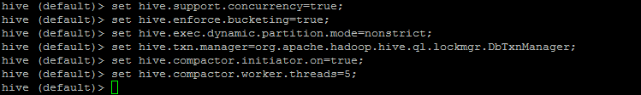

**Step2: Creating table**

CREATE TABLE Student_Session16_2(Stud_Id int,Std_Name string,School string,Class int) clustered by (Stud_id) into 4 buckets stored as orc TBLPROPERTIES(‘transactional’=’true’);



**Step3: Inserting Data into Hive table**

INSERT INTO table Student_Session16_2 values(1,’Jiggy’,’Canossa’,1), (2,’Pooja’,’Saraswati’,6), (3,’Aadi’,’Canossa’,3), (4,’Golu’,’Army’,5), (5,’Neelu’,’Mount’,4), (6,’Tarun’,’Army’,4), (7,’Elesh’,’Mount’,2), (8,’Divi’,’Canossa’,3), (9,’Namrata’,’Army’,4), (10,’Ayush’,’Dev Bhomi’,5);

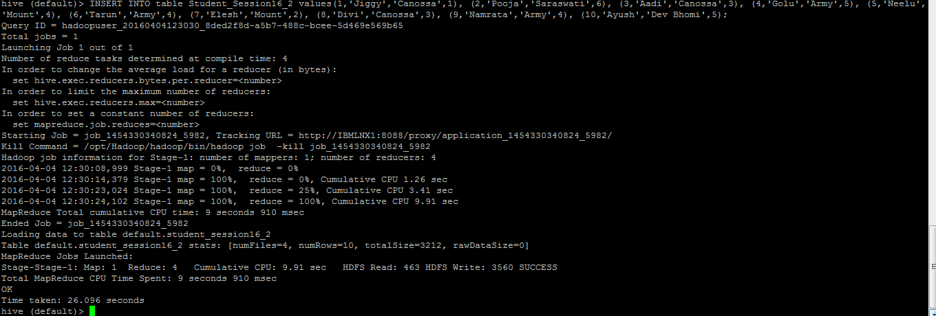

Select * FROM Student_Session16_2;

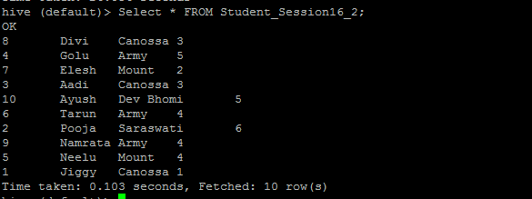

**Step4: Updating Data into Hive table**

Update Student_Session16_2 set School=’Saraswati’ where Stud_id=4;

Select * FROM Student_Session16_2;

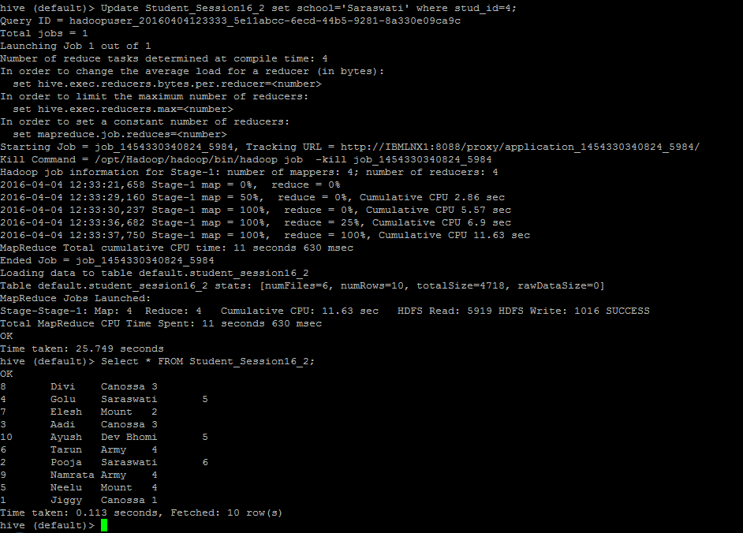

**Step5: Delete Data from Hive table**

Delete from Student_Session16_2 where Stud_id=6;

Select * FROM Student_Session16_2;

