Session 18: HBase Data Model and CRUD OperationsAssignment 1

# Problem Statement

**Use Hbase shell for performing the following operations**

1. Create the table customer with two column families

* Personal details and order details as column families

**Ans:**

create ‘Company’,’Personal_Details’,’Order_Details’

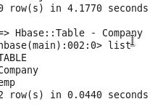

* Create a unique number as row key (ssn/Adhar no.,etc)

**Ans:**

put 'Company','CUST001' ,’Personal_Details:Name’,’Deepa’

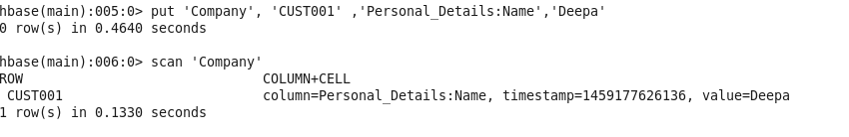

* Insert following values for personal details column family

Name, age, city, state

**Ans:**

put 'Company','CUST001','Personal_Details:Name','Deepa'

put 'Company','CUST001', 'Personal_Details:Age','23'

put 'Company','CUST001','Personal_Details:City','Delhi'

put 'Company','CUST001','Personal_Details:State','Delhi'

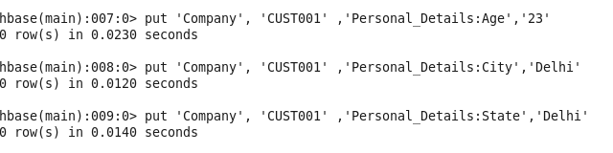

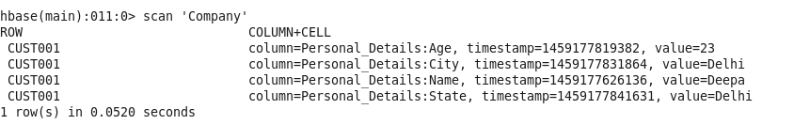

* Insert following values for order details column family

Order no., order quantity, and order amount

**Ans:**

put 'Company','CUST001','Order_Details:OrderNo','ORD01'

put 'Company','CUST001', 'Order_Details:Quantity','5'

put 'Company','CUST001','Order_Details:Amount','370'

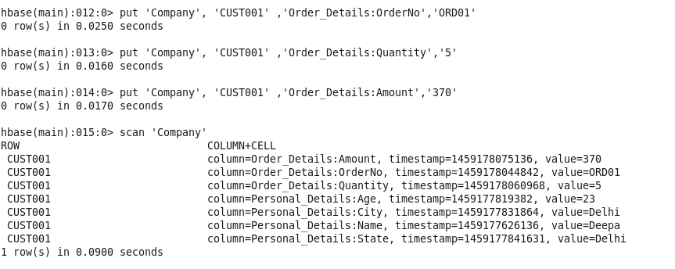

* Use put command to insert the values for each record.

put 'Company','CUST002', 'Personal_Details:Name','Tarun'

put 'Company','CUST002', 'Personal_Details:Age','26'

put 'Company','CUST002', 'Personal_Details:City','Ranikhet'

put ‘Company','CUST002','Personal_Details:State','Uttarakhand'

put 'Company','CUST002', 'Order_Details:OrderNo','ORD02'

put 'Company','CUST002', 'Order_Details:Quantity','11'

put 'Company','CUST002', 'Order_Details:Amount','2370'

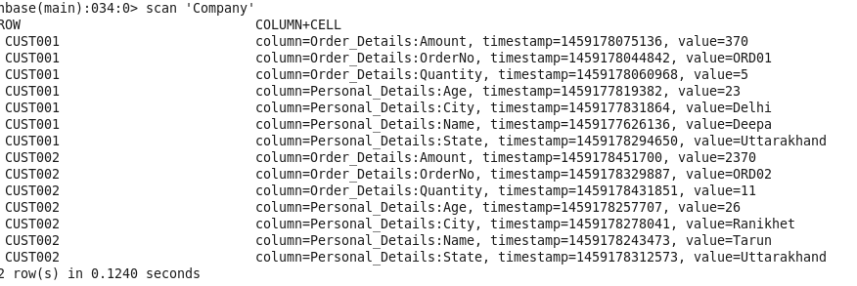

* Insert at least 10 records to each column

**Ans:**

**First Record:**

put 'Company','CUST003', 'Personal_Details:Name','Namrata'

put 'Company','CUST003', 'Personal_Details:Age','31'

put 'Company','CUST003', 'Personal_Details:City','Noida'

put 'Company','CUST003', ‘Personal_Details:State','Delhi'

put 'Company','CUST003', 'Order_Details:OrderNo','ORD03'

put 'Company','CUST003', 'Order_Details:Quantity','15'

put 'Company','CUST003', 'Order_Details:Amount','1278.45'

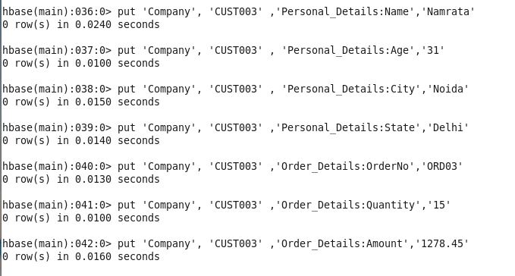

**Second Record:**

put 'Company','CUST004', 'Personal_Details:Name','Aditya'

put 'Company','CUST004', 'Personal_Details:Age','27'

put 'Company','CUST004', 'Personal_Details:City','Kashipur'

put 'Company','CUST004','Personal_Details:State','Uttarakhand'

put 'Company','CUST004', 'Order_Details:OrderNo','ORD04'

put 'Company','CUST004', 'Order_Details:Quantity','3'

put 'Company','CUST004', 'Order_Details:Amount','101'

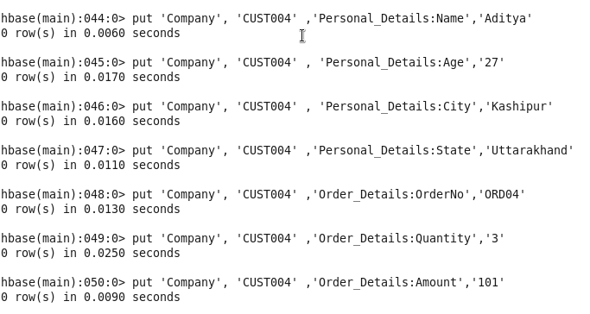

**Third Record:**

put 'Company','CUST005', 'Personal_Details:Name','Jigyasa'

put 'Company','CUST005', 'Personal_Details:Age','28'

put 'Company','CUST005', 'Personal_Details:City','Gurgaon'

put 'Company','CUST005', 'Personal_Details:State','Haryana',

put 'Company','CUST005', 'Order_Details:OrderNo','ORD05'

put 'Company','CUST005', 'Order_Details:Quantity','10'

put 'Company','CUST005', 'Order_Details:Amount','1119.9'

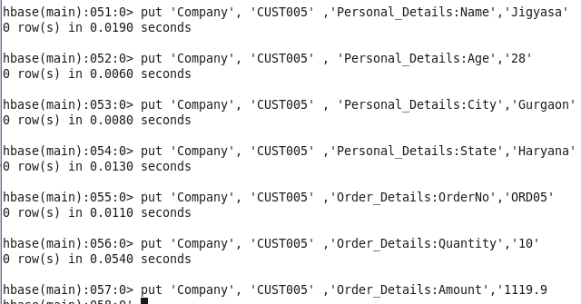

**Fourth Record:**

put 'Company','CUST006', 'Personal_Details:Name','Elesh'

put 'Company','CUST006', 'Personal_Details:Age','33'

put 'Company','CUST006', 'Personal_Details:City','Haldwani'

put 'Company','CUST006','Personal_Details:State','Uttarakhand'

put 'Company','CUST006', 'Order_Details:OrderNo','ORD06'

put 'Company','CUST006', 'Order_Details:Quantity','2'

put 'Company','CUST006', 'Order_Details:Amount','128.20'

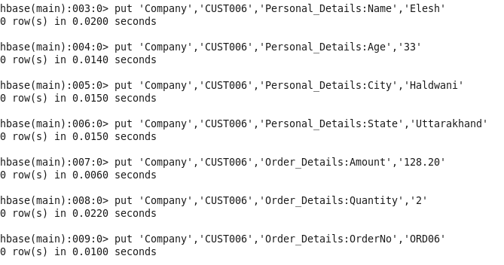

**Fifth Record:**

put 'Company','CUST007', 'Personal_Details:Name','Tanmay'

put 'Company','CUST007', 'Personal_Details:Age','28'

put 'Company','CUST007', 'Personal_Details:City','Almora'

put 'Company','CUST006', 'Personal_Details:State','Uttarakhand'

put 'Company','CUST006', 'Order_Details:OrderNo','O007',

put 'Company','CUST006', 'Order_Details:Quantity','7'

put 'Company','CUST006', 'Order_Details:Amount','49'

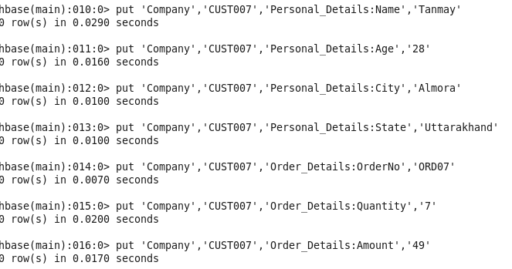

**Sixth Record:**

put 'Company','CUST008', 'Personal_Details:Name','Bipin'

put 'Company','CUST008', 'Personal_Details:Age','45'

put 'Company','CUST008', 'Personal_Details:City','Ranikhet'

put 'Company','CUST008', 'Personal_Details:State','Uttarakhand'

put 'Company','CUST008', 'Order_Details:OrderNo','ORD08'

put 'Company','CUST008', 'Order_Details:Quantity','9'

put 'Company','CUST008', 'Order_Details:Amount','105'

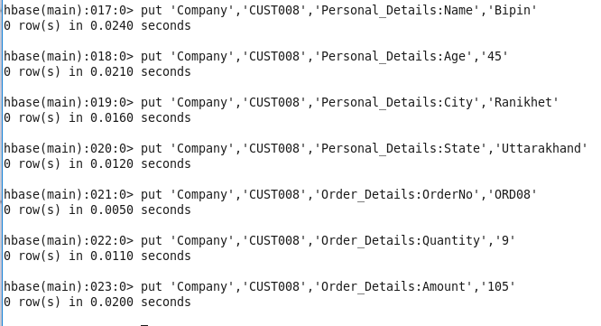

**Seventh Record:**

put 'Company','CUST009', 'Personal_Details:Name','Lata'

put 'Company','CUST009', 'Personal_Details:Age','42'

put 'Company','CUST009', 'Personal_Details:City','Almora'

put 'Company','CUST009', 'Personal_Details:State','Uttarakhand'

put 'Company','CUST009', 'Order_Details:OrderNo','ORD09'

put 'Company','CUST009', 'Order_Details:Quantity','15'

put 'Company','CUST009', 'Order_Details:Amount','1660'

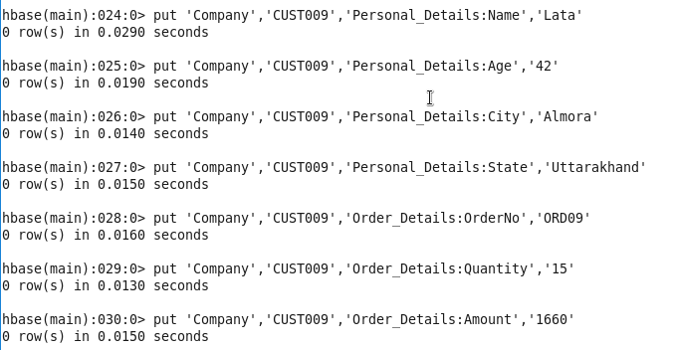

**Eighth Record:**

put 'Company','CUST010', 'Personal_Details:Name','Ayush'

put 'Company','CUST010', 'Personal_Details:Age','31'

put 'Company','CUST010', 'Personal_Details:City','Gurgaon'

put 'Company','CUST010', 'Personal_Details:State','Haryana'

put 'Company','CUST010', 'Order_Details:OrderNo','ORD10'

put 'Company','CUST010', 'Order_Details:Quantity','4'

put 'Company','CUST010', 'Order_Details:Amount','600'

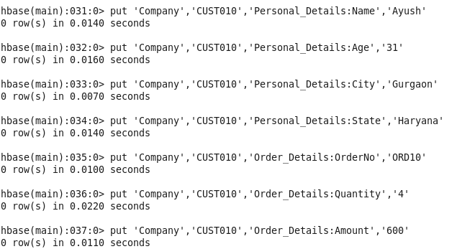

**Ninth Record:**

put 'Company','CUST011', 'Personal_Details:Name','Tarun'

put 'Company','CUST011', 'Personal_Details:Age','25'

put 'Company','CUST011', 'Personal_Details:City','Gurgaon'

put 'Company','CUST011', 'Personal_Details:State','Haryana'

put 'Company','CUST011', 'Order_Details:OrderNo','ORD11'

put 'Company','CUST011', 'Order_Details:Quantity',’06'

put 'Company','CUST011', 'Order_Details:Amount','76'

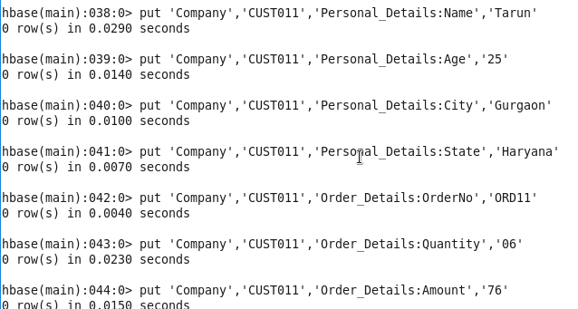

**Tenth Record:**

put 'Company','CUST012', 'Personal_Details:Name','Ahana'

put 'Company','CUST012', 'Personal_Details:Age','4'

put 'Company','CUST012', 'Personal_Details:City','Delhi'

put 'Company','CUST012', 'Personal_Details:State','Delhi'

put 'Company','CUST012', 'Order_Details:OrderNo','ORD12'

put 'Company','CUST012', 'Order_Details:Quantity',’2'

put 'Company','CUST012', 'Order_Details:Amount','20'

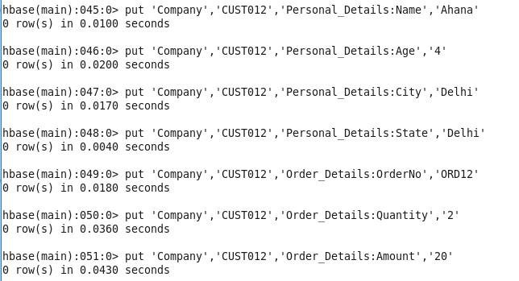

scan ‘Company’

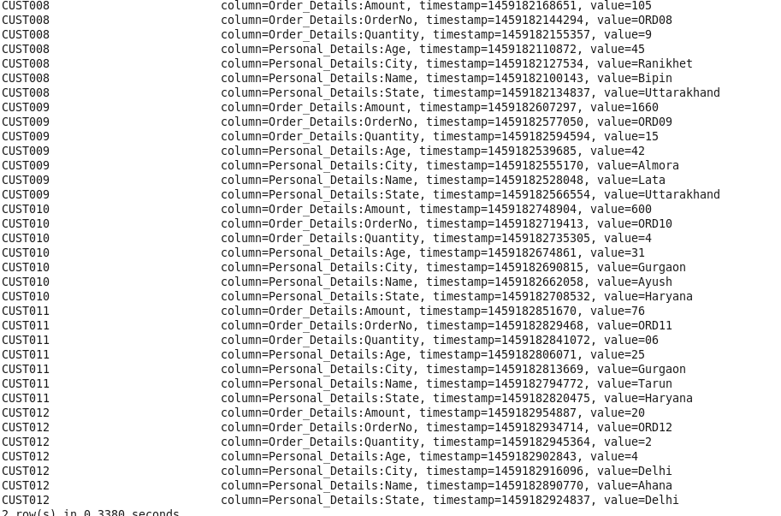

* Use get command, to retrieve all the records of single customer.

**Ans:**

get 'Company',' CUST004'

