Session 19: HBase Thrift and Rest ServerAssignment 1

# Problem Statement

[**https://acadgild.com/blog/integrating-hive-with-hbase/**](https://acadgild.com/blog/integrating-hive-with-hbase/)

Follow the above link and integrate Hbase with Hive as shown in the blog and send us the screenshot of your vm with the final output.

**Note:** Students are required to insert their own data into Hbase table.

**Solution:**

**Step1: Create HBase table**

Create ‘student’,’ personaldetails’,’collegedetails’

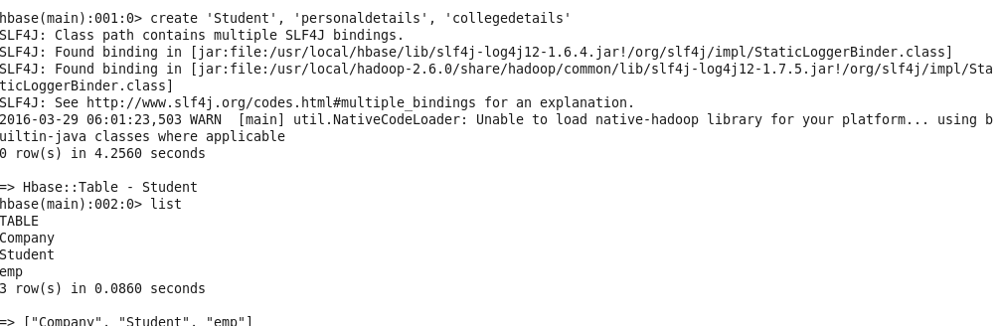

**Step2: Insert data into HBase table**

put ‘student’,’Stud01’,’ personaldetails:Fname’,’Tarun’

put ‘student’,’Stud01’,’ personaldetails:Lname’,’Choudhary’

put ‘student’,’Stud01’,’ personaldetails:Age’,’20’

put ‘student’,’Stud01’,’collegedetails:Name’,’Gyan Vihar Jaipur’

put ‘student’,’Stud01’,’collegedetails:Course’,’BTech’

put ‘student’,’Stud01’,’collegedetails:Year’,’First’

put ‘student’,’Stud01’,’collegedetails:Semester’,’2’

put ‘student’,’Stud02’,’ personaldetails:Fname’,’Aditya’

put ‘student’,’Stud02’,’ personaldetails:Lname’,’Trivedi’

put ‘student’,’Stud02’,’ personaldetails:Age’,’21’

put ‘student’,’Stud02’, ’collegedetails:Name’,’Birla Institute of Applied Sciences’

put ‘student’,’Stud02’,’collegedetails:Course’,’MCA’

put ‘student’,’Stud02’,’collegedetails:Year’,’Second’

put ‘student’,’Stud02’,’collegedetails:Semester’,’3’

put ‘student’,’Stud03’,’ personaldetails:Fname’,’Neha’

put ‘student’,’Stud03’,’ personaldetails:Lname’,’Bisht’

put ‘student’,’Stud03’,’ personaldetails:Age’,’19’

put ‘student’,’Stud03’,’collegedetails:Name’,’Graphic Era University’

put ‘student’,’Stud03’,’collegedetails:Course’,’BCA’

put ‘student’,’Stud03’,’collegedetails:Year’,’Third’

put ‘student’,’Stud03’,’collegedetails:Semester’,’5’

put ‘student’,’Stud04’,’ personaldetails:Fname’,’Kritika’

put ‘student’,’Stud04’,’ personaldetails:Lname’,’Joshi’

put ‘student’,’Stud04’,’ personaldetails:Age’,’26’

put ‘student’,’Stud04’,’collegedetails:Name’,’GB Pant University’

put ‘student’,’Stud04’,’collegedetails:Course’,’MTech’

put ‘student’,’Stud04’,’collegedetails:Year’,’Second’

put ‘student’,’Stud04’,’collegedetails:Semester’,’4’

put ‘student’,’Stud05’,’ personaldetails:Fname’,’Jigyasa’

put ‘student’,’Stud05’,’ personaldetails:Lname’,’Choudhary’

put ‘student’,’Stud05’,’ personaldetails:Age’,’22’

put ‘student’,’Stud05’,’collegedetails:Name’,’Birla Institute of Applied Sciences’

put ‘student’,’Stud05’,’collegedetails:Course’,’MCA’

put ‘student’,’Stud05’,’collegedetails:Year’,’Second’

put ‘student’,’Stud05’,’collegedetails:Semester’,’3’

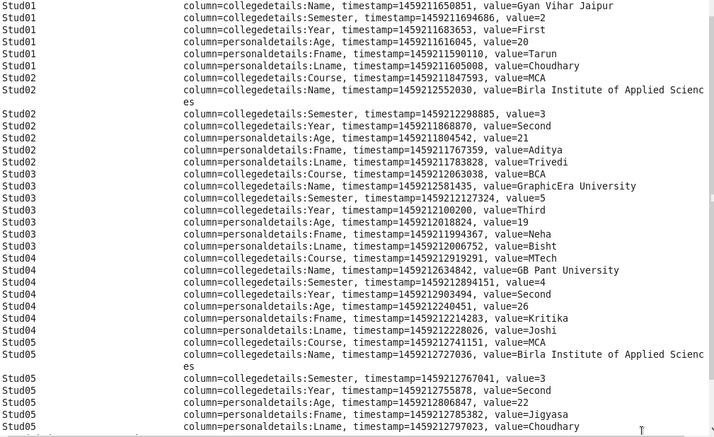

**Step3: Create Hive table pointing to HBase table**

create external table Student_hbase(Sid String, F_Name string, L_Name string, Age int)

STORED BY 'org.apache.hadoop.hive.hbase.HBaseStorageHandler'

with serdeproperties ("hbase.columns.mapping"=":key,personaldetails:Fname,personaldetails:Lname,personaldetails:Age") tblproperties("hbase.table.name"="Student");



**Step4: Select data from Hive table**

Select * FROM Student_hbase;

