Session 19: HBase Thrift and Rest ServerAssignment 1

# Problem Statement

**https://acadgild.com/blog/loading-data-into-hbase-using-pig-scripts/**

Follow the above link and load some sample dataset from Pig to Hbase table and send the screenshot of the final output as shown in the blog.

**Solution:**

**DataSet:**

StudentName, sector, DOB, qualification, score, state, randomName

Tarun,Government,30-Jul-1990,MTECH,9.5,Haryana,tarun*

Aditya,Private,12-Aug-1995,BE,2.5,Pune,aditya+

Bipin,Government,7-Jul-1988,BSC,9.5,Rajasthan,bipin!

Pooja,Government,20-Apr-1987,BTECH,4.5,Punjab,pooja$

Mamta,Private,30-Jun-1980,MCA,5.5,Uttarakhand,mamta@

Kavita,Government,30-Dec-1990,MTECH,6.5,Haryana,kavita/

Neha,Private,12-Apr-1985,BE,3.5,Pune,neha#

Namrata,Government,27-Oct-1988,BSC,9.5,Rajasthan,namrata$

Lata,Government,5-May-1987,BTECH,3.5,Punjab,lata$

Ahana,Private,22-Apr-1980,MCA,9.5,Uttarakhand,ahana#

Kritika,Government,26-Aug-1990,MTECH,4.5,Haryana,kritika*

Deepti,Private,30-Nov-1995,BE,9.5,Pune,deepti+

Tanmay,Government,22-May-1988,BSC,2.5,Rajasthan,tanmay!

Meenu,Government,25-May-1987,BTECH,1.5,Punjab,meenu$

Somya,Private,17-Mar-1980,MCA,7.5,Uttarakhand,somya@

Jyoti,Government,3-Jul-1990,MTECH,9.5,Haryana,jyoti$

Rupali,Private,2-Jan-1995,BE,2.5,Pune,rupali+

Divi,Government,17-Jan-1988,BSC,3.5,Rajasthan,divi!

Swati,Government,21-Aug-1987,BTECH,4.5,Punjab,swati$

Vivek,Private,22-Jun-1980,MCA,5.5,Uttarakhand,vivek@

Manoj,Government,23-Feb-1990,MTECH,6.5,Haryana,manoj*

Mahi,Private,10-Oct-1995,BE,7.5,Pune,mahi+

Deepika,Government,7-Sep-1988,BSC,8.5,Rajasthan,deepika!

Lavita,Government,20-Nov-1987,BTECH,9.5,Punjab,lavita@

Jigyasa,Private,23-Feb-1980,MCA,9.5,Uttarakhand,jigyasa$

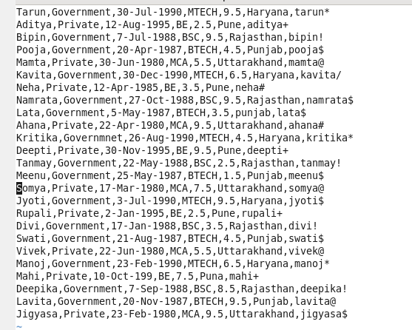

**STEP1: Copy dataset to HDFS**

hadoop dfs –put Session19Assignment2 /

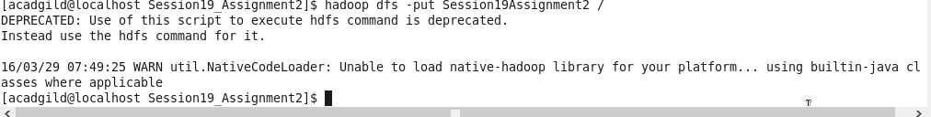

**STEP2: include few jar files of Hbase to the pig classpath**

Export PIG_CLASSPATH=/home/hadoop/HADOOP/hbase-0.98.4-hadoop2/lib/hbase-server-0.98.4-hadoop2:/home/hadoop/HADOOP/hbase-0.98.4-hadoop2/lib/hbase-*.jar;



**Step3: Start hbase shell and create table**

hbase shell

create ‘Student_Session19_Assignmnet2’,’student_details’

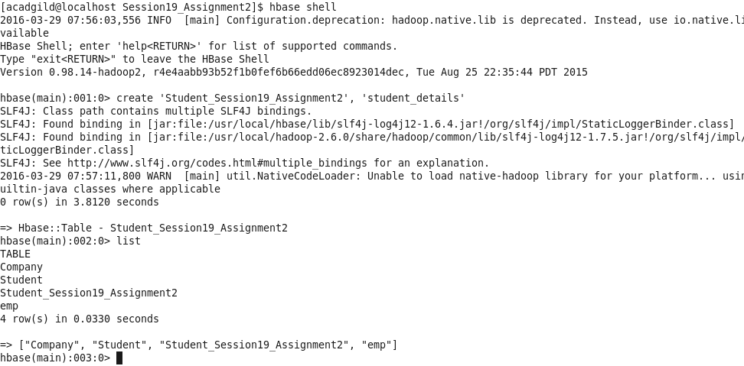

**Step4: Start pig and load data**

rawD = LOAD ‘/Session19Assignment2/’ USING PigStorage(‘,’) (StudentName:chararray, sector: chararray, DOB:chararray, qualification:chararray, score:float, state:chararray, randomName:chararray);

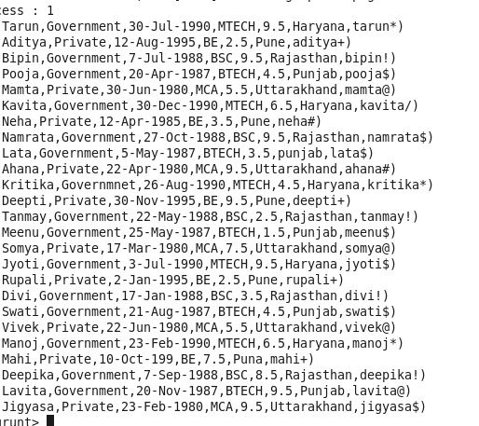

**Step5: Transfer data to Hbase table created in Step 3**

STORE rawD INTO ‘hbase://Student_Session19_Assignmnet2’ USING org.apache.pig.backend.hadoop.hbase.HBaseStorage(’student_details:StudentName, student_details:sector, student_details:DOB, student_details:qualification, student_details:score, student_details:state, student_details:randomName);

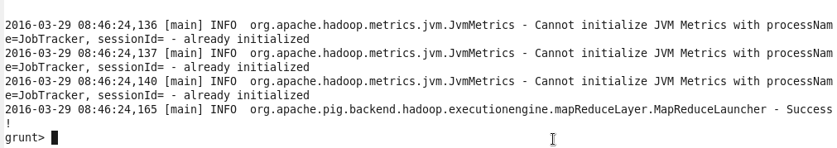

**Step6: See the data inserted in Hbase table**

scan ‘Student_Session19_Assignmnet2’

