**Name:** CHINMAYA GARNAIK

**Course:** FYMCA

**Division:** B

**PRN:** 1132220942

**ADVANCE JAVA ASSIGNMENT 1**

1. Create an interface for Employee Details

import java.awt.*;

import java.awt.event.*;

import javax.swing.*;

public class EmployeeDetails extends JFrame {

private JLabel lblName;

private JTextField txtName;

private JLabel lblAge;

private JTextField txtAge;

private JLabel lblDesignation;

private JTextField txtDesignation;

private JButton btnSave;

public EmployeeDetails() {

setTitle("Employee Details");

setSize(300, 200);

setLayout(new FlowLayout());

setDefaultCloseOperation(JFrame.EXIT_ON_CLOSE);

lblName = new JLabel("Name: ");

txtName = new JTextField(20);

lblAge = new JLabel("Age: ");

txtAge = new JTextField(3);

lblDesignation = new JLabel("Designation: ");

txtDesignation = new JTextField(20);

btnSave = new JButton("Save");

add(lblName);

add(txtName);

add(lblAge);

add(txtAge);

add(lblDesignation);

add(txtDesignation);

add(btnSave);

setVisible(true);

}

public static void main(String[] args) {

new EmployeeDetails();

}

}

Output:

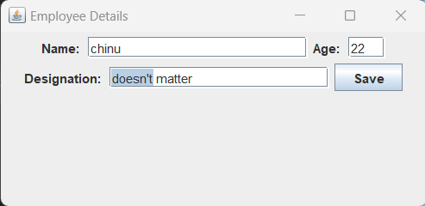

2. Create an interface for Hotel website.

import java.awt.*;

import java.awt.event.*;

public class question2 extends Frame implements ActionListener {

private Label hotelNameLabel, roomsLabel, amenitiesLabel, contactLabel,

hotelNameText;

private TextField roomsText, amenitiesText, contactText;

private Button submitButton, exitButton;

public question2() {

// Set the frame properties

setTitle("Hotel Website");

setSize(500, 400);

setLayout(new GridLayout(5, 2));

setVisible(true);

// Add the labels and text fields for hotel name, number of rooms,

// amenities, and contact information

hotelNameLabel = new Label("Hotel Name: ");

add(hotelNameLabel);

hotelNameText = new Label(" Sunrise Hotel ");

add(hotelNameText);

roomsLabel = new Label("Number of Rooms:");

add(roomsLabel);

roomsText = new TextField();

add(roomsText);

amenitiesLabel = new Label("Amenities:");

add(amenitiesLabel);

amenitiesText = new TextField();

add(amenitiesText);

contactLabel = new Label("Contact Information:");

add(contactLabel);

contactText = new TextField();

add(contactText);

// Add the submit and exit buttons

submitButton = new Button("Submit");

add(submitButton);

submitButton.addActionListener(this);

exitButton = new Button("Exit");

add(exitButton);

exitButton.addActionListener(this);

// Set the default close operation

addWindowListener(new WindowAdapter() {

public void windowClosing(WindowEvent windowEvent) {

System.exit(0);

}

});

}

public void actionPerformed(ActionEvent e) {

if (e.getSource() == submitButton) {

String hotelName = hotelNameText.getText();

int numberOfRooms = Integer.parseInt(roomsText.getText());

String amenities = amenitiesText.getText();

String contactInfo = contactText.getText();

System.out.println("Hotel Name: " + hotelName);

System.out.println("Number of Rooms: " + numberOfRooms);

System.out.println("Amenities: " + amenities);

System.out.println("Contact Information: " + contactInfo);

} else if (e.getSource() == exitButton) {

System.exit(0);

}

}

public static void main(String[] args) {

new question2();

}

}

Output:

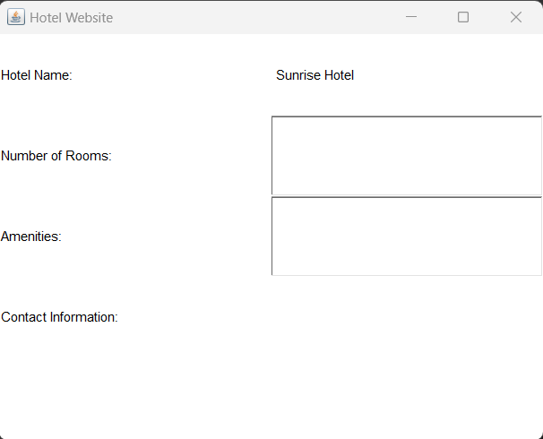

3. Implement Interface and abstract class.

interface Shape {

double area();

}

abstract class Polygon implements Shape {

protected int numSides;

Polygon(int numSides) {

this.numSides = numSides;

}

}

class Rectangle extends Polygon {

private double width;

private double height;

Rectangle(double width, double height) {

super(4);

this.width = width;

this.height = height;

}

@Override

public double area() {

return width * height;

}

}

class Square extends Polygon {

private double side;

Square(double side) {

super(4);

this.side = side;

}

@Override

public double area() {

return side * side;

}

}

class question3 {

public static void main(String[] args) {

Rectangle rectangle = new Rectangle(5, 10);

Square square = new Square(5);

System.out.println("Area of rectangle: " + rectangle.area());

System.out.println("Area of square: " + square.area());

}

}

Output:

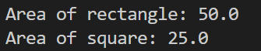

4. Implement inheritance and polymorphism.

class Animal {

public void move() {

System.out.println("Animals can move");

}

}

class Dog extends Animal {

public void move() {

System.out.println("Dogs can walk and run");

}

public void bark() {

System.out.println("Dogs can bark");

}

}

class Cat extends Animal {

public void move() {

System.out.println("Cats can walk and run");

}

public void meow() {

System.out.println("Cats can meow");

}

}

public class question4 {

public static void main(String[] args) {

Animal a = new Animal();

Animal b = new Dog();

Animal c = new Cat();

a.move();

b.move();

c.move();

}

}

Output:

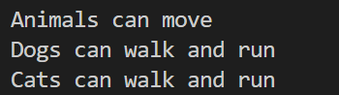

5. Implement parameterized constructor.

public class question5 {

String studentName;

int studentAge;

// constructor

question5(String name, int age) {

studentName = name;

studentAge = age;

}

void display() {

System.out.println(studentName + " " + studentAge);

}

public static void main(String args[]) {

question5 myObj = new question5("Chinmaya", 22);

myObj.display();

}

}

Output:

