**Name:** CHINMAYA GARNAIK

**Course:** FYMCA

**Division:** B

**PRN:** 1132220942

**ADVANCE JAVA ASSIGNMENT 2**

1) Write a program that crates a class student. Display student information. Calculate his result and show it. Use Constructor, methods.

class Student {

public String name;

public int Registration_Number;

public float physics;

public float chemistry;

public float mathematics;

public float percentage;

// constructor

public Student(

String name,

int Registration_Number,

float physics,

float chemistry,

float mathematics) {

this.name = name;

this.Registration_Number = Registration_Number;

this.physics = physics;

this.chemistry = chemistry;

this.mathematics = mathematics;

}

// method to calcluate the percentage

public void calculateresult() {

percentage = ((physics + chemistry + mathematics) / 3);

}

// method to display the student details

public void detaildisplay() {

System.out.println("Name = " + name);

System.out.println("Registration Number = " + Registration_Number);

}

// method to display the Result

public void resultdisplay() {

System.out.println("Percentage received = " + percentage);

}

}

class question1 {

public static void main(String args[]) throws Exception {

Student student = new Student("Chinamya", 112, 98, 90, 99);

student.calculateresult();

student.detaildisplay();

student.resultdisplay();

}

}

Output:

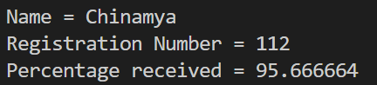

2) Write a Program that implements multilevel inheritance. Use Method Overriding.

//Multilevel inheritance and method overriding.

import java.util.Scanner;

// Base class A

class A {

int a;

Scanner sc = new Scanner(System.in);

void variablea() {

System.out.println("Please enter first number for addition");

a = sc.nextInt();

}

void overmessage() {

System.out.println(" Welcome to the base class A");

}

}

// Derived class B

class B extends A {

int b;

void getvariable() {

System.out.println("Please enter the second number for addition");

b = sc.nextInt();

}

void overmessage() {

System.out.println("Welcome to the derived class B that extends A");

}

}

// Derived class C

class C extends B {

void addition() {

System.out.println("Addition of the variables you entered is " + (a + b));

}

void overmessage() {

System.out.println("Welcome to the derived class C that extends B which extends A");

System.out.println("Hence, Method overridden");

}

}

// Main class

class question2 {

public static void main(String args[]) {

System.out.println("Method overridding and multi level inheritance");

C c = new C();

c.variablea();

c.getvariable();

c.addition();

c.overmessage();

}

}

Output:

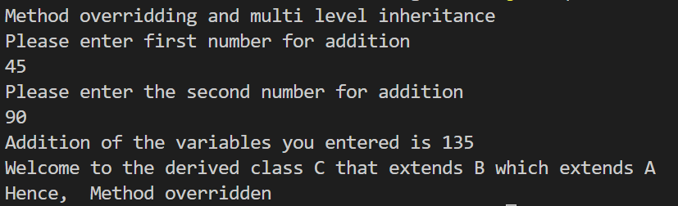

3) Write a program that implements abstract class.

abstract class shape {

abstract void area();

abstract void perimeter();

}

class square extends shape {

void area() {

System.out.println("Area of Square= Side * Side");

}

void perimeter() {

System.out.println("Perimeter of Square= 4 * Side");

}

}

class rectangle extends shape {

void area() {

System.out.println("Area of Rectangle= Length * Breadth");

}

void perimeter() {

System.out.println("Perimeter of rectangle= 2 * (Length + Breadth)");

}

}

class question3 {

public static void main(String args[]) {

square sq = new square();

sq.area();

sq.perimeter();

rectangle r = new rectangle();

r.area();

r.perimeter();

}

}

Output:

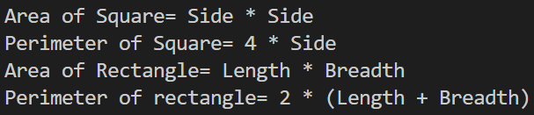

4) Write a program that implements interface.

interface perimeter {

float calculate(float x, float y);

}

class rectangle implements perimeter {

public float calculate(float x, float y) {

return (2 * (x + y));

}

}

class square implements perimeter {

public float calculate(float x, float y) {

return 4 * x;

}

}

class question4 {

public static void main(String args[]) {

square s = new square();

rectangle rc = new rectangle();

perimeter p;

p = s;

System.out.println("Area of square with side length of 4 is " + p.calculate(4, 0));

p = rc;

System.out.println("Area of rectangle with length 7 and breadth 3 is " + p.calculate(7, 3));

}

}

Output:

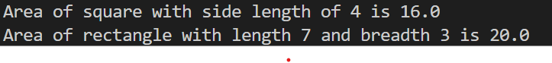

5) Write an program that creates package named EMP. Add Class EMP_Dtls in it and display emp information.

class shape {

String defcolor = "yellow";

}

class square extends shape {

String defcolor = "red";

void supertest() {

System.out.println(defcolor);

System.out.println(super.defcolor);

}

}

class question5 {

public static void main(String[] abs) {

square sq = new square();

sq.supertest();

}

}

Output:

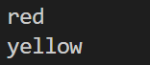

6) Implement inheritance. Use Super keyword.

import emp.Emp_Dtls;

class question6 {

public static void main(String args[]) {

System.out.println(" EMPLOYEE Details :");

var em1 = new emp.Emp_Dtls(1, "Chinmaya");

em1.Display();

var em2 = new emp.Emp_Dtls(2, "Gaurav");

em2.Display();

}

}

Output:

