**Name:** CHINMAYA GARNAIK

**Course:** FYMCA

**Division:** B

**PRN:** 1132220942

**ADVANCE JAVA ASSIGNMENT 4**

1)Demonstrate use of super keyword using program.

class Animal {

// overridden method

public void display() {

System.out.println("I am an animal");

}

}

class Dog extends Animal {

// overriding method

@Override

public void display() {

System.out.println("I am a dog");

}

public void printMessage() {

// this calls overriding method

display();

// this calls overridden method

super.display();

}

}

class question1 {

public static void main(String[] args) {

Dog dog1 = new Dog();

dog1.printMessage();

}

}

Output:

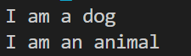

2) Demonstrate Abstract class and interface.

abstract class Shape {

public abstract double getArea();

}

interface Drawable {

public void draw();

}

class Circle extends Shape implements Drawable {

private double radius;

public Circle(double radius) {

this.radius = radius;

}

public double getArea() {

return Math.PI * radius * radius;

}

public void draw() {

System.out.println("Drawing a circle with radius " + radius);

}

}

public class question2 {

public static void main(String[] args) {

Circle c = new Circle(5);

System.out.println("Area of circle: " + c.getArea());

c.draw();

}

}

Output:

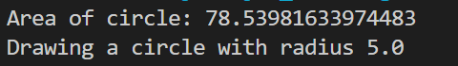

3) Implement Method overriding and overloading.

class Parent {

public void display() {

System.out.println("Parent display method");

}

}

class Child extends Parent {

@Override

public void display() {

System.out.println("Child display method");

}

}

class Overload {

public void display(int num) {

System.out.println("display(int) method: " + num);

}

public void display(String message) {

System.out.println("display(String) method: " + message);

}

public void display(double num) {

System.out.println("display(double) method: " + num);

}

}

public class question3 {

public static void main(String[] args) {

Parent p = new Child();

p.display();

Child c = new Child();

c.display();

Overload o = new Overload();

o.display(5);

o.display("Hello, World!");

o.display(3.14);

}

}

Output:

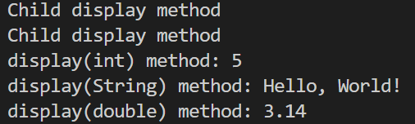

4)Create a package cal_data. Write down functions for mathematical functions like area,square,cube etc.

package cal_data;

public class MathFunctions {

public static double squareArea(double side) {

return side * side;

}

public static double rectangleArea(double length, double width) {

return length * width;

}

public static double triangleArea(double base, double height) {

return 0.5 * base * height;

}

public static double square(double num) {

return num * num;

}

public static double cube(double num) {

return num * num * num;

}

}

5) Use Above package and use all methods in it.

import cal_data.MathFunctions;

public class question5 {

public static void main(String[] args) {

MathFunctions mf = new MathFunctions();

double squareArea = mf.squareArea(5);

System.out.println("Square area: " + squareArea);

double rectangleArea = mf.rectangleArea(5, 7);

System.out.println("Rectangle area: " + rectangleArea);

double triangleArea = mf.triangleArea(5, 7);

System.out.println("Triangle area: " + triangleArea);

double square = mf.square(5);

System.out.println("Square: " + square);

double cube = mf.cube(5);

System.out.println("Cube: " + cube);

}

}

Output:

Square area: 25.0

Rectangle area: 35.0

Triangle area: 17.5

Square: 25.0

Cube: 125.0