

MIT OPEN CREDIT MANAGEMENT SYSTEM
Rule-Driven Academic Enrollment, Result & Financial Management Platform
SE 801 :Software Project Lab 3

Submitted by

MD. Jihad Hossain
BSSE Roll No. : 1413
BSSE Session: 2021-22

Supervised by
Dr. Md. Nurul Ahad Tawhid
Associate Professor
Institute of Information Technology
University of Dhaka
02-08-2026

Table of Contents 2
List of Figures 4
1. Project Overview 5
1.1 Project Title 5
1.2 Problem Statement 5
1.3 Objectives 5
1.4 Scope 6
1.5 Deliverables 6
2. Requirements Analysis 7
2.1 Functional Requirements 7
2.2 Non-functional Requirements 8
2.3 Stakeholders 8
2.4 Usage Scenarios 8
3. System Modeling 9
3.1 Use Case Diagrams and Descriptions 9
Level 0 — System Overview 9
Level 1 — Full System (Actor-Based) 10
Level 1.1 — Authentication & Role Access 11
Level 1.2 — Student Course Registration 12
Level 1.3 — Student Academic Progress & Finance 13
Level 1.4 — Teacher Marks Management 14
Level 1.5 — Admin Academic & Financial Administration 15
3.2 Activity Diagrams 16
3.2.1 Authentication & Role Routing 16
3.2.2 Student Course Registration 17
3.2.3 Teacher Marks Entry 18
3.2.4 Result Calculation & Publication 19
3.2.5 Fee, Payment & Dues Update 20
3.3 Data Flow Diagrams 22
3.3.1 DFD Level 0 — System Context 22
3.3.2 DFD Level 1 — Major Processes 23
3.3.3 DFD Level 2 — Student Semester Registration 24
4. Data & Information Modeling 25
4.1 Data Objects and Relationships 25
4.2 Entity Relationship Diagram 26
4.3 Database Schema Summary 27
5. Software Design 28
5.1 Component Diagram 28
5.2 UI-to-Database Interaction 29
6. Software Architecture & Traceability 30
6.1 Requirement Traceability Matrix 30
7. Preliminary Test Plan 31
8. Implementation Progress & Challenges 31
9. Timeline & Demonstration Plan 32
9.1 Presentation Demonstration Sequence 32

List of Figures
Figure 1: Use case diagram — Level 0 system overview …….. 8
Figure 2: Use case diagram — Level 1 full system 9
Figure 3: Authentication & Role Access 10
Figure 4: Student Course Registration 11
Figure 5: Student Academic Progress & Finance 12
Figure 6: Teacher Marks Management 13
Figure 7: Admin Academic & Financial Administration 14
Figure 8: Authentication activity 15
Figure 9: Course registration activity 16
Figure 10: Teacher marks activity 17
Figure 11: Result calculation and publication activity 18
Figure 12: Fee and dues activity 19
Figure 13: DFD Level 0 — system context 20
Figure 14: DFD Level 1 — process decomposition 21
Figure 15: DFD Level 2 — semester registration 22
Figure 16: Logical ER diagram 24
Figure 17: Code-aligned component architecture 26
Figure 18: UI click-to-database flow 27
Figure 19: Layered runtime and deployment view 28
Figure 20: Timeline and presentation milestone 30

1. Project Overview

1.1 Project Title
MIT Open Credit Management System — a secure, role-based academic platform for managing open-credit enrollment, marks, results, CGPA and student financial records.

1.2 Problem Statement
The open-credit process combines semester registration, mandatory and optional courses, limited seats, teacher assignment, marks submission, result processing and financial penalties. When these activities are managed through disconnected forms or spreadsheets, credit totals may be invalid, seats may be allocated inconsistently, marks and CGPA may be calculated incorrectly, and academic or financial records may become difficult to verify. Students need a clear and trustworthy registration and progress view; Teachers need controlled access to assigned courses and rosters; and Administrators need consistent academic, result and finance management without bypassing institutional rules.

1.3 Objectives
• O1 — Secure Access: Authenticate Student, Teacher and Admin users with JWT and enforce role-based access at both frontend and backend.
• O2 — Credit Control: Support the approved requirement of exactly 12 credits per semester and 36 credits for the programme.
• O3 — Seat Control: Enforce a maximum of 40 seats for optional courses and protect the final seat against concurrent requests.
• O4 — Academic Results: Allow Teachers to enter marks and enable grade, GPA and CGPA calculation with an explicit publication workflow.
• O5 — Finance: Calculate retake and semester-gap fees and maintain transparent charge, payment and dues records.
• O6 — Usability & Maintainability: Provide clear role dashboards using Angular, Spring Boot and PostgreSQL with traceable requirements and testable rules.

1.4 Scope
In scope:
• JWT authentication and Student/Teacher/Admin RBAC.
• Student dashboard, profile, course catalogue, enrollment history, results, CGPA and dues.
• Teacher dashboard, assigned courses, enrolled student roster and validated midterm/final mark entry.
• Admin management of students, teachers, courses, semesters, fees and system statistics.
• Academic rules for credit validation, seat availability, grade calculation and CGPA.
• Angular 18 frontend, Spring Boot 3.3 / Java 21 backend, PostgreSQL 16 and Flyway V1–V7.
Out of scope for the midterm baseline:
• Mobile application, AI recommendation or chatbot features.
• Microservices and other speculative distributed infrastructure.
• Full online payment-gateway settlement and unrelated university ERP modules.

1.5 Deliverables
# | Deliverable | Description
1 | Angular Frontend | Role-based Student, Teacher and Admin screens with routing, forms, API services and dashboard views.
2 | Spring Boot Backend | JWT security, REST controllers, service-layer validation and JPA persistence.
3 | PostgreSQL Database | Flyway V1–V7 schema for users, courses, semesters, enrollments, grades and fees.
4 | System Models | Use case, activity, DFD, ERD, component and deployment models.
5 | Test & Presentation Package | Preliminary test plan, progress analysis, Gantt chart and demonstration sequence.

2. Requirements Analysis

2.1 Functional Requirements
ID | Functional Requirement | Current Status
FR-01 | Authenticate valid users and issue JWT access based on Student, Teacher or Admin role. | Implemented
FR-02 | Show role-specific dashboards and prevent cross-role access. | Implemented
FR-03 | Display courses, credit values, seats and active semester information. | Implemented with limitation
FR-04 | Allow a Student to create and remove own course enrollments. | Implemented with limitation
FR-05 | Confirm only an exactly 12-credit semester registration; reject partial confirmation. | Target correction
FR-06 | Prevent duplicate enrollment and reject a full optional course above 40 seats. | Implemented with limitation
FR-07 | Allow a Teacher to view assigned courses and enrolled Students. | Implemented
FR-08 | Validate and save midterm/final marks for authorized courses only. | Implemented
FR-09 | Calculate total marks, grade point and CGPA accurately. | Implemented with limitation
FR-10 | Publish results before they become visible to Students. | Target correction
FR-11 | Generate retake and semester-gap fees and show outstanding dues. | Implemented with limitation
FR-12 | Record and verify payments against outstanding charges. | Target correction
FR-13 | Allow Admin to manage students, teachers, courses, semesters and fees. | Implemented with limitation
FR-14 | Provide statistics, monitoring and traceable validation messages. | Implemented with limitation

2.2 Non-functional Requirements
Category | Requirement
Security | BCrypt password hashing, signed JWT, backend RBAC, ownership checks and non-revealing authentication errors.
Integrity | Enrollment, seat, grade and fee updates must avoid partial or duplicated records.
Performance | Normal pages should respond within approximately 2 seconds under presentation-scale load.
Usability | Readable responsive pages, clear validation messages, consistent navigation and no text overlap.
Maintainability | Angular components/services and Spring controller/service/repository responsibilities remain separated.
Deployability | A clean PostgreSQL database must migrate through Flyway V1–V7 and the Angular/Maven builds must succeed.

2.3 Stakeholders
Stakeholder | Main Need
Student | Secure registration, results, CGPA, fee and due visibility.
Teacher | Assigned-course roster and reliable marks entry.
Admin | Master-data management, monitoring, results and finance control.
Academic Authority | Correct enforcement of credit, seat and grade policies.
Supervisor / Evaluator | Clear, correct and consistent modelling with honest progress evidence.

2.4 Usage Scenarios
• Student Registration: Student signs in, opens available courses, selects a course or semester package, receives validation and sees the saved enrollment.
• Teacher Marks: Teacher opens an assigned course, loads the roster, enters valid marks and saves them for grade processing.
• Admin Control: Admin manages academic data, monitors seats and fees, and reviews result or payment status.

3. System Modeling

3.1 Use Case Diagrams and Descriptions
The use case model progresses from a high-level system view to the concrete responsibilities of Student, Teacher and Admin. The diagrams describe the required system behaviour; the implementation-progress section separately identifies current limitations.

Level 0 — System Overview
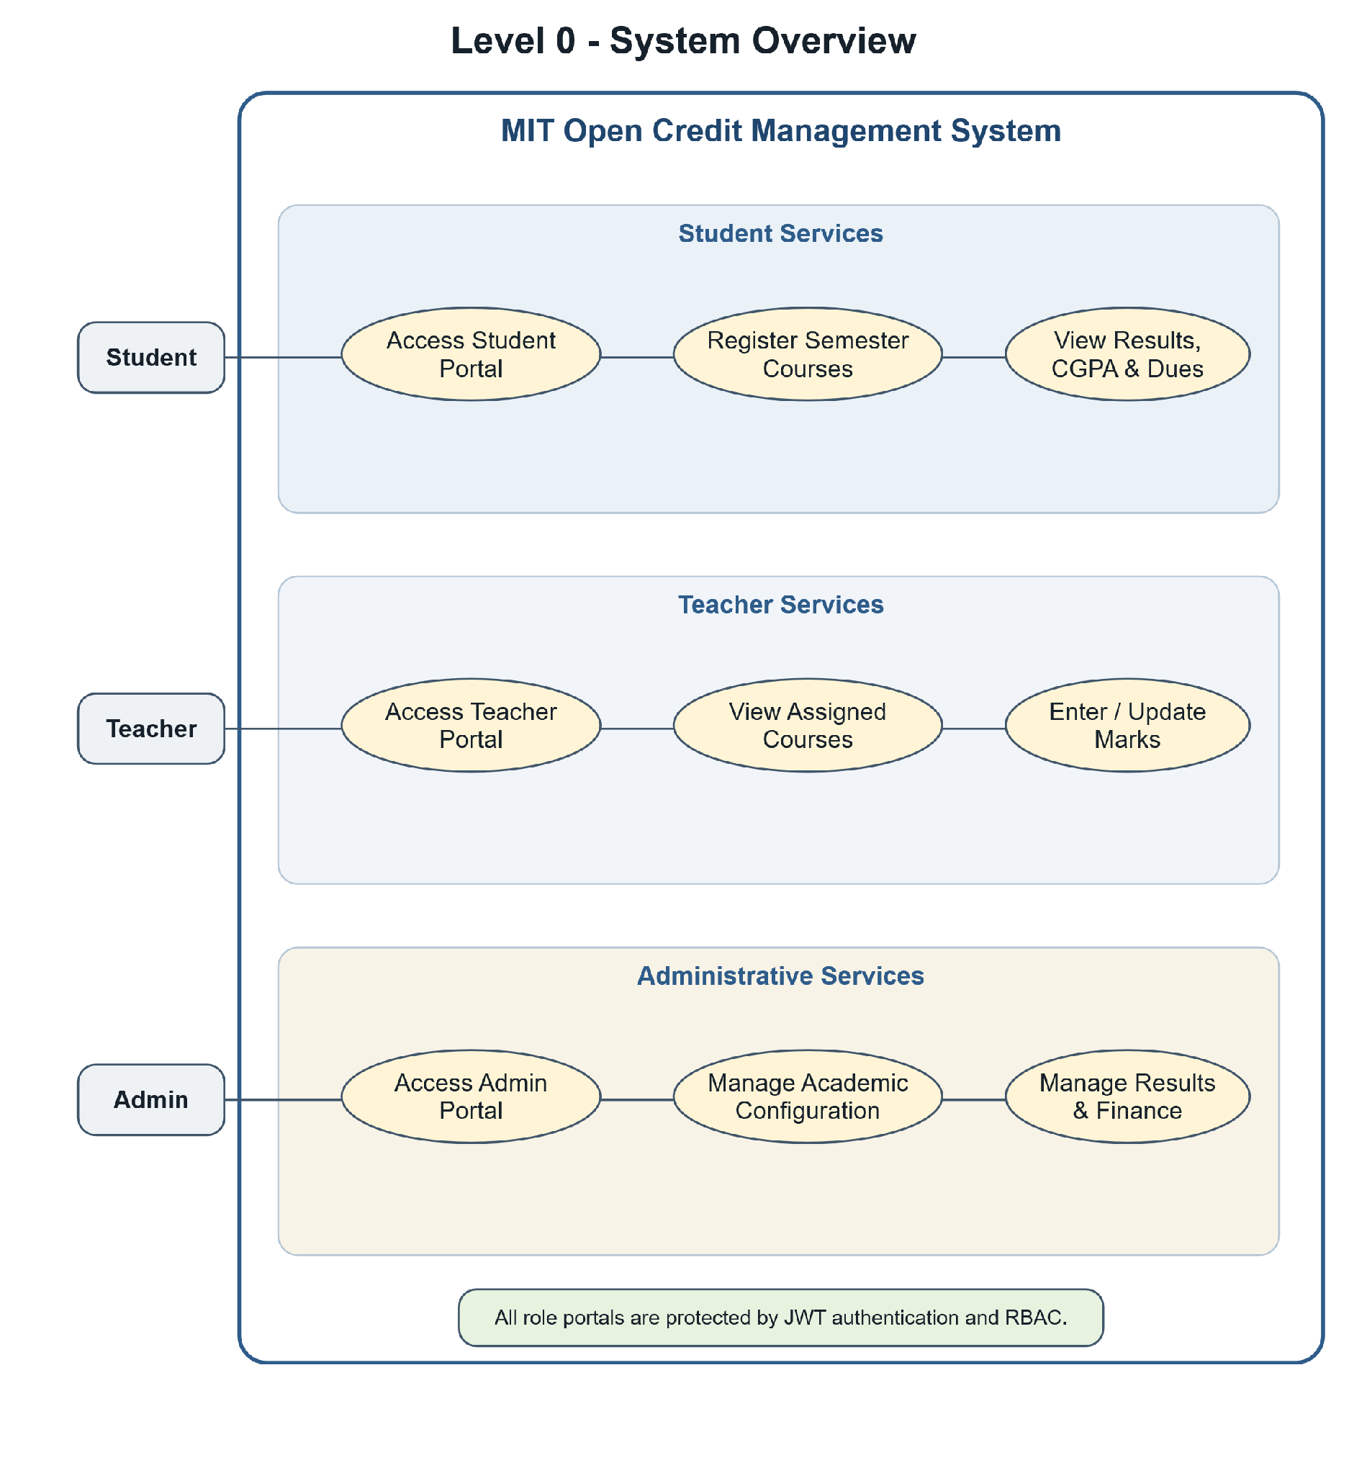
Figure 1: Use case diagram — Level 0 system overview
Students register courses and view results, CGPA and dues. Teachers manage marks and course results. Administrators manage academic and financial data. All actors enter through protected role access.

Level 1 — Full System (Actor-Based)
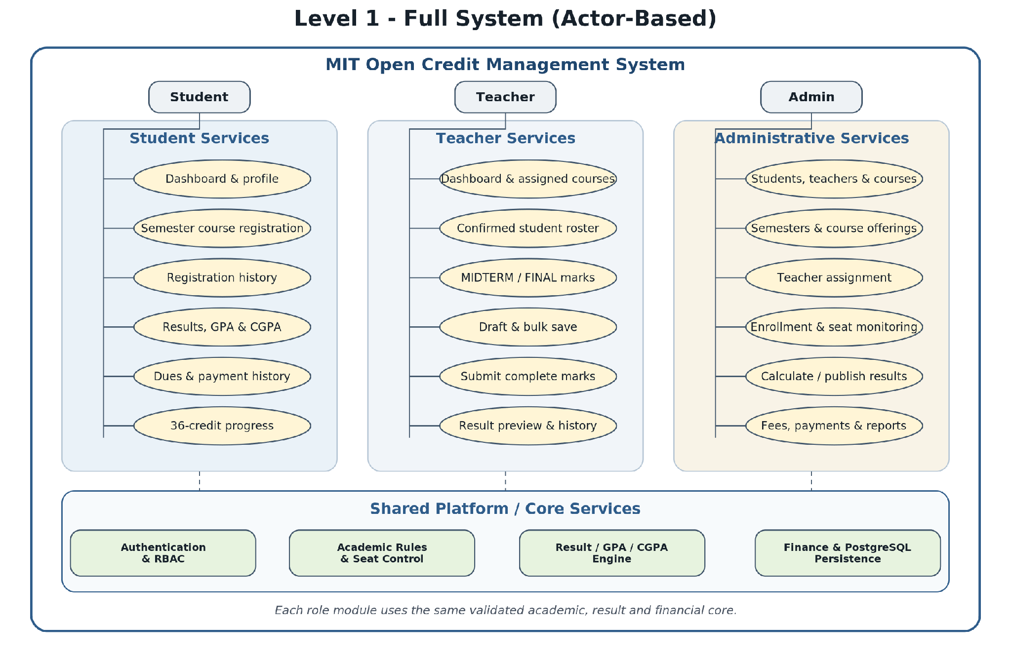
Figure 2: Use case diagram — Level 1 full system
The full-system diagram separates Student, Teacher and Administrative responsibilities into clear clusters so the role interactions remain readable during presentation and discussion.

Level 1.1 — Authentication & Role Access
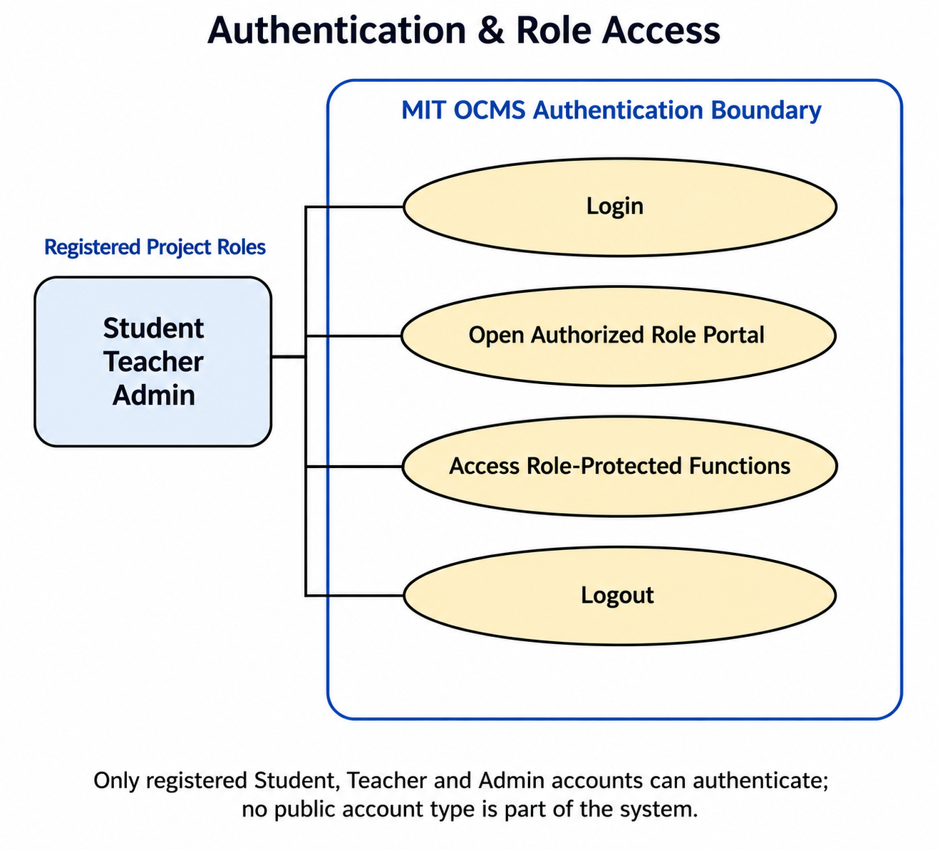
Figure 3: Use case diagram — Authentication & Role Access
Use Case Name: Authentication & Role Access
Primary Actors: Student, Teacher, Admin
Secondary Actors: —
Action – Reply
• Action: A Student, Teacher or Admin submits an email address and password.
• Reply: System validates credentials, account status and role, then issues a signed JWT access token.
• Action: The authenticated actor opens a protected route or role function.
• Reply: The Angular guard and Spring Security verify the required Student, Teacher or Admin role.
• Action: The actor logs out or the access token expires.
• Reply: The client clears authentication state; protected requests are rejected and the browser returns to the login page.

Level 1.2 — Student Course Registration
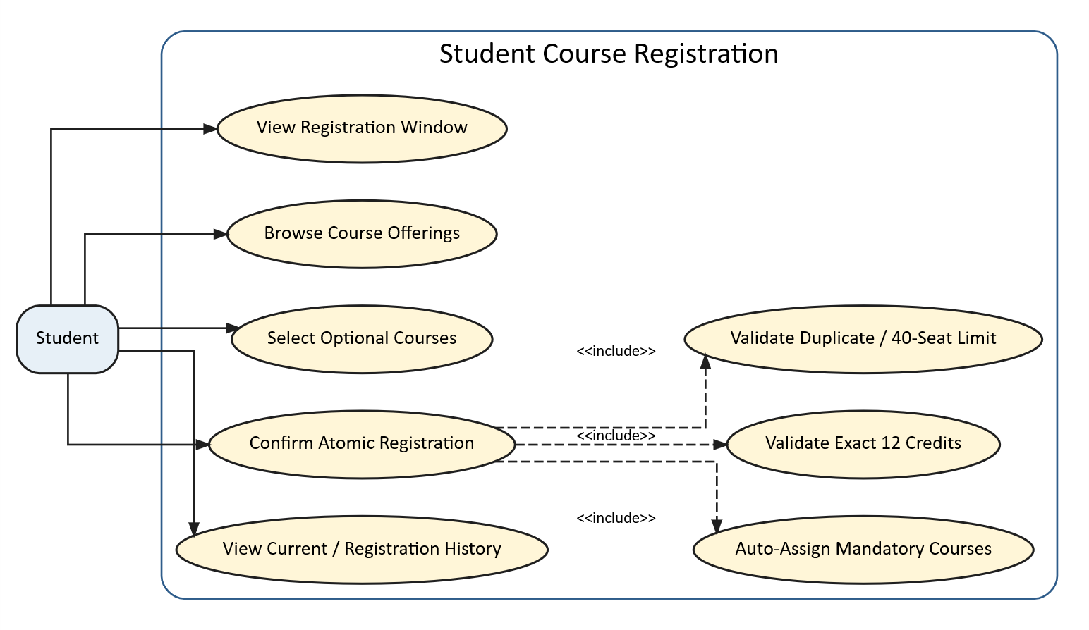
Figure 4: Use case diagram — Student Course Registration
Use Case Name: Student Course Registration
Primary Actors: Student
Secondary Actors: —
Action – Reply
• Action: Student opens the registration page and reviews mandatory and optional courses.
• Reply: System returns course, credit and seat information for the active semester.
• Action: Student submits a semester course package.
• Reply: System checks semester, duplicates, exact 12 credits and optional-course seats before saving.
• Action: Any validation fails.
• Reply: System rejects the full request with a clear reason and keeps the stored state unchanged.

Level 1.3 — Student Academic Progress & Finance
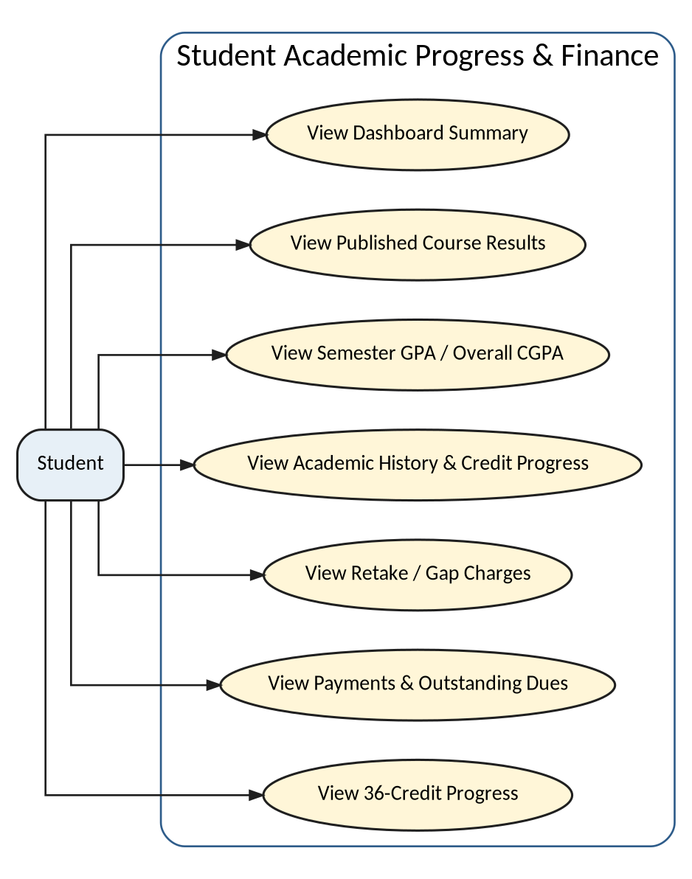
Figure 5: Use case diagram — Student Academic Progress & Finance
Use Case Name: Student Academic Progress & Finance
Primary Actors: Student
Secondary Actors: —
Action – Reply
• Action: Student opens the dashboard, results or dues page.
• Reply: System loads only the authenticated Student’s enrollment, grade, CGPA and fee records.
• Action: Student selects a semester or course result.
• Reply: System shows marks, total, grade point and the CGPA contribution available in the current data.
• Action: Student opens financial history.
• Reply: System shows generated fees and outstanding dues; verified payment allocation remains a target workflow.

Level 1.4 — Teacher Marks Management
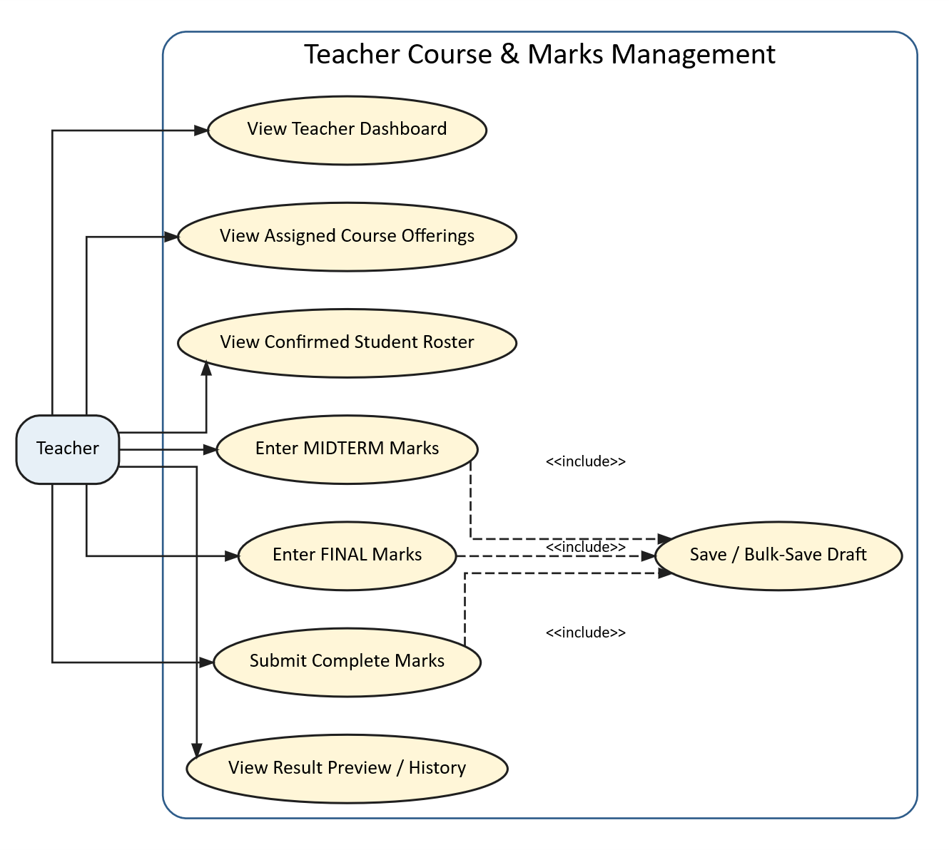
Figure 6: Use case diagram — Teacher Marks Management
Use Case Name: Teacher Marks Management
Primary Actors: Teacher
Secondary Actors: —
Action – Reply
• Action: Teacher opens an assigned course.
• Reply: System verifies course ownership and returns enrolled Students.
• Action: Teacher enters midterm and final marks.
• Reply: System validates the allowed range and saves a grade record for the correct enrollment.
• Action: Teacher attempts to access an unassigned course.
• Reply: System rejects the request.

Level 1.5 — Admin Academic & Financial Administration
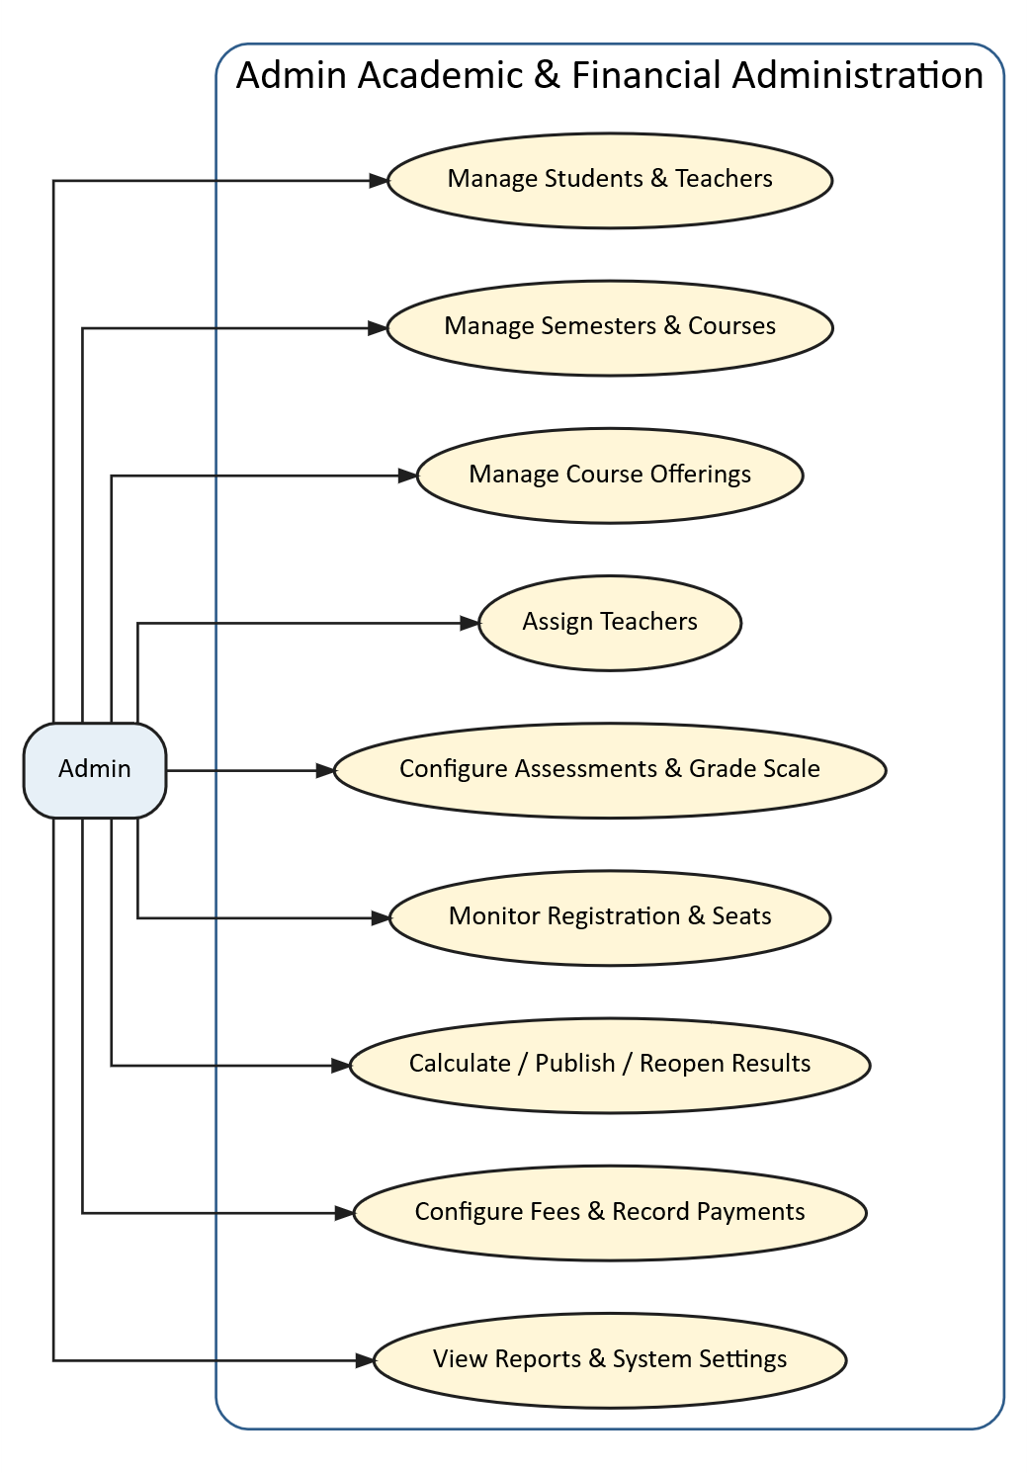
Figure 7: Use case diagram — Admin Academic & Financial Administration
Use Case Name: Admin Academic & Financial Administration
Primary Actors: Admin
Secondary Actors: —
Action – Reply
• Action: Admin creates or updates students, teachers, courses, semesters or fees.
• Reply: System validates the data and stores the authorized change.
• Action: Admin opens statistics or monitoring.
• Reply: System aggregates current academic and financial records.
• Action: Admin publishes results or records a payment.
• Reply: The required target workflow validates state, preserves auditability and prevents invalid balance changes.

3.2 Activity Diagrams
Activity diagrams show the dynamic flow of the most important workflows. Decision paths are explicit so the presentation can explain both successful and rejected cases.

3.2.1 Authentication & Role Routing
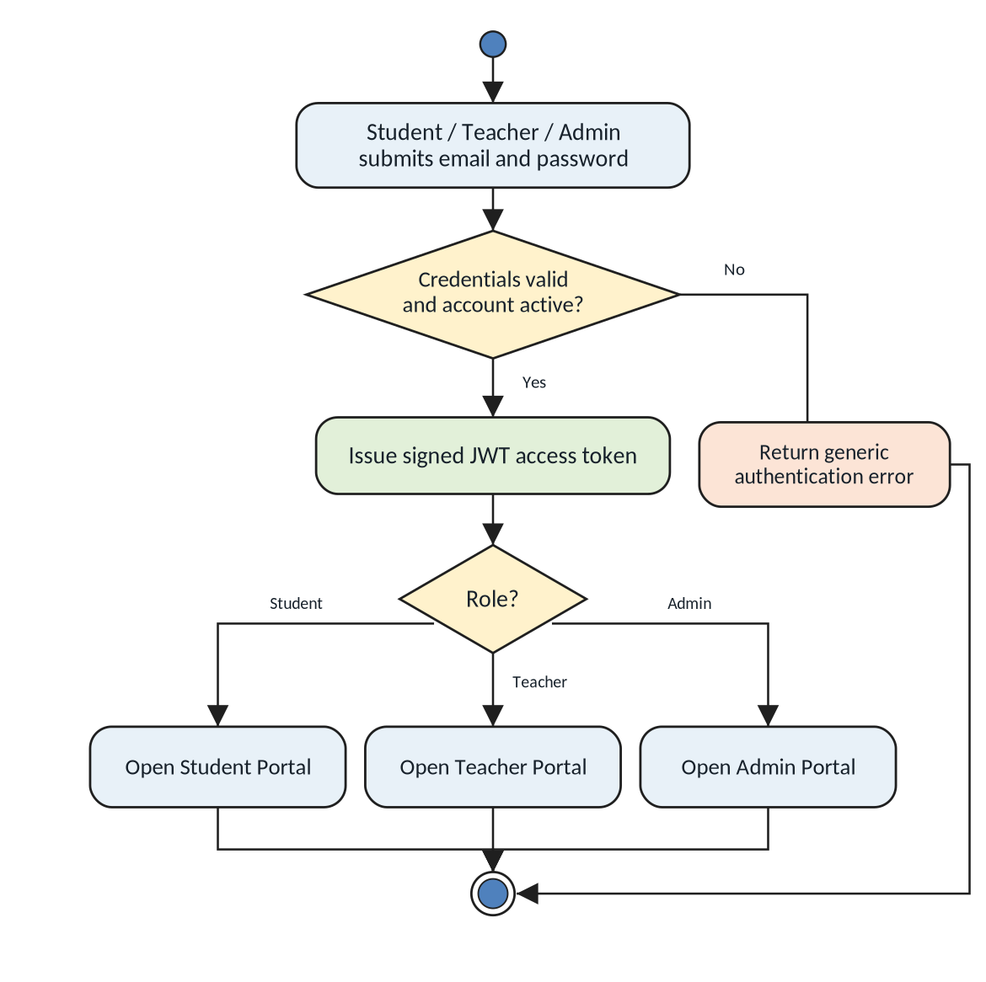
Figure 8: Activity diagram — Authentication & Role Routing
The system validates credentials and account status before routing the user to the correct dashboard. Invalid credentials or role mismatches terminate the attempt without exposing protected data.

3.2.2 Student Course Registration
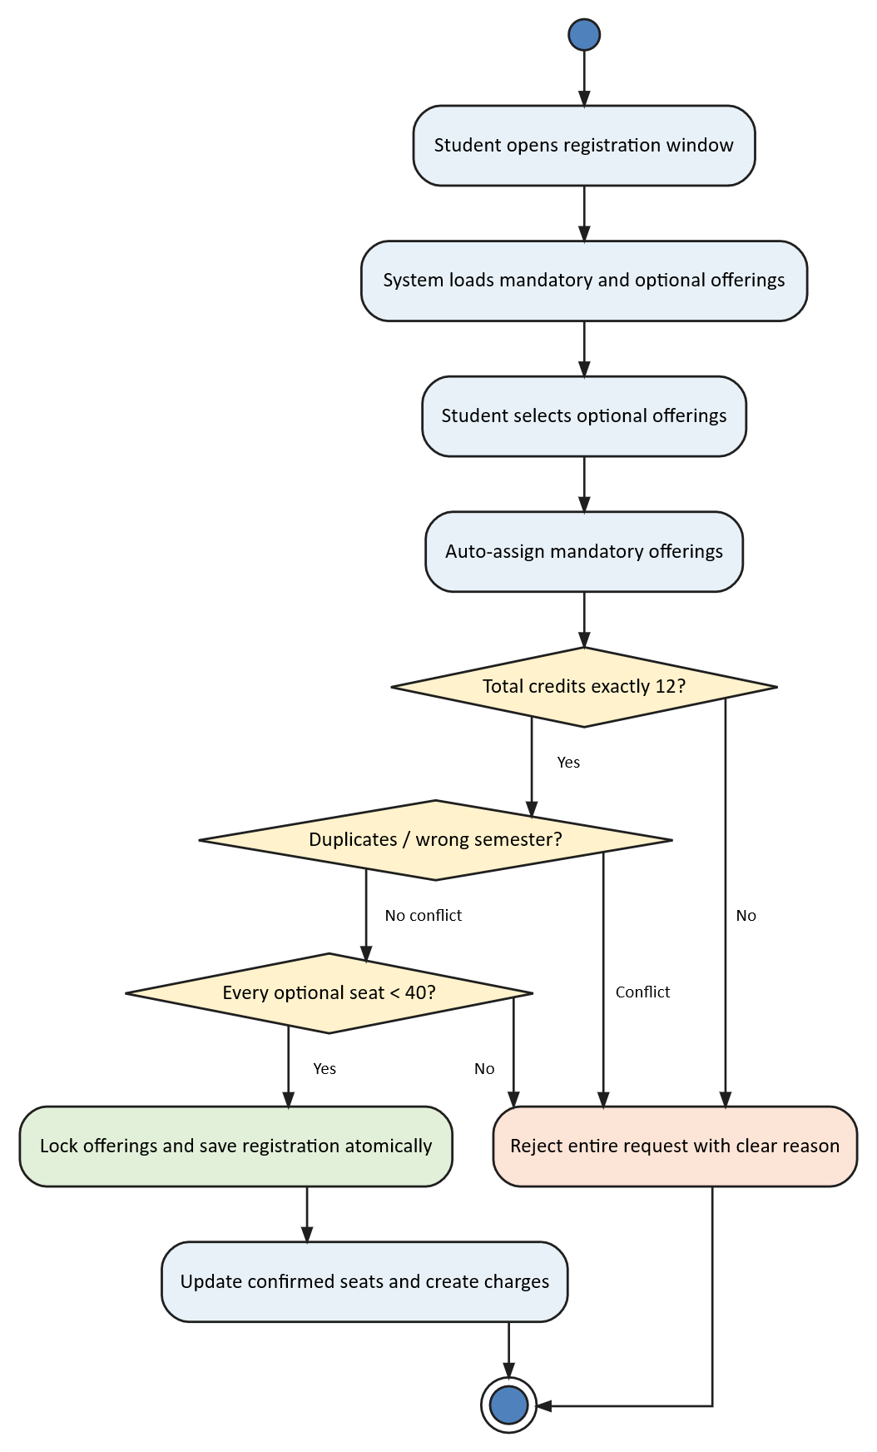
Figure 9: Activity diagram — Student Course Registration
This is the required corrected flow: build the complete package, validate exact credits, duplicates and seats, then persist all records as one transaction.

3.2.3 Teacher Marks Entry
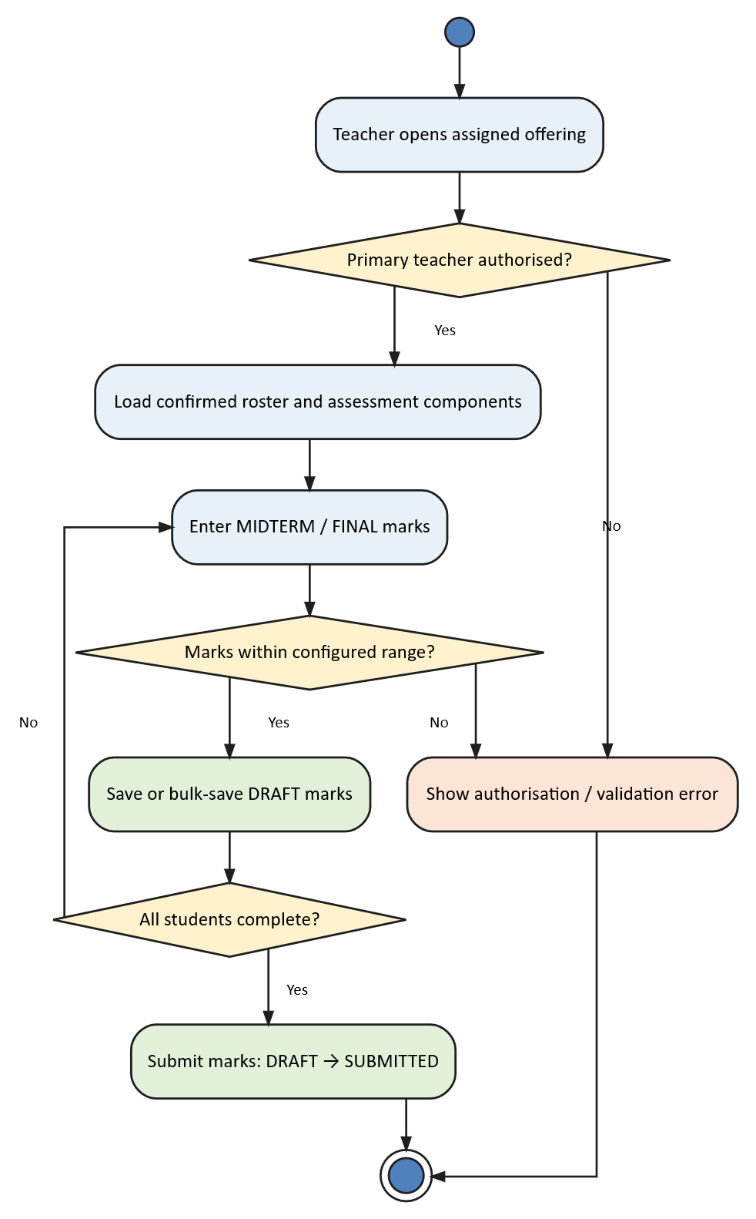
Figure 10: Activity diagram — Teacher Marks Entry
Teacher authorization, roster ownership and marks-range validation protect the grade-entry process. Draft/submit states are the recommended completion model.

3.2.4 Result Calculation & Publication
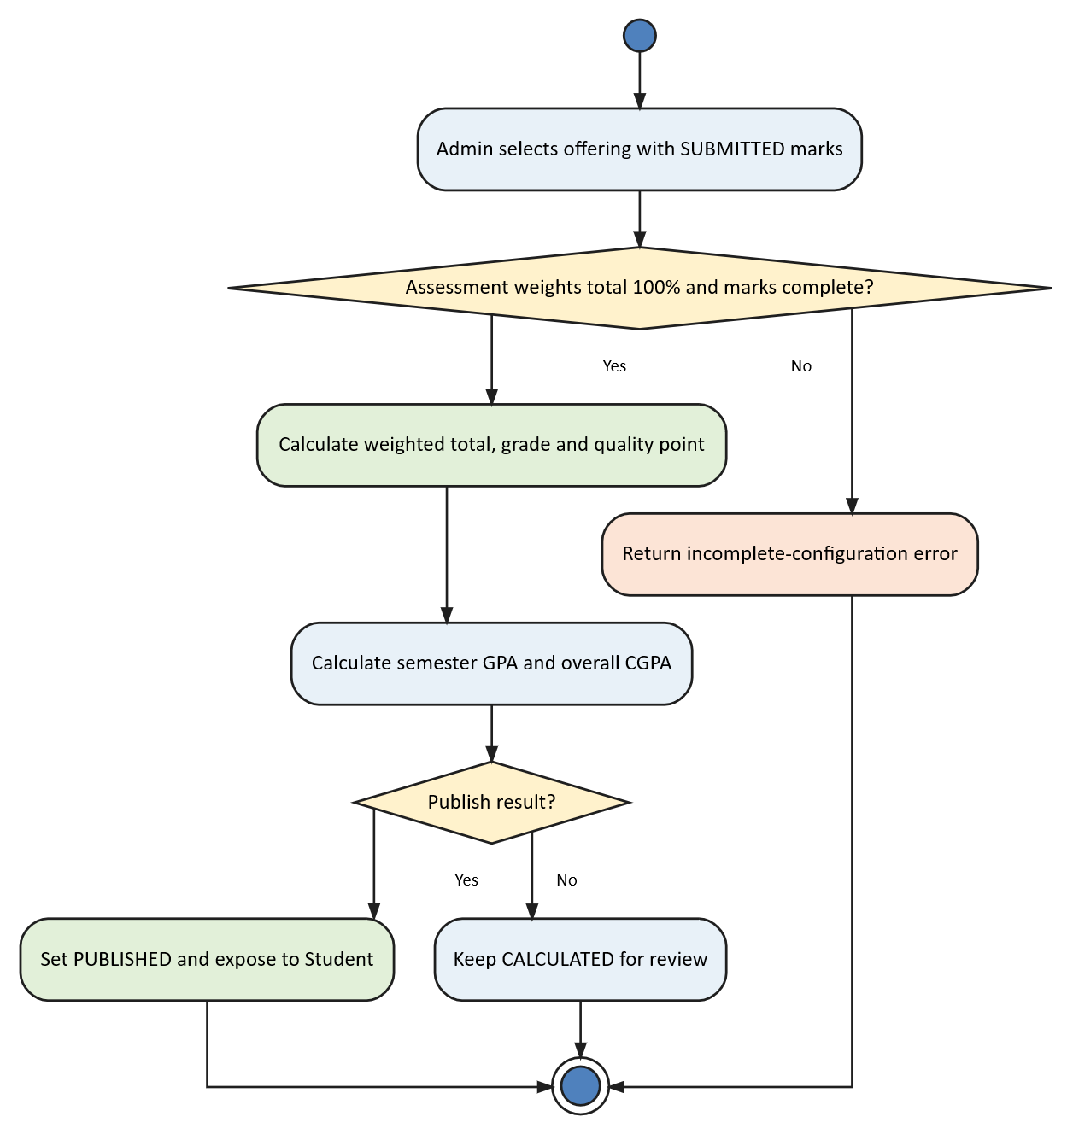
Figure 11: Activity diagram — Result Calculation & Publication
The intended lifecycle separates mark entry from calculation and publication. Students should see only published results.

3.2.5 Fee, Payment & Dues Update
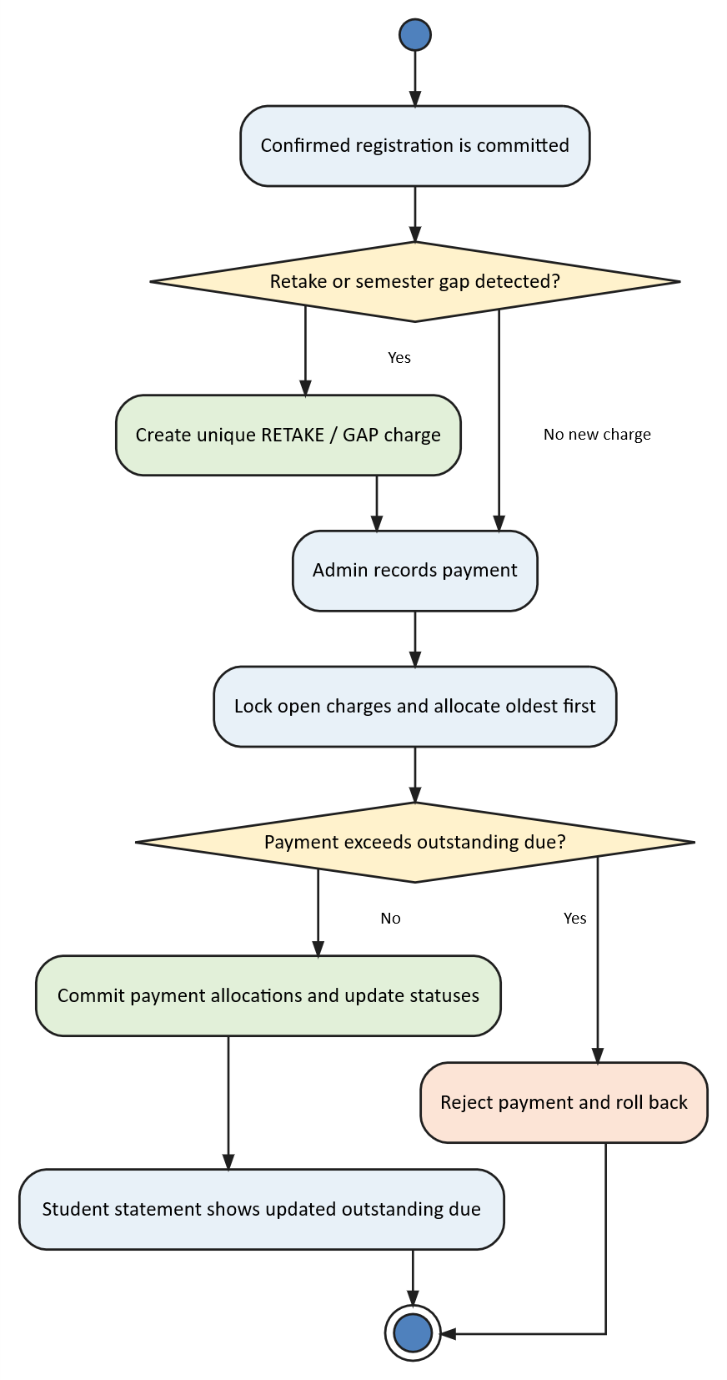
Figure 12: Activity diagram — Fee, Payment & Dues Update
Retake and semester-gap conditions should be derived from academic history. Payments should be verified and allocated to charges rather than represented only as a status change.

3.3 Data Flow Diagrams

3.3.1 DFD Level 0 — System Context
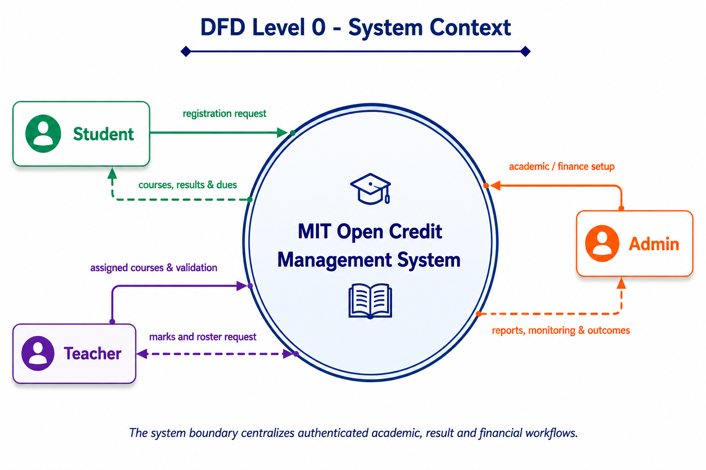
Figure 13: DFD Level 0 — system context
The context diagram treats MIT OCMS as one process and shows the academic and financial information exchanged by each external actor.

3.3.2 DFD Level 1 — Major Processes
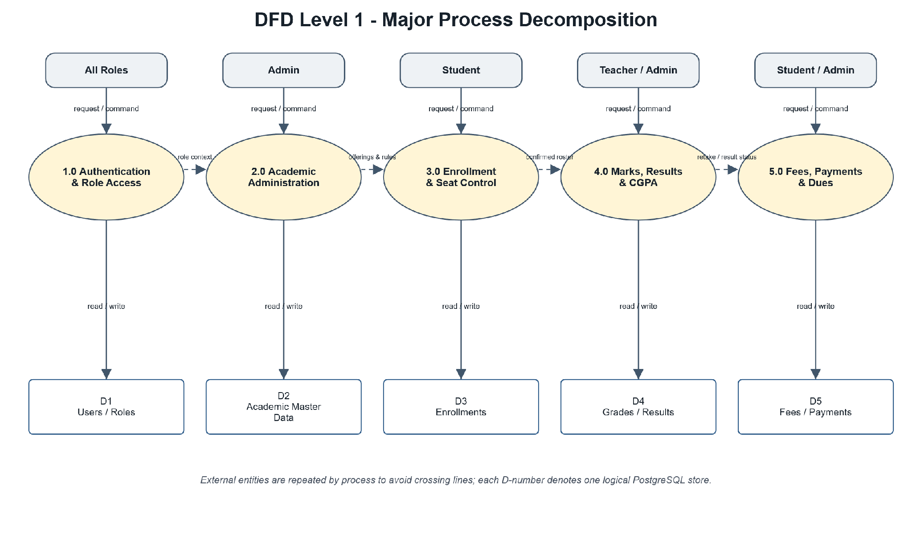
Figure 14: DFD Level 1 — major process decomposition
Level 1 now separates authentication, academic administration, enrollment, marks/results and finance in a more readable layout while preserving the same backend data responsibilities.

3.3.3 DFD Level 2 — Student Semester Registration
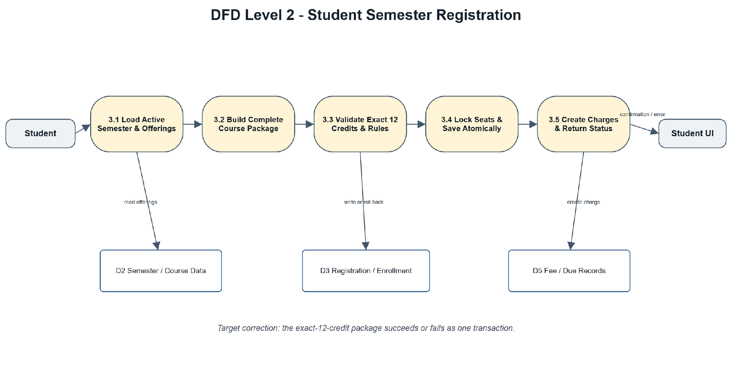
Figure 15: DFD Level 2 — semester registration
The registration decomposition now shows a clearer left-to-right flow: load semester data, build the full package, validate exact 12 credits and seat rules, then persist or reject atomically.

4. Data & Information Modeling

4.1 Data Objects and Relationships
The data model is derived from the recurring problem-space nouns in requirements and usage scenarios. Interface terms such as page, button, token and API are solution concepts; the objects below carry persistent academic or financial meaning.
Data Object | Purpose | Main Relationships
User | Authentication identity and role. | One user may own one Student or Teacher profile.
Student / Teacher | Role-specific identity and status. | Student owns enrollments, grades and fees; Teacher owns assigned courses.
Semester | Academic term and registration context. | Contains enrollments and should own course offerings.
Course | Course code, title, credit, type and capacity. | Referenced by enrollments and grades; current seat/teacher data are global.
Enrollment | Student–Course–Semester association. | Links Student, Course, Semester and Grade.
Grade | Midterm, final, total, letter grade and point. | Belongs to one Enrollment.
Fee / Payment | Retake, gap and other financial records. | Belongs to a Student and may reference a Semester or Enrollment.
CourseOffering (required) | Semester-specific course section, seat count and Teacher. | Required to correct global seat/teacher limitations.

Relationship summary: A Student enrolls in Courses during a Semester; a Teacher handles an assigned course; each Enrollment may have one Grade; a Student may have multiple Fees and Payments. The corrected model inserts CourseOffering between Course/Semester and Enrollment.

4.2 Entity Relationship Diagram
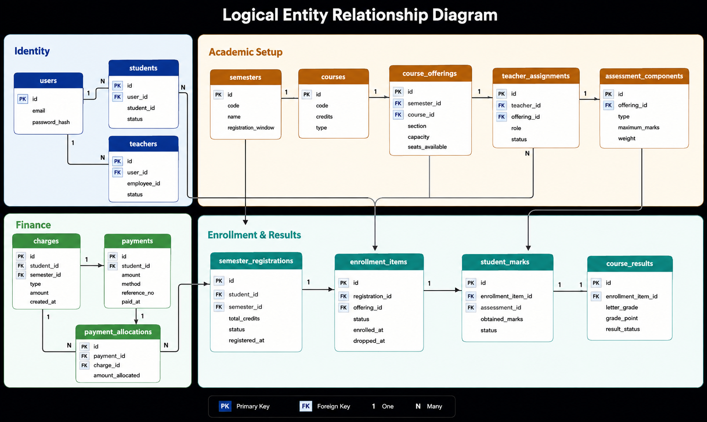
Figure 16: Logical ER diagram
The ERD shows the logical state, including semester-specific CourseOffering, TeacherAssignment, SemesterRegistration and PaymentAllocation.

4.3 Database Schema Summary
Table / Entity | Key Fields | Constraint or Presentation Note
users | id, email, password_hash, role, active | Unique email; BCrypt password; privileged role creation must be restricted.
students / teachers | id, user_id, roll/employee_id | One profile per user; unique roll or employee ID.
courses | id, code, title, credit, type, capacity | Current capacity and Teacher assignment are global; move to offering.
semesters | id, name/year/term, active | Registration-window uniqueness requires refinement.
enrollments | id, student_id, course_id, semester_id, status | Unique student + course + semester; current flow is course-by-course.
grades | id, enrollment_id, midterm, final, total, point | One grade per enrollment; publication state is absent.
fees / payments | id, student_id, type, amount, status | Current payment verification/allocation and gap automation are incomplete.
course_offerings (required) | semester_id, course_id, section, teacher_id, capacity, seats | Required for exact semester registration and concurrency-safe seats.
semester_registrations (required) | student_id, semester_id, total_credits, status | Required aggregate for exactly 12 credits and atomic commit.

Database authority: Backend services and PostgreSQL constraints—not the browser—must make the final decision for credits, duplicates, seats, grades and balances.

5. Software Design

5.1 Component Diagram
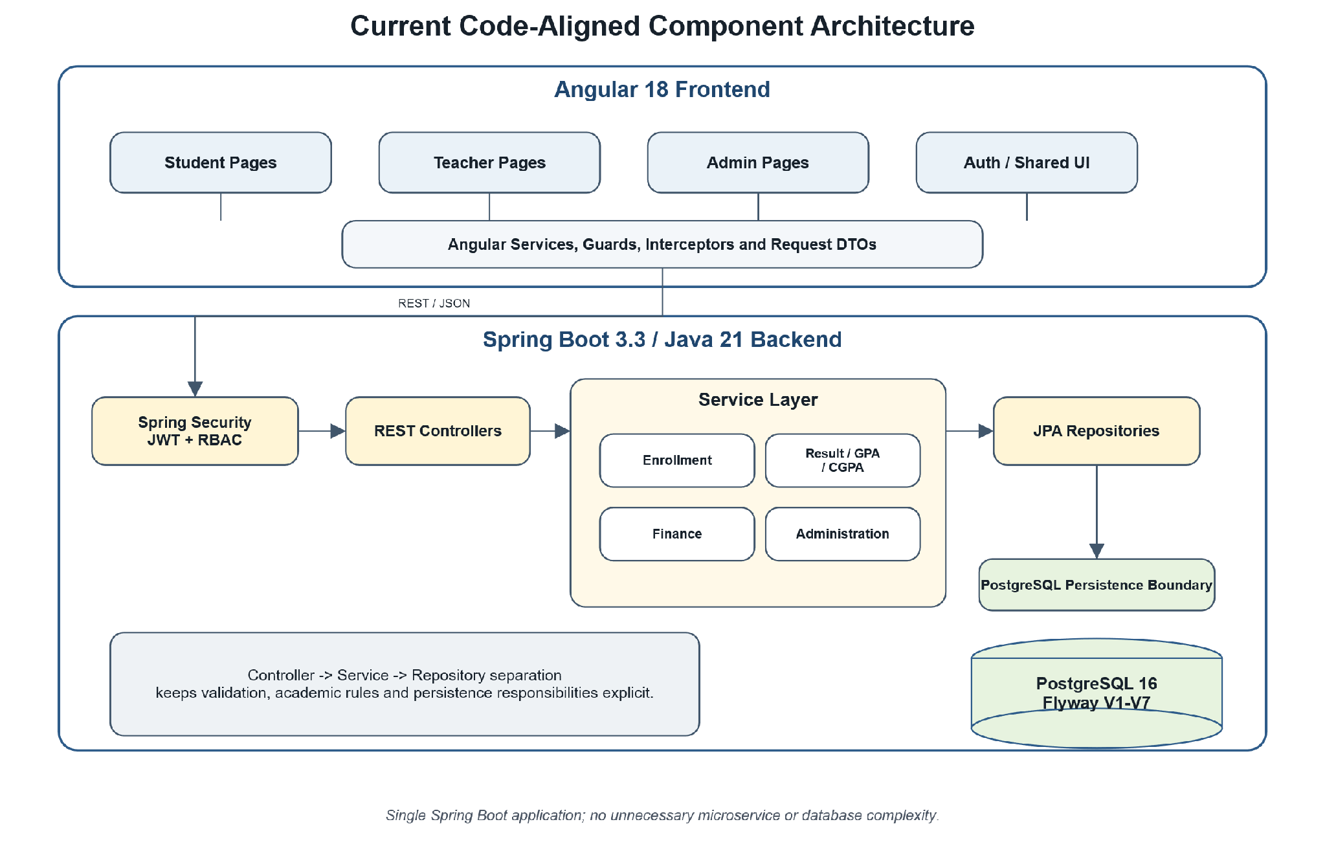
Figure 17: Code-aligned component architecture
The component diagram highlights the actual Angular → Spring Security/Controller → Service → Repository → PostgreSQL path with larger, clearer boundaries for presentation.

5.2 UI-to-Database Interaction
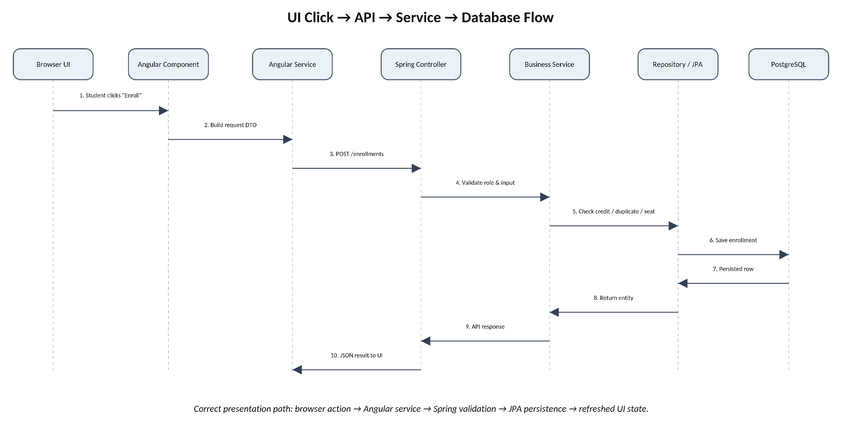
Figure 18: UI click-to-database flow
This sequence-style interaction view emphasizes the complete request lifecycle from a browser click through backend validation and persistence to the refreshed UI result.

6. Software Architecture & Traceability
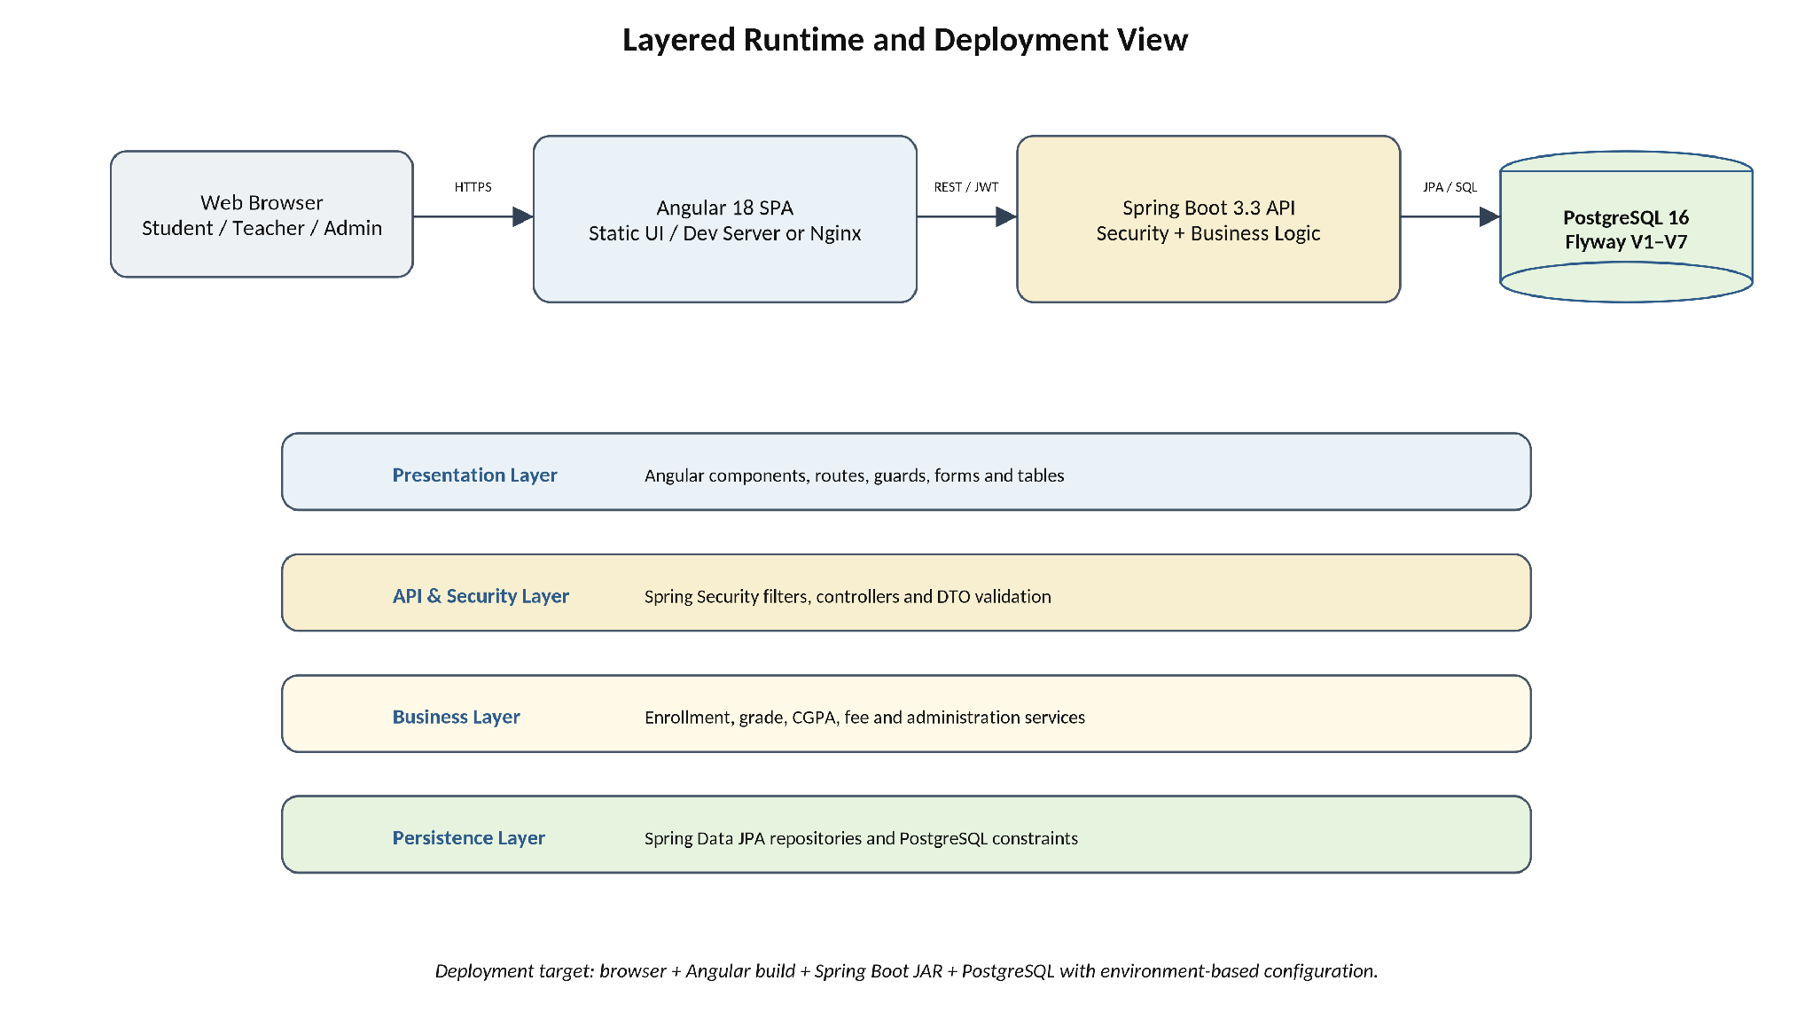
Figure 19: Layered runtime and deployment view
Architecture decision: Use a straightforward Angular SPA → Spring Boot REST API → PostgreSQL design. This matches the current project, supports easy deployment and avoids unnecessary infrastructure.

6.1 Requirement Traceability Matrix
Requirement | Use Case / Diagram | Implementation Area | Status
FR-01/02 | UC Authentication; Figure 3/8 | Login UI, AuthController, SecurityConfig, users | Implemented
FR-03/04 | UC Registration; Figure 4/9/15 | Course UI, EnrollmentController/Service, enrollments | Limited
FR-05/06 | Figure 9/15 | Required SemesterRegistration + CourseOffering transaction | Target
FR-07/08 | UC Teacher; Figure 6/10 | Teacher UI, GradeController/Service, grades | Implemented
FR-09/10 | Figure 11 | Grade/CGPA logic; required publication state | Limited
FR-11/12 | Figure 12 | Fee services; required payment/allocation workflow | Limited / Target
FR-13/14 | UC Admin; Figure 7 | Admin UI/API, statistics and master-data tables | Limited

7. Preliminary Test Plan
ID | Area | Pass Condition
TC-01 | Authentication | Valid credentials issue JWT; invalid credentials reveal no sensitive detail.
TC-02 | Role isolation | Student, Teacher and Admin cannot access another role namespace.
TC-03 | Credit rule | Exactly 12 credits accepted; other totals rejected without partial records.
TC-04 | Duplicate enrollment | Second student-course-semester association is rejected.
TC-05 | Seat control | Full-course request fails and seat count remains correct under concurrency.
TC-06 | Marks range | Values outside allowed midterm/final range are rejected.
TC-07 | Grade / CGPA | Known marks and credits produce the expected grade points and CGPA.
TC-08 | Payment / dues | Verified payment changes due by the allocated amount only.
TC-09 | Migration / build | Fresh Flyway V1–V7 migration, Maven build and Angular build succeed.

8. Implementation Progress & Challenges
Status | Capability | Evidence / Remaining Work
Completed | Foundation, JWT/RBAC and core entities | Angular/Spring/PostgreSQL structure, authentication and role-based routes exist.
Completed | Basic Student and Teacher workflows | Dashboard/profile, course list, course-wise enrollment/drop, grade entry and CGPA view exist.
In Progress | Admin and finance experience | Core CRUD, fees and statistics exist but remain incomplete.
Not Yet Correct | Exact-12 aggregate registration | Current code validates ≤12 and saves course-by-course.
Not Yet Correct | Semester-specific offering and last-seat safety | Seats and Teacher remain on Course; transaction/locking correction required.
Not Yet Complete | Publication, verified payment and gap automation | Explicit result state, payment allocation and gap detection remain required.

8.1 Recent Achievements (Project Status Update)
100% Passing Test Suite: Both backend (Spring Boot/JUnit/Mockito) and frontend test suites are now completely stabilized and passing, resolving prior ApplicationContext and Mocking failures.
UI/UX Refinement: The user interface has been overhauled to a professional Navy & Coral theme, meeting presentation requirements for stakeholders.
Database & Role Alignment: The default system roles (Admin) and teacher designations (Dr. Md. Nurul Ahad Tawhid) are now fully seeded in the PostgreSQL database and UI.

9. Timeline & Demonstration Plan
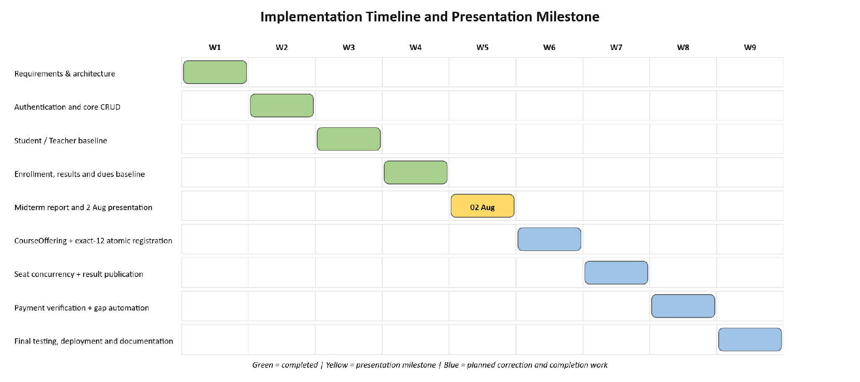
Figure 20: Timeline and 2 August presentation milestone

9.1 Presentation Demonstration Sequence
Time | Action | Expected Evidence
0:00–0:45 | Explain problem, actors and Angular → Spring Boot → PostgreSQL architecture. | Figures 1, 17 and 19.
0:45–1:30 | Login as Student and open the role dashboard. | JWT session and protected route.
1:30–3:15 | Open course catalogue and perform an enrollment action. | Real API request and saved/updated enrollment view.
3:15–4:30 | Login as Teacher and show roster/mark entry. | Assigned-course ownership and grade validation.
4:30–5:30 | Show CGPA or dues loaded from backend data. | Second database-backed feature.
5:30–6:30 | Explain current limitations and next correction plan honestly. | Progress table, DFD Level 2 and Gantt chart.

