Problem Statement (我的一些想法):
说明一个社群是否脆弱是决定这个社群关系发展的一个重要因素，越脆弱的社群越容易被破坏，越不稳定，在现实生活中应给予更多的关注。应用如加强社交网络中的部分节点间的关系，评估社群友好度和排外性（越稳定的社群越排外），评估引入新成员对于整体社群的影响以及社群对于新成员的影响（越稳定的社群具有更强的tolerance，不会因新成员的引入而改变，但反过来可能会改变新成员的内部关系The clique is easy to receive traditions reversely if its own susceptibility is higher than that of the social group it’s added to，这就是我们所说的社会的同化作用）。

future work:
可进一步找到那些社群中不稳定的子图，度量其不稳定性对于整体社群的影响。
也可以将单一的正负权重数值化，以亲密度intimacy进行度量，更新权重时采用一下策略：
w3=w3+λw1w2 （λ为常数）
仅更新unbalanced triangles的最小权值边w3，因为其最易受影响。可以看到若w1>0, w2>0, w3<0，则上式使w3增加，向Δ₀的 方向发展；若w1w2<0, w3>0，则上式使w3减少，向Δ₂的方向发展；若w1<0, w2<0, w3<0，则上式使w3增加，向Δ₂的方向发展。这样便使得整个社会网络有向平衡网络发展的趋势，从而由收敛的差异性进一步分析多因素对于权值稳定性的影响。这个模型更符合实际，因为现实中人与人的关系并非单一的敌友关系，而是由亲密度来描述的，同时我们也可以更好地刻画某些因素对于平衡性带来的变化。例如新加入的clique与原网络形成的边权值应较小于原网络内部边的权值，因为新形成的关系一定不会比原有关系更加亲密，但随着迭代的进行，新形成的关系可能会进一步加强。

Assumptions:

In this model, we discuss about how the balance ratio of a social network can influence its susceptibility. We define the susceptibility of a social network as the proportion of edges with weight changed after introducing a new clique to the original network. We mainly deal with two factors:
- The size of clique added into the graph;
- The number of edges formed between the clique and the original graph.
The clique is a small complete balanced graph generated with 70% positive links. When a clique is added into the original graph, we randomly create links between the clique and the original graph, and randomize the weights of the links. The newly formed unbalanced triangles will break the current state of the graph. So we should update the weights of edges to rebalance the graph by iterations. The updating rules are [Social balance on networks: The dynamics of friendship and enmity]:
(1) Go through each triad; if it is balanced do nothing.
(2) If the triad is unbalanced with 1 unfriendly link, then with probability p, change the unfriendly link to a friendly link; with probability 1 − p, change a friendly link to an unfriendly link.
(3) If the triad is unbalanced with 3 unfriendly links, then change an unfriendly link to a friendly link.

We test our model on a simulated graph. This graph is a random graph with (n=1300, p=0.03). Weights are generated based on the balance ratios we want to test. According to investigations on some real networks like Epinions, Slashdot, Wikipedia [Signed Networks in Social Media], we give different preferences to the four types of triangles (Δ₀: Δ₂ = 9:1, Δ₁: Δ₃ = 7:3. Δ_{k} represents triangles with k unfriendly links).
The results are as expected [See Figure 1, 2, 3, 4]:
Claim 1: The bigger the size of clique added into the graph, the more original relationships will be changed (friendly links change into unfriendly ones and unfriendly links change into friendly ones). This is easy to understand. A big clique has more chances to set up a large number of complicated links with the original social groups, therefore, they can well interact with the members in the group and have more influence on them, which may lead to a big change of relationships in the original social network.
Claim 2: The larger the number of edges formed between the clique and the original graph, the more original relationships will be changed. More newly formed edges introduce more complicated interactions with the original graph, thus lead to more changes of relationships.
Claim 3: The original balance ratio to some extent determines the susceptibility of a social group. A more balanced group will have more tolerance to a new clique. This mean the new clique is hard to affect the original relationships on a large scale. If the original group is greatly unbalanced, it will be easily influenced by a new clique joining in.
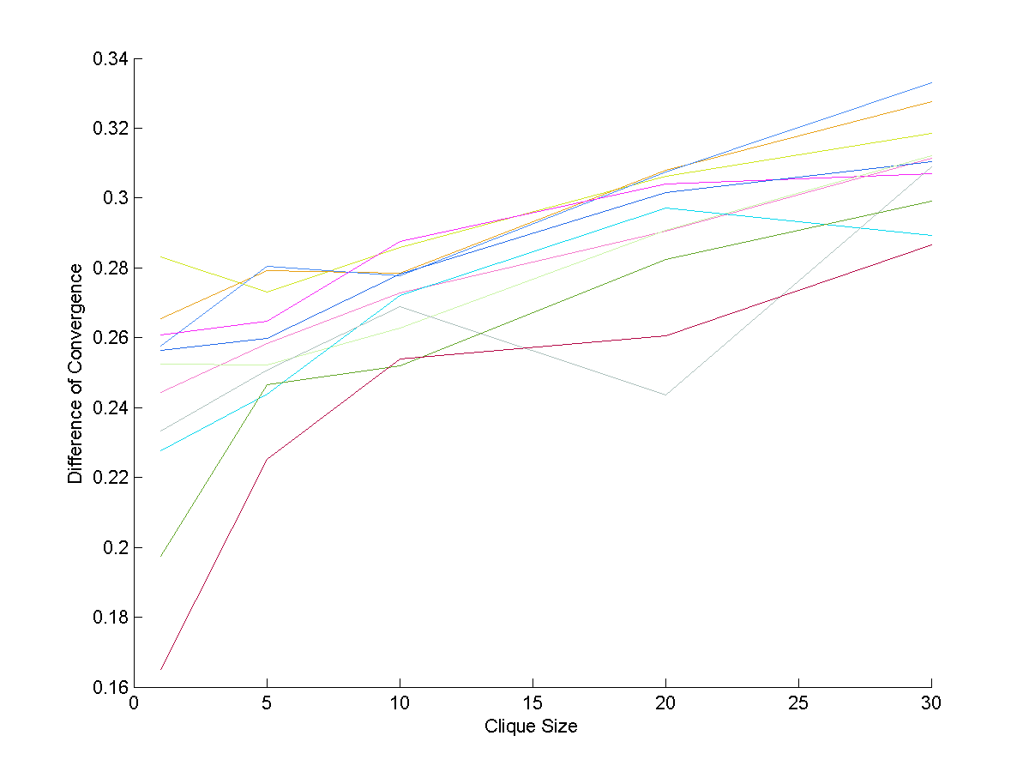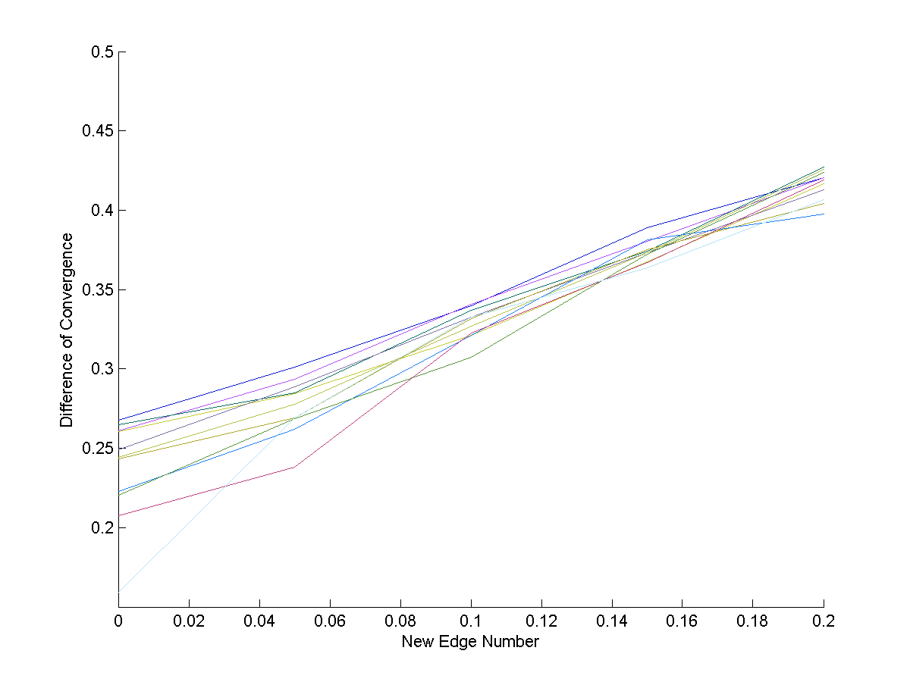
Figure 1 Figure 2
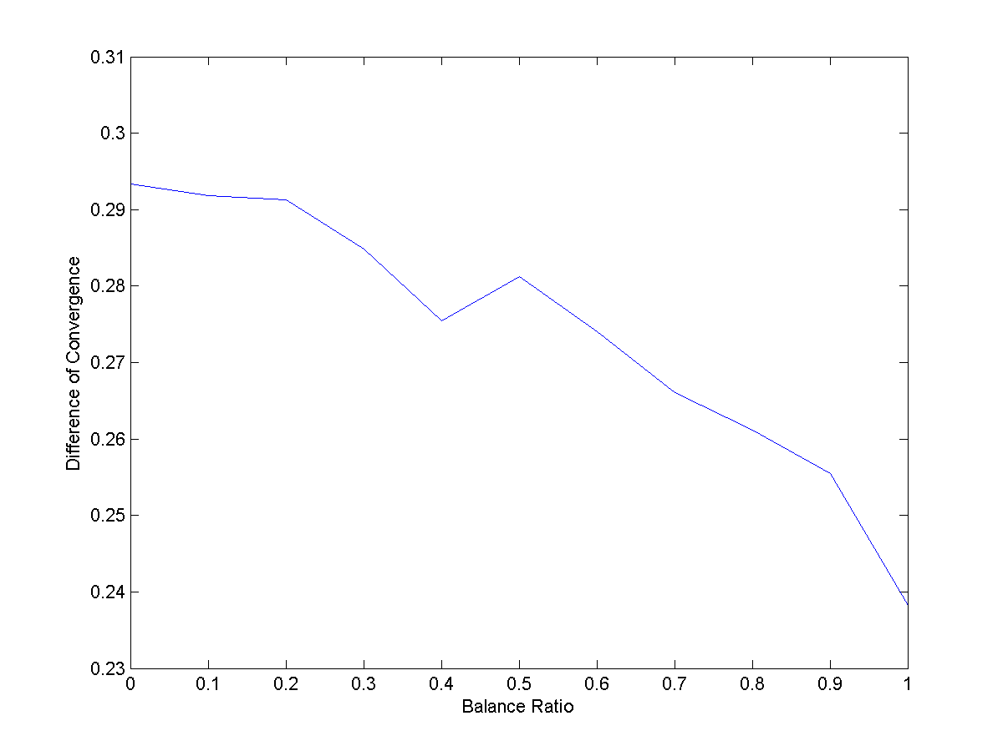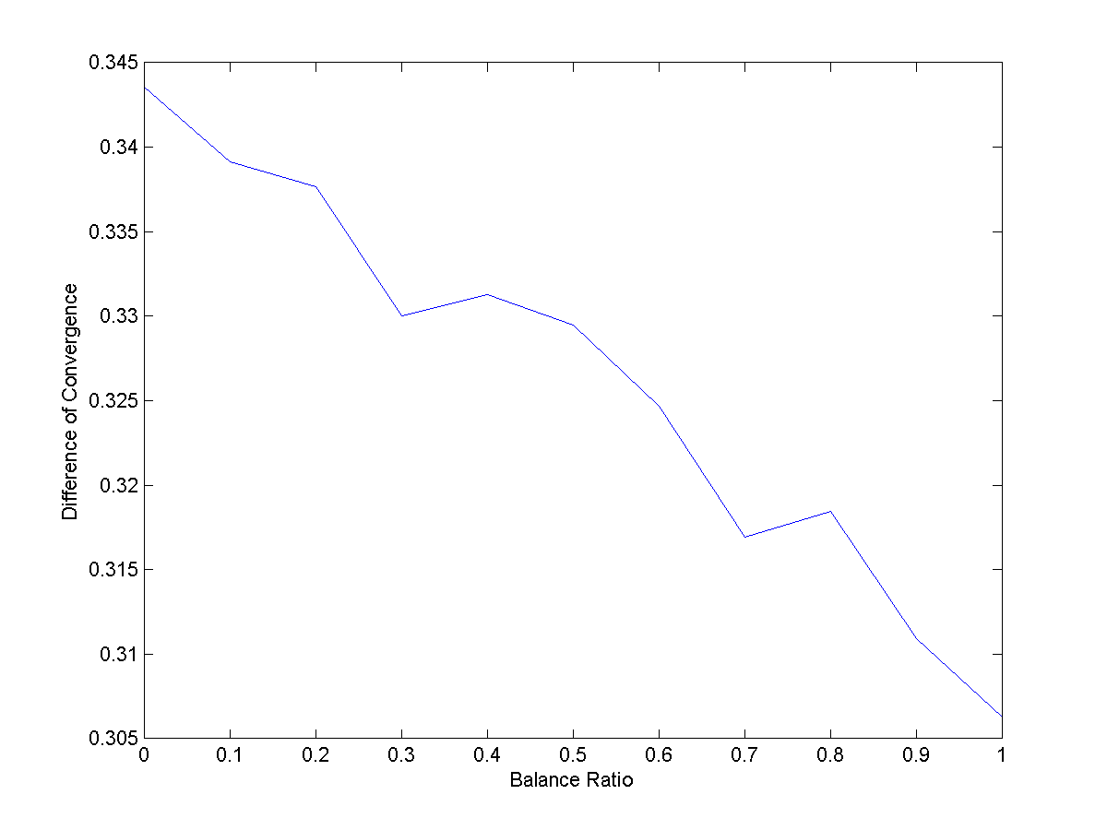
Figure 3 Figure 4
Figure 1 shows the trend of susceptibility with clique size under different balance ratios of the network. Figure 2 shows the trend of susceptibility with number of new edges under different balance ratios of the network. Figure 3 and 4 shows the average trend of susceptibility with balance ratio based on various clique size and the number of new edges.

To validate our results, we test the model on some real networks like********. The results we get are similar with the theoretical ones. In this way, we can prove the applicability of our model into the analysis of a real social network.

