Technical Documentation: Syrian National Health Facilities Geographic Location Platform

Technical Specification

Table of Contents
- Executive Summary
- Project Overview
- Functional Requirements
- Technology Stack
- Architecture & System Design
- Data Model & Schema
- Appwrite Service Configuration
- Frontend Implementation
- Backend Logic & Validation
- User Workflows & UX Flows
- Security & Access Control
- Performance & Optimization
- Deployment & Infrastructure
- Testing Strategy
- Project Timeline & Milestones
- Monitoring, Maintenance & Scalability

1. Executive Summary
The Syrian National Health Facilities Geographic Location Platform is a web-based application that enables users to explore, search, and manage geographical information about healthcare, facilities across the country. The platform provides:
- Read-Only Public Access: Visitors can view and filter facilities on an interactive map, search by multiple criteria, and access statistical dashboards.
- Authenticated User Editing: Registered editors can add new facilities or modify existing data, with all changes logged and optionally subject to admin approval.
- Admin Oversight: Administrators manage user roles, approve/reject edits, and view comprehensive audit trails.
- Responsive Dashboard: Real-time analytics including facility counts by governorate, type, status, and owner; visualization of facility distribution; and recent activity feeds.
Technology: React (frontend) + Appwrite Cloud (backend), deployed on Vercel/Netlify (frontend) and Appwrite Cloud (BaaS).
Scope Constraints: No facility document/image storage. Focus on geographical data management and analytics.

2. Project Overview

2.1 Vision
Create a centralized, intuitive platform to maintain and disseminate health facility information at a national scale, enabling better resource planning, accessibility analysis, and public awareness.

2.2 Target Users
- General Public/Visitors: Access facility locations, search by name, filter by attributes (governorate, type, status), and view statistics without authentication.
- Facility Managers/Editors: Add new facilities, update existing information, and track change history with attribution.
- System Administrators: Oversee data quality, approve/reject edits, manage user permissions, and generate audit reports.

2.3 Key Objectives
- Provide accurate, up-to-date facility location data visible on an interactive map.
- Enable participation through facility data updates.
- Maintain data integrity through role-based permissions and audit logging.
- Support decision-making with comprehensive statistical dashboards.
- Ensure system reliability and scalability within free/affordable hosting tiers.

3. Functional Requirements

3.1 Visitor/Public Features (Unauthenticated Access)

3.1.1 Map Visualization
- Requirement: Display all active facilities as markers on an interactive OpenStreetMap base layer.
- Implementation:
  - Use Leaflet.js for map rendering (lightweight, responsive).
  - Cluster markers when zoomed out (using Leaflet.MarkerCluster) to avoid clutter.
  - Use different colored/styled markers to represent facility types (icon differentiation).
  - Smooth zoom/pan controls.

3.1.2 Facility Details Popup
- Requirement: Clicking a marker reveals a popup showing key facility information.
- Details Displayed:
  - Facility Name / Establishment Name
  - Governorate
  - Facility Type Label
  - Facility Status
  - Owner
  - Classification
  - Affiliation
  - Contact information (derived if available in future; not in current schema)
- Implementation: React Leaflet Popup component with styled card layout (TailwindCSS).

3.1.3 Advanced Filtering & Search
- Requirement: Visitors can filter facilities by multiple attributes.
- Filter Options:
  - By Governorate: Dropdown selector; map updates in real-time.
  - By Facility Type Label: Multi-select; shows only facilities of selected types.
  - By Status: Filter active vs. inactive facilities.
  - By Owner/Classification/Affiliation: Additional selectors to narrow results.
  - Search by Name: Text input searches Facility Name or Establishment Name using fuzzy/substring matching.
- Implementation:
  - Filter state in React component (FilterPanel).
  - Appwrite Query API combines multiple filters: Query.equal('governorate', selected), Query.equal('status', 'active'), etc.
  - Debounced search for performance.

3.1.4 Dashboard & Analytics (Read-Only)
- Requirement: Visitors view statistical aggregates without detailed edit histories.
- Statistics Provided:
  - Total Facilities Count
  - Facilities by Governorate (bar chart or map heatmap)
  - Facilities by Type Label (pie or bar chart)
  - Facilities by Status (donut chart showing active/inactive breakdown)
  - Facilities by Owner (top 10 owners by facility count)
  - Facilities by Classification (breakdown of classifications)
  - Trend/Timeline (facilities added per month, if available)
- Implementation:
  - Recharts library for chart rendering.
  - Aggregation queries using Appwrite’s list API with counts.
  - Data cached via React Query to avoid repeated API calls.

3.2 Editor Features (Authenticated, Non-Admin Users)

3.2.1 Add New Facility
- Requirement: Authenticated editors can add new facilities to the database.
- Form Fields:
  - Facility Name / Establishment Name (required, text input)
  - Governorate (required, dropdown from Governorates collection)
  - Facility Status (required, enum: active/inactive/pending)
  - Facility Type Label (required, text/dropdown)
  - Facility Owner (required, text input)
  - Facility Classification (required, text/dropdown)
  - Facility Affiliation (optional, text input)
  - Longitude (required, auto-populated from map or manual input, float)
  - Latitude (required, auto-populated from map or manual input, float)
- Location Selection:
  - Editor can click on the map to set location, or manually input coordinates.
  - Real-time marker shows selected location.
  - Coordinate validation (valid WGS84 range: latitude [-90, 90], longitude [-180, 180]).
- Submission & Validation:
  - Frontend validates all required fields.
  - Appwrite serverless function performs server-side validation.
  - On success, facility document created with:
    - createdBy: Current user ID
    - createdAt: Timestamp
    - status: Set to ‘pending’ if admin approval workflow enabled, else ‘active’
  - Edit logged to EditsLog collection with action=‘created’.
- Permissions: Editor can only view/edit facilities they created (unless admin).

3.2.2 Edit Existing Facility
- Requirement: Editors can update facility information; all changes tracked.
- Form Behavior:
  - Pre-populated with current facility data.
  - Editor modifies fields and submits.
  - Frontend diff identifies changed fields.
  - Appwrite function validates changes.
  - Document updated; EditsLog entry created with action='updated' and changes field storing before/after values.
  - lastEditedBy and updatedAt fields refreshed.
- Permissions:
  - Editors can edit facilities they created.
  - Admins can edit any facility.
  - Non-owners cannot edit (enforced by Appwrite permissions).

3.2.3 View Edit History
- Requirement: Editors see a log of their contributions.
- Display:
  - Timeline or list view of edits made by the user.
  - For each edit: facility name, action (created/updated), timestamp, status (pending/approved).
- Implementation: Query EditsLog filtered by userId and facilityId.

3.3 Admin Features

3.3.1 Approve/Reject Facility Edits
- Requirement: Admins review pending edits and decide approval.
- Optional Workflow:
  - If enabled, new facilities and edits set status=‘pending’ until approved.
  - Admin dashboard shows pending items.
  - Admin can view changes, then approve (status=‘active’) or reject (status=‘rejected’).
- Implementation:
  - Separate route/component for admin approval panel.
  - Update EditsLog.status field.
  - Notify editor of approval status (optional: email or in-app notification).

3.3.2 User Management
- Requirement: Admins assign/revoke editor and admin roles.
- User List View:
  - Display all registered users with current role, email, join date.
  - Search/filter by email or name.
- Role Assignment:
  - Admin can change a user’s role (visitor → editor, editor → admin, etc.).
  - Changes logged with timestamp and admin user ID.
- Implementation:
  - Create separate Users collection or leverage Appwrite Teams.
  - Appwrite permissions ensure only admins can modify roles.

3.3.3 Audit Trail & Reporting
- Requirement: Comprehensive audit log of all system changes for compliance/debugging.
- Log Contents:
  - Facility creation/updates: user, timestamp, changes, status, approval status.
  - User role changes: admin, timestamp, before/after role.
  - Bulk operations: time range, count of changes.
- Access: Admin-only; standard visitors do not see audit logs.
- Implementation:
  - EditsLog collection stores all changes with full detail.
  - Admin dashboard queries EditsLog with filters (date range, user, action, facility).
  - Export to CSV functionality for reporting.

4. Technology Stack

4.1 Frontend Architecture

React Framework
- Version: 18.x or later
- Benefits: Component-based, state management via hooks, large ecosystem, rapid development.
- Key Libraries:
  - react-router-dom: Client-side routing (map view, detail view, admin dashboard)
  - react-query (TanStack Query): Server state management, caching, synchronization
  - axios or fetch: HTTP client for Appwrite API calls

Mapping Library: React Leaflet
- Why Leaflet:
  - Lightweight (42 KB gzipped)
  - Extensive plugin ecosystem (clustering, heatmaps, drawn/editable layers)
  - Industry standard for web GIS
  - Mobile-friendly with touch support
  - Large community and excellent documentation
- Leaflet Plugins:
  - leaflet.markercluster: Cluster markers at high zoom-outs
  - leaflet-draw: Enable editors to draw/edit geometries (optional for future)
  - leaflet.heat: Heatmap visualization for density analysis (optional dashboard feature)

Styling & UI Components
- TailwindCSS: Utility-first CSS framework for rapid, responsive design
- Headless UI / Radix UI: Unstyled, accessible component primitives (modals, dropdowns, etc.)
- Alternative: Material-UI if design consistency across Google ecosystem desired
- Responsive Design: Mobile-first approach; works on phones, tablets, desktops

Dashboard & Data Visualization
- Recharts: React component library for charts (bar, pie, line, area charts)
- D3.js (optional): For highly custom visualizations (e.g., network graphs of facility affiliations)

Authentication & API Integration
- Appwrite Web SDK: Official JavaScript SDK for all Appwrite services
- Installation: npm install appwrite
- Services Used:
  - Account: User login, registration, session management
  - Databases: CRUD operations on Facilities, EditsLog, Governorates collections
  - Realtime: Live subscriptions to collection updates
  - Functions: Trigger server-side logic for validation, notifications

4.2 Backend (BaaS) - Appwrite Cloud

Appwrite Core Services
1. Authentication & Authorization - Features: - Email/password authentication - OAuth integration (Google, GitHub, etc., optional) - Session management (JWT tokens) - Multi-factor authentication (MFA, optional for admin accounts) - Role-Based Access Control (RBAC): - Teams: Group users into roles (editors, admins) - Permissions: Document-level access control - Custom roles can be defined via metadata
2. Database & Collections - PostgreSQL backend: Reliable, ACID-compliant storage - Geospatial Queries: Appwrite supports spatial data types (Point, LineString, Polygon) - Collections: - Facilities: Main collection (detailed in Section 6) - EditsLog: Audit trail and change tracking - Governorates: Reference data for governorate boundaries/names - Users (implicit): Managed by Appwrite Auth
3. Serverless Functions - Purpose: Validation, business logic, notifications - Runtimes Supported: Node.js, Python, PHP, Deno, etc. - Triggers: - HTTP endpoints - Document create/update events - Scheduled (cron) - Example Function: validateFacilityEdit performs coordinate validation, duplicate checking, format verification
4. Realtime Subscriptions - WebSocket-based: Live updates without polling - Use Cases: - Dashboard updates when new facility added/edited - Map refreshes in real-time across multiple connected clients - Admin notified when pending edits require approval - Subscription Pattern: client.subscribe('databases.{dbId}.collections.{collId}.documents', callback)
5. Storage (Not Used in Current Version) - Bucket system for file uploads - Skipped per requirements (no documents/images) - Reserved for future enhancements

4.3 Hosting & Deployment

Frontend Hosting
- Platform: Vercel or Netlify
- Why:
  - Free tier includes unlimited deployments and projects
  - Automatic Git-based CI/CD (push to main → automatic deploy)
  - Global CDN for fast content delivery
  - Environment variable management (.env.local → deployed secrets)
  - Serverless function support (if additional backend logic needed)
  - SSL/TLS certificates included
  - Custom domain support
- Build Process:
  - npm run build generates optimized production bundle (React SPA)
  - Vercel/Netlify automatically detects React and configures build
  - Deployment URL: e.g., SYR-facility-map.vercel.app

Backend (Appwrite Cloud)
- Managed Infrastructure: No server management required
- Free Tier Limits:
  - 2 projects
  - 2 GB database storage
  - 5 GB monthly bandwidth
  - 75,000 monthly active users (request volume metric)
  - 750,000 function executions/month
- Scaling:
  - Auto-scales with usage
  - Paid plans remove/increase limits

5. Architecture & System Design

5.1 High-Level System Architecture
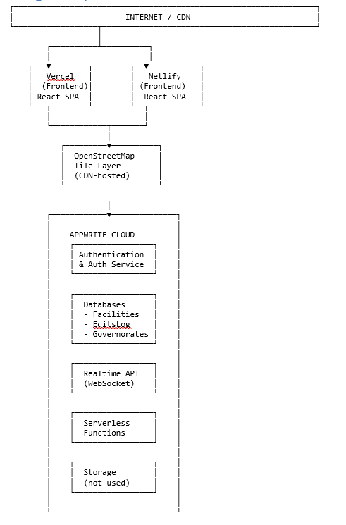

5.2 Component Interaction Diagram
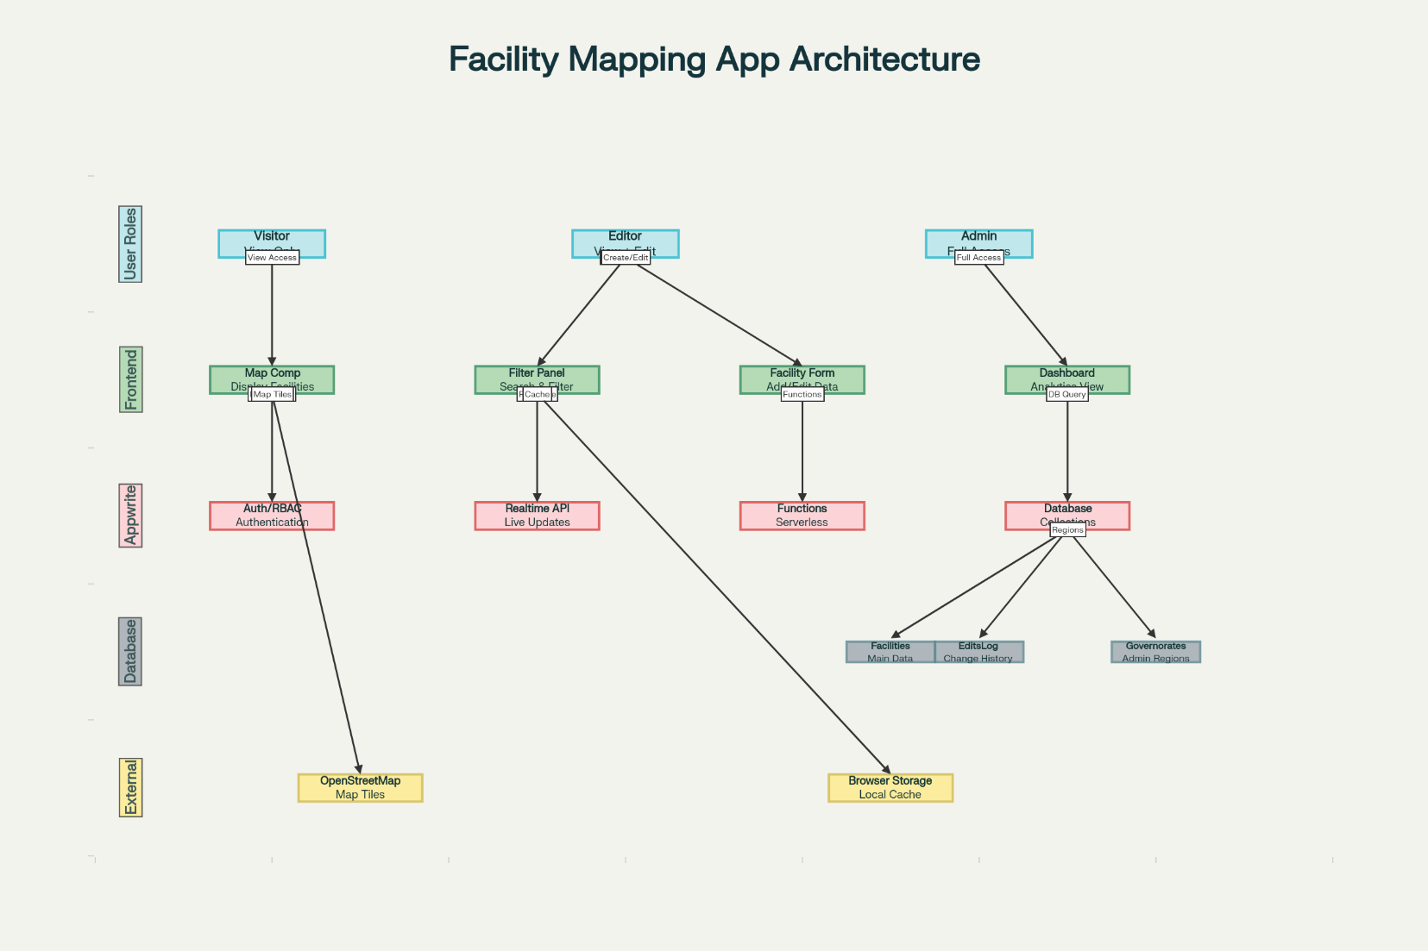Comprehensive architecture diagram showing React components, Appwrite services, and data flows.

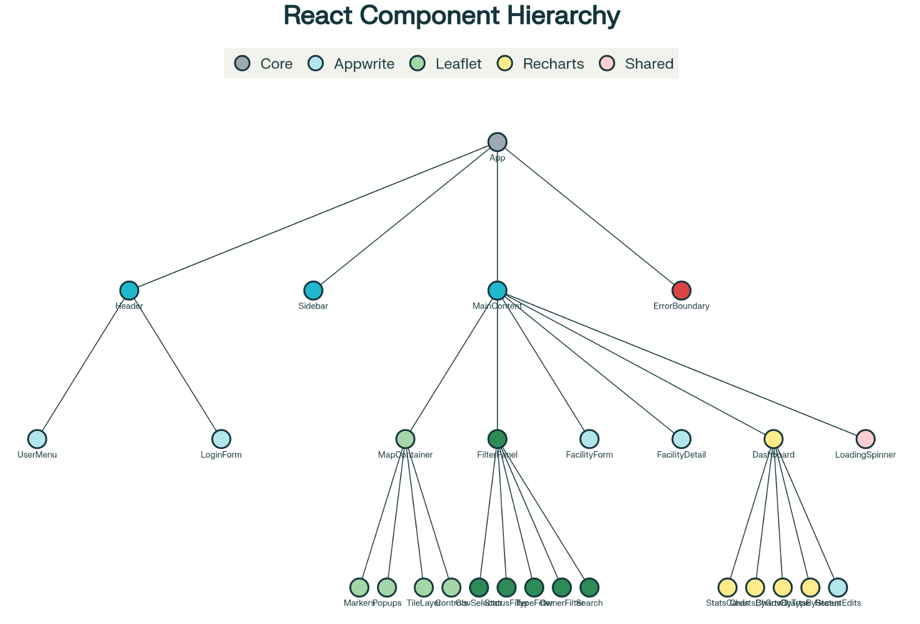
Comprehensive architecture diagram showing React components hierarchy.

5.3 Request/Response Flow Example (Loading Facilities)
1. User loads app → React renders MapContainer component
2. MapContainer useEffect triggers on mount:
- Calls Appwrite Databases.listDocuments('facilities')
3. Appwrite API receives request, authenticates (session token)
4. Query executed: SELECT * FROM Facilities WHERE status='active' LIMIT 50
5. Results serialized to GeoJSON format
6. Response returned to frontend (array of facility documents)
7. React state updated: setFacilities(data)
8. Leaflet re-renders with new Markers for each facility
9. Clustering plugin automatically groups nearby markers
10. User interacts: clicks marker → popup appears

5.4 Authentication Flow
Unauthenticated User:
Visits app → Sees map/filters/dashboard
Cannot edit → Read-only mode
New User Registration:
Clicks "Sign Up" → Form with email/password
Frontend calls Account.create(email, password)
Appwrite validates, creates account, returns session
User automatically logged in, redirected to dashboard
Existing User Login:
Clicks "Log In" → Email/password form
Frontend calls Account.createSession(email, password)
Appwrite validates credentials, creates JWT session token
Session stored in browser cookies/localStorage
Subsequent API calls include session token in Authorization header
Admin/Editor Distinction:
On login, check user's Teams membership
If user in 'admins' team → grant admin UI/permissions
If user in 'editors' team → grant editor UI/permissions
Else → treat as visitor (if logged in for personal edit history)

6. Data Model & Schema

6.1 Entity Relationships Diagram
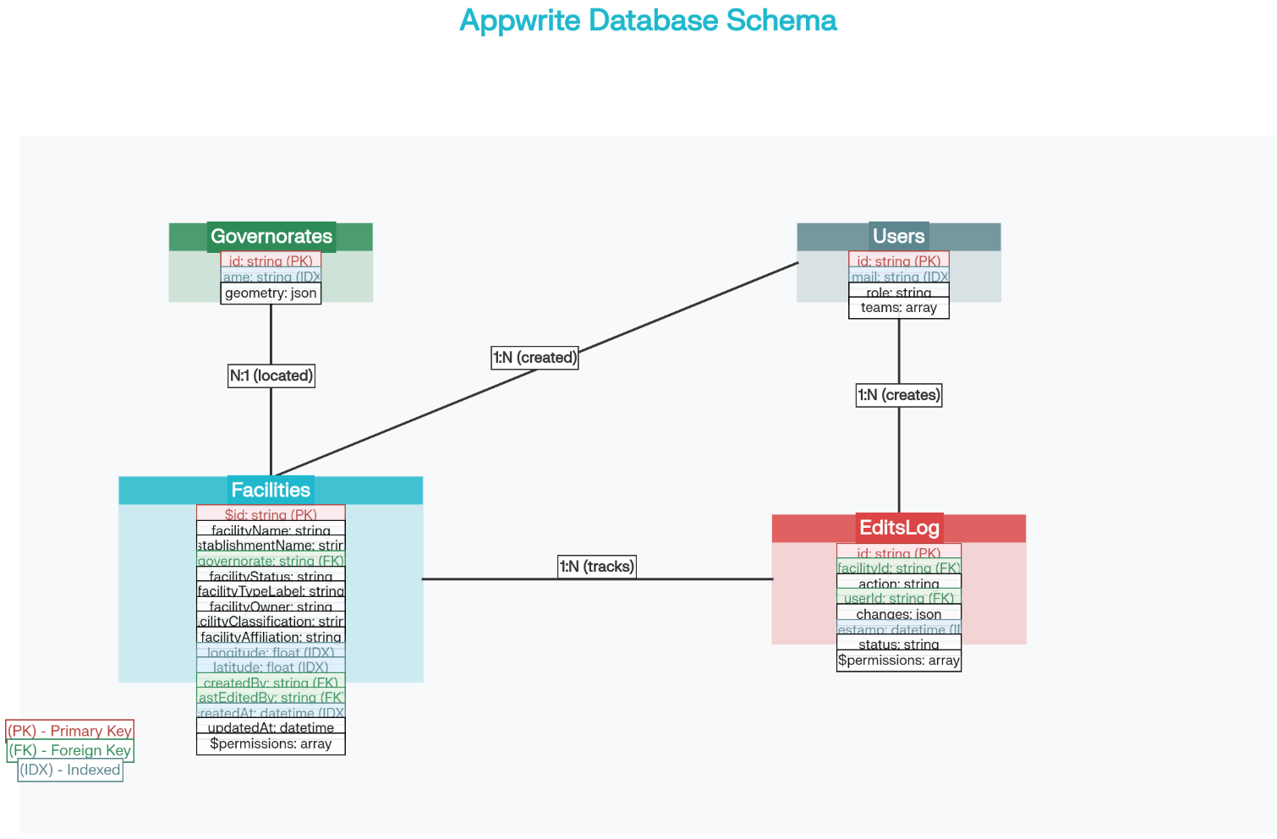
Comprehensive database schema showing all collections, fields, data types, and relationships.

6.2 Facilities Collection
Collection ID: facilities (or custom name in Appwrite console)
Document Structure:
Field Name | Data Type | Required | Description | Index | Example
$id | String | Auto | Appwrite auto-generated unique document ID | PK | “doc_123abc…”
facilityName | String | Yes | Official facility name | Yes | “Central Hospital”
establishmentName | String | No | Legal or alternative establishment name | Yes | “Hopital Central”
governorate | String | Yes | Governorate/region name; should match Governorates collection | Yes | “Tunis”
facilityStatus | String/Enum | Yes | Operational status: active, inactive, pending, suspended | Yes | “active”
facilityTypeLabel | String | Yes | Type of facility (Hospital, Clinic, Lab, Primary Health Center) | Yes | “Hospital”
facilityOwner | String | Yes | Owning organization/ministry/entity | Yes | “Ministry of Health”
facilityClassification | String | Yes | Classification category (Primary, Secondary, Tertiary) | Yes | “Secondary”
facilityAffiliation | String | No | Network/department/affiliation (e.g., Red Crescent, NHS district) | Yes | “Red Crescent”
longitude | Float | Yes | Geographic longitude (WGS84 EPSG:4326) | Spatial | 10.1967
latitude | Float | Yes | Geographic latitude (WGS84 EPSG:4326) | Spatial | 36.8065
location | Point | Yes | Spatial Point [longitude, latitude] for geo-queries (auto-derived) | Spatial | [10.1967, 36.8065]
createdBy | String | Auto | User ID who created this facility | Yes | “user_xyz123”
lastEditedBy | String | Auto | User ID who last modified this facility | Yes | “user_abc456”
createdAt | DateTime | Auto | Timestamp of creation (ISO 8601) | Yes | “2025-11-01T…”
updatedAt | DateTime | Auto | Timestamp of last modification | Yes | “2025-11-01T…”
$permissions | Array | Auto | Appwrite permission objects (read, write, delete per role) | — | […]

Indexes: - Primary Key: $id - Spatial Index on (longitude, latitude): Enables fast bounding-box and distance queries - Composite Index on (governorate, facilityStatus): Fast filtering by governorate and status - Index on (facilityTypeLabel, facilityOwner): Fast filtering by type and owner
Constraints: - longitude: -180 ≤ longitude ≤ 180 - latitude: -90 ≤ latitude ≤ 90 - facilityStatus: Enum values (active, inactive, pending, suspended) - facilityName, governorate, facilityTypeLabel, facilityOwner, facilityClassification: Not null

6.3 EditsLog Collection
Purpose: Immutable audit trail of all facility changes for compliance and debugging.
Collection ID: edits_log
Document Structure:
Field Name | Data Type | Required | Description | Example
$id | String | Auto | Unique edit record ID | “edit_456def…”
facilityId | String | Yes | Reference to Facilities collection $id | “doc_123abc…”
action | String/Enum | Yes | Type of action: ‘created’, ‘updated’, ‘deleted’ | “updated”
userId | String | Yes | User ID who performed the action | “user_xyz123”
changes | JSON/Object | Yes | Object containing changed fields (before/after or delta) | {field: "status", before: "pending", after: "active"}
timestamp | DateTime | Auto | When the change occurred (ISO 8601) | “2025-11-01T14:30:00Z”
status | String/Enum | Yes | Edit status: ‘pending’, ‘approved’, ‘rejected’ | “pending”
adminNotes | String | No | Optional notes from approver/rejector | “Verified on-site visit”
$permissions | Array | Auto | Appwrite permissions (typically admin-read-only) | […]

Indexes: - Index on facilityId: Quick lookup of all edits for a facility - Index on userId: Quick lookup of edits by a user - Index on timestamp: Sort by recent changes - Composite Index on (timestamp, status): Fast filtering for admin approval queue

6.4 Governorates Collection
Purpose: Reference data for governorate names and optionally geographic boundaries.
Collection ID: governorates
Document Structure:
Field Name | Data Type | Required | Description | Example
$id | String | Auto | Unique governorate ID | “gov_001”
name | String | Yes | Governorate name (unique) | “Tunis”
code | String | No | ISO or administrative code | “TN”
boundary | Polygon | No | WGS84 polygon geometry (GeoJSON-style) for map visualization | {type: "Polygon", coordinates: [...]}
population | Integer | No | Optional census data for context | 1234567
area | Float | No | Area in km² (informational) | 2500
$permissions | Array | Auto | Read-only for all, no edits | […]

Data: - Pre-populate with all governorates of the country (static reference). - Optionally include polygon boundaries for map overlay/heatmap visualization.

6.5 Users Collection (Implicit via Appwrite Auth)
Appwrite Auth service manages users. Optional custom Users collection can store additional metadata:
Collection ID: users_metadata (optional)
Field Name | Data Type | Required | Description | Example
$id | String | Auto | Matches Appwrite Auth user $id | “auth_user_789”
email | String | Yes | User email (unique) | “editor@example.com”
role | String/Enum | Yes | User role: ‘visitor’, ‘editor’, ‘admin’ | “editor”
teamIds | Array | Auto | List of Appwrite Teams user belongs to | [“team_1”, “team_2”]
createdAt | DateTime | Auto | Account creation date | “2025-10-01T…”
lastLogin | DateTime | No | Last login timestamp | “2025-11-01T…”
activeEdits | Integer | No | Count of edits/contributions | 42
$permissions | Array | Auto | User can view own profile; admin can view all | […]

7. Appwrite Service Configuration

7.1 Creating Collections in Appwrite Console
Steps to Create Facilities Collection:
- Log into Appwrite Console → Select your project
- Click “Databases” → Create database (or use existing)
- Inside database, click “Create Collection”
- Name: facilities, enable “Enable Collection” and “Encrypt” if desired
- Add attributes for each field:
  - facilityName: String, Required, Size 255
  - establishmentName: String, Optional, Size 255
  - governorate: String, Required
  - facilityStatus: String, Required (Enum: active, inactive, pending, suspended)
  - facilityTypeLabel: String, Required
  - facilityOwner: String, Required
  - facilityClassification: String, Required
  - facilityAffiliation: String, Optional
  - longitude: Float, Required
  - latitude: Float, Required
  - createdBy: String, Required (auto-set to current user)
  - lastEditedBy: String, Required
  - createdAt: DateTime, Auto-set to now
  - updatedAt: DateTime, Auto-set to now
- Create indexes:
  - Spatial index on (longitude, latitude)
  - Index on governorate
  - Index on facilityStatus
  - Composite on (governorate, facilityStatus)
Repeat for EditsLog and Governorates collections (see schemas in Section 6).

7.2 Setting Up Authentication
Steps:
- Enable Email/Password Auth:
  - Settings → Auth Providers
  - Enable “Email & Password”
  - Configure email validation (optional)
- Optional OAuth (for ease of signup):
  - Settings → Auth Providers
  - Enable “Google”, “GitHub” as desired
  - Provide OAuth app credentials from Google/GitHub
- Configure Session Timeout:
  - Settings → Security
  - Set session duration (e.g., 7 days)
- Create Teams for Roles:
  - Teams section → Create “editors” team
  - Create “admins” team
  - Admins manage team membership

7.3 Creating Serverless Function (Validation)
Function Name: validateFacilityEdit
Trigger: HTTP (or database event trigger)
Runtime: Node.js 18+
File: validate-facility-edit/src/main.js
import { Client, Databases, Messaging } from 'node-appwrite';
export default async ({ req, res, log, error }) => {
// Validate facility edit before persisting
const client = new Client()
.setEndpoint(process.env.APPWRITE_ENDPOINT)
.setProject(process.env.APPWRITE_FUNCTION_PROJECT_ID)
.setKey(req.headers['x-appwrite-key']);
const databases = new Databases(client);
try {
const { facilityId, facilityName, longitude, latitude, governorate, status } = JSON.parse(req.body);
// Validate coordinates
if (longitude < -180 || longitude > 180) {
throw new Error('Invalid longitude; must be between -180 and 180');
}
if (latitude < -90 || latitude > 90) {
throw new Error('Invalid latitude; must be between -90 and 90');
}
// Validate name is not empty
if (!facilityName || facilityName.trim().length === 0) {
throw new Error('Facility name cannot be empty');
}
// Check for duplicate by name and governorate (optional)
const existing = await databases.listDocuments(
process.env.APPWRITE_DATABASE_ID,
'facilities',
[
Query.equal('facilityName', facilityName),
Query.equal('governorate', governorate)
]
);
if (existing.documents.length > 0 && existing.documents[0].$id !== facilityId) {
// Duplicate found (and it's not the same document being updated)
throw new Error(`Facility "${facilityName}" already exists in ${governorate}`);
}
log('Validation passed for facility');
return res.json({ success: true, message: 'Validation successful' });
} catch (err) {
error(`Validation error: ${err.message}`);
return res.json({ success: false, error: err.message }, 400);
}
};
Deployment:
appwrite deploy function --functionId validateFacilityEdit

7.4 Setting Permissions (RBAC)
Document-Level Permissions:
When creating a facility, set permissions:
import { Permission, Role } from 'appwrite';
const permissions = [
// Everyone can read
Permission.read(Role.any()),
// Editors team can update
Permission.update(Role.team('team-editors-id')),
// Only admins can delete
Permission.delete(Role.team('team-admins-id')),
// Creator has full access
Permission.write(Role.user(userId))
];
await databases.createDocument(
'database-id',
'facilities',
'unique()',
documentData,
permissions
);

8. Frontend Implementation

8.1 Project Structure
facility-mapping-app/
├── public/
│ ├── index.html
│ └── favicon.ico
├── src/
│ ├── components/
│ │ ├── Map/
│ │ │ ├── MapContainer.jsx # Main Leaflet map
│ │ │ ├── FacilityMarker.jsx # Individual marker component
│ │ │ ├── FacilityPopup.jsx # Marker click popup
│ │ │ └── MapControls.jsx # Map zoom/pan controls
│ │ ├── Filter/
│ │ │ ├── FilterPanel.jsx # Filter sidebar
│ │ │ ├── GovernorateFilter.jsx # Governorate selector
│ │ │ ├── TypeFilter.jsx # Facility type selector
│ │ │ ├── StatusFilter.jsx # Status selector
│ │ │ └── SearchBar.jsx # Name search input
│ │ ├── Facility/
│ │ │ ├── FacilityForm.jsx # Add/Edit facility form
│ │ │ ├── FacilityList.jsx # List view of facilities
│ │ │ └── FacilityDetail.jsx # Detailed view modal
│ │ ├── Dashboard/
│ │ │ ├── Dashboard.jsx # Main dashboard page
│ │ │ ├── StatisticsCards.jsx # KPI cards
│ │ │ ├── ChartsByGovernorate.jsx # Governorate breakdown chart
│ │ │ ├── ChartsByType.jsx # Type breakdown chart
│ │ │ ├── ChartsByStatus.jsx # Status breakdown chart
│ │ │ ├── ChartsByOwner.jsx # Owner breakdown chart
│ │ │ └── RecentActivityFeed.jsx # Recent edits timeline
│ │ ├── Auth/
│ │ │ ├── LoginForm.jsx # Email/password login
│ │ │ ├── SignupForm.jsx # User registration
│ │ │ ├── UserMenu.jsx # User dropdown (profile, logout)
│ │ │ └── ProtectedRoute.jsx # Route guard for authenticated-only pages
│ │ ├── Admin/
│ │ │ ├── ApprovalQueue.jsx # Pending edits for approval
│ │ │ ├── UserManagement.jsx # User role/permissions management
│ │ │ ├── AuditLog.jsx # Edit history log view
│ │ │ └── AdminDashboard.jsx # Admin overview page
│ │ └── Common/
│ │ ├── Header.jsx # Navigation header
│ │ ├── Sidebar.jsx # Left sidebar navigation
│ │ ├── Footer.jsx # App footer
│ │ ├── LoadingSpinner.jsx # Loading indicator
│ │ ├── ErrorBoundary.jsx # React error boundary
│ │ └── Modal.jsx # Reusable modal component
│ ├── services/
│ │ ├── appwrite-client.js # Appwrite SDK setup & exports
│ │ ├── auth.js # Authentication logic (login, signup, logout)
│ │ ├── facilities.js # Facilities collection API (CRUD)
│ │ ├── editsLog.js # EditsLog collection API
│ │ ├── governorates.js # Governorates collection API
│ │ └── realtime.js # Realtime subscription helpers
│ ├── hooks/
│ │ ├── useAuth.js # Custom hook for auth state
│ │ ├── useFacilities.js # Custom hook for facilities data
│ │ ├── useFilters.js # Custom hook for filter state
│ │ └── useRealtime.js # Custom hook for realtime subscriptions
│ ├── pages/
│ │ ├── HomePage.jsx # Public home with map & dashboard
│ │ ├── AdminPage.jsx # Admin control panel
│ │ ├── ProfilePage.jsx # User profile
│ │ └── NotFoundPage.jsx # 404 page
│ ├── utils/
│ │ ├── validators.js # Form validation helpers
│ │ ├── formatters.js # Data formatting (dates, numbers)
│ │ ├── constants.js # App constants (facility types, statuses)
│ │ └── geospatial.js # Coordinate math/calculations
│ ├── styles/
│ │ ├── globals.css # Global TailwindCSS imports
│ │ ├── leaflet-custom.css # Leaflet customizations
│ │ └── animations.css # Custom animations
│ ├── App.jsx # Root component & routing
│ └── main.jsx # React entry point
├── .env.local # Local environment variables (dev)
├── .env.production # Production environment variables
├── package.json
├── vite.config.js # Vite build config
├── tailwind.config.js # TailwindCSS config
└── README.md

8.2 Key Components Implementation

8.2.1 MapContainer.jsx
import React, { useEffect, useState } from 'react';
import { MapContainer, TileLayer, Marker, Popup, useMap } from 'react-leaflet';
import L from 'leaflet';
import 'leaflet.markercluster';
import 'leaflet.markercluster/dist/MarkerCluster.css';
import { useFacilities } from '../hooks/useFacilities';
import { useFilters } from '../hooks/useFilters';
import FacilityPopup from './FacilityPopup';
export default function MapComponent() {
const { facilities, loading } = useFacilities();
const { filters } = useFilters();
const [filteredFacilities, setFilteredFacilities] = useState([]);
useEffect(() => {
// Filter facilities based on active filters
const filtered = facilities.filter(f => {
if (filters.governorate && f.governorate !== filters.governorate) return false;
if (filters.status && f.facilityStatus !== filters.status) return false;
if (filters.type && f.facilityTypeLabel !== filters.type) return false;
if (filters.owner && !f.facilityOwner.includes(filters.owner)) return false;
if (filters.searchTerm &&
!f.facilityName.toLowerCase().includes(filters.searchTerm.toLowerCase()) &&
!f.establishmentName.toLowerCase().includes(filters.searchTerm.toLowerCase())) {
return false;
}
return true;
});
setFilteredFacilities(filtered);
}, [facilities, filters]);
const mapCenter = [36.7372, 10.3375]; // Tunisia center
const mapZoom = 7;
return (
<div className="w-full h-full">
{loading && <div className="absolute top-4 left-4 bg-white p-2 rounded shadow">Loading facilities...</div>}
<MapContainer center={mapCenter} zoom={mapZoom} style={{ height: '100%', width: '100%' }}>
<TileLayer
url="https://{s}.tile.openstreetmap.org/{z}/{x}/{y}.png"
attribution='&copy; OpenStreetMap contributors'
/>
{/* Render markers for filtered facilities */}
{filteredFacilities.map(facility => (
<Marker
key={facility.$id}
position={[facility.latitude, facility.longitude]}
icon={getIconByType(facility.facilityTypeLabel)}
>
<Popup>
<FacilityPopup facility={facility} />
</Popup>
</Marker>
))}
</MapContainer>
</div>
);
}
function getIconByType(type) {
// Color-coded icons by facility type
const colors = {
Hospital: 'red',
Clinic: 'blue',
Lab: 'green',
'Primary Health Center': 'orange'
};
const color = colors[type] || 'gray';
return L.icon({
iconUrl: `https://raw.githubusercontent.com/pointhi/leaflet-color-markers/master/img/marker-${color}.png`,
iconSize: [25, 41],
iconAnchor: [12, 41],
popupAnchor: [1, -34]
});
}

8.2.2 FilterPanel.jsx
import React from 'react';
import { useFilters } from '../hooks/useFilters';
import { useAppwrite } from '../hooks/useAppwrite';
export default function FilterPanel() {
const { filters, setFilters } = useFilters();
const { governorates, facilityTypes, statuses } = useAppwrite();
return (
<div className="w-full max-w-md p-4 bg-white shadow-lg rounded-lg">
<h2 className="text-lg font-bold mb-4">Filters</h2>
{/* Search Box */}
<div className="mb-4">
<label className="block text-sm font-medium mb-2">Search Facility Name</label>
<input
type="text"
placeholder="Search by name..."
value={filters.searchTerm}
onChange={(e) => setFilters({ ...filters, searchTerm: e.target.value })}
className="w-full px-3 py-2 border border-gray-300 rounded-md"
/>
</div>
{/* Governorate Filter */}
<div className="mb-4">
<label className="block text-sm font-medium mb-2">Governorate</label>
<select
value={filters.governorate}
onChange={(e) => setFilters({ ...filters, governorate: e.target.value })}
className="w-full px-3 py-2 border border-gray-300 rounded-md"
>
<option value="">All Governorates</option>
{governorates.map(g => (
<option key={g.$id} value={g.name}>{g.name}</option>
))}
</select>
</div>
{/* Status Filter */}
<div className="mb-4">
<label className="block text-sm font-medium mb-2">Status</label>
<select
value={filters.status}
onChange={(e) => setFilters({ ...filters, status: e.target.value })}
className="w-full px-3 py-2 border border-gray-300 rounded-md"
>
<option value="">All Statuses</option>
{statuses.map(s => (
<option key={s} value={s}>{s}</option>
))}
</select>
</div>
{/* Type Filter */}
<div className="mb-4">
<label className="block text-sm font-medium mb-2">Facility Type</label>
<select
value={filters.type}
onChange={(e) => setFilters({ ...filters, type: e.target.value })}
className="w-full px-3 py-2 border border-gray-300 rounded-md"
>
<option value="">All Types</option>
{facilityTypes.map(t => (
<option key={t} value={t}>{t}</option>
))}
</select>
</div>
{/* Reset Button */}
<button
onClick={() => setFilters({
governorate: '',
status: '',
type: '',
owner: '',
searchTerm: ''
})}
className="w-full bg-gray-400 text-white px-4 py-2 rounded-md hover:bg-gray-500"
>
Reset Filters
</button>
</div>
);
}

8.2.3 FacilityForm.jsx (Add/Edit)
import React, { useState, useEffect } from 'react';
import { useAuth } from '../hooks/useAuth';
import { databases } from '../services/appwrite-client';
import { validateFacility } from '../utils/validators';
export default function FacilityForm({ facilityId = null, onSuccess }) {
const { user } = useAuth();
const [formData, setFormData] = useState({
facilityName: '',
establishmentName: '',
governorate: '',
facilityStatus: 'active',
facilityTypeLabel: '',
facilityOwner: '',
facilityClassification: '',
facilityAffiliation: '',
longitude: '',
latitude: ''
});
const [errors, setErrors] = useState({});
const [loading, setLoading] = useState(false);
// Load existing facility if editing
useEffect(() => {
if (facilityId) {
async function loadFacility() {
try {
const doc = await databases.getDocument('database-id', 'facilities', facilityId);
setFormData(doc);
} catch (err) {
console.error('Error loading facility:', err);
}
}
loadFacility();
}
}, [facilityId]);
const handleChange = (e) => {
const { name, value } = e.target;
setFormData(prev => ({ ...prev, [name]: value }));
};
const handleSubmit = async (e) => {
e.preventDefault();
// Validate form
const validationErrors = validateFacility(formData);
if (Object.keys(validationErrors).length > 0) {
setErrors(validationErrors);
return;
}
setLoading(true);
try {
if (facilityId) {
// Update existing
await databases.updateDocument('database-id', 'facilities', facilityId, {
...formData,
lastEditedBy: user.$id,
updatedAt: new Date().toISOString()
});
// Log edit
await databases.createDocument('database-id', 'edits_log', 'unique()', {
facilityId,
action: 'updated',
userId: user.$id,
changes: formData,
timestamp: new Date().toISOString(),
status: 'approved'
});
} else {
// Create new
const doc = await databases.createDocument('database-id', 'facilities', 'unique()', {
...formData,
createdBy: user.$id,
lastEditedBy: user.$id,
createdAt: new Date().toISOString(),
updatedAt: new Date().toISOString()
});
// Log creation
await databases.createDocument('database-id', 'edits_log', 'unique()', {
facilityId: doc.$id,
action: 'created',
userId: user.$id,
changes: formData,
timestamp: new Date().toISOString(),
status: 'approved'
});
}
onSuccess?.();
alert(facilityId ? 'Facility updated successfully!' : 'Facility created successfully!');
} catch (err) {
console.error('Submission error:', err);
alert('Error saving facility: ' + err.message);
} finally {
setLoading(false);
}
};
return (
<form onSubmit={handleSubmit} className="max-w-2xl mx-auto p-6 bg-white rounded-lg shadow-lg">
<h2 className="text-2xl font-bold mb-6">{facilityId ? 'Edit Facility' : 'Add New Facility'}</h2>
<div className="grid grid-cols-2 gap-4">
{/* Facility Name */}
<div>
<label className="block text-sm font-medium mb-1">Facility Name *</label>
<input
type="text"
name="facilityName"
value={formData.facilityName}
onChange={handleChange}
required
className="w-full px-3 py-2 border border-gray-300 rounded-md"
/>
{errors.facilityName && <span className="text-red-500 text-xs">{errors.facilityName}</span>}
</div>
{/* Establishment Name */}
<div>
<label className="block text-sm font-medium mb-1">Establishment Name</label>
<input
type="text"
name="establishmentName"
value={formData.establishmentName}
onChange={handleChange}
className="w-full px-3 py-2 border border-gray-300 rounded-md"
/>
</div>
{/* Governorate */}
<div>
<label className="block text-sm font-medium mb-1">Governorate *</label>
<select
name="governorate"
value={formData.governorate}
onChange={handleChange}
required
className="w-full px-3 py-2 border border-gray-300 rounded-md"
>
<option value="">Select Governorate</option>
{/* Populate from governorates collection */}
</select>
{errors.governorate && <span className="text-red-500 text-xs">{errors.governorate}</span>}
</div>
{/* Facility Status */}
<div>
<label className="block text-sm font-medium mb-1">Status *</label>
<select
name="facilityStatus"
value={formData.facilityStatus}
onChange={handleChange}
className="w-full px-3 py-2 border border-gray-300 rounded-md"
>
<option value="active">Active</option>
<option value="inactive">Inactive</option>
<option value="pending">Pending</option>
<option value="suspended">Suspended</option>
</select>
</div>
{/* Type, Owner, Classification, Affiliation... (similar pattern) */}
{/* Longitude */}
<div>
<label className="block text-sm font-medium mb-1">Longitude *</label>
<input
type="number"
name="longitude"
value={formData.longitude}
onChange={handleChange}
step="0.0001"
required
className="w-full px-3 py-2 border border-gray-300 rounded-md"
/>
{errors.longitude && <span className="text-red-500 text-xs">{errors.longitude}</span>}
</div>
{/* Latitude */}
<div>
<label className="block text-sm font-medium mb-1">Latitude *</label>
<input
type="number"
name="latitude"
value={formData.latitude}
onChange={handleChange}
step="0.0001"
required
className="w-full px-3 py-2 border border-gray-300 rounded-md"
/>
{errors.latitude && <span className="text-red-500 text-xs">{errors.latitude}</span>}
</div>
</div>
<button
type="submit"
disabled={loading}
className="mt-6 w-full bg-blue-500 text-white px-4 py-2 rounded-md hover:bg-blue-600 disabled:bg-gray-400"
>
{loading ? 'Saving...' : 'Save Facility'}
</button>
</form>
);
}

8.2.4 Dashboard.jsx
import React, { useEffect, useState } from 'react';
import { BarChart, Bar, PieChart, Pie, Cell, LineChart, Line, XAxis, YAxis, CartesianGrid, Tooltip, Legend, ResponsiveContainer } from 'recharts';
import { useFacilities } from '../hooks/useFacilities';
export default function Dashboard() {
const { facilities } = useFacilities();
const [stats, setStats] = useState({
total: 0,
byGovernorate: {},
byType: {},
byStatus: {},
byOwner: {}
});
useEffect(() => {
if (facilities.length === 0) return;
const stats = {
total: facilities.length,
byGovernorate: {},
byType: {},
byStatus: {},
byOwner: {}
};
facilities.forEach(f => {
stats.byGovernorate[f.governorate] = (stats.byGovernorate[f.governorate] || 0) + 1;
stats.byType[f.facilityTypeLabel] = (stats.byType[f.facilityTypeLabel] || 0) + 1;
stats.byStatus[f.facilityStatus] = (stats.byStatus[f.facilityStatus] || 0) + 1;
stats.byOwner[f.facilityOwner] = (stats.byOwner[f.facilityOwner] || 0) + 1;
});
setStats(stats);
}, [facilities]);
const governorateData = Object.entries(stats.byGovernorate).map(([name, count]) => ({ name, count }));
const typeData = Object.entries(stats.byType).map(([name, count]) => ({ name, count }));
const statusData = Object.entries(stats.byStatus).map(([name, count]) => ({ name, count }));
const COLORS = ['#0088FE', '#00C49F', '#FFBB28', '#FF8042'];
return (
<div className="p-6 bg-gray-50 min-h-screen">
<h1 className="text-3xl font-bold mb-8">Facility Dashboard</h1>
{/* KPI Cards */}
<div className="grid grid-cols-1 md:grid-cols-4 gap-4 mb-8">
<StatCard title="Total Facilities" value={stats.total} />
<StatCard title="Active" value={stats.byStatus.active || 0} />
<StatCard title="Inactive" value={stats.byStatus.inactive || 0} />
<StatCard title="Governorates" value={Object.keys(stats.byGovernorate).length} />
</div>
{/* Charts */}
<div className="grid grid-cols-1 lg:grid-cols-2 gap-6 mb-8">
{/* By Governorate */}
<div className="bg-white p-4 rounded-lg shadow">
<h3 className="text-lg font-bold mb-4">Facilities by Governorate</h3>
<ResponsiveContainer width="100%" height={300}>
<BarChart data={governorateData}>
<CartesianGrid strokeDasharray="3 3" />
<XAxis dataKey="name" />
<YAxis />
<Tooltip />
<Bar dataKey="count" fill="#8884d8" />
</BarChart>
</ResponsiveContainer>
</div>
{/* By Type */}
<div className="bg-white p-4 rounded-lg shadow">
<h3 className="text-lg font-bold mb-4">Facilities by Type</h3>
<ResponsiveContainer width="100%" height={300}>
<PieChart>
<Pie
data={typeData}
cx="50%"
cy="50%"
labelLine={false}
label={({ name, count }) => `${name}: ${count}`}
outerRadius={80}
fill="#8884d8"
dataKey="count"
>
{typeData.map((entry, index) => (
<Cell key={`cell-${index}`} fill={COLORS[index % COLORS.length]} />
))}
</Pie>
<Tooltip />
</PieChart>
</ResponsiveContainer>
</div>
{/* By Status */}
<div className="bg-white p-4 rounded-lg shadow">
<h3 className="text-lg font-bold mb-4">Facilities by Status</h3>
<ResponsiveContainer width="100%" height={300}>
<PieChart>
<Pie
data={statusData}
cx="50%"
cy="50%"
labelLine={false}
label={({ name, count }) => `${name}: ${count}`}
outerRadius={80}
fill="#8884d8"
dataKey="count"
>
{statusData.map((entry, index) => (
<Cell key={`cell-${index}`} fill={COLORS[index % COLORS.length]} />
))}
</Pie>
<Tooltip />
</PieChart>
</ResponsiveContainer>
</div>
</div>
</div>
);
}
function StatCard({ title, value }) {
return (
<div className="bg-white p-6 rounded-lg shadow-md">
<p className="text-gray-500 text-sm font-medium">{title}</p>
<p className="text-3xl font-bold text-blue-600">{value}</p>
</div>
);
}

9. Backend Logic & Validation

9.1 Data Validation
Frontend Validation (User Experience): - Real-time validation as user types - Instant feedback with error messages - Prevent invalid form submission
Backend Validation (Data Integrity): - All inputs re-validated server-side - Appwrite Functions execute validation logic - Reject invalid requests with detailed error responses

9.2 Validation Rules
Facility Fields:
// utils/validators.js
export function validateFacility(data) {
const errors = {};
// Facility Name: required, non-empty, max 255 chars
if (!data.facilityName || data.facilityName.trim().length === 0) {
errors.facilityName = 'Facility name is required';
} else if (data.facilityName.length > 255) {
errors.facilityName = 'Facility name must be ≤ 255 characters';
}
// Governorate: required
if (!data.governorate) {
errors.governorate = 'Governorate is required';
}
// Facility Status: required, valid enum
const validStatuses = ['active', 'inactive', 'pending', 'suspended'];
if (!validStatuses.includes(data.facilityStatus)) {
errors.facilityStatus = 'Invalid facility status';
}
// Longitude: required, valid range -180 to 180
const lon = parseFloat(data.longitude);
if (isNaN(lon) || lon < -180 || lon > 180) {
errors.longitude = 'Longitude must be between -180 and 180';
}
// Latitude: required, valid range -90 to 90
const lat = parseFloat(data.latitude);
if (isNaN(lat) || lat < -90 || lat > 90) {
errors.latitude = 'Latitude must be between -90 and 90';
}
return errors;
}

9.3 Server-Side Validation (Appwrite Function)
See Section 7.3 for validateFacilityEdit function.

9.4 REST API
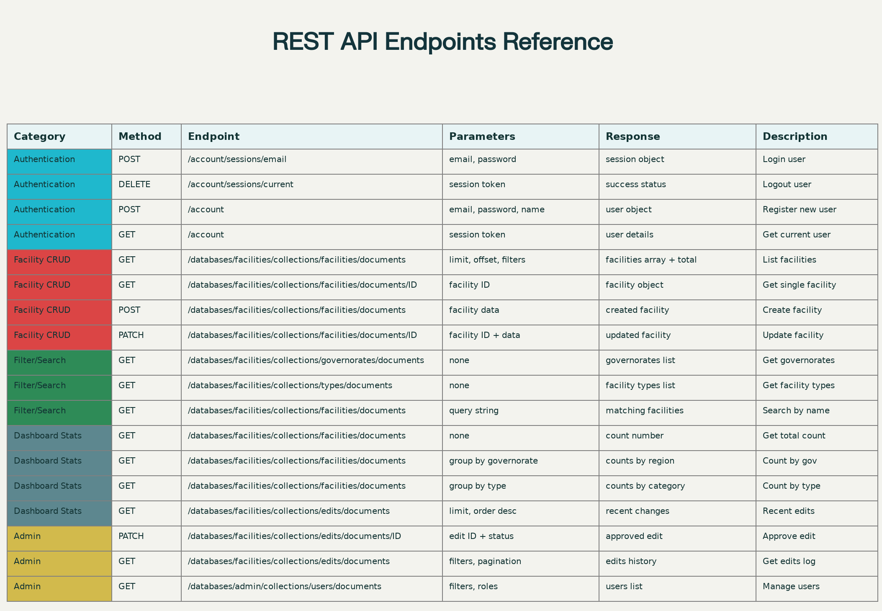

10. User Workflows & UX Flows
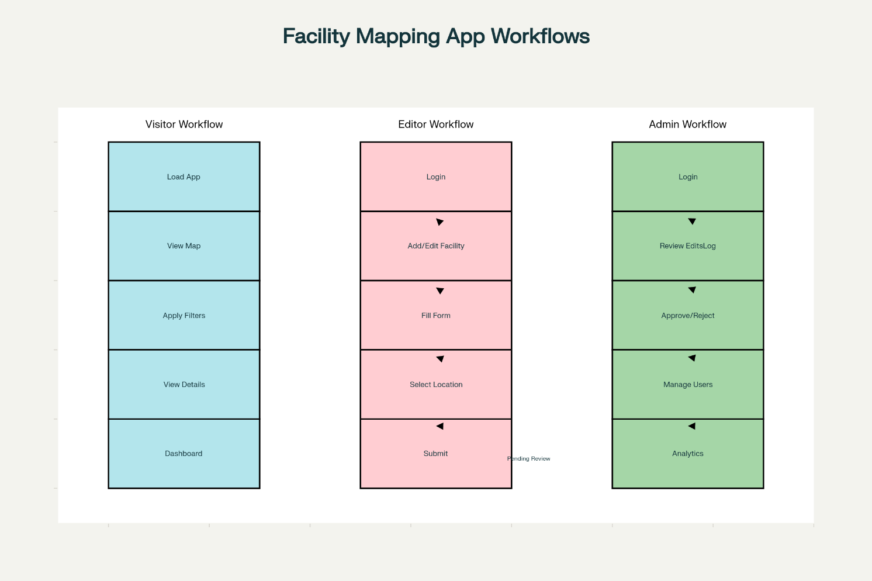
Complete workflow diagram showing user journeys and decision points.

10.1 Visitor Workflow
1. Open app → Home page loads
- Map displays all active facilities
- Dashboard shows aggregated statistics
- Filters panel visible on left
- "Login" button in top-right
2. Explore map
- Zoom/pan map to navigate
- See facility markers colored by type
- Click marker → popup shows facility details
- Close popup, continue exploring
3. Apply filters
- Select governorate from dropdown → map updates
- Select facility type → only matching facilities shown
- Enter search term → results filtered by name
- Reset button clears all filters
4. View dashboard
- Scroll down to statistics section
- See charts: facilities by governorate, type, status
- View KPI cards (total count, active/inactive, etc.)
- No edit/admin actions available
5. (If want to edit)
- Click "Login" button
- Redirected to login form
- Register or sign in with email/password
- Logged-in experience unlocked (see Editor Workflow)

10.2 Editor Workflow
1. Sign in
- Click "Login" button
- Email/password form (or OAuth if enabled)
- Verify email if required
- Session created, redirected to home
2. View map & dashboard
- Same as visitor experience
- Plus: "Add Facility" and "My Edits" buttons appear
3. Add new facility
- Click "Add Facility" button
- Facility form opens (modal or new page)
- Populate all fields:
- Text inputs: name, owner, classification, affiliation
- Dropdowns: governorate, type, status
- Coordinate inputs or map selection for location
- Frontend validates form
- Submit → Appwrite function validates server-side
- On success: document created, EditsLog entry, confirmation message
- Form clears, map updates in real-time (if realtime subscription active)
4. View personal contributions
- Click "My Edits" button
- Timeline/list of facilities created or edited by user
- See status: approved, pending, etc.
- Click to view/edit facility details
5. Edit facility
- Click marker → popup with "Edit" button
- Or navigate from "My Edits" list and click edit
- Pre-populated form opens
- Make changes
- Submit → EditsLog entry created with action='updated'
- Status of edit depends on approval workflow setting
6. Logout
- Click user menu (top-right)
- Select "Logout"
- Session terminated, redirected to home

10.3 Admin Workflow
1. Sign in as admin
- Admin account created and assigned to 'admins' team
- Login experience same as editor
- Admin menu/dashboard visible
2. Approval queue (if workflow enabled)
- Click "Admin Dashboard"
- See list of pending edits/facilities
- Review each item: facility name, changes, submitter, timestamp
- Click "Approve" or "Reject"
- Optional: add admin notes
- Approved: facility visible in public map
- Rejected: facility hidden, editor notified
3. User management
- "Users" section in admin dashboard
- List all registered users
- View: email, role, join date, contribution count
- Search by email
- Change user role: visitor → editor, editor → admin (or revoke)
- Changes logged with admin ID and timestamp
4. Audit log
- "Audit Log" section
- Filter by:
- Date range
- User
- Action type (create, update, delete)
- Facility
- View full change history with before/after values
- Export to CSV for external reporting/compliance
5. Analytics
- "Analytics" section with advanced aggregations
- Facility creation trend over time
- Most active editors
- Rejected edit reasons/patterns
- Geographic heatmap of data entry activity
6. Logout
- Same as editor

11. Security & Access Control

11.1 Authentication
- Email/Password: Secure password hashing (bcrypt by Appwrite)
- Sessions: JWT tokens with configurable expiration (default 7 days)
- Optional OAuth: Reduces password fatigue, easier signup
- MFA (Multi-Factor Auth): Optional for admin accounts (enhance security)

11.2 Authorization (RBAC)
Appwrite Teams + Custom Roles:
// Visitor Role (default, unauthenticated)
- Permission.read(Role.any()) on Facilities collection
- No write, update, delete permissions
- Can view map and dashboard
// Editor Role (authenticated, in 'editors' team)
- Permission.read(Role.any()) on Facilities
- Permission.create(Role.team('editors')) on Facilities
- Permission.update(Role.team('editors')) on own documents
- Can create and edit facilities they own
// Admin Role (authenticated, in 'admins' team)
- Permission.read(Role.team('admins')) on all collections
- Permission.create(Role.team('admins'))
- Permission.update(Role.team('admins')) on any document
- Permission.delete(Role.team('admins'))
- Full access to EditsLog, Users collection, sensitive data

11.3 API Security
- CORS: Frontend domain whitelist in Appwrite settings
- Rate Limiting: Per-IP request throttling (via Appwrite or CDN)
- Input Sanitization: Appwrite automatically sanitizes/escapes strings
- SQL Injection Prevention: Appwrite uses parameterized queries
- HTTPS Only: All communication encrypted in transit

11.4 Data Protection
- At Rest: Appwrite encrypts database at rest (optional encryption config)
- Audit Logging: All user actions logged to EditsLog with immutable timestamps
- Permission Enforcement: Row-level security ensures users see only allowed data
- Soft Delete (Optional): Instead of hard delete, mark status=‘deleted’, keep in audit log

12. Performance & Optimization

12.1 Frontend Optimization
Code Splitting: - React Router enables route-based code splitting - Map component lazy-loaded only when needed - Dashboard charts loaded on-demand
Caching: - React Query: Cache facility data, avoid re-fetching on component remount - Service Worker (optional): Offline access to last-loaded data
Map Performance: - Marker Clustering: Groups nearby markers, reduces DOM nodes - Virtual Scrolling: Large facility lists rendered efficiently (react-window) - Lazy-Load Images: Facility icons loaded on-demand
Build Optimization: - Minification and tree-shaking by Vite - Gzip compression by CDN (Vercel/Netlify) - Image optimization: Compress PNGs, convert to WebP if supported

12.2 Backend Optimization
Database Queries: - Indexes on frequently-queried columns (governorate, status, type) - Pagination: Fetch facilities in chunks (50 documents per request) - Projection: Query only needed fields (e.g., no metadata on large list)
Spatial Queries: - Bounding-box queries using spatial index (fast polygon/distance matching) - Avoid full-table scans with proper WHERE clauses
API Response Caching: - Static reference data (governorates) cached at CDN level - Immutable facility data cached with long TTL
Realtime Subscriptions: - Use targeted subscriptions (specific collection, not entire database) - Unsubscribe when component unmounts to avoid memory leaks

12.3 Monitoring
- APM (Application Performance Monitoring): Sentry for frontend error tracking
- Analytics: Google Analytics for user behavior (with privacy compliance)
- Uptime Monitoring: Pingdom or similar for API availability alerts

13. Deployment & Infrastructure

13.1 Frontend Deployment (Vercel/Netlify)
Steps:
- Connect Git Repository
  - Push code to GitHub, GitLab, or Bitbucket
  - Vercel/Netlify auto-detects React project
- Configure Build Settings
- Build Command: npm run build
Output Directory: dist (or build)
Node Version: 18.x (specify in vercel.json or netlify.toml)
- Environment Variables
  - Create .env.production file
- REACT_APP_APPWRITE_ENDPOINT=https://cloud.appwrite.io/v1
REACT_APP_APPWRITE_PROJECT=<PROJECT_ID>
  - Add to Vercel/Netlify secrets in project settings
- Deploy
  - Push to main branch → automatic deployment
  - Preview deployments for pull requests
  - Rollback to previous deployment if issues
- Custom Domain
  - Add custom domain in hosting provider
  - Auto-SSL certificate provisioning

13.2 Backend (Appwrite Cloud)
- Managed Service: No deployment steps required
- Auto-Scaling: Infrastructure scales with demand
- Backup: Automated daily backups (retention policy)
- Database: PostgreSQL managed by Appwrite

13.3 DNS & CDN Configuration
- Frontend CDN: Automatically served via Vercel/Netlify global CDN
- Tile Server (OpenStreetMap): Third-party CDN (no config needed)
- API Endpoints: Appwrite Cloud endpoints globally available

13.4 Monitoring & Alerts
- Uptime Alerts: Email/Slack notifications if API down
- Performance Alerts: Warn if API response time > threshold
- Storage Alerts: Notify when approaching free tier 2GB limit
- Function Execution: Monitor monthly function invocations

14. Testing Strategy

14.1 Unit Tests
Frontend Components: - Test filters apply correctly to facility list - Test form validation logic - Test chart data aggregation
// example test
import { render, screen } from '@testing-library/react';
import FilterPanel from '../components/Filter/FilterPanel';
test('governorate filter updates facilities', () => {
render(<FilterPanel />);
const selector = screen.getByRole('combobox', { name: /governorate/i });
// ... assertions
});

14.2 Integration Tests
- Auth Flow: Sign up, login, session persistence, logout
- Facility CRUD: Create, read, update, delete facilities
- Filtering & Search: Combine multiple filters, verify results
- Real-time Updates: Multiple clients add facility, all see update

14.3 End-to-End (E2E) Tests
Using Cypress or Playwright: - User visits home → sees map - User logs in → added facility button appears - User adds facility → appears on map and dashboard - Admin approves edit → facility status changes - Visitor filters facilities → results correct

14.4 Performance Testing
- Load Testing: Simulate 100+ concurrent users with Apache JMeter or Locust
- Map Rendering: Test 1000+ markers render smoothly
- Database Queries: Measure query times for large result sets

14.5 Security Testing
- OWASP Top 10:
  - SQL Injection: Appwrite parameterized queries prevent
  - XSS (Cross-Site Scripting): React auto-escapes HTML
  - CSRF (Cross-Site Request Forgery): Appwrite session tokens
- Permission Testing: Verify editor cannot delete another’s facility
- API Rate Limiting: Test throttling enforcement

15. Project Timeline & Milestones

Phase 1: Foundation (Days 1-2)
- ☐ Set up Appwrite project and collections
- ☐ Configure authentication (email/password signup/login)
- ☐ Set up React project structure
- ☐ Connect Appwrite SDK to React
- Deliverable: Boilerplate app with auth working

Phase 2: Map & Filters (Days 3-5)
- ☐ Integrate Leaflet + React Leaflet
- ☐ Render facility markers on map
- ☐ Implement governorate, status, type filters
- ☐ Build search functionality
- ☐ Add marker popup with facility details
- ☐ Realtime updates when new facility added
- Deliverable: Interactive map with filtering, visitors can explore facilities

Phase 3: Dashboard & Analytics (Days 6-7)
- ☐ Create statistics aggregation queries
- ☐ Build dashboard layout with KPI cards
- ☐ Implement charts (Recharts): by governorate, type, status
- ☐ Add recent activity feed (EditsLog display)
- ☐ Optimize dashboard queries (pagination, caching)
- Deliverable: Public dashboard with statistical insights

Phase 4: Facility CRUD (Days 8-10)
- ☐ Build facility form component (add/edit)
- ☐ Implement map-based location selection
- ☐ Server-side validation (Appwrite Function)
- ☐ Handle form submission, create/update documents
- ☐ Log changes to EditsLog
- ☐ Show confirmation messages
- ☐ Test permission enforcement (non-admin can’t delete)
- Deliverable: Editors can add and modify facilities; changes logged

Phase 5: Admin Features (Days 11-12)
- ☐ Build approval queue UI (if approval workflow enabled)
- ☐ Implement user management (assign roles)
- ☐ Create audit log viewer with filters/export
- ☐ Admin dashboard with analytics
- ☐ Testing: admin permissions enforcement
- Deliverable: Admins can manage users, approve edits, view audit trails

Phase 6: Testing & Optimization (Days 13-14)
- ☐ Unit tests for critical components
- ☐ Integration tests (auth, CRUD, filtering)
- ☐ E2E tests (user workflows)
- ☐ Performance testing (map with many markers, large datasets)
- ☐ Security review (OWASP compliance)
- ☐ Browser compatibility testing (Chrome, Firefox, Safari, Edge)
- ☐ Mobile responsiveness testing
- Deliverable: All features tested, bugs fixed

Phase 7: Deployment & Launch (Day 15)
- ☐ Configure environment variables
- ☐ Deploy frontend to Vercel/Netlify
- ☐ Verify Appwrite cloud connectivity
- ☐ Run smoke tests in production
- ☐ Set up monitoring and alerts
- ☐ Create user documentation
- ☐ Launch to public
- Deliverable: Live application, ready for users

16. Monitoring, Maintenance & Scalability

16.1 Post-Launch Monitoring
Key Metrics: - API response time (target: < 500ms) - Database query latency (target: < 200ms) - Frontend load time (target: < 3s) - Uptime (target: 99.5%) - Error rate (target: < 0.1%)
Alerting: - Email/Slack alerts if API down - Alert if response time > 1s - Alert if database storage > 1.5GB (half of 3GB limit) - Alert on error spike (>5% errors in 5min window)

16.2 Common Issues & Resolutions
Free Tier Limits Exceeded: - Issue: “Storage exceeded” error after uploading many facilities - Resolution: - Archive old/deleted facilities (soft delete) - Move historical data to external archive - Upgrade to paid Appwrite plan
Realtime Subscriptions Lag: - Issue: Live updates delayed or missing - Resolution: - Reduce subscription frequency - Batch updates (queue, then flush periodically) - Check WebSocket connection stability
Map Performance Degradation: - Issue: Slow marker rendering with 5000+ facilities - Resolution: - Enable marker clustering (already in design) - Implement viewport-based rendering (only show visible markers) - Upgrade to MapLibre or other high-performance library

16.3 Maintenance Schedule
Weekly: - Monitor error logs, fix bugs - Review user feedback
Monthly: - Analyze facility data quality (duplicates, invalid coordinates) - Review audit logs for anomalies - Backup data (Appwrite handles auto-backup)
Quarterly: - Update dependencies (React, Leaflet, TailwindCSS) - Performance optimization review - Security audit - Feature planning based on user feedback

16.4 Scalability Plan
Free Tier (Current): - 2GB storage, 5GB bandwidth/month - Suitable for ~5,000-10,000 facilities + editing
Growth Path: 1. Approaching free tier limits: - Upgrade Appwrite to Starter plan ($15/month) - Doubles storage, bandwidth
- Integrating more facilities:
  - Upgrade to Pro plan ($50/month)
  - Unlimited projects, 500GB storage
  - Consider database replication for redundancy
- Integrating independent practioners on a national scale:
  - Self-hosted Appwrite or migration to dedicated database
  - CDN for tile layers (MapBox, etc.)
  - Distributed API replicas for geographic latency reduction
  - Data sharding by governorate or region
Feature Expansion: - Mobile app (React Native or Flutter) - Advanced GIS analysis (accessibility, routing) - Integration with external systems (census, epidemiology) - Multi-language support (Arabic, French, English) - Batch import/export tools (GIS formats: Shapefile, GeoJSON)

Appendices

A. Environment Variables Template
# .env.local (development)
REACT_APP_APPWRITE_ENDPOINT=http://localhost/v1
REACT_APP_APPWRITE_PROJECT=<DEV_PROJECT_ID>
REACT_APP_APPWRITE_DATABASE=<DEV_DATABASE_ID>
REACT_APP_APPWRITE_FACILITIES_COLLECTION=<COLLECTION_ID>
REACT_APP_APPWRITE_EDITS_LOG_COLLECTION=<COLLECTION_ID>
REACT_APP_APPWRITE_GOVERNORATES_COLLECTION=<COLLECTION_ID>
# .env.production
REACT_APP_APPWRITE_ENDPOINT=https://cloud.appwrite.io/v1
REACT_APP_APPWRITE_PROJECT=<PROD_PROJECT_ID>
REACT_APP_APPWRITE_DATABASE=<PROD_DATABASE_ID>
REACT_APP_APPWRITE_FACILITIES_COLLECTION=<COLLECTION_ID>
REACT_APP_APPWRITE_EDITS_LOG_COLLECTION=<COLLECTION_ID>
REACT_APP_APPWRITE_GOVERNORATES_COLLECTION=<COLLECTION_ID>

B. Useful Resources
- Appwrite Docs: https://appwrite.io/docs
- Leaflet Documentation: https://leafletjs.com/
- React Documentation: https://react.dev
- TailwindCSS: https://tailwindcss.com/
- Recharts: https://recharts.org/

C. Code Templates & Snippets
See inline code examples throughout Sections 7-10 for ready-to-use implementations.

Conclusion
This comprehensive technical document provides all specifications, architecture details, implementation guidance, and deployment procedures for building a production-ready Syrian National Health Facilities Geographic Location Platform using React, Appwrite, and open-source geospatial tools. The design emphasizes security, performance, user experience, and maintainability while leveraging cost-effective free-tier services. As facility data and user base grow, the architecture cleanly scales to paid tiers and more sophisticated infrastructure without major refactoring.

