Run KPCASOM-test first. The KPCASOM_test main script provides two examples for ranking the spatial models:

The first example is on a gradual deformation between two SGS models.

The second example is on an ensemble of 500 realizations of 2D permeability field with 68*64 cells.

A jupyter notebook file (kpcasom_test) is also included to visualize some models.

Relations between the functions implemented and the logical flow from input to output are shown in the figure below:

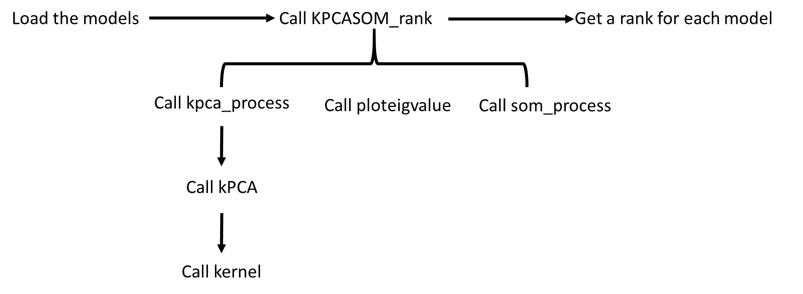

For the example of Libyan reservoir case, there are 314,325 cells. Since it takes time to finish this process and the files are too large, we did not include them here. The results of spatial ranks are included in *PriorParameters_Spatial.dat* in *InputData* directory. In order to obtain sensitivity, the file loaded should be changed from ‘PriorParameters.dat’ to ‘PriorParameters_Spatial.dat in main_DGSA_Reservoir_Sensitivity.m in the upper directory.