23/FA-COSC-2403-FA01 Object – oriented Analysis / Design

Professor Han-Chieh Wei

11 / 29 / 2023

**Project**

3. How many rooms are in the scenario?

5 rooms. Specifically, there are pub, outside, theater, lab, and office.

4. Draw a map of the rooms.

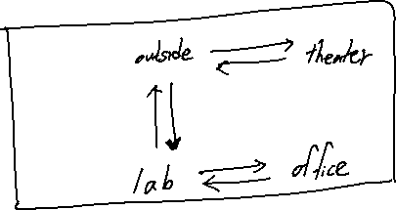

Updated rooms

