Supplementary Materials

##### Supplementary Text 1: Intraclass Correlation Coefficient (ICC) Computation

### To assess the reliability of ratings across raters, we estimated the ICC using a variance components model implemented via the *‘fitVCA()’* function in R. The model specified participant and each item (e.g., each image) as crossed random effects, with an interaction term (subject × item) representing person-specific variability across items, and rater as an additional random error:

### Variance components were extracted from the resulting ANOVA table, and a single-measure, consistency-type ICC was computed to quantify the proportion of variance attributable to true person-by-item differences, relative to residual error variance. We computed the single-measure consistency ICC as:

where and denote the subject and subject-by-item variance components, respectively, and represents residual error variance. This formulation assesses the consistency of ratings across raters (GPT vs. average human ratings) while ignoring any overall mean differences between them. An ICC value approaching 1.0 indicates that most observed variance reflects stable between-subject and subject-by-item differences rather than random measurement error.

##### Supplementary Text 2: Lexicon-Based Approach to Compute Abstractness vs. Concreteness

### To further validate GPT-rated relative abstractness scores, we compared the scores with publically available concreteness ratings (as opposed to abstractness) collected by Brysbaert et al. (2014) on 40,000 English words. Brysbaert et al. (2014) recruited human participants to rate concreteness for each of the 40,000 English words on a Likert scale of 5 (1 - “abstract (language-based)” to 5 - “concrete (experience-based)”). We tokenized each of the written interpretations in both pilot and confirmatory data, and each word was converted to a corresponding Brysbaert et al. (2014) concreteness score if the word and its corresponding score were included in the list of 40,000 English words (NA if not included). We computed the mean concreteness score of each text response. Brysbaert et al. (2014) concreteness scores were used for validation purposes only. To be consistent with our pre-registration and the main focus of this project, we did not use the lexicon-based approach scores to test our main hypotheses.

##### Supplementary Text 3: PCA Loadings

### We computed PCA loadings using BDI-II, STAI-S short form, and STAI-T short form scores for the pilot and confirmatory datasets. Because PCA loadings vary with sample size and data-specific score distributions, we combined the two datasets to compute overall PCA loadings for the final analyses. To ensure our findings were not specific to these particular PCA loadings, we validated them using an external dataset (n = 440) from the same laboratory that had collected BDI-II, STAI-S short form, and STAI-T short form scores for a different study. We recomputed PCA loadings using this external dataset, applied the external loadings to estimate individual component scores in our dataset, and re-ran the primary analyses (Tables S8-14).

##### Figure S1

#### Mean Word Count Increases as Scenarios Become Clearer in Both Pilot and Confirmatory Data

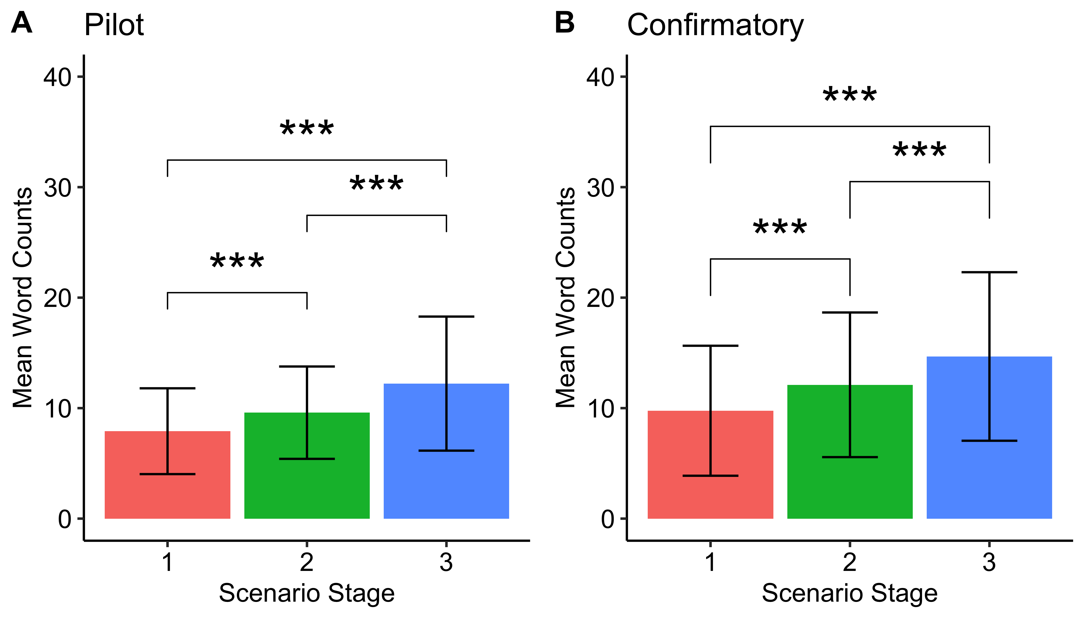 *Note*. As pre-registered, mean word counts per scenario stage gradually increased in both (A) pilot and (B) confirmatory datasets (Stage 1 = 80% blur, Stage 2 = 20% blur, Stage 3 = 0% blur). When scenarios became clearer, participants wrote more words to describe what seemed to be happening. *\* p < .05, ** p < .01, *** p < .001.*

##### Figure S2

#### Mean Negativity Increases as Scenarios Become Clearer in Negative Scenarios and Decreases in Positive/Neutral Scenarios in Both Pilot and Confirmatory Data

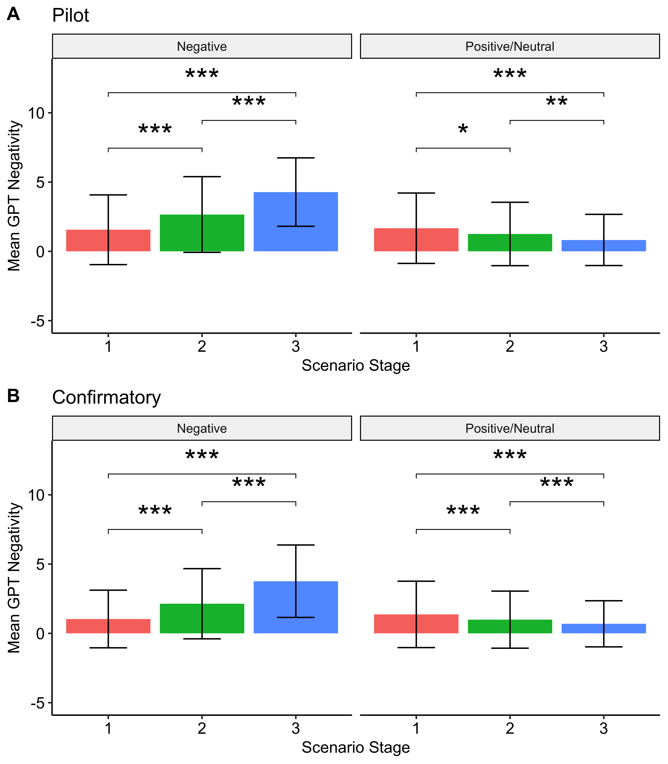 *Note.* As pre-registered, mean GPT-rated negativity per scenario stage gradually increased in a valence-congruent way in both (A) pilot and (B) confirmatory datasets (Stage 1 = 80% blur, Stage 2 = 20% blur, Stage 3 = 0% blur). For negative scenarios, mean GPT-rated negativity scores increased as the scenarios became clearer, whereas for positive/neutral scenarios, mean GPT-rated negativity scores decreased as the scenarios became clearer. *\* p < .05, ** p < .01, *** p < .001.*

##### Figure S3

#### Mean Relative Abstractness Increases as Scenarios Become Clearer in Both Pilot and Confirmatory Data

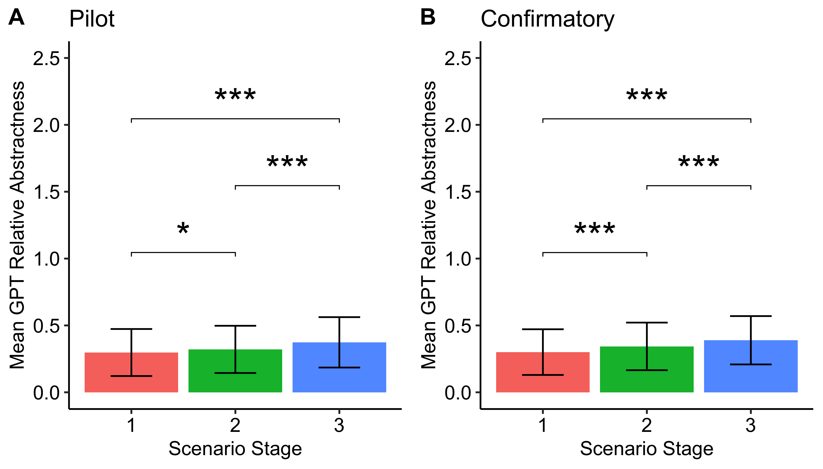 *Note*. Mean GPT-rated relative abstractness score per scenario stage significantly increased in both (A) pilot and (B) confirmatory datasets (Stage 1 = 80% blur, Stage 2 = 20% blur, Stage 3 = 0% blur). *\* p < .05, ** p < .01, *** p < .001.*

##### Figure S4

#### Mean Human-Rated Negativity and Realtive Abstractness Increase as Scenarios Become Clearer (Pilot Data Only)

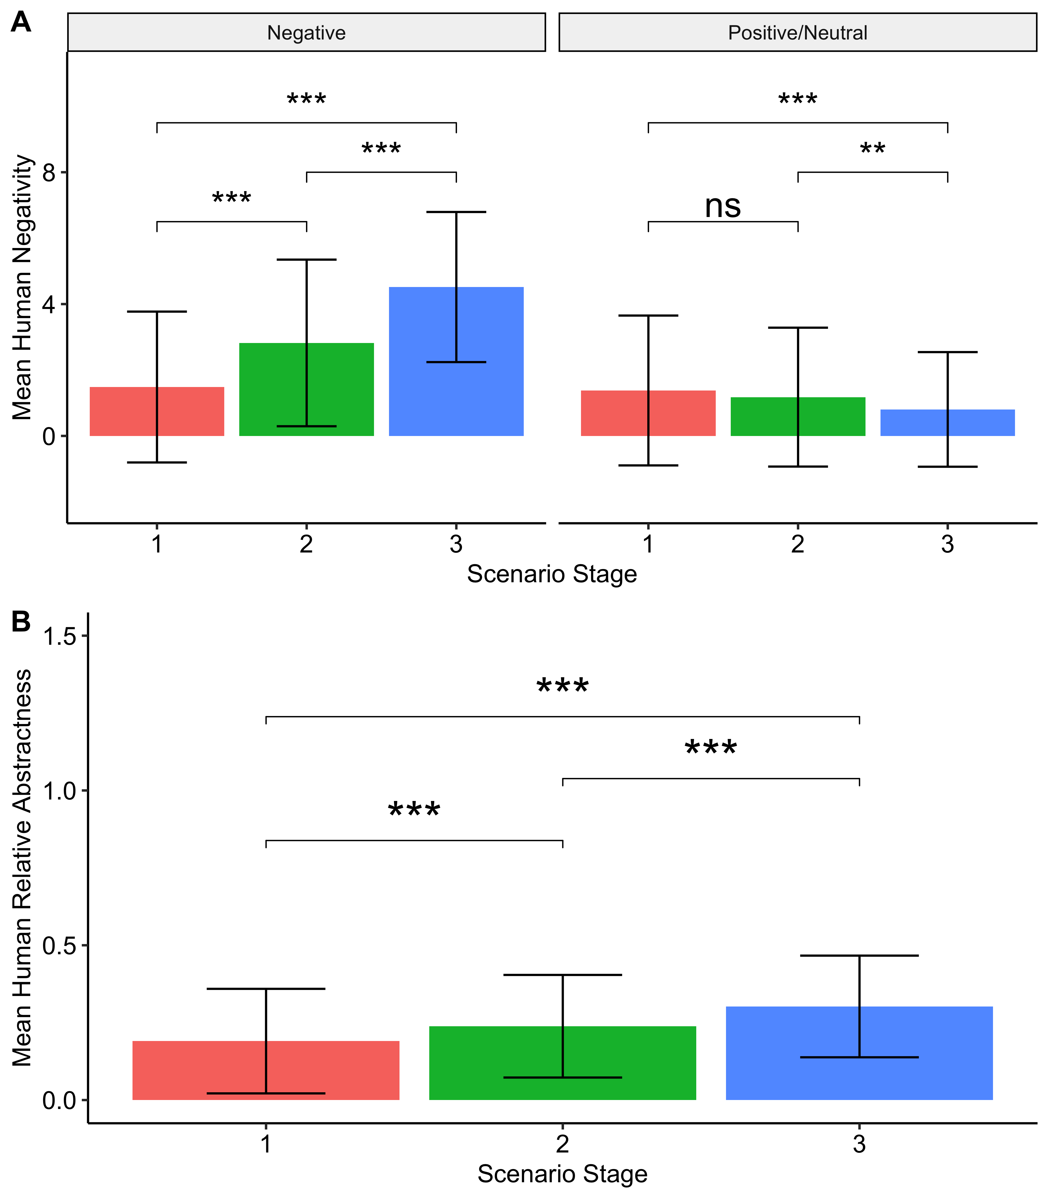 *Note*. Mean human-rated negativity (A) and relative abstractness (B) scores per scenario stage significantly increased in pilot data as blur decreased (Stage 1 = 80% blur, Stage 2 = 20% blur, Stage 3 = 0% blur). (A) Mean human-rated negativity ratings increased as scenarios became clearer in a valence-congruent way, replicating GPT-rated negativity patterns. (B) Mean human-rated relative abstractness increased as scenarios revealed more detail. *\* p < .05, ** p < .01, *** p < .001.*

##### Figure S5

#### Mean Negativity and Relative Abstractness Vary by Scenario Item

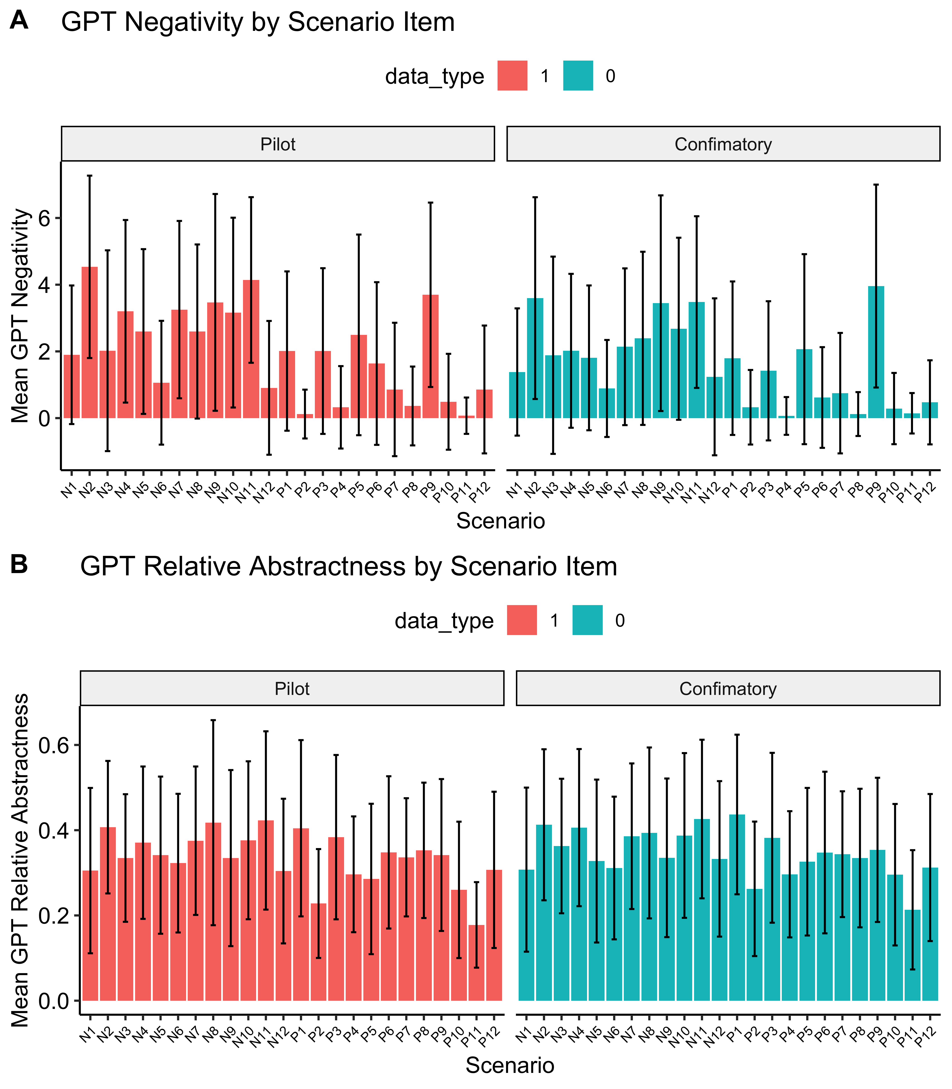 *Note*. Mean negativity (A) and relative abstractness (B) scores varied significantly based on scenario item in both pilot and confirmatory data. Each bar represents the mean score for a scenario item, averaged across its three stages.

##### Figure S6

#### Trait Internalizing Symptoms Related to Greater Negativity for Negative and Clearer Scenarios

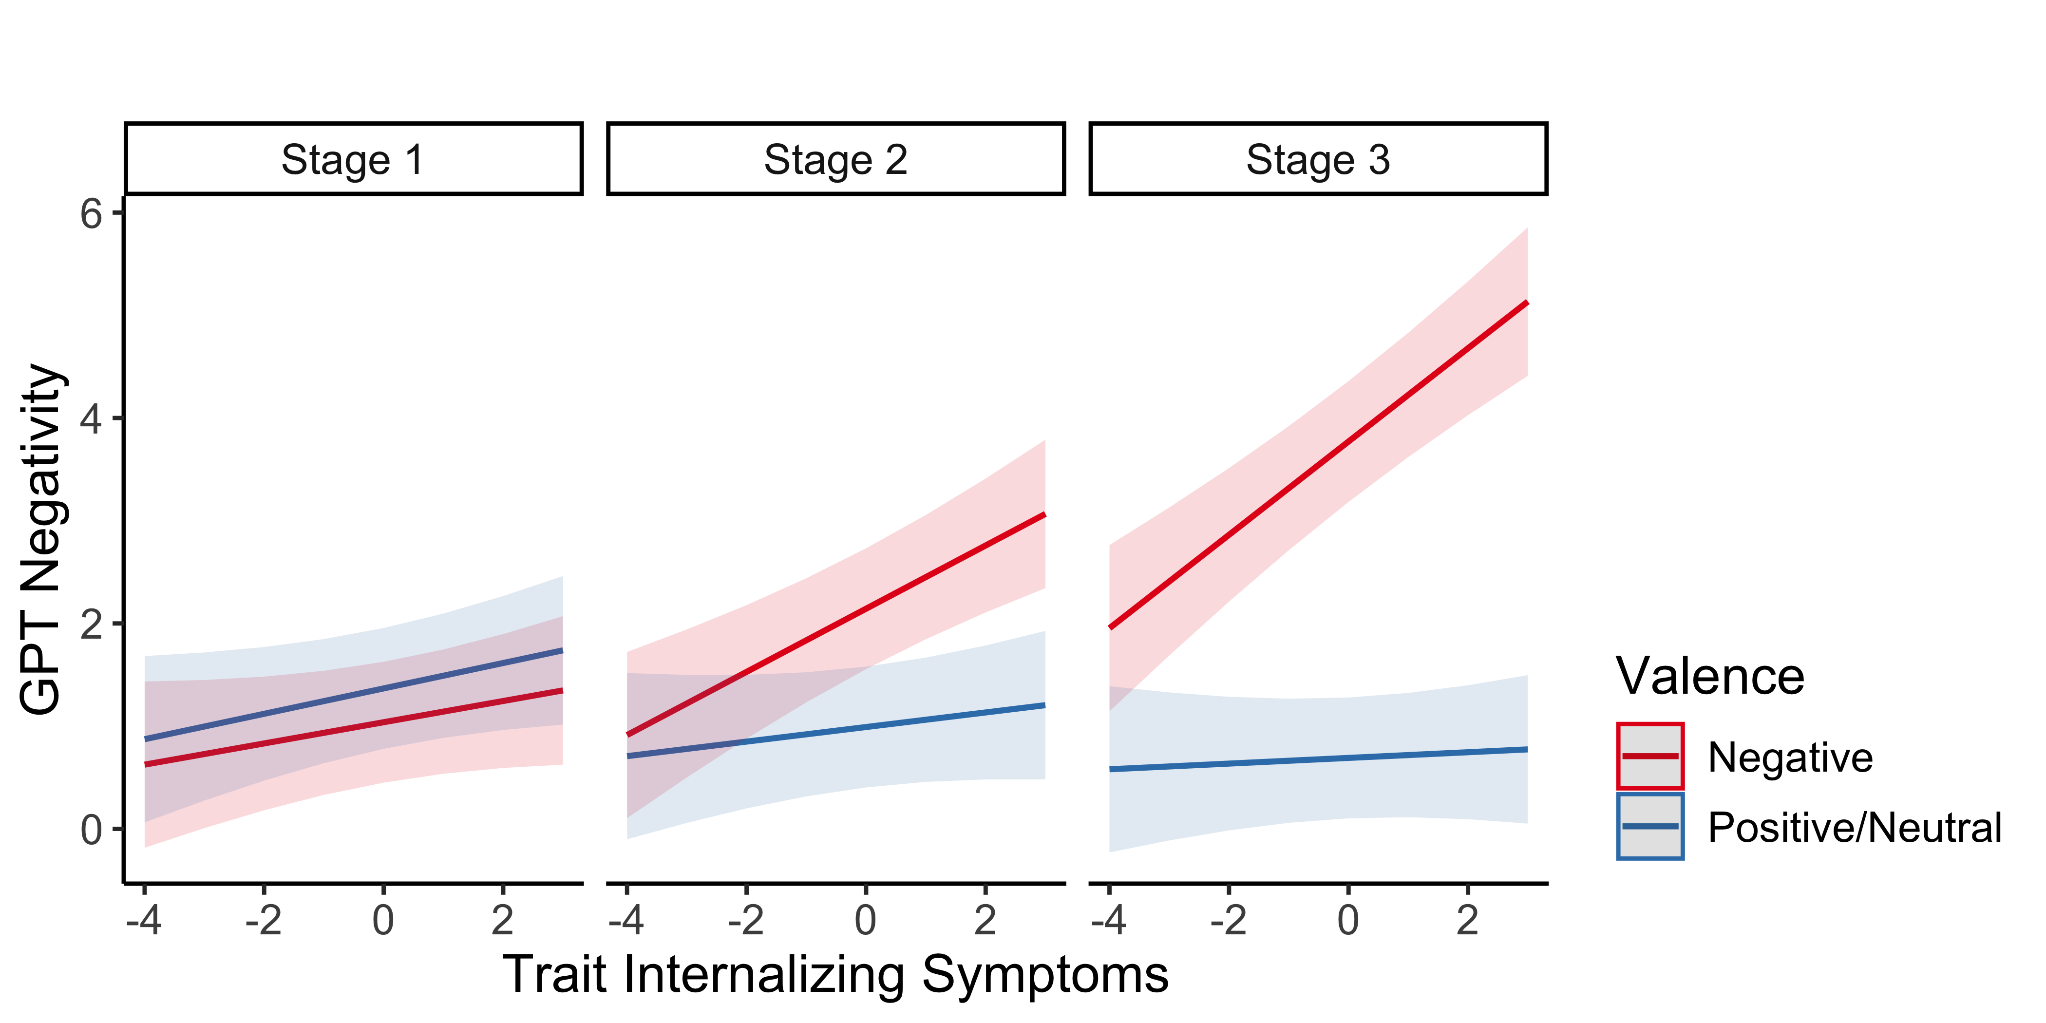 *Note*. Trait internalizing symptoms were associated with GPT-rated negativity scores, with effects moderated by scenario valence and stage (blur level). The association between symptoms and negativity ratings was stronger for negative scenarios than positive/neutral scenarios, and this valence effect was more pronounced at clearer stages (Stages 2 and 3) compared the most ambiguous stage (Stage 1). *\* p < .05, ** p < .01, *** p < .001.*

##### Figure S7

#### Higher Trait Internalizing Symptoms (Using External PCA Loadings) Associated with Greater Increases in Relative Abstractness

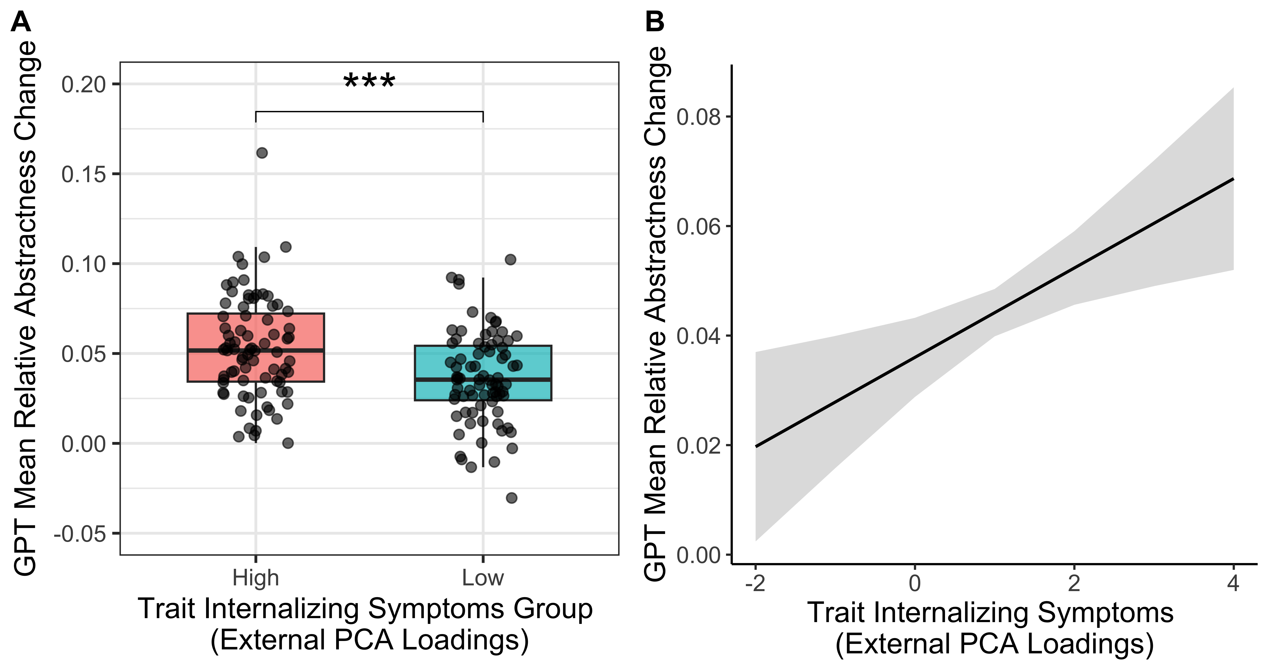 *Note*. Using external PCA loadings, we replicated the findings reported in Figure 3. (A) The high trait internalizing group (median split for visualization) showed a significantly greater increase in mean GPT-rated relative abstractness than the low trait internalizing group. The height of each box represents the 25th and 75th percentiles of the data, and the middle line within each box represents the median for each group. (B) Higher trait internalizing symptoms were associated with greater increases in mean GPT-rated relative abstractness in a linear regression analysis. Shaded areas represent 95% confidence intervals around predicted values. p values indicated are from the corresponding analyses. *\* p < .05; ** p < .01; *** p < .001.*

##### Table S1

#### Full Regression Results for Trait Internalizing Symptoms Predicting Negativity

(#tab:table s1)

**

| Term |  | 95% CI |  |  |  |
| --- | --- | --- | --- | --- | --- |
| Intercept | 0.02 | [-0.52, 0.57] | 0.08 | 64.41 | .933 |
| Trait Internalizing Score | 0.11 | [0.03, 0.20] | 2.58 | 145.79 | .011 |
| Word Counts | 0.02 | [0.02, 0.03] | 8.66 | 2,347.33 | < .001 |
| Age | -0.01 | [-0.02, 0.00] | -3.00 | 143.46 | .003 |
| Gender | 0.06 | [-0.07, 0.19] | 0.89 | 143.68 | .377 |
| Education | -0.02 | [-0.08, 0.03] | -0.86 | 144.25 | .393 |
| GPT Relative Abstractness | 4.84 | [4.60, 5.08] | 39.53 | 7,837.37 | < .001 |

##### Table S2

#### Full Regression Results for Trait Internalizing Symptoms Predicting Negativity with Valence Moderation Term

(#tab:table s2)

**

| Term |  | 95% CI |  |  |  |
| --- | --- | --- | --- | --- | --- |
| Intercept | 0.56 | [-0.06, 1.18] | 1.78 | 47.41 | .082 |
| Trait Internalizing Score | 0.22 | [0.12, 0.32] | 4.40 | 225.02 | < .001 |
| Scenario Valence Positive/Neutral | -1.07 | [-1.79, -0.35] | -2.92 | 22.00 | .008 |
| Word Counts | 0.02 | [0.02, 0.03] | 8.59 | 2,347.21 | < .001 |
| Age | -0.01 | [-0.02, 0.00] | -3.00 | 143.59 | .003 |
| Gender | 0.06 | [-0.07, 0.19] | 0.89 | 143.82 | .377 |
| Education | -0.02 | [-0.08, 0.03] | -0.85 | 144.39 | .394 |
| GPT Relative Abstractness | 4.84 | [4.60, 5.08] | 39.57 | 7,838.98 | < .001 |
| Trait Internalizing Score Scenario Valence Positive/Neutral | -0.21 | [-0.29, -0.12] | -4.73 | 11,166.89 | < .001 |

##### Table S3

#### Full Regression Results for Trait Internalizing Symptoms Predicting Negativity with Stage Moderation Term

(#tab:table s3)

**

| Term |  | 95% CI |  |  |  |
| --- | --- | --- | --- | --- | --- |
| Intercept | 0.00 | [-0.54, 0.54] | -0.01 | 59.47 | .995 |
| Trait Internalizing Score | 0.11 | [0.01, 0.21] | 2.11 | 353.56 | .035 |
| Scenario Stage 2 | 0.13 | [0.04, 0.22] | 2.83 | 11,302.47 | .005 |
| Scenario Stage 3 | 0.54 | [0.44, 0.64] | 11.03 | 10,944.02 | < .001 |
| Word Counts | 0.01 | [0.01, 0.02] | 4.57 | 1,741.86 | < .001 |
| Age | -0.01 | [-0.02, 0.00] | -3.18 | 148.48 | .002 |
| Gender | 0.06 | [-0.06, 0.19] | 0.98 | 148.74 | .328 |
| Education | -0.02 | [-0.07, 0.03] | -0.63 | 149.45 | .528 |
| GPT Relative Abstractness | 4.59 | [4.35, 4.83] | 37.18 | 7,359.05 | < .001 |
| Trait Internalizing Score Scenario Stage 2 | 0.02 | [-0.08, 0.13] | 0.41 | 11,171.74 | .680 |
| Trait Internalizing Score Scenario Stage 3 | 0.05 | [-0.05, 0.16] | 0.94 | 11,181.90 | .346 |

##### Table S4

#### Full Regression Results for Trait Internalizing Symptoms Predicting Negativity with Valence and Stage Moderation Terms

(#tab:table s4)

**

| Term |  | 95% CI |  |  |  |
| --- | --- | --- | --- | --- | --- |
| Intercept | 0.07 | [-0.55, 0.68] | 0.21 | 42.87 | .831 |
| Trait Internalizing Score | 0.12 | [0.00, 0.25] | 2.01 | 785.03 | .044 |
| Scenario Valence Positive/Neutral | 0.26 | [-0.47, 1.00] | 0.70 | 22.78 | .490 |
| Scenario Stage 2 | 0.80 | [0.68, 0.93] | 13.02 | 11,271.43 | < .001 |
| Scenario Stage 3 | 2.09 | [1.96, 2.21] | 31.76 | 11,139.45 | < .001 |
| Word Counts | 0.01 | [0.00, 0.01] | 2.77 | 1,856.04 | .006 |
| Age | -0.01 | [-0.02, 0.00] | -3.22 | 151.69 | .002 |
| Gender | 0.07 | [-0.05, 0.20] | 1.15 | 151.95 | .254 |
| Education | -0.01 | [-0.06, 0.04] | -0.39 | 152.67 | .698 |
| GPT Relative Abstractness | 3.96 | [3.72, 4.19] | 33.17 | 7,503.09 | < .001 |
| Trait Internalizing Score Scenario Valence Positive/Neutral | -0.02 | [-0.16, 0.12] | -0.25 | 11,167.59 | .802 |
| Trait Internalizing Score Scenario Stage 2 | 0.14 | [-0.01, 0.28] | 1.88 | 11,169.34 | .060 |
| Trait Internalizing Score Scenario Stage 3 | 0.25 | [0.11, 0.39] | 3.47 | 11,175.68 | < .001 |
| Scenario Valence Positive/Neutral Scenario Stage 2 | -1.26 | [-1.43, -1.09] | -14.66 | 11,179.52 | < .001 |
| Scenario Valence Positive/Neutral Scenario Stage 3 | -2.91 | [-3.08, -2.74] | -33.39 | 11,239.55 | < .001 |
| Trait Internalizing Score Scenario Valence Positive/Neutral Scenario Stage 2 | -0.21 | [-0.41, -0.01] | -2.06 | 11,167.05 | .039 |
| Trait Internalizing Score Scenario Valence Positive/Neutral Scenario Stage 3 | -0.37 | [-0.57, -0.17] | -3.65 | 11,167.66 | < .001 |

#### Regression Results for Other Symptoms Predicting Negativity with Stage Moderation Term

##### Table S5

#### Full Regression Results for Trait Internalizing Symptoms Predicting Relative Abstractness

(#tab:table s5)

**

| Term |  | 95% CI |  |  |  |
| --- | --- | --- | --- | --- | --- |
| Intercept | 0.20 | [0.14, 0.27] | 6.14 | 169.88 | < .001 |
| Trait Internalizing Score | -0.01 | [-0.02, 0.01] | -0.67 | 152.86 | .501 |
| Word Counts | 0.00 | [0.00, 0.00] | 18.17 | 10,642.70 | < .001 |
| Age | 0.00 | [0.00, 0.00] | 0.83 | 152.30 | .407 |
| Gender | 0.01 | [-0.01, 0.04] | 0.98 | 152.30 | .328 |
| Education | 0.00 | [-0.01, 0.01] | 0.79 | 152.44 | .428 |
| GPT Negativity | 0.02 | [0.02, 0.02] | 38.68 | 11,109.41 | < .001 |

##### Table S6

#### Full Regression Results for Trait Internalizing Symptoms Predicting Relative Abstractness with Valence Moderation Term

(#tab:table s6)

**

| Term |  | 95% CI |  |  |  |
| --- | --- | --- | --- | --- | --- |
| Intercept | 0.20 | [0.14, 0.27] | 6.01 | 175.91 | < .001 |
| Trait Internalizing Score | -0.01 | [-0.02, 0.01] | -1.02 | 164.35 | .311 |
| Scenario Valence Positive/Neutral | -0.01 | [-0.04, 0.03] | -0.33 | 22.09 | .744 |
| Word Counts | 0.00 | [0.00, 0.00] | 18.18 | 10,640.20 | < .001 |
| Age | 0.00 | [0.00, 0.00] | 0.83 | 152.29 | .406 |
| Gender | 0.01 | [-0.01, 0.04] | 0.98 | 152.29 | .328 |
| Education | 0.00 | [-0.01, 0.01] | 0.79 | 152.44 | .428 |
| GPT Negativity | 0.02 | [0.02, 0.02] | 38.66 | 11,204.97 | < .001 |
| Trait Internalizing Score Scenario Valence Positive/Neutral | 0.01 | [0.00, 0.01] | 1.88 | 11,174.66 | .060 |

##### Table S7

#### Full Regression Results for Trait Internalizing Symptoms Predicting Relative Abstractness with Stage Moderation Term

(#tab:table s7)

**

| Term |  | 95% CI |  |  |  |
| --- | --- | --- | --- | --- | --- |
| Intercept | 0.19 | [0.13, 0.26] | 5.88 | 171.07 | < .001 |
| Trait Internalizing Score | -0.01 | [-0.02, 0.01] | -1.09 | 176.17 | .279 |
| Scenario Stage 2 | 0.03 | [0.02, 0.03] | 8.93 | 11,210.30 | < .001 |
| Scenario Stage 3 | 0.05 | [0.04, 0.06] | 14.99 | 11,299.43 | < .001 |
| Word Counts | 0.00 | [0.00, 0.00] | 11.36 | 10,307.21 | < .001 |
| Age | 0.00 | [0.00, 0.00] | 0.80 | 152.66 | .423 |
| Gender | 0.01 | [-0.01, 0.04] | 0.99 | 152.66 | .322 |
| Education | 0.00 | [-0.01, 0.01] | 0.94 | 152.83 | .349 |
| GPT Negativity | 0.02 | [0.02, 0.02] | 36.36 | 11,097.80 | < .001 |
| Trait Internalizing Score Scenario Stage 2 | 0.01 | [0.00, 0.02] | 2.24 | 11,172.19 | .025 |
| Trait Internalizing Score Scenario Stage 3 | 0.01 | [0.00, 0.02] | 2.58 | 11,174.55 | .010 |

##### Table S8

#### External PCA Loadings Replicate Full Regression Results for Trait Internalizing Symptoms Predicting Negativity

(#tab:table s8)

**

| Term |  | 95% CI |  |  |  |
| --- | --- | --- | --- | --- | --- |
| Intercept | -0.11 | [-0.67, 0.44] | -0.40 | 68.02 | .689 |
| External Trait Internalizing Score | 0.12 | [0.03, 0.22] | 2.62 | 145.92 | .010 |
| Word Counts | 0.02 | [0.02, 0.03] | 8.63 | 2,356.42 | < .001 |
| Age | -0.01 | [-0.02, 0.00] | -2.97 | 143.31 | .003 |
| Gender | 0.06 | [-0.07, 0.19] | 0.89 | 143.54 | .377 |
| Education | -0.02 | [-0.08, 0.03] | -0.85 | 144.12 | .394 |
| GPT Relative Abstractness | 4.84 | [4.60, 5.08] | 39.54 | 7,826.22 | < .001 |

##### Table S9

#### External PCA Loadings Replicate Full Regression Results for Trait Internalizing Symptoms Predicting Negativity with Valence Moderation Term

(#tab:table s9)

**

| Term |  | 95% CI |  |  |  |
| --- | --- | --- | --- | --- | --- |
| Intercept | 0.31 | [-0.32, 0.94] | 0.95 | 50.27 | .346 |
| External Trait Internalizing Score | 0.24 | [0.13, 0.34] | 4.43 | 225.32 | < .001 |
| Scenario Valence Positive/Neutral | -0.84 | [-1.56, -0.11] | -2.26 | 22.82 | .034 |
| Word Counts | 0.02 | [0.02, 0.03] | 8.56 | 2,356.65 | < .001 |
| Age | -0.01 | [-0.02, 0.00] | -2.97 | 143.44 | .003 |
| Gender | 0.06 | [-0.07, 0.19] | 0.89 | 143.67 | .377 |
| Education | -0.02 | [-0.08, 0.03] | -0.85 | 144.25 | .395 |
| GPT Relative Abstractness | 4.84 | [4.60, 5.08] | 39.58 | 7,828.30 | < .001 |
| External Trait Internalizing Score Scenario Valence Positive/Neutral | -0.22 | [-0.31, -0.13] | -4.70 | 11,166.57 | < .001 |

##### Table S10

#### External PCA Loadings Replicate Full Regression Results for Trait Internalizing Symptoms Predicting Negativity with Stage Moderation Term

(#tab:table s10)

**

| Term |  | 95% CI |  |  |  |
| --- | --- | --- | --- | --- | --- |
| Intercept | -0.13 | [-0.68, 0.42] | -0.47 | 64.83 | .642 |
| External Trait Internalizing Score | 0.12 | [0.01, 0.23] | 2.10 | 354.45 | .036 |
| Scenario Stage 2 | 0.10 | [-0.05, 0.25] | 1.28 | 11,214.38 | .200 |
| Scenario Stage 3 | 0.48 | [0.33, 0.63] | 6.21 | 11,312.59 | < .001 |
| Word Counts | 0.01 | [0.01, 0.02] | 4.53 | 1,745.01 | < .001 |
| Age | -0.01 | [-0.02, 0.00] | -3.14 | 148.37 | .002 |
| Gender | 0.06 | [-0.06, 0.19] | 0.98 | 148.63 | .329 |
| Education | -0.02 | [-0.07, 0.04] | -0.63 | 149.36 | .533 |
| GPT Relative Abstractness | 4.59 | [4.35, 4.83] | 37.19 | 7,338.71 | < .001 |
| External Trait Internalizing Score Scenario Stage 2 | 0.03 | [-0.08, 0.14] | 0.54 | 11,171.92 | .590 |
| External Trait Internalizing Score Scenario Stage 3 | 0.06 | [-0.05, 0.17] | 1.00 | 11,183.35 | .315 |

##### Table S11

#### External PCA Loadings Replicate Full Regression Results for Trait Internalizing Symptoms Predicting Negativity with Valence and Stage Moderation Terms

(#tab:table s11)

**

| Term |  | 95% CI |  |  |  |
| --- | --- | --- | --- | --- | --- |
| Intercept | -0.07 | [-0.70, 0.56] | -0.21 | 47.30 | .832 |
| External Trait Internalizing Score | 0.12 | [-0.01, 0.25] | 1.86 | 788.18 | .064 |
| Scenario Valence Positive/Neutral | 0.26 | [-0.49, 1.02] | 0.69 | 24.96 | .499 |
| Scenario Stage 2 | 0.63 | [0.43, 0.83] | 6.20 | 11,197.43 | < .001 |
| Scenario Stage 3 | 1.78 | [1.57, 1.98] | 17.10 | 11,295.65 | < .001 |
| Word Counts | 0.01 | [0.00, 0.01] | 2.74 | 1,859.88 | .006 |
| Age | -0.01 | [-0.02, 0.00] | -3.19 | 151.62 | .002 |
| Gender | 0.07 | [-0.05, 0.20] | 1.14 | 151.89 | .255 |
| Education | -0.01 | [-0.06, 0.04] | -0.38 | 152.62 | .703 |
| GPT Relative Abstractness | 3.96 | [3.72, 4.19] | 33.18 | 7,483.76 | < .001 |
| External Trait Internalizing Score Scenario Valence Positive/Neutral | 0.00 | [-0.15, 0.15] | 0.00 | 11,167.39 | .998 |
| External Trait Internalizing Score Scenario Stage 2 | 0.16 | [0.01, 0.31] | 2.08 | 11,169.48 | .038 |
| External Trait Internalizing Score Scenario Stage 3 | 0.29 | [0.14, 0.44] | 3.77 | 11,176.14 | < .001 |
| Scenario Valence Positive/Neutral Scenario Stage 2 | -1.01 | [-1.29, -0.72] | -6.99 | 11,169.37 | < .001 |
| Scenario Valence Positive/Neutral Scenario Stage 3 | -2.45 | [-2.73, -2.16] | -16.95 | 11,189.66 | < .001 |
| External Trait Internalizing Score Scenario Valence Positive/Neutral Scenario Stage 2 | -0.24 | [-0.45, -0.03] | -2.20 | 11,166.96 | .028 |
| External Trait Internalizing Score Scenario Valence Positive/Neutral Scenario Stage 3 | -0.44 | [-0.65, -0.22] | -4.00 | 11,167.41 | < .001 |

##### Table S12

#### External PCA Loadings Replicate Full Regression Results for Trait Internalizing Symptoms Predicting Relative Abstractness

(#tab:table s12)

**

| Term |  | 95% CI |  |  |  |
| --- | --- | --- | --- | --- | --- |
| Intercept | 0.21 | [0.14, 0.28] | 6.10 | 168.18 | < .001 |
| External Trait Internalizing Score | -0.01 | [-0.02, 0.01] | -0.79 | 152.93 | .428 |
| Word Counts | 0.00 | [0.00, 0.00] | 18.17 | 10,649.90 | < .001 |
| Age | 0.00 | [0.00, 0.00] | 0.83 | 152.31 | .408 |
| Gender | 0.01 | [-0.01, 0.04] | 0.99 | 152.31 | .323 |
| Education | 0.00 | [-0.01, 0.01] | 0.78 | 152.45 | .439 |
| GPT Negativity | 0.02 | [0.02, 0.02] | 38.68 | 11,109.54 | < .001 |

##### Table S13

#### External PCA Loadings Replicate Full Regression Results for Trait Internalizing Symptoms Predicting Relative Abstractness with Valence Moderation Term

(#tab:table s13)

**

| Term |  | 95% CI |  |  |  |
| --- | --- | --- | --- | --- | --- |
| Intercept | 0.21 | [0.15, 0.28] | 6.08 | 175.76 | < .001 |
| External Trait Internalizing Score | -0.01 | [-0.03, 0.01] | -1.13 | 164.45 | .259 |
| Scenario Valence Positive/Neutral | -0.01 | [-0.05, 0.02] | -0.70 | 23.93 | .489 |
| Word Counts | 0.00 | [0.00, 0.00] | 18.19 | 10,647.41 | < .001 |
| Age | 0.00 | [0.00, 0.00] | 0.83 | 152.30 | .408 |
| Gender | 0.01 | [-0.01, 0.04] | 0.99 | 152.31 | .323 |
| Education | 0.00 | [-0.01, 0.01] | 0.77 | 152.45 | .440 |
| GPT Negativity | 0.02 | [0.02, 0.02] | 38.66 | 11,205.11 | < .001 |
| External Trait Internalizing Score Scenario Valence Positive/Neutral | 0.01 | [0.00, 0.01] | 1.87 | 11,174.65 | .061 |

##### Table S14

#### External PCA Loadings Replicate Full Regression Results for Trait Internalizing Symptoms Predicting Relative Abstractness with Stage Moderation Term

(#tab:table s14)

**

| Term |  | 95% CI |  |  |  |
| --- | --- | --- | --- | --- | --- |
| Intercept | 0.20 | [0.14, 0.27] | 5.96 | 171.20 | < .001 |
| External Trait Internalizing Score | -0.01 | [-0.03, 0.01] | -1.22 | 176.24 | .224 |
| Scenario Stage 2 | 0.02 | [0.01, 0.03] | 3.56 | 11,182.36 | < .001 |
| Scenario Stage 3 | 0.04 | [0.03, 0.05] | 7.44 | 11,216.39 | < .001 |
| Word Counts | 0.00 | [0.00, 0.00] | 11.34 | 10,317.71 | < .001 |
| Age | 0.00 | [0.00, 0.00] | 0.80 | 152.66 | .423 |
| Gender | 0.01 | [-0.01, 0.04] | 1.00 | 152.67 | .317 |
| Education | 0.00 | [-0.01, 0.01] | 0.92 | 152.83 | .358 |
| GPT Negativity | 0.02 | [0.02, 0.02] | 36.35 | 11,097.89 | < .001 |
| External Trait Internalizing Score Scenario Stage 2 | 0.01 | [0.00, 0.02] | 2.30 | 11,172.25 | .021 |
| External Trait Internalizing Score Scenario Stage 3 | 0.01 | [0.00, 0.02] | 2.73 | 11,174.90 | .006 |