JEEVA A

# PROFILE

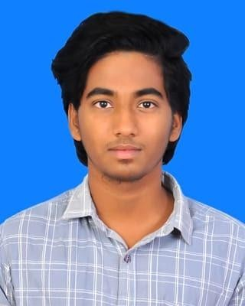

Seeking a beginner role to enhance and explore my technical knowledge gained in the last three years. Eager to use my skills and to keep the team up and running.

# CONTACT

PHONE:

+91 63832 74868

EMAIL:

[jiiva0212@gmail.com](mailto:jiiva0212@gmail.com)

# HOBBIES

Watching movies, Listening music, Diary Writing

# INTEREST

To work with productivity application, and collaboration software

### EDUCATION

#### Hindusthan College Of Engineering And Technology

2020-2024

B.E Computer Science Engineering, with 9.05 CGPA

#### PACM Boys Higher Secondary School

2019-2020

HSC,percentage – 70%

#### Maharishi Vidya Mandir School

2017 – 2018

SSLC,percentage – 74%

### CERTIFICATION

* Completion of course of Communication skills in TCS.
* Participated in Learnathon challenge of 2021 as well as 2022.
* Undergone 21 days of internship on web designing.

**SKILLS**

**Soft Skills :**

* Team work and bonding
* Work place involvement
* Problem Solving
* Innovation
* Logical thinking

## Technical Skills :

* HTML
* CSS
* Javascript - Beginner
* SQL - Beginner
* C - Intermediate
* JAVA – Intermediate