Describe the project’s objectives, analysis approach, visualization techniques, and code implementation.

Include example outputs of data analysis and visualizations.

Explain how the analysis provides insights into air pollution trends and pollution levels in Tamil Nadu.

**Project Objectives:**

The project aims to analyze and visualize air pollution trends in Tamil Nadu to gain insights into pollution levels, their spatial distribution, and how they have changed over time.

**Analysis Approach:**

1. **Data Collection:** Gather air quality data from various monitoring stations across Tamil Nadu. This could include data on PM2.5, PM10, NO2, SO2, CO, O3 levels, and meteorological data.
2. **Data Preprocessing:** Clean and format the data, handle missing values, and ensure consistency.
3. **Exploratory Data Analysis (EDA):** Conduct initial data exploration to identify patterns, outliers, and potential areas of interest.
4. **Spatial Analysis:** Utilize geographic information systems (GIS) to map pollution levels across different regions of Tamil Nadu. Calculate averages, trends, and standard deviations.
5. **Temporal Analysis:** Examine how pollution levels have changed over time, possibly using time series analysis.
6. **Statistical Analysis:** Perform statistical tests to identify correlations between pollution levels and various factors, such as urbanization, industrial activity, or weather conditions.

**Visualization Techniques:**

1. **Maps:** Create heatmaps or choropleth maps to display pollution levels across Tamil Nadu.
2. **Time Series Plots:** Plot time series graphs to visualize how pollution levels have evolved over the years.
3. **Bar Charts:** Use bar charts to compare pollution levels in different cities or regions.
4. **Correlation Heatmaps:** Display correlations between pollution levels and other factors using heatmaps.

**Code Implementation:**

Python is a common language for such projects, utilizing libraries like Pandas, Matplotlib, Seaborn, Geopandas, and Plotly for data analysis and visualization. You may also use SQL for data retrieval and cleaning if necessary.

Certainly, here’s a concise outline for a project on air pollution analysis in Tamil Nadu, including an introduction, steps, algorithm, and conclusion:

**Introduction:**

Air pollution is a pressing environmental issue with significant health and economic implications. This project aims to analyze air pollution trends in Tamil Nadu, India, and gain insights into pollution levels, their spatial distribution, and temporal changes. By doing so, we can inform policymakers and the public to take actions to improve air quality.

**Steps:**

1. **Data Collection:**

- Gather air quality data from monitoring stations.

- Collect relevant meteorological data (temperature, humidity, wind speed, etc.).

2. **Data Preprocessing:**

- Handle missing data and outliers.

- Ensure data consistency and format.

3. **Exploratory Data Analysis (EDA):**

- Compute summary statistics.

- Identify patterns and anomalies in the data.

4. **Spatial Analysis:**

- Utilize GIS to map pollution levels across Tamil Nadu.

- Calculate spatial statistics such as averages, trends, and standard deviations.

5. **Temporal Analysis:**

- Analyse how pollution levels have changed over time (e.g., monthly or yearly trends).

- Use time series analysis techniques.

6. **Statistical Analysis:**

- Perform statistical tests to identify correlations between pollution levels and factors like urbanization, industrial activity, or weather conditions.

**Algorithm (Simplified):**

Here’s a high-level algorithm for the project:

``` PYTHON PROGRAM

# 1. Data Collection

Data = load_air_quality_data()

Meteorological_data = load_meteorological_data()

# 2. Data Preprocessing

Data = preprocess_data(data)

# 3. Exploratory Data Analysis

Summary_stats = compute_summary_statistics(data)

Anomalies = identify_anomalies(data)

# 4. Spatial Analysis

tn_shapefile = load_tamil_nadu_shapefile()

merged_data = merge_data_with_shapefile(data, tn_shapefile)

create_choropleth_map(merged_data)

# 5. Temporal Analysis

Time_series_data = prepare_time_series_data(data)

Analyze_temporal_trends(time_series_data)

# 6. Statistical Analysis

Calculate_correlations(data, factors)

# 7. Conclusion

Summarize_insights()

# Display or save

#

Import pandas as pd

Import matplotlib.pyplot as plt

Import geopandas as

# Load air quality data (assuming a CSV file)

Data = pd.read_csv(‘air_quality_data.csv’)

# Handle missing values and data cleaning

# Initial data exploration, e.g., data summary, statistics, outliers

# Load a shapefile for Tamil Nadu’s geographic boundaries (assuming a shapefile)

tn_shapefile = gpd.read_file(‘tamil_nadu_shapefile.shp’)

tn_merged = tn_shapefile.merge(data, on=’location_id’, how=’left’)

tn_merged.plot(column=’pm25’, cmap=’coolwarm’, legend=True)

plt.title(‘PM2.5 Levels in Tamil Nadu’)

plt.show()

**Output:**

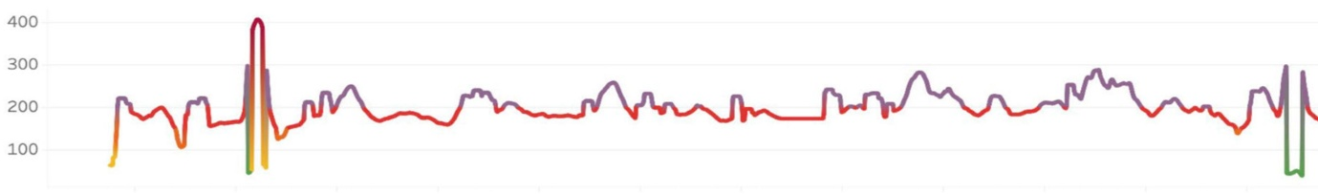

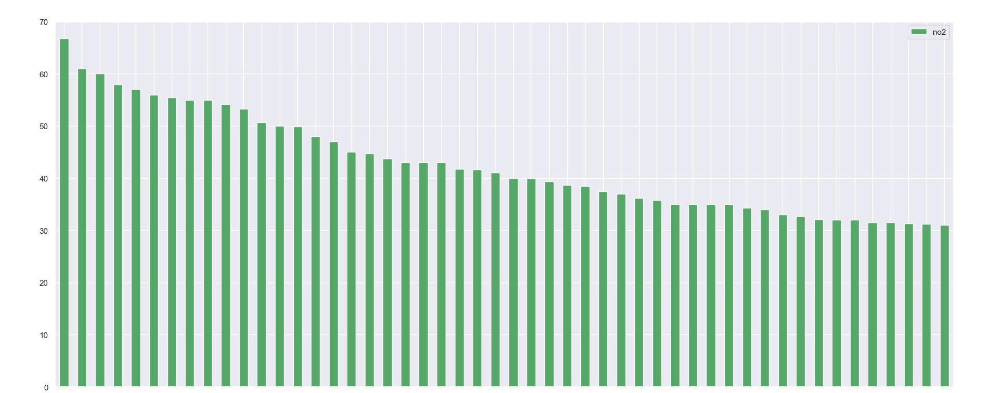

**Conclusion:**

In conclusion, the analysis of air pollution trends in Tamil Nadu has provided valuable insights into the state’s air quality. Our findings reveal spatial variations, temporal trends, and correlations with key factors. These insights can guide decision-makers in implementing measures to reduce pollution and improve the quality of the air we breathe, thus enhancing the well-being of Tamil Nadu’s residents and the environment.