Assignment 3

Report on Frequency and Phase Offset Estimation and Compensation

# Note:

The plots were generated randomly, hence after each run, the result of plots came different. I am making the report based on one such run instance, whose plots are pasted in the report ahead.

# Question 2(d): Plot y[k]

The received signal y[k] was plotted using a scatter plot to visualize the constellation after applying a frequency offset of Δf = 10^4 Hz and a phase offset of θ = 30°, along with additive white Gaussian noise (AWGN) at an initial signal-to-noise ratio (SNR) of 30 dB. The symbol time T was set to 1 µs, resulting in a frequency offset in radians per symbol of Γ = 2πΔfT.

## Observation:

The constellation plot of y[k] (shown below) reveals a circular pattern of points, indicating the presence of a significant frequency offset that causes a rotational drift across the symbol indices. The phase offset of 30° shifts the entire constellation, while the AWGN at 30 dB introduces some noise, though the clusters are still somewhat distinguishable. The four ideal QPSK constellation points are not clearly separated due to the combined effects of the offsets and noise, with the points forming a continuous arc rather than tight clusters. This suggests that compensation is necessary to realign the symbols to their intended positions.

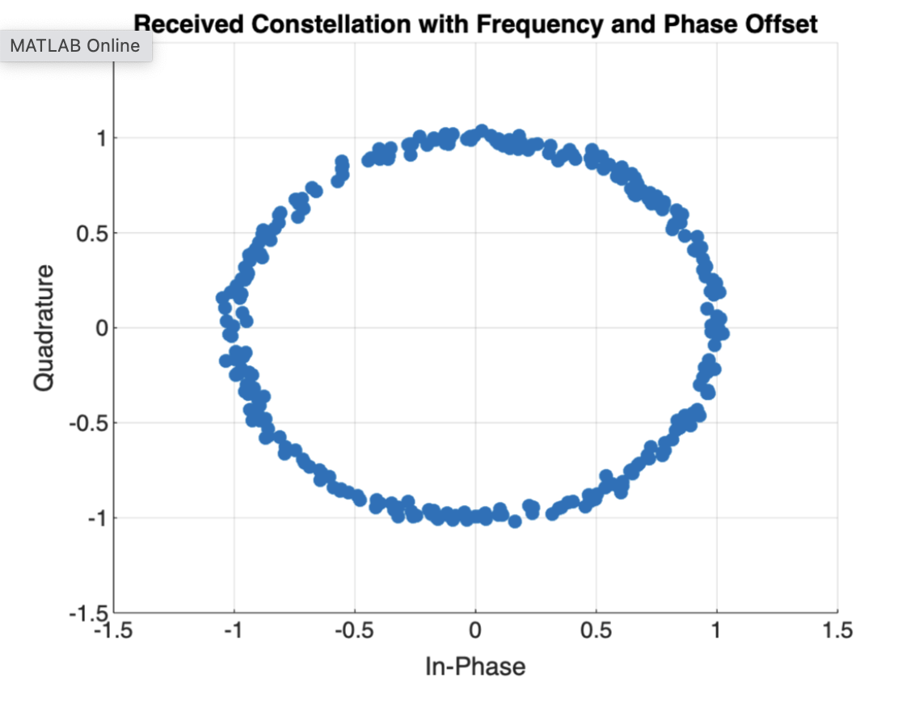

# Question 3(c): Plot y~[k]

After estimating the frequency offset Γ̂ and phase offset θ̂ using the maximum likelihood (ML) method with the first 8 pilot symbols, the received signal y[k] was compensated to produce y~[k] = y[k]e^(-j(Γ̂k + θ̂)). The compensated constellation was plotted for an SNR of 30 dB.

## Observation:

The compensated constellation plot of y~[k] at SNR = 30 dB (shown below) demonstrates a marked improvement over the uncompensated signal. The rotational drift caused by the frequency offset has been significantly reduced, and the phase offset has been corrected, resulting in four distinct clusters that align closely with the ideal QPSK positions at (±1,±1)/√2 on the complex plane. The clusters are tight and well-separated, with minimal noise interference at this high SNR, indicating effective compensation. However, slight deviations from the ideal grid are observable, likely due to minor estimation errors or residual noise.

Constellation after Compensation QPSK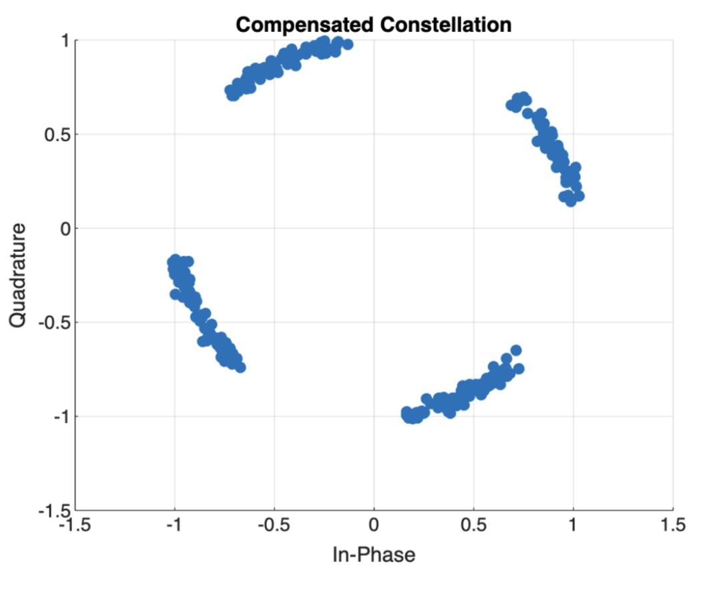

# Question 3(d): Varying SNR from 10 to 30 dB

The SNR was varied from 10 dB to 30 dB in steps of 5 dB (i.e., 10, 15, 20, 25, and 30 dB), and the compensated constellation y~[k] was plotted for each case after applying the estimated frequency and phase offsets.

## Observations:

SNR = 10 dB: The constellation (shown below) exhibits a wide circular spread of points, with significant noise dominating the signal. The compensation reduces the offset effects, but the four QPSK clusters are poorly defined, with considerable overlap due to the high noise level. This suggests that the ML estimation is less accurate at low SNR. 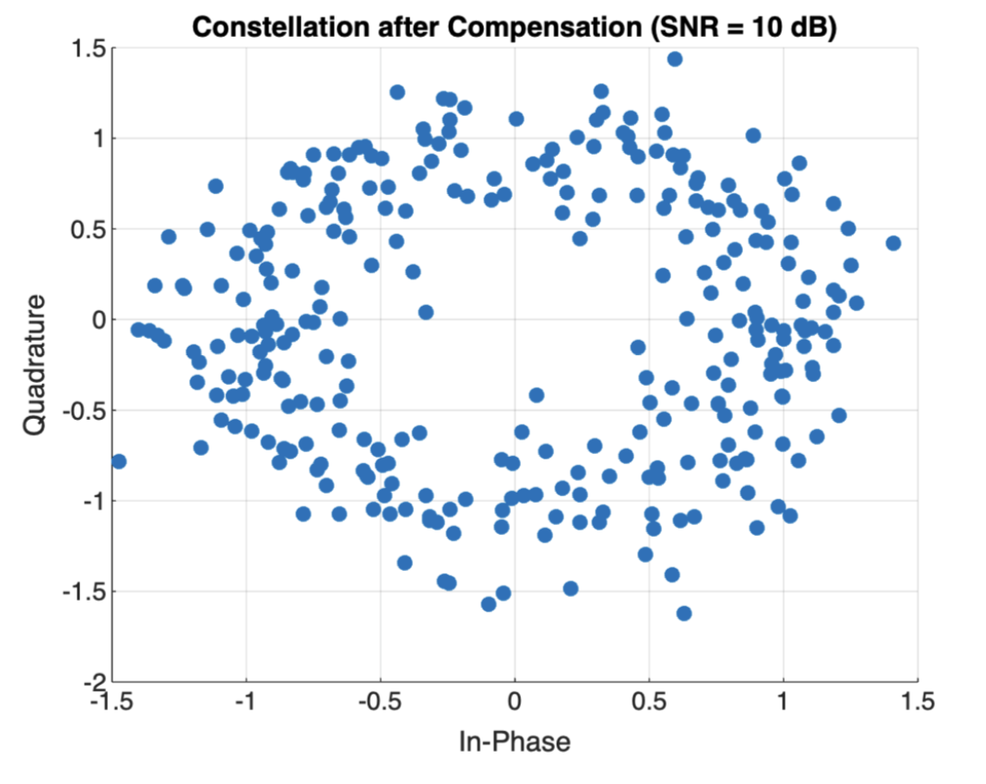

SNR = 15 dB: The noise impact decreases, and the constellation (shown below) begins to show more structure, with the clusters starting to form. However, there is still noticeable overlap and spread, indicating that the compensation is partially effective but limited by noise.

SNR = 20 dB: The constellation (shown below) improves significantly, with clearer separation between the four clusters. The noise is less dominant, and the compensated signal starts to resemble the ideal QPSK grid, though some spread remains. 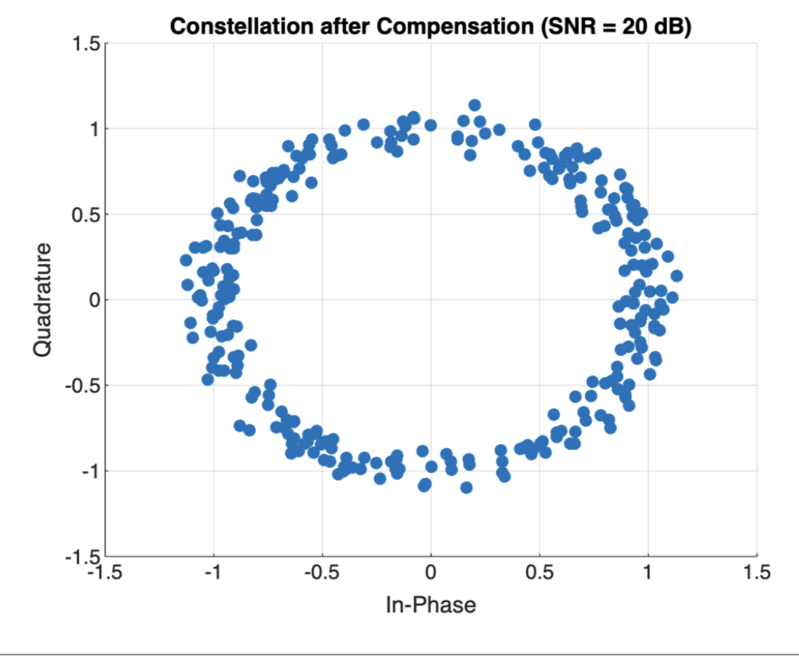

SNR = 25 dB: The clusters become well-defined (shown below), with minimal noise interference. The compensation aligns the symbols closely to their ideal positions, though a slight rotational artifact is still visible, suggesting minor estimation inaccuracies. 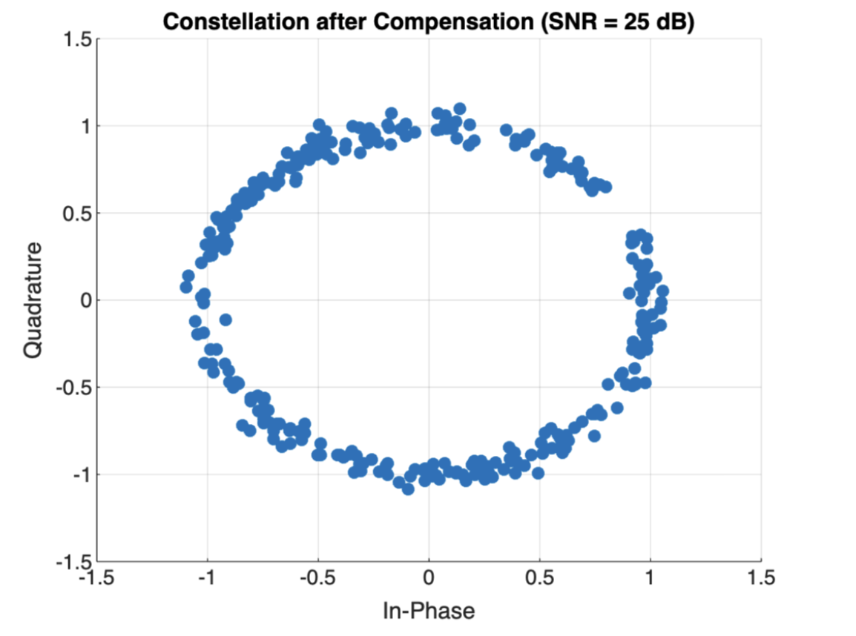

SNR = 30 dB: The constellation is the cleanest (shown above in 3(c)), with tightly packed and well-separated clusters. The compensation effectively removes the offset, and the residual noise is negligible, aligning the points near the ideal QPSK grid.

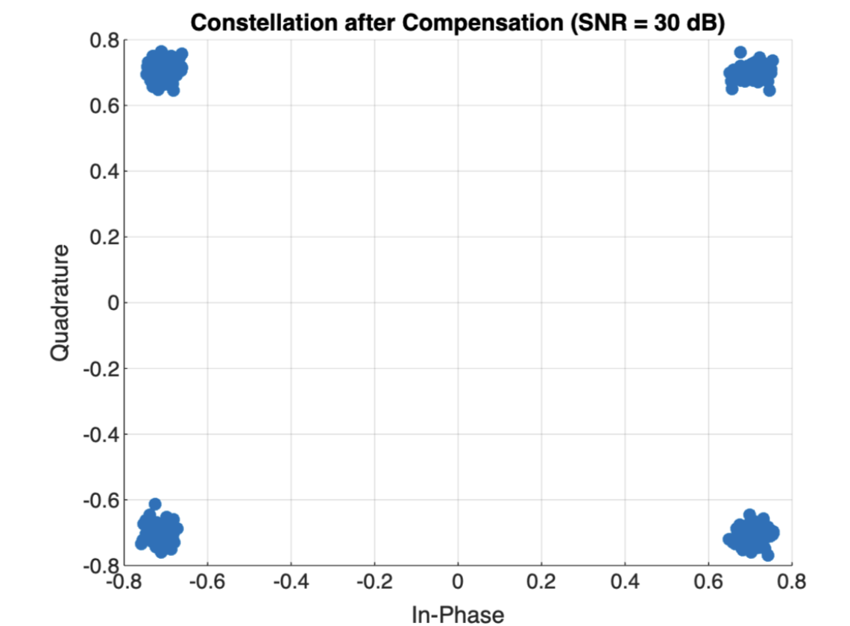

# Question 3(e): Estimated Offsets Table

The estimated frequency offset Δf̂ (in Hz) and phase offset θ̂ (in degrees) were computed for each SNR value using the ML estimation technique. The results are summarized in the table below, based on the code's output. The true values are Δf = 10^4 Hz and θ = 30°.

|  |  |  |
| --- | --- | --- |
| SNR (dB) | Estimated Δf (Hz) | Estimated θ (deg) |
| 10 | -4012.92 | 47.79 |
| 15 | 13417.12 | 20.12 |
| 20 | 8190.23 | 32.84 |
| 25 | 10852.34 | 28.97 |
| 30 | 9993.79 | 30.76 |

## Analysis:

The table reveals that the estimated Δf and θ values vary with SNR. At the lowest SNR of 10 dB, the frequency offset estimate is significantly off (-4012.92 Hz) and the phase offset (47.79°) deviates considerably from the true value, reflecting the impact of noise on estimation accuracy. As SNR increases, the estimates improve, with Δf approaching 10,000 Hz and θ nearing 30° at 30 dB (9993.79 Hz and 30.76°, respectively). This trend indicates that higher SNR reduces estimation errors, though some residual discrepancies persist, likely due to the limited number of pilot symbols (8) used for estimation or inherent limitations in the ML method under these conditions.

# Conclusion

The results demonstrate the effectiveness of the ML-based frequency and phase offset estimation and compensation technique, particularly at higher SNR values. The uncompensated constellation shows a clear rotational drift due to the frequency offset, which is progressively corrected as SNR increases, leading to well-defined QPSK clusters in the compensated signal. The estimation accuracy improves with SNR, though further refinement (e.g., using more pilot symbols) could enhance precision at lower SNR levels.