**Map of The Plastic Flow in the oceans all over the world:**

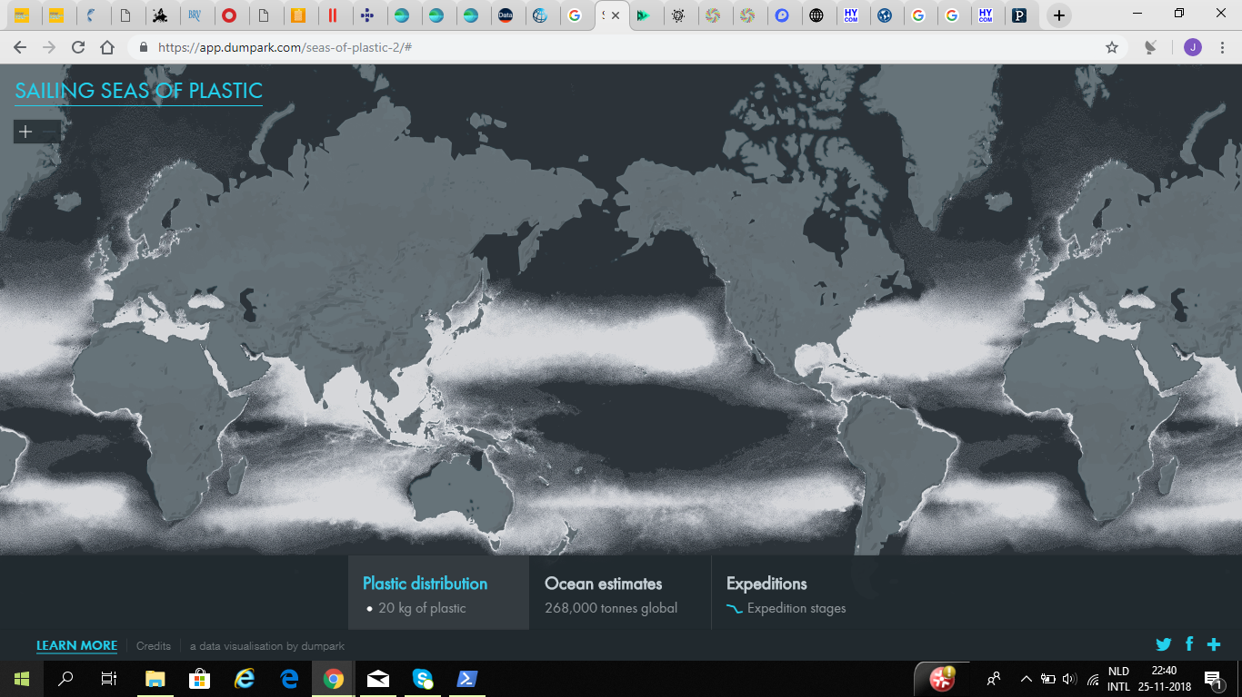

2010

2017

2016

2015

2014

2013

2012

2011

Now it shows the current Plastic Flow for the year 2014: but users can move the red button to different years to see how the Plastic Flow is located in those years, so how it changes over the years.