Youngjune Kim

Lab 11 Post Lab

Part 1

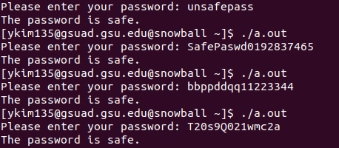

Part 2

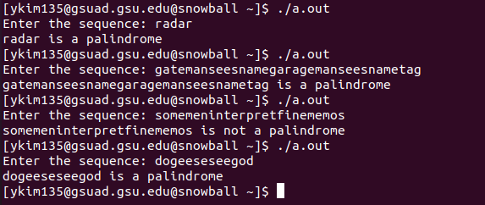

Part 3

