1. /home/ykim135
2. The output, when repeating the step 3, changed to the folder “csc3320”. The working directory was changed to the folder created in step 4.
3. The command “pwd” should be typed to display current working directory.
4. The command “mkdir lab2” should be typed to make the new folder.
5. The command “cd lab2” should be typed to go to the new folder.
6. The “>” is used with cat to specify the input source and ctrl D is used to save and close the file.
7. 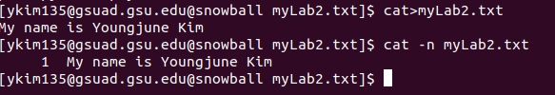
8. 