Youngjune Kim

Lab Assignment 3

Part 2: VI Editing – Large file

3) vi RealEstate.csv

4) Use the down arrow key to move it down

5) “:set number”

6) Press ESC and then type “/111 EAST”

896

“:896d”

7) “:50”

8) “:50,54 s/,/:/g”

9) “:50y”

“:54”

“cc”

Press ESC then “p”

“dd” the blank line

10) “:50,54d”

11) Text mode is entered by “i”

“:2”

Enter text mode then press enter to create new line

Enter the new line “Recorded in year 2008”

12) Press ESC to switch back to command mode

13) “:wq”

Part 3: Permissions for files

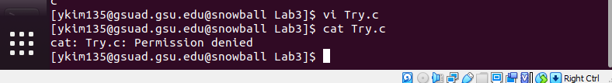10)

12) The file permission changed to r- - r- -r- - and this means that the owner, group, and others can only read the file.

15) The error message is shown as: ‘readonly’ option is set (add ! to override). The vi editor can be shut down without saving by typing the code “:q!”

16) Have to type the following code to individually add:

“chmod u+w Try.c”

“chmod g+w Try.c”

“chmod o+w Try.c”

17) The file permission for Try.c is now rw-rw-rw-. This means that the user, group, and others can now read and write in the file

Part 4: Permission for directories

6)

|  |  |  |  |  |  |  |
| --- | --- | --- | --- | --- | --- | --- |
| Owner’s Permissions | ls | mkdir | cat > | rm | cp | cd |
| --- | N | N | N | N/A | N/A | N |
| --x | N | N | N | N/A | N/A | Y |
| -w- | N | N | N | N/A | N/A | N |
| -wx | N | Y | Y | Y | Y | Y |
| r-- | N | N | N | N/A | N/A | N |
| r-x | N | N | Y | N/A | Y | Y |
| rw- | N | N | N | N/A | N/A | N |
| rwx | Y | Y | Y | Y | Y | Y |