Youngjune Kim

Lab Assignment 4 Part 1

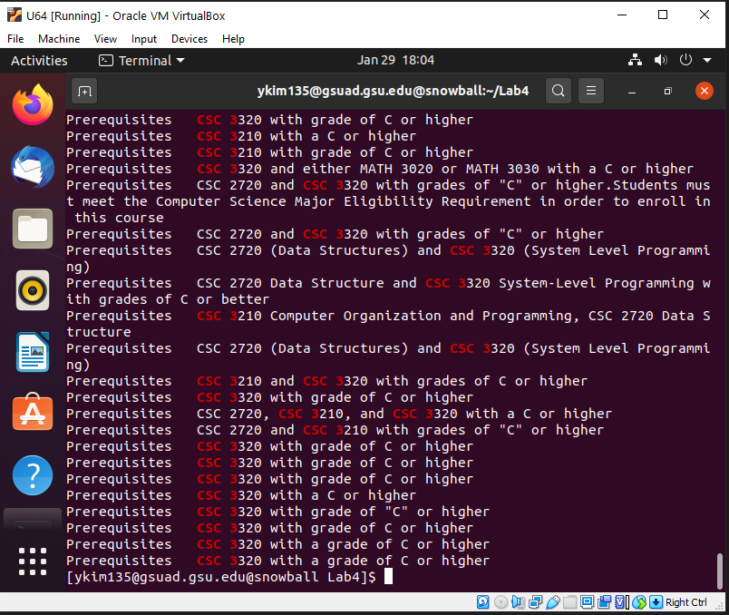4) The grep command does a case sensitive search to find all the lines containing ‘CSC 3’.

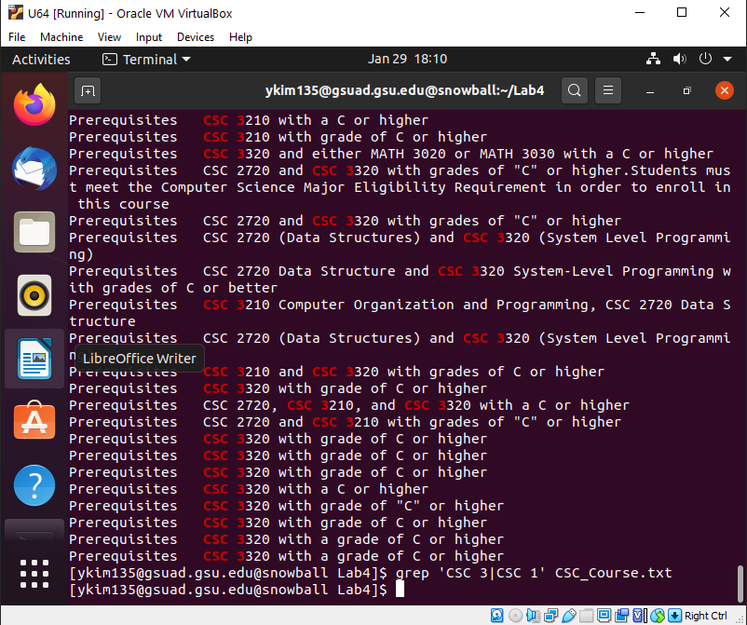5) It performs a case sensitive search on ‘CSC 3’ and ‘CSC 1’.

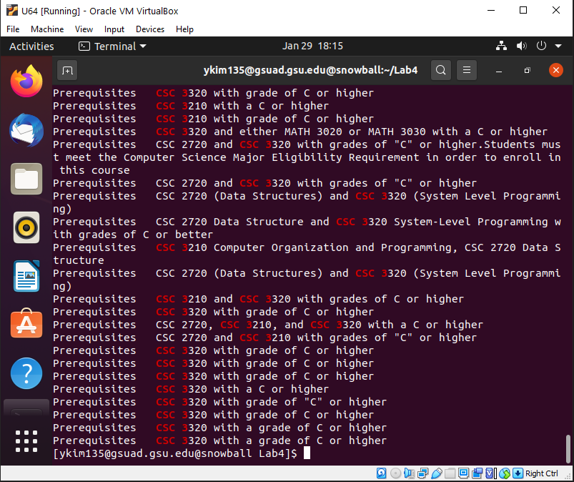6) It searches for the term ‘CSC 3’ and ‘CSC 1’ without reporting syntax error.

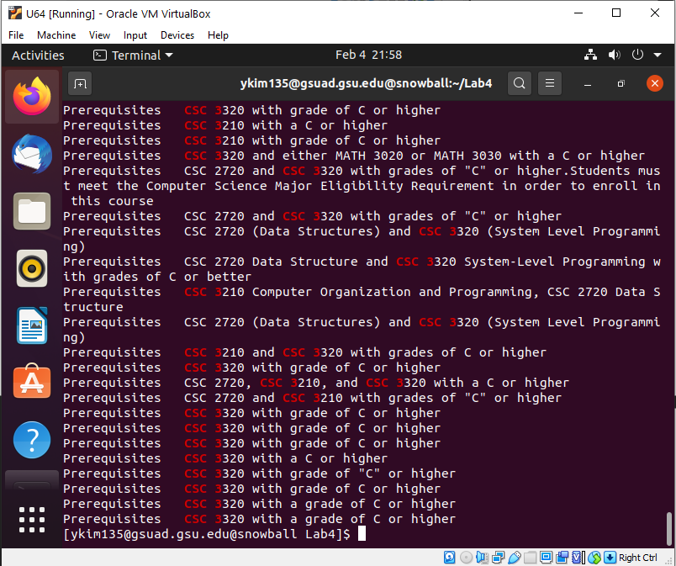7) egrep is essentially the same as grep -E where it treats all the lines as extended regular expressions and prints out the following pattern.

8) N/A

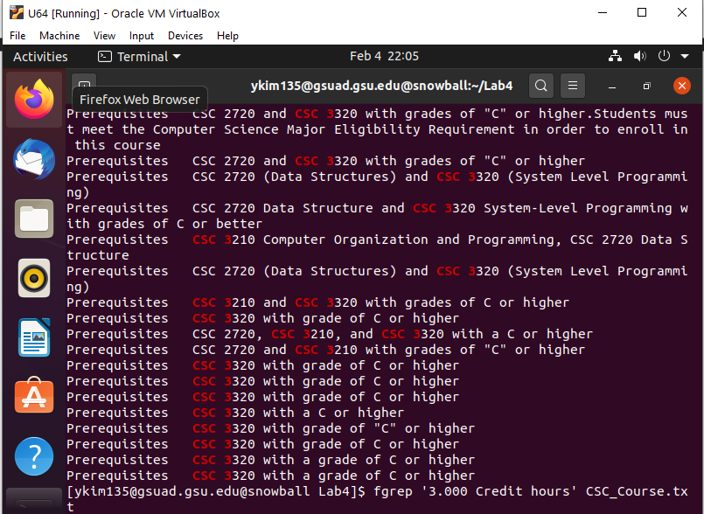

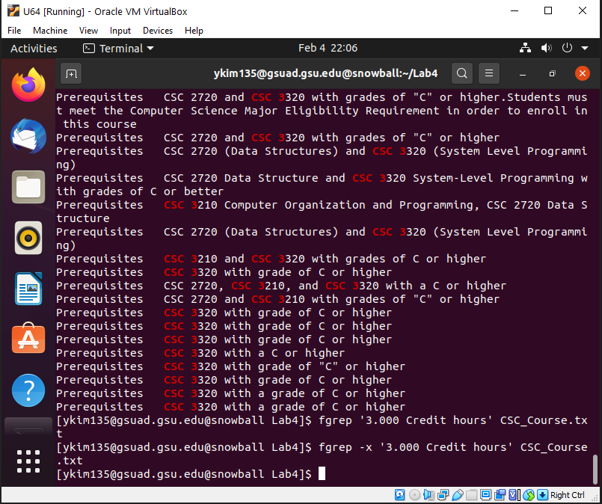9) N/A

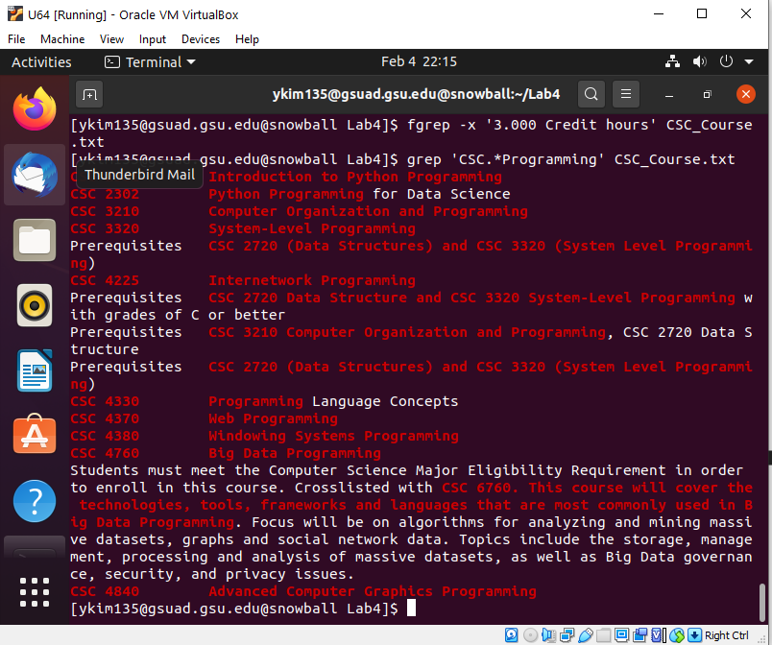10) The command would match the phrase ‘CSC’, all the lines that come after that, and all the lines that come before ‘Programming’.

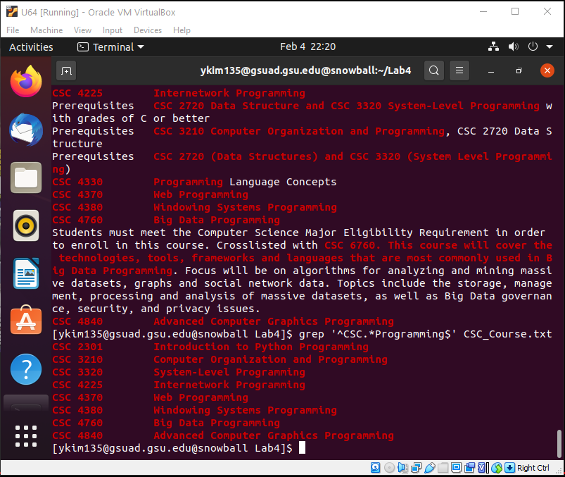11) This command strictly matches and outputs the lines that start with ‘CSC’ and ends with ‘Programming’ which are the class numbers and titles.

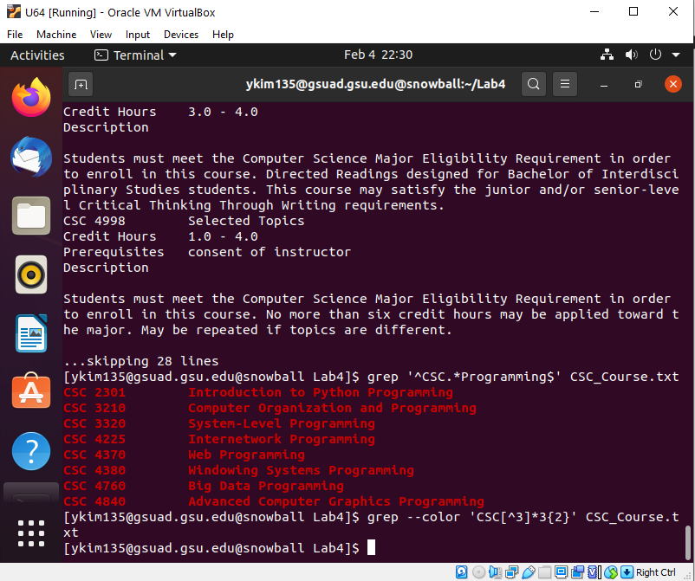12) This command highlights the matched phrase which contains ‘CSC’ and the character after it with ‘3’ written twice.

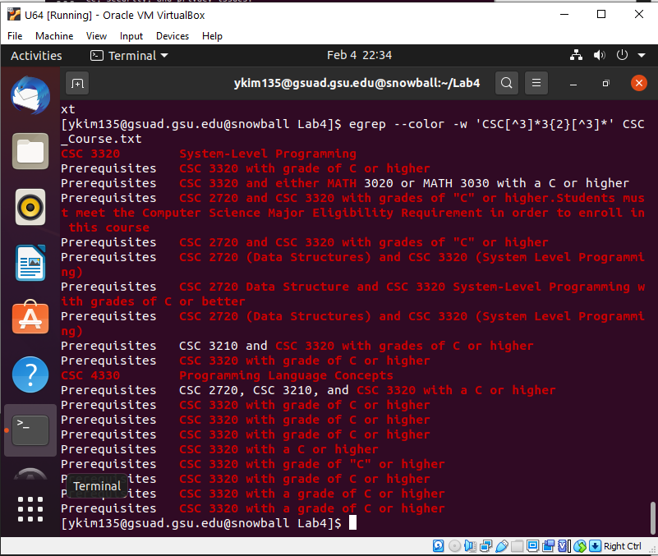13) This command matches ‘CSC’ and matches any character not in the set and match two of the proceeding tokens.

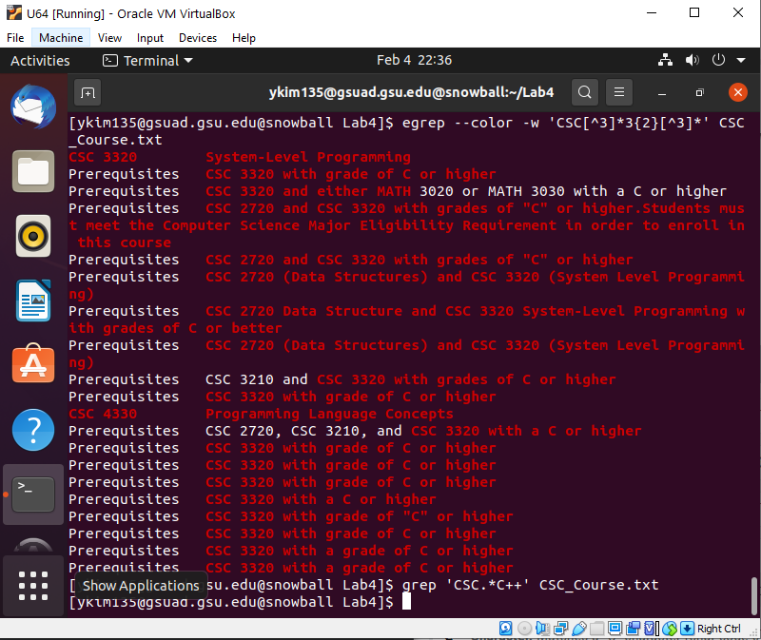14) This command matches ‘CSC’ with the lines that come after with ‘C’ and 1 or more proceeding symbol.

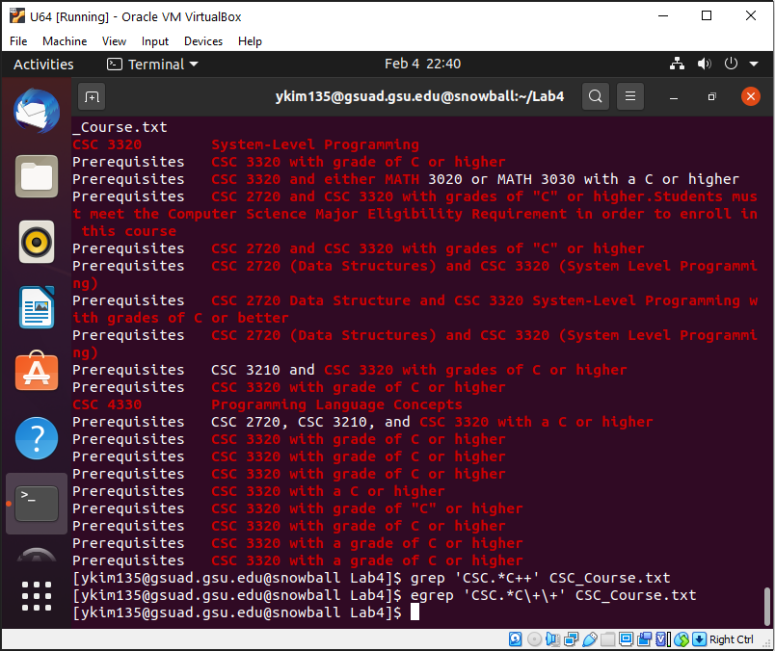15) This command matches ‘CSC’ and the lines after including the ‘C’ with ‘+’ and ‘+’.

16) This command matches lines or parts that start with ‘CSC’ and matches the rest of it until the ending is in ‘C’.