Youngjune Kim

Lab Assignment 4 Part 2

1. grep ‘Towns\|Union’ mountainList.txt
2. grep “grep” mountainList.txt | wc -l
3. grep -c “Rabun” mountainList.txt
4. 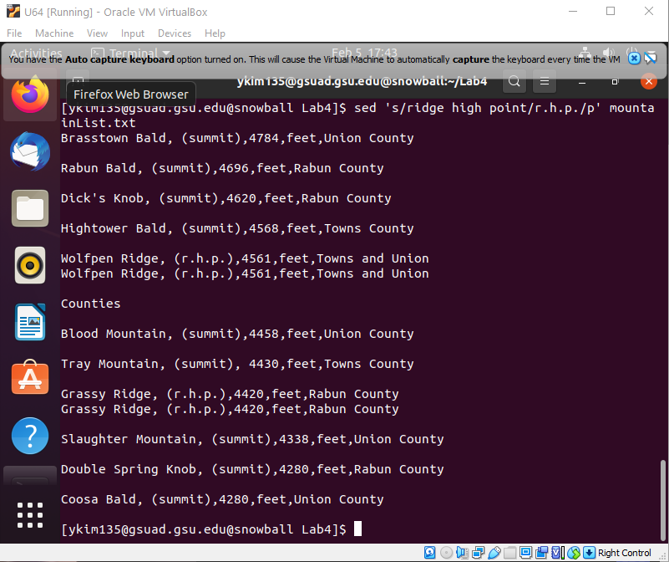a.

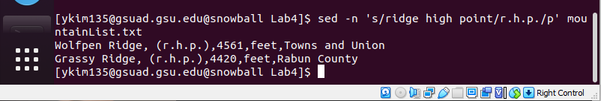b.

c. -n of sed only prints out only the replaced lines in the command.

d. sed command is used substitute the pattern in the file. The s flag is used for that. P flag prints the replaced line twice.

5) sed ‘s/^[ \t]\*//’ mountainList.txt

6) sed ‘s/^[ \t]\*//’ mountainList.txt > newList.txt

7) sed -n /^[\s]’/p mountainList.txt

8) sed ‘s/mountain//g’ mountainList.txt

9) sed -r ‘s/,([^,]\*){3},/,/g’ mountainList.txt

10) awk -r ‘s/,([^,]\*){3},/,/g’ mountainList.txt

11) sed -r ‘s/Table: Eleven highest mountains in Georgia//’ mountainList.txt

12) sort mountainList.txt

13) sort -r mountainList.txt

14) sed -E ‘s/ (Union)\s(County)/\1:\2/g’ mountainList.txt

15) sed -E ‘s/, . \* , / , /’ mountainList.txt