Youngjune Kim

Lab 6 In-Lab

Part1

Line: 1 error: $#/bin/bash correction: #!/bin/bash

Line: 2 error: /\* Check for Error Script \*/ correction: # Check Error Script

Line: 13 error: -ENDHERE correction: END

Line: 7 error: ‘^[^a]\*ce$’ correction: ‘^[^a]\*ce’

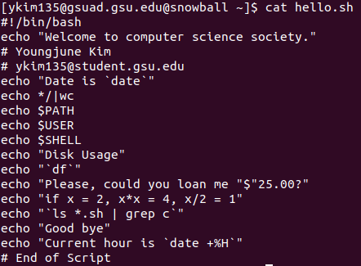Part 2